**20231116| 小一班**

Daily life

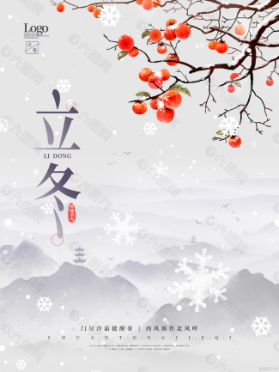

**「来园情况」**

今日星期四，共有8人来园，4人请假。

**「日常生活观察」**

|  |  |  |  |  |  |  |  |  |
| --- | --- | --- | --- | --- | --- | --- | --- | --- |
| **序号** | **姓名** | **入园情绪** | **早点** | **午餐** | | | **午睡** | **午点** |
| **饭** | **菜** | **汤** |
| 1 | 韩昕怡 | √ | √ | √ | √ | √ | √ | √ |
| 2 | 韩昕悦 | √ | √ | √ | √ | √ | √ | √ |
| 3 | 吴清墨 | 请假 |  |  |  |  |  |  |
| 4 | 陆晟涵 | √ | √ | √ | √ | √ | √ | √ |
| 5 | 杨雨涵 | √ | √ | √ | √ | √ | √ | √ |
| 6 | 张梅伊 | √ | √ | √ | √ | √ | √ | √ |
| 7 | 吴沐檀 | 请假 |  |  |  |  |  |  |
| 8 | 曹果 | √ | √ | √ | √ | √ | √ | √ |
| 9 | 曹煜琪 | √ | √ | √ | √ | √ | √ | √ |
| 10 | 蒋安乐 | √ | √ | √ | √ | √ | √ | √ |
| 11 | 韩书华 | √ | √ | √ | √ | √ | √ | √ |
| 12 | 顾言希 | √ | √ | √ | √ | √ | √ | √ |
| 13 | 贾钧尧 | √ | √ | √ | √ | √ | √ | √ |
| 14 | 杨宸 | √ | √ | √ | √ | √ | √ | √ |
| 15 | 张予安 | √ | √ | √ | √ | √ | √ | √ |
| 16 | 高瑞泽 | √ | √ | √ | √ | √ | √ | √ |
| 17 | 张路翔 | 请假 |  |  |  |  |  |  |
| 18 | 谢咏呈 | √ | √ | √ | √ | √ | √ | √ |
| 19 | 汤凌宇 | √ | √ | √ | √ | √ | √ | √ |
| 20 | 韩以轩 | √ | √ | √ | √ | √ | √ | √ |
| 21 | 冯煦晨 | 请假 |  |  |  |  |  |  |
| 22 | 郑哲皓 | √ | √ | √ | √ | √ | √ | √ |

**「区域游戏」**

|  |  |  |
| --- | --- | --- |
| **IMG_8357** | **IMG_8358** | **IMG_8361** |
| **IMG_8364** | **IMG_8367** | **IMG_8370** |

**「早点」**

|  |  |  |  |
| --- | --- | --- | --- |
| **IMG_8371** | **IMG_8377** | **IMG_8378** | **IMG_8389** |
| **IMG_8381** | **IMG_8382** | **IMG_8386** | **IMG_8388** |

**「集体活动」**

谈话《我最爱的玩具》这是一节谈话活动。玩具是孩子的最亲密伴侣，每个孩子都有自己喜欢的玩具，孩子们通过玩玩具去感知和认识世界。本次活动主要引导孩子们能用简短的话语大胆的在集体中介绍自己喜欢的玩具，并且能够与同伴交流、倾听和分享。

|  |  |  |
| --- | --- | --- |
| IMG_8391 | IMG_8396 | IMG_8404 |
| IMG_8422 | IMG_8425 | IMG_8426 |