**20230906| 小三班**

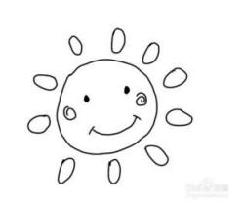

Daily life



**「来园情况」**

1. 今日星期二，共有14人来园，7位小朋友请假。
2. 现在孩子来园基本上都能主动插卡，自己把水杯放下来并绕好水杯带，真的是越来越能干了呢！
3. 孩子们来园做好准备工作后，能主动选择自己喜欢的区域进行游戏计划，棒棒的！

****

**「日常生活观察」**

**今日食谱：**

早点：牛奶、核桃仁、熊字饼干/太平苏打/葱油饼干

午餐：红薯饭、鹌鹑蛋红烧肉、平菇白萝卜烧豆腐、小青菜鱼丸汤

下午点心：枣蓉核桃蛋糕、百吉福奶酪棒

水果：青提、小番茄

|  |  |  |  |  |  |  |  |  |
| --- | --- | --- | --- | --- | --- | --- | --- | --- |
| **序号** | **姓名** | **入园情绪** | **早点** | **午餐** | | | **午睡** | **午点** |
| **饭** | **菜** | **汤** |
| 1 | 杨奕 | √ | √ | ⭕ | ⭕ | √ | √ | √ |
| 2 | 邹枔安 | √ | √ | √ | √ | √ | √ | √ |
| 3 | 谈嘉洛 | 请假 |  |  |  |  |  |  |
| 4 | 穆紫琪 | √ | √ | √ | √ | √ | √ | √ |
| 5 | 孔奕昕 | √ | √ | √ | √ | √ | √ | √ |
| 6 | 郭宸希 | ⭕ | ⭕ | ⭕ | ⭕ | ⭕ | √ | ⭕ |
| 7 | 奚子甯 | √ | √ | √ | √喂 | √ | √ | √ |
| 8 | 吴优 | 请假 |  |  |  |  |  |  |
| 9 | 郑袁一 | 请假 |  |  |  |  |  |  |
| 10 | 刘宸硕 | √ | √ | √ | ⭕喂 | √喂 | ⭕ | √ |
| 11 | 黄赫然 | 请假 |  |  |  |  |  |  |
| 12 | 高嘉豪 | 请假 |  |  |  |  |  |  |
| 13 | 袁宇恩 | √ | √ | √ | ⭕ | √ | √ | √ |
| 14 | 李锦熙 | √ | √ | √ | ⭕ | ⭕ | √ | √ |
| 15 | 范景铭 | 请假 |  |  |  |  |  |  |
| 16 | 王元熙 | 请假 |  |  |  |  |  |  |
| 17 | 张慕礼 | √ | √ | √ | √喂 | √ | √ | √ |
| 18 | 滕梓皓 | √ | √ | √ | √ | √ | √ | √ |
| 19 | 晁嘉佐 | √ | √ | √ | ⭕喂 | √ | √ | ⭕ |
| 20 | 邵芃宇 | √ | √ | ⭕ | ⭕喂 | √ | √ | ⭕ |
| 21 | 李显一 | 请假 | √ | ⭕喂 | ⭕喂 | √ | √ | √ |

**备注：“**√”表示很好；“⭕”慢、晚，有待提高；“**S”剩一点**

|  |  |  |
| --- | --- | --- |
| C:/Users/lulu/OneDrive/桌面/11.7/IMG_5914.JPGIMG_5914C:/Users/lulu/OneDrive/桌面/11.7/IMG_5918.JPGIMG_5918 | C:/Users/lulu/OneDrive/桌面/11.7/IMG_5915.JPGIMG_5915C:/Users/lulu/OneDrive/桌面/11.7/IMG_5916.JPGIMG_5916 | C:/Users/lulu/OneDrive/桌面/11.7/IMG_5917.JPGIMG_5917C:/Users/lulu/OneDrive/桌面/11.7/IMG_5922.JPGIMG_5922 |

**「音乐：苹果」**

歌曲《苹果》是四四拍的歌曲。曲调流畅、旋律简单、规整，情绪欢快，歌曲内容主要引导孩子喜欢吃苹果，身体才会更健康。本次活动我们将创设“秋天大丰收，帮猪妈妈摘苹果”的情境，让幼儿在情境中学唱歌曲。

小班幼儿已经逐渐能跟随教师学唱歌曲，有意识倾听前奏。但是，部分幼儿音准还有所欠缺，旋律的节奏也难以把握。而且不能运用正确的方式发声。

|  |  |  |
| --- | --- | --- |
| C:/Users/lulu/OneDrive/桌面/11.7/IMG_5944.JPGIMG_5944C:/Users/lulu/OneDrive/桌面/11.7/IMG_5951.JPGIMG_5951 | C:/Users/lulu/OneDrive/桌面/11.7/IMG_5945.JPGIMG_5945C:/Users/lulu/OneDrive/桌面/11.7/IMG_5952.JPGIMG_5952 | C:/Users/lulu/OneDrive/桌面/11.7/IMG_5949.JPGIMG_5949C:/Users/lulu/OneDrive/桌面/11.7/IMG_5953.JPGIMG_5953 |

**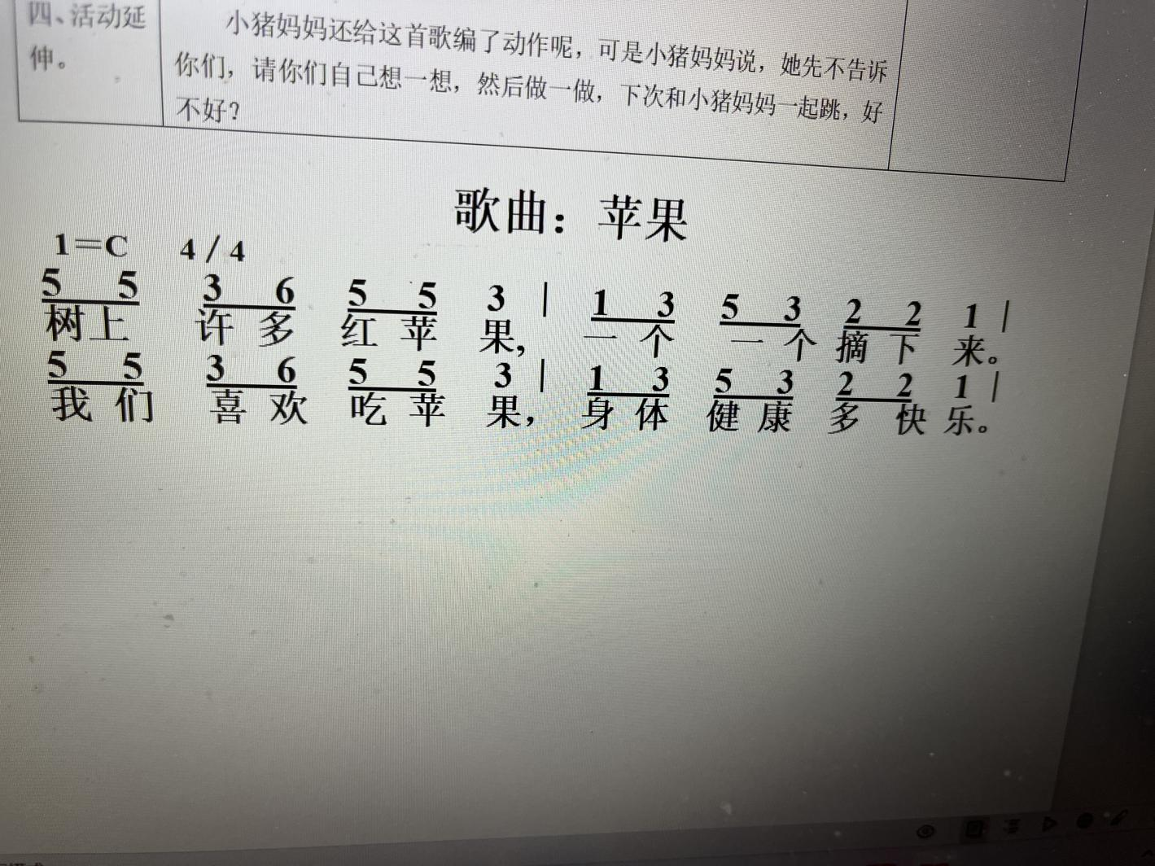**

**「户外游戏」**

今天我们还是进行小班混班游戏，瞧，孩子们在游戏中玩的多开心啊！

|  |  |  |
| --- | --- | --- |
| C:/Users/lulu/OneDrive/桌面/11.7/IMG_5923.JPGIMG_5923C:/Users/lulu/OneDrive/桌面/11.7/IMG_5929.JPGIMG_5929 | C:/Users/lulu/OneDrive/桌面/11.7/IMG_5924.JPGIMG_5924C:/Users/lulu/OneDrive/桌面/11.7/IMG_5930.JPGIMG_5930 | C:/Users/lulu/OneDrive/桌面/11.7/IMG_5925.JPGIMG_5925C:/Users/lulu/OneDrive/桌面/11.7/IMG_5939.JPGIMG_5939 |

**「区域游戏」**

|  |  |  |
| --- | --- | --- |
| C:/Users/lulu/OneDrive/桌面/11.7/IMG_5893.JPGIMG_5893C:/Users/lulu/OneDrive/桌面/11.7/IMG_5897.JPGIMG_5897 | C:/Users/lulu/OneDrive/桌面/11.7/IMG_5894.JPGIMG_5894C:/Users/lulu/OneDrive/桌面/11.7/IMG_5899.JPGIMG_5899 | C:/Users/lulu/OneDrive/桌面/11.7/IMG_5896.JPGIMG_5896C:/Users/lulu/OneDrive/桌面/11.7/IMG_5902.JPGIMG_5902 |

**「请你关注」**

|  |
| --- |
| ★各位家长下午好，定杂志的小朋友今天已经把9月份2本和10月份2本带回家了，请查收！  ★汗背巾用完了还没有带过来的小朋友明天一定带过来哦！  ★最近天气温度忽高忽低，请家长根据天气情况给孩子适量穿脱衣服，以免感冒受凉！ |