**20231101| 小一班**

Daily life

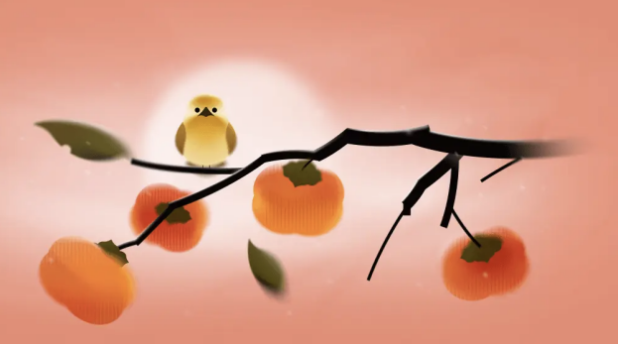

**「来园情况」**

今日星期四，共有15人来园，7人请假。

**「日常生活观察」**

|  |  |  |  |  |  |  |  |  |
| --- | --- | --- | --- | --- | --- | --- | --- | --- |
| **序号** | **姓名** | **入园情绪** | **早点** | **午餐** | | | **午睡** | **午点** |
| **饭** | **菜** | **汤** |
| 1 | 韩昕怡 | √ | √ | √ | √ | √ | √ | √ |
| 2 | 韩昕悦 | √ | √ | √ | √ | √ | √ | √ |
| 3 | 吴清墨 | √ | √ | √ | √ | √ | √ | √ |
| 4 | 陆晟涵 | √ | √ | √ | √ | √ | √ | √ |
| 5 | 杨雨涵 | 请假 |  |  |  |  |  |  |
| 6 | 张梅伊 | √ | √ | √ | √ | √ | √ | √ |
| 7 | 吴沐檀 | √ | √ | √ | √ | √ | √ | √ |
| 8 | 曹果 | √ | √ | √ | √ | √ | √ | √ |
| 9 | 曹煜琪 | 请假 |  |  |  |  |  |  |
| 10 | 蒋安乐 | √ | √ | √ | √ | √ | √ | √ |
| 11 | 韩书华 | 请假 |  |  |  |  |  |  |
| 12 | 顾言希 | √ | √ | √ | √ | √ | √ | √ |
| 13 | 贾钧尧 | √ | √ | √ | √ | √ | √ | √ |
| 14 | 杨宸 | 请假 |  |  |  |  |  |  |
| 15 | 张予安 | √ | √ | √ | √ | √ | √ | √ |
| 16 | 高瑞泽 | √ | √ | √ | √ | √ | √ | √ |
| 17 | 张路翔 | 请假 |  |  |  |  |  |  |
| 18 | 谢咏呈 | √ | √ | √ | √ | √ | √ | √ |
| 19 | 汤凌宇 | 请假 |  |  |  |  |  |  |
| 20 | 韩以轩 | √ | √ | √ | √ | √ | √ | √ |
| 21 | 冯煦晨 | 请假 |  |  |  |  |  |  |
| 22 | 郑哲皓 | √ | √ | √ | √ | ⭕ | √ | √ |

**「区域游戏」**

今天早晨入园后，孩子们自己选择自己喜欢的区域进行游戏。

皓皓在娃娃家煮饭。六六在地面建构区大建高楼。高瑞泽在万能工匠区拼手枪。

谢咏呈在益智区玩亿童玩具—创意拼图。蒋安乐在玩磁力大师。

韩以轩和贾钧尧在植物角观察小动物。

|  |  |  |
| --- | --- | --- |
| 1FF16E5EC59A63F0CD7C8AAD9D9EE683 | C5ED31EE2FF1CC999C6CA4524FCAA2F2 | C29BAED8C5CA2029C0C52994AF51ECD7 |
| B4DB08EFE5B8CD74BBD52F79A61B785A | 64CF0ECCDB567535E32CC780D5C5E6C6 | 643D0374FEB8CB84FC1C9C92EA7A3FEA |