**20231024| 小一班**

Daily life

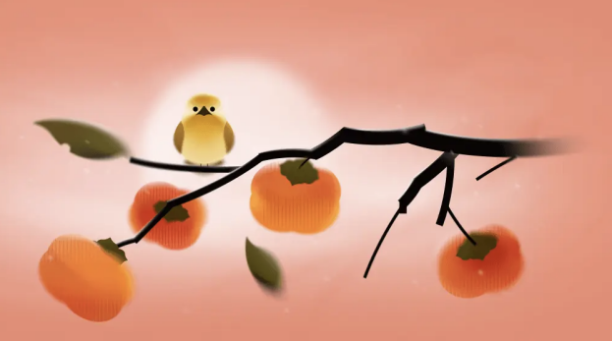

**「来园情况」**

今日星期二，共有12人来园，10人请假。

**「日常生活观察」**

|  |  |  |  |  |  |  |  |  |
| --- | --- | --- | --- | --- | --- | --- | --- | --- |
| **序号** | **姓名** | **入园情绪** | **早点** | **午餐** | | | **午睡** | **午点** |
| **饭** | **菜** | **汤** |
| 1 | 韩昕怡 | 请假 |  |  |  |  |  |  |
| 2 | 韩昕悦 | 请假 |  |  |  |  |  |  |
| 3 | 吴清墨 | 请假 |  |  |  |  |  |  |
| 4 | 陆晟涵 | √ | √ | √ | √ | √ | √ | √ |
| 5 | 杨雨涵 | 请假 |  |  |  |  |  |  |
| 6 | 张梅伊 | √ | √ | √ | √ | √ | √ | √ |
| 7 | 吴沐檀 | √ | √ | √ | √ | √ | √ | √ |
| 8 | 曹果 | 请假 |  |  |  |  |  |  |
| 9 | 曹煜琪 | √ | √ | √ | 喂√ | √ | √ | √ |
| 10 | 蒋安乐 | √ | √ | √ | √ | √ | √ | √ |
| 11 | 韩书华 | √ | √ | √ | √ | √ | √ | √ |
| 12 | 顾言希 | 请假 |  |  |  |  |  |  |
| 13 | 贾钧尧 | 请假 |  |  |  |  |  |  |
| 14 | 杨宸 | 请假 |  |  |  |  |  |  |
| 15 | 张予安 | √ | √ | √ | √ | √ | √ | √ |
| 16 | 高瑞泽 | √ | √ | √ | √ | √ | √ | √ |
| 17 | 张路翔 | 请假 |  |  |  |  |  |  |
| 18 | 谢咏呈 | √ | √ | √ | √ | √ | √ | √ |
| 19 | 汤凌宇 | 请假 |  |  |  |  |  |  |
| 20 | 韩以轩 | √ | √ | √ | √ | √ | √ | √ |
| 21 | 冯煦晨 | √ | √ | √ | √ | ⭕ | √ | √ |
| 22 | 郑哲皓 | √ | √ | √ | √ | ⭕ | √ | √ |

**「户外活动」**

今天我们来到了中操场进行户外混班活动，小班的所有小朋友都出来户外活动啦，我们中操场有：平衡区、综合区、大型亿童积木、攀爬架等。小朋友们可以自由选择感兴趣的地方进行户外游戏。

|  |  |  |
| --- | --- | --- |
| 26bdad3336f1c8ee5b42ec8d4edb3ac7 | b3a4383ad3d50e05329cffc7fcf6db45 | b58919cb87fb5886f33f1e3697e680a7 |
| 686d9082b537fb0334809e4e4fcc0bda | 1dfc293635ada873bbc1d75203b2cbcb |  |