**20231026| 小一班**

Daily life

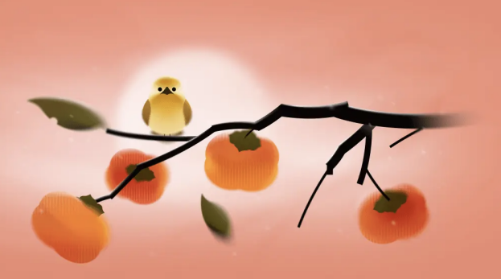

**「来园情况」**

今日星期四，共有9人来园，13人请假。

**「日常生活观察」**

|  |  |  |  |  |  |  |  |  |
| --- | --- | --- | --- | --- | --- | --- | --- | --- |
| **序号** | **姓名** | **入园情绪** | **早点** | **午餐** | | | **午睡** | **午点** |
| **饭** | **菜** | **汤** |
| 1 | 韩昕怡 | 请假 |  |  |  |  |  |  |
| 2 | 韩昕悦 | 请假 |  |  |  |  |  |  |
| 3 | 吴清墨 | 请假 |  |  |  |  |  |  |
| 4 | 陆晟涵 | 请假 |  |  |  |  |  |  |
| 5 | 杨雨涵 | 请假 |  |  |  |  |  |  |
| 6 | 张梅伊 | √ | √ | √ | √ | √ | √ | √ |
| 7 | 吴沐檀 | √ | √ | √ | √ | √ | √ | √ |
| 8 | 曹果 | 请假 |  |  |  |  |  |  |
| 9 | 曹煜琪 | 请假 |  |  |  |  |  |  |
| 10 | 蒋安乐 | √ | √ | √ | √ | √ | √ | √ |
| 11 | 韩书华 | 请假 |  |  |  |  |  |  |
| 12 | 顾言希 | 请假 |  |  |  |  |  |  |
| 13 | 贾钧尧 | 请假 |  |  |  |  |  |  |
| 14 | 杨宸 | 请假 |  |  |  |  |  |  |
| 15 | 张予安 | √ | √ | √ | √ | √ | √ | √ |
| 16 | 高瑞泽 | √ | √ | √ | √ | √ | √ | √ |
| 17 | 张路翔 | 请假 |  |  |  |  |  |  |
| 18 | 谢咏呈 | √ | √ | √ | √ | √ | √ | √ |
| 19 | 汤凌宇 | 请假 |  |  |  |  |  |  |
| 20 | 韩以轩 | √ | √ | √ | √ | √ | √ | √ |
| 21 | 冯煦晨 | √ | √ | √ | √ | ⭕ | √ | √ |
| 22 | 郑哲皓 | √ | √ | √ | √ | ⭕ | √ | √ |

**「户外活动」**

今天延时班我们跟着老师一起用太空泥做了美味的橘子，有的小朋友的橘子大大小小、有的小朋友的橘子好像在排队、有的小朋友的橘子排成了两三排好整齐呢。

|  |  |  |  |
| --- | --- | --- | --- |
| B881036109B4DBBE26E205CB60DD87F6 | B23C221CDF0057F164D0FC7063484E3C | 333285C30F2F2C1B65B114D387D70808 | 53507DA1F320ABF26BD7B6F524D9E447 |
| 38623B13F18B4599A80A30E143FF0CC0 | 7791EF8C97451F1602CB79B476E9BB81 | 82A9FDEB869CD8C26EE839D813F578D1 | 28EBB1354AC9D4F4ABF27789BF309B97 |