**20231012| 小一班**

Daily life

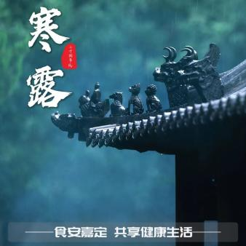

**「来园情况」**

今日星期四，共有18人来园，4人请假。

**「日常生活观察」**

|  |  |  |  |  |  |  |  |  |
| --- | --- | --- | --- | --- | --- | --- | --- | --- |
| **序号** | **姓名** | **入园情绪** | **早点** | **午餐** | | | **午睡** | **午点** |
| **饭** | **菜** | **汤** |
| 1 | 韩昕怡 | √ | √ | 喂√ | √ | √ | √ | √ |
| 2 | 韩昕悦 | √ | √ | √ | √ | √ | √ | √ |
| 3 | 吴清墨 | 请假 |  |  |  |  |  |  |
| 4 | 陆晟涵 | ⭕ | √ | ⭕ | √ | √ | √ | √ |
| 5 | 杨雨涵 | √ | √ | √ | √ | √ | √ | √ |
| 6 | 张梅伊 | √ | √ | √ | ⭕ | ⭕ | √ | √ |
| 7 | 吴沐檀 | √ | √ | √ | √ | √ | √ | √ |
| 8 | 曹果 | 请假 |  |  |  |  |  |  |
| 9 | 曹煜琪 | ⭕ | √ | 喂√ | √ | √ | √ | √ |
| 10 | 蒋安乐 | √ | √ | √ | √ | √ | √ | √ |
| 11 | 韩书华 | √ | √ | √ | √ | √ | √ | √ |
| 12 | 顾言希 | 请假 |  |  |  |  |  |  |
| 13 | 贾钧尧 | √ | √ | √ | √ | √ | √ | √ |
| 14 | 杨宸 | 请假 |  |  |  |  |  |  |
| 15 | 张予安 | √ | √ | √ | √ | √ | √ | √ |
| 16 | 高瑞泽 | √ | √ | √ | √ | √ | √ | √ |
| 17 | 张路翔 | 请假 |  |  |  |  |  |  |
| 18 | 谢咏呈 | √ | √ | √ | √ | √ | √ | √ |
| 19 | 汤凌宇 | √ | √ | √ | ⭕ | ⭕ | √ | √ |
| 20 | 韩以轩 | √ | √ | ⭕ | ⭕ | ⭕ | √ | √ |
| 21 | 冯煦晨 | √ | √ | 喂 |  |  | √ | √ |
| 22 | 郑哲皓 | ⭕ | √ | √ | √ | ⭕ | √ | √ |

**「户外活动」**

今天我们来到了中操场进行户外混班活动，小班的所有小朋友都出来户外活动啦，我们中操场有：综合区、平衡区、沙包投掷区、大型亿童积木区和攀爬架区。小朋友们可以自由选择感兴趣的地方进行户外游戏。

|  |  |  |
| --- | --- | --- |
| IMG_7049 | IMG_7050 | IMG_7051 |
| IMG_7052 | IMG_7053 | IMG_7055 |
| IMG_7056 | IMG_7057 | IMG_7058 |
| IMG_7059 | IMG_7060 | IMG_7061 |