**20231016| 小一班**



Daily life

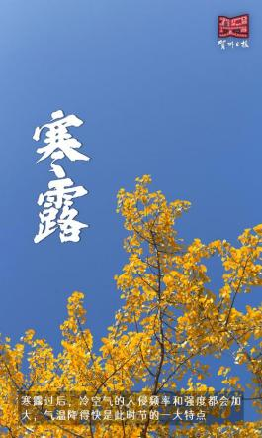

**「来园情况」**

今日星期一，共有14人来园，8人请假。

**「日常生活观察」**

|  |  |  |  |  |  |  |  |  |
| --- | --- | --- | --- | --- | --- | --- | --- | --- |
| **序号** | **姓名** | **入园情绪** | **早点** | **午餐** | | | **午睡** | **午点** |
| **饭** | **菜** | **汤** |
| 1 | 韩昕怡 | 请假 |  |  |  |  |  |  |
| 2 | 韩昕悦 | 请假 |  |  |  |  |  |  |
| 3 | 吴清墨 | 请假 |  |  |  |  |  |  |
| 4 | 陆晟涵 | √ | √ | √ | √ | ⭕ | √ | ⭕ |
| 5 | 杨雨涵 | √ | √ | √ | √ | √ | √ | √ |
| 6 | 张梅伊 | √ | √ | √ | √ | √ | √ | √ |
| 7 | 吴沐檀 | 请假 |  |  |  |  |  |  |
| 8 | 曹果 | 请假 |  |  |  |  |  |  |
| 9 | 曹煜琪 | 请假 |  |  |  |  |  |  |
| 10 | 蒋安乐 | √ | √ | √ | √ | √ | √ | √ |
| 11 | 韩书华 | √ | √ | √ | 蔬⭕ | √ | √ | √ |
| 12 | 顾言希 |  |  |  |  |  |  |  |
| 13 | 贾钧尧 | 请假 |  |  |  |  |  |  |
| 14 | 杨宸 | 请假 |  |  |  |  |  |  |
| 15 | 张予安 | √ | √ | √ | √ | √ | √ | √ |
| 16 | 高瑞泽 | √ | √ | √ | √ | √ | √ | √ |
| 17 | 张路翔 |  |  |  |  |  |  |  |
| 18 | 谢咏呈 | √ | √ | √ | √ | √ | √ | √ |
| 19 | 汤凌宇 | √ | √ | √ | ⭕ | √ | √ | √ |
| 20 | 韩以轩 | √ | √ | √ | ⭕ | √ |  |  |
| 21 | 冯煦晨 | √ | √ | 喂√ | 喂√ | ⭕ | √ | √ |
| 22 | 郑哲皓 | ⭕ | √ | √ | 蔬⭕ | √ | √ | √ |

**「区域游戏」**

|  |  |  |
| --- | --- | --- |
| **IMG_0790** | **IMG_0789** | **IMG_0788** |
| **IMG_0786** | **IMG_0787** |  |

**「户外游戏」**

|  |  |  |
| --- | --- | --- |
| **IMG_0801** | **IMG_0795** | **IMG_0816** |
| **IMG_0819** | **IMG_0814** | **IMG_0802(1)** |
| **IMG_0809(1)** | **IMG_0791** | **IMG_0794(1)** |

**「语言：秋天的画报」**

《秋天的画报》这首诗歌浅显易懂、短小精练而又生动活泼。它用多彩的颜色和各种妇幼象征性的水果来描述丰收的秋天，如梨、枣、苹果、葡萄，不仅让幼儿感受到了水果的丰富多彩，而且向我们展示了一个色彩斑斓的秋天，又给人以视觉和味觉上的享受，使幼儿的心灵和情感得到熏陶。

|  |  |  |
| --- | --- | --- |
| **QQ图片20231014134718QQ图片20231014134709IMG_0838(1)** | **IMG_0837(1)** | **IMG_0836** |