**20231010| 小一班**

Daily life

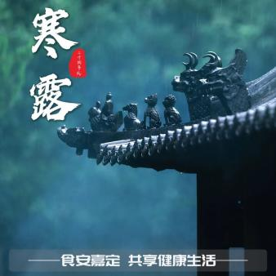

**「来园情况」**

今日星期日，共有17人来园，5人请假。

**「日常生活观察」**

|  |  |  |  |  |  |  |  |  |
| --- | --- | --- | --- | --- | --- | --- | --- | --- |
| **序号** | **姓名** | **入园情绪** | **早点** | **午餐** | | | **午睡** | **午点** |
| **饭** | **菜** | **汤** |
| 1 | 韩昕怡 | √ | √ | 喂√ | √ | √ | √ | √ |
| 2 | 韩昕悦 | √ | √ | √ | √ | √ | √ | √ |
| 3 | 吴清墨 | 请假 |  |  |  |  |  |  |
| 4 | 陆晟涵 | ⭕ | √ | ⭕ | √ | √ | √ | √ |
| 5 | 杨雨涵 | √ | √ | √ | √ | √ | √ | √ |
| 6 | 张梅伊 | √ | √ | √ | ⭕ | ⭕ | √ | √ |
| 7 | 吴沐檀 | √ | √ | √ | √ | √ | √ | √ |
| 8 | 曹果 | 请假 |  |  |  |  |  |  |
| 9 | 曹煜琪 | ⭕ | √ | 喂√ | √ | √ | √ | √ |
| 10 | 蒋安乐 | √ | √ | √ | √ | √ | √ | √ |
| 11 | 韩书华 | √ | √ | √ | √ | √ | √ | √ |
| 12 | 顾言希 | 请假 |  |  |  |  |  |  |
| 13 | 贾钧尧 | √ | √ | √ | √ | √ | √ | √ |
| 14 | 杨宸 | 请假 |  |  |  |  |  |  |
| 15 | 张予安 | √ | √ | √ | √ | √ | √ | √ |
| 16 | 高瑞泽 | √ | √ | √ | √ | √ | √ | √ |
| 17 | 张路翔 | 请假 |  |  |  |  |  |  |
| 18 | 谢咏呈 | √ | √ | √ | √ | √ | √ | √ |
| 19 | 汤凌宇 | √ | √ | √ | ⭕ | ⭕ | √ | √ |
| 20 | 韩以轩 | √ | √ | ⭕ | ⭕ | ⭕ | √ | √ |
| 21 | 冯煦晨 | √ | √ | 喂 |  |  | √ | √ |
| 22 | 郑哲皓 | ⭕ | √ | √ | √ | ⭕ | √ | √ |

**「集体活动」**

美术《多彩的树叶》这是一节涂色活动。树叶有圆形、扇形等形状之分。本次活动通过欣赏树叶的实物、动手操作，从而认识树叶，了解树叶颜色变化的基础上，给树叶涂上适当的颜色，感受秋天树叶的色彩美。

|  |  |  |
| --- | --- | --- |
| IMG_6980 | IMG_6981 | IMG_6982 |

**「户外活动」**

今天我们来到了中操场的综合区进行户外游戏，需要我们跨越障碍、跳过小云朵、走过独木桥、最后爬过大油桶。

|  |  |  |
| --- | --- | --- |
| IMG_6947 | IMG_6951 | IMG_6955 |
| IMG_6957 | IMG_6966 | IMG_6970 |