Title | Unit 3 A healthy diet融合绘本We all love ice cream
Subject | English |  | Teacher | Angela
Textbook analysis
文本解读
1.【What】主要内容
教材六下Until3 A healthy diet传达的理念是关注健康饮食中适量的问题，在绘本《We all love ice cream》中关注了现实生活中孩子们普遍存在的挑食现象，引导学生在感知、理解、运用、创新的过程中充分思考和反思健康饮食中还应关注均衡饮食的状况。
2.【Why】主题意义
本课时旨在学生通过文本的学习，让学生认识到均衡饮食对健康的重要性。
3.【How】文本结构
本课是交际互动式语篇，主要涉及到劝吃蔬菜等的句型If you...you can/I will...复现了学过的单词，根据食物的可数与不可数强调食物的量法。
Learner analysis
从学习能力来看，在图片、文字、视频等资源的助力下，学生能较好地整体感知文本；
基于相关学习经验，学生能较准确地朗读单词；能在小组合作中完成任务，但分工的效率还有待提高；
在语言能力方面，学生已掌握了一定量的相关句型表达，学生基于之前的学习，能初步运用动词的三单进行谈论；并能运用一般将来时时态进行表达；
思维品质方面，在保证学生思维的准确性的基础上，学生思维的多元性需要教师引导；
在文化意识方面，激发学生对健康饮食更深层次的理解。
Teaching objectives
- 能在语境中感知、理解、准确朗读词汇：brocolli，carrots；
- 能准确理解文本中的大意，并能用If you...you can/I will...It’s/They’re not...It’s/They’re...进行劝说；
- 能在语境中理解并运用动词的三单形式；
- 能在理解文本的基础上，进行预测并准确表达；
- 通过文本的学习，让学生认识到均衡饮食对健康的重要性。
Key points & challenges
- 能准确理解文本中的大意，并能用If you...you can/I will...It’s/They’re not...It’s/They’re...进行劝说；
- 能在理解文本的基础上，进行预测并准确表达；
- 再次感受教材中健康饮食标准：适量，在通过文本的学习后，让学生认识到健康饮食标准：均衡。
Teaching methods
Task-based teaching method
Teaching procedures
Teaching activities |  | Predicted students’ activities |  | Teaching purpose
Before class
A game: Sing a song  《Healthy eating》 |  |  |  | 通过歌曲，激发学生的学习兴趣，激活学生已有认知，为后文拓展做铺垫。
Step1 Pre-reading
Think and say  Talk about your diet  To have a healthy diet, we should pey attention to the moderate amout of food. |  | S1: I like... I have...  ...I have a healthy diet.  S2: ...I don’t have a healthy diet. |  | 通过谈论自己的健康饮食习惯，复习教材内容，再次呈现教材中所提到的主题意义：适量饮食，找到与绘本之间的联结
Step 2 While-reading
- Look and say  Do you have any questions?  - Watch and answer  Q: What is the story mainly about?  - Look and say  - brocolli  T: Fred doesn’t like...  Teach brocolli  Try to read  - Carrots  T: What about Mum?  - Part 1  Read page by page  - Listen and find(p6-7)  Q: What will Mum say?  - Think and say(p8-11)  Q: What will Mum say?  Teach”an hour”  追问：What time is it?  - Conclude and say  Q: If you were mum, what else will you say?  T: ice cream, watching TV... they are all rewards.（板书）  - Part 2  - Work in pairs  T: What will they say? Work in pairs and try to act...  （板书）If you ...I will...  - Report in pairs  - Read page by page  Teach” do the dishes”,”do the laundry”  - Think and say  T: Look, Mum doesn’t like carrots. But she’s mum, she must...set an example（板书）You eat...first.  - Part 3  - Let’s infer  Q: What will dad say?  - Read  - Wacth a video  T: What else can he say?  呈现They are not...  They are...  When we persuade, we can use the imagination（板书）  - Imagine and act |  | S1: Who are they?  S2: Where?  S3: Why are they happy?  ...  S: brocolli.  I don’t like...  S: carrots.  I don’t like...  S: eat an ice cieam...  S: It’s 11 o’clock.  S1: If you... you can ...(play games, buy new clothes...)  - Act in pairs  - Report and watch  - Learn  Wash the dishes  Wash the clothes  - Try to say  - Look and say  S1: If you eat... you can...  - Read  - Watch and say  - Act |  | 通过观察图片，猜测故事内容并提问。  通过观察发现作者的表达意图，并尝试读出相应的语气。  通过观察图片猜测故事的发展，理解故事。  通过已有的知识经验，迁移运用语言支架。  同桌合作自学第二部分  通过罗拉和查理的视频，学生能初步感受劝说方法之一：运用想象  通过归纳总结的劝说方法：奖励、榜样、想象，激发学生已有的生活经验和知识框架，小组合作迁移使用框架并有所创新。
Step 3 Post-reading
T: Do they have a healthy diet?  Why?  Yes. They like...  Can they eat the ice cream?  - Give suggestions  T: Yes, They can eat ice cream, but they also should eat ... they should eat...too（呈现金字塔）  - Think and say  Q: To have a healthy diet, what should we do?  T: To have a healthy diet, we should pay attention to the moderate amout of food, we should have a balanced eating habit too. They all help us have a healthy diet. |  | S: No.  They don’t eat...  Ice cream  Yes, but they...  S: They can eat...but they also sholud eat... |  | 通过自主选择练习，为不同程度的学生设置检测梯度。  通过绘本的学习和问题Can they eat the ice cream?的激发，让学生自然输出but they...在思考和回答问题的同时，感受均衡饮食。
Homework
【Need to do】
- Read the picture book.
- Share the story with your family.
【Choose to do】
Retell the story according to the mind map.
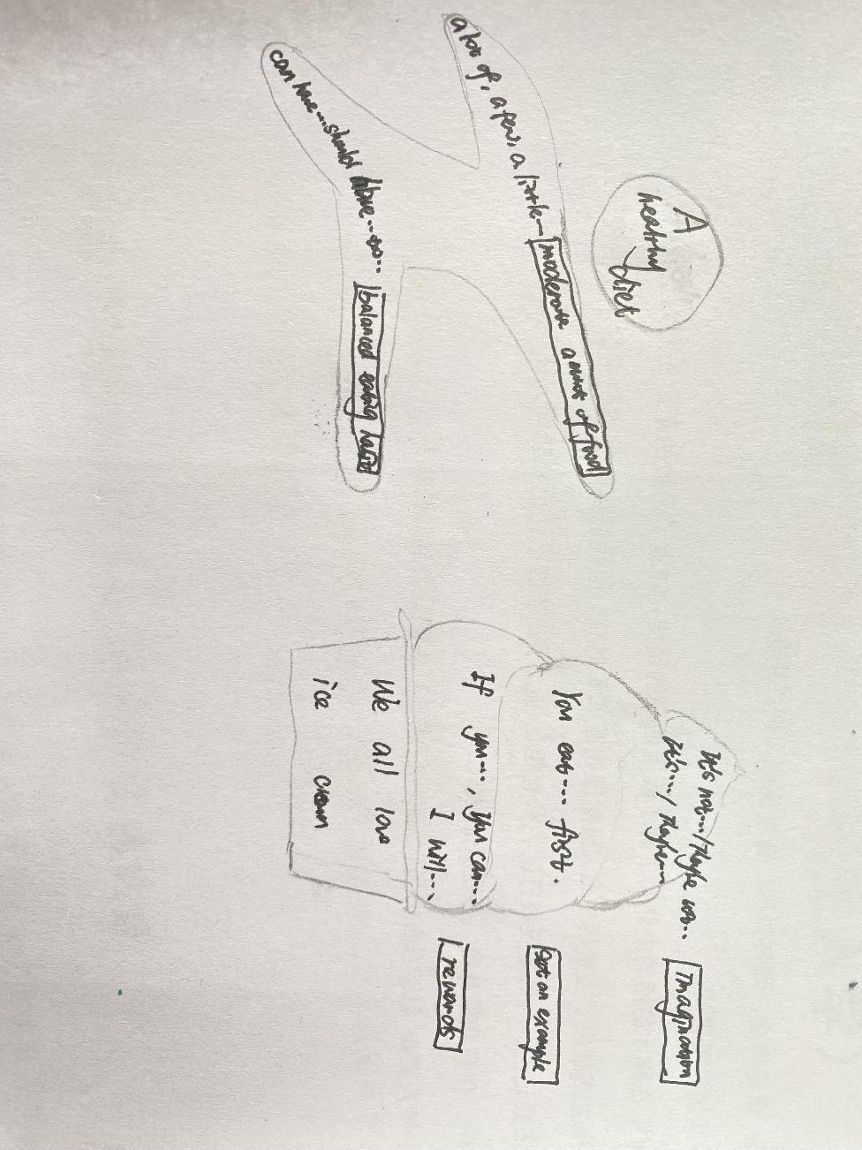
Blackboard design

反思：在第二部分自学后，又再次重复了问题：If you were Fred, what will you say?跟之前两人合作自学部分重复，这一部分值得商榷；此外在最后一部分，在主题意义的升华之前，可以让学生稍微说一说，Do they have a healthy diet? 再追问why?在追问的过程中让学生自发说出they can eat ice cream, but they...等表达想法，在学生充分谈论之后带领学生一起总结绘本的主题意义---健康饮食：均衡。

