Title | 五下Unit8 Birthdays (story time)
Subject | English |  | Contestant | 诸江萍
Learner analysis
本单元谈论自己的生日。课文中呈现了教室的场景，Miss Li和学生们在课堂上谈论生日的话题，Su Hai 和Mike分别介绍了各自的生日，呈现了中西方文化的差异。
Teaching key & difficult points:
1.Ss can read, comprehend and tell the story.
2.Ss can understand and know the words and sentence patterns:eleventh,eighth,together,birthday,game;When is your birthday?
It’s on...What do you do on your birthday? I usually...
3.Ss can talk about their birthdays.

Teaching objectives
- Ss are able to read,comprehend and tell the story.
- Ss are able to understand and know the words and sentence patterns:eleventh,eighth,together,birthday,game;When is your birthday?
It’s on...
- Ss are able to locate information in detailed reading.
- Ss are able to talk about their birthdays.
- To love and to be love is the greatest happiness in our life.
- Ss feels the beautiful structure of mindmap.

Teaching methods
PWP
Teaching procedures
Teaching activities |  | Predicted students’ activities |  |  | Teaching purpose
Pre-reading:  - I say you say  2.Look and say  they are all about...  3.Free talk  1.What can we do on birthdays?  - Yes or no game  1. Do you eat cakes on your birthday?  2. Do you eat noodles on your birthday?  3. do you get presents on your birthday?  Birthdays are very happy, right?  总计： this is（板书）  What we know about birthdays.  While reading:  - Look and say  - Whose birthdays ?  - Listen and find  - When is Su Hai’s birthday?  简单讲解序数词  - Look and say  When is Mike’s birthday?  Can you find the answers on the pics?  3.try to ask  What do you want to know about Su Hai’s birthdays?  You want to know a lot.  4.watch and answer  Let’s first focus on what do you do, Su hai?  Q1: why do they eat noodles?  Q2: what other food do we eat on birthdays?  T: in china, people always eat noodles on their birthdays. It’s a Chinese tradition.  Q3: say something about the picture.(where is the cat? What is she doing?why？)  (联系五上u7 at weekendsk课文内容)  5.yes or no game  1. Does Su Hai have presents?  T: look! Are they happy? Why? Because they....  For苏海， presents can be______  6.Read and imitate  Can you read happily?  6.Ask and answer  Choose one to talk about suhai’s birthday.  - work in pairs  Finish Mike’s birthday mindmap  - presentation.  (美的展示)  9.read and imitate  10.Let’s think  What present does Mike get?  9.what do you think can be a present? |  | I am xxx.  I am a boy.  I like...  I can...  S:birthday  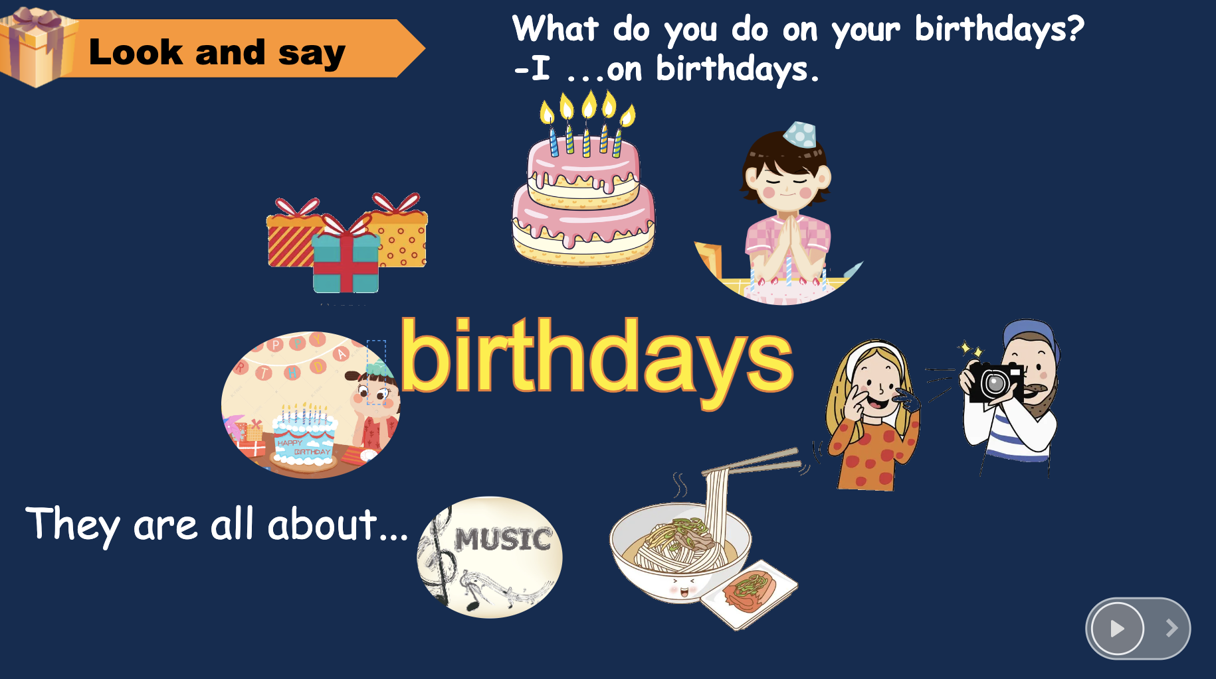  Buy a birthday cake;  Make a wish;  Put candles on the cake;  Eat some noodles;  Sing a song;  (can you sing it ?together!)  Have a party:  Get presents  S1:a book.  S2: a toy car.  S3:... (sounds great!)  S4: ...(that’s cool!)  S5: (so lucky you are!)  - Su hai and Mike’s birthdays.(板书)  It’s on the eleventh of May.  It’s eleven.  It’s on the eleventh of May.  T: Great. And here "th" pronounced..  It’s on the eighth of April.  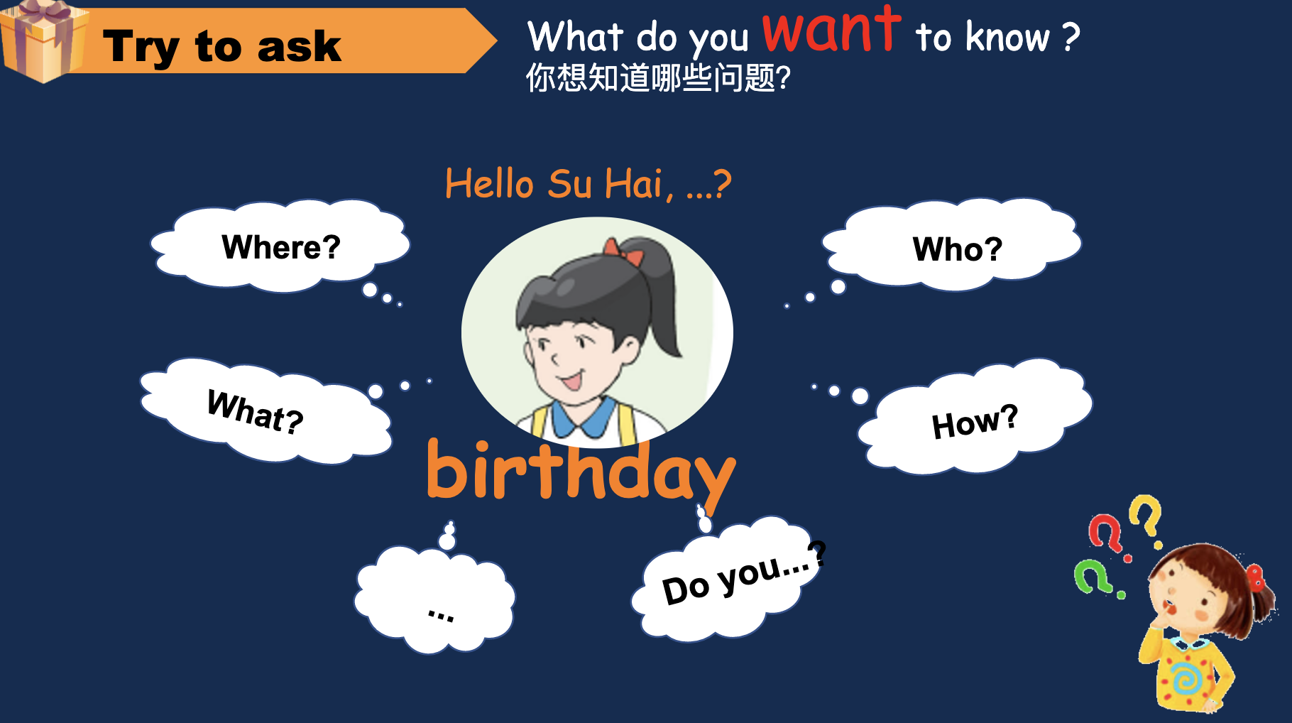  Where is your birthday?  Who comes?  How do you feel?  What do you do?  Do you eat a cake?  Do you...?  How old are you?  1.What do you do?  Have a big dinner  Eat some noodles  S1: for longevity.  Eggs;  peach  Play with kitty the cat  S1:also cat’s birthday.  S2: feel the happiness too.  It’s sitting on the chair.  She is eating noodles. Suhai is feeding her.  It is also a family member.  S1:no  - A big dinner  - Get together with families  - Reunion  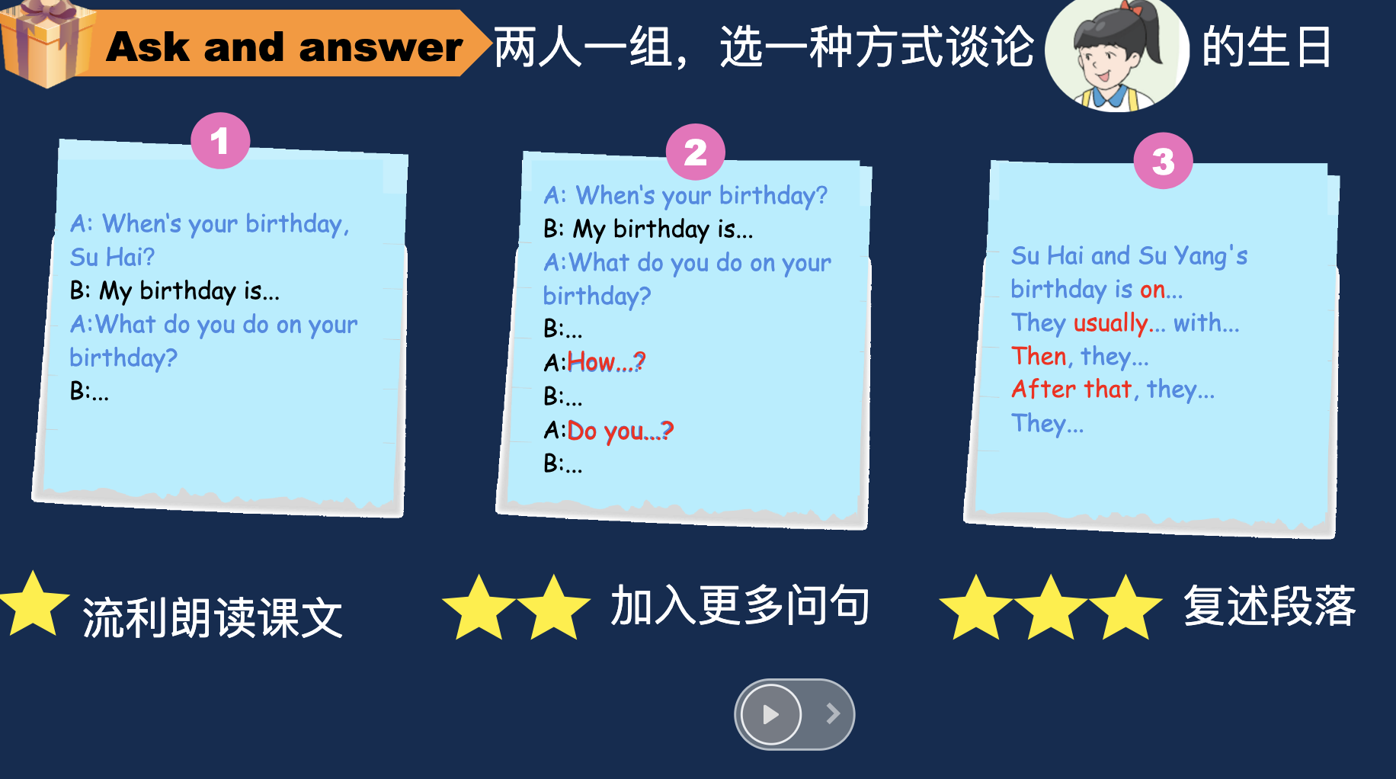  - wow, you can read nicely.  - You can ask so many good questions.  - You can retell the story. I’m so proud of you!  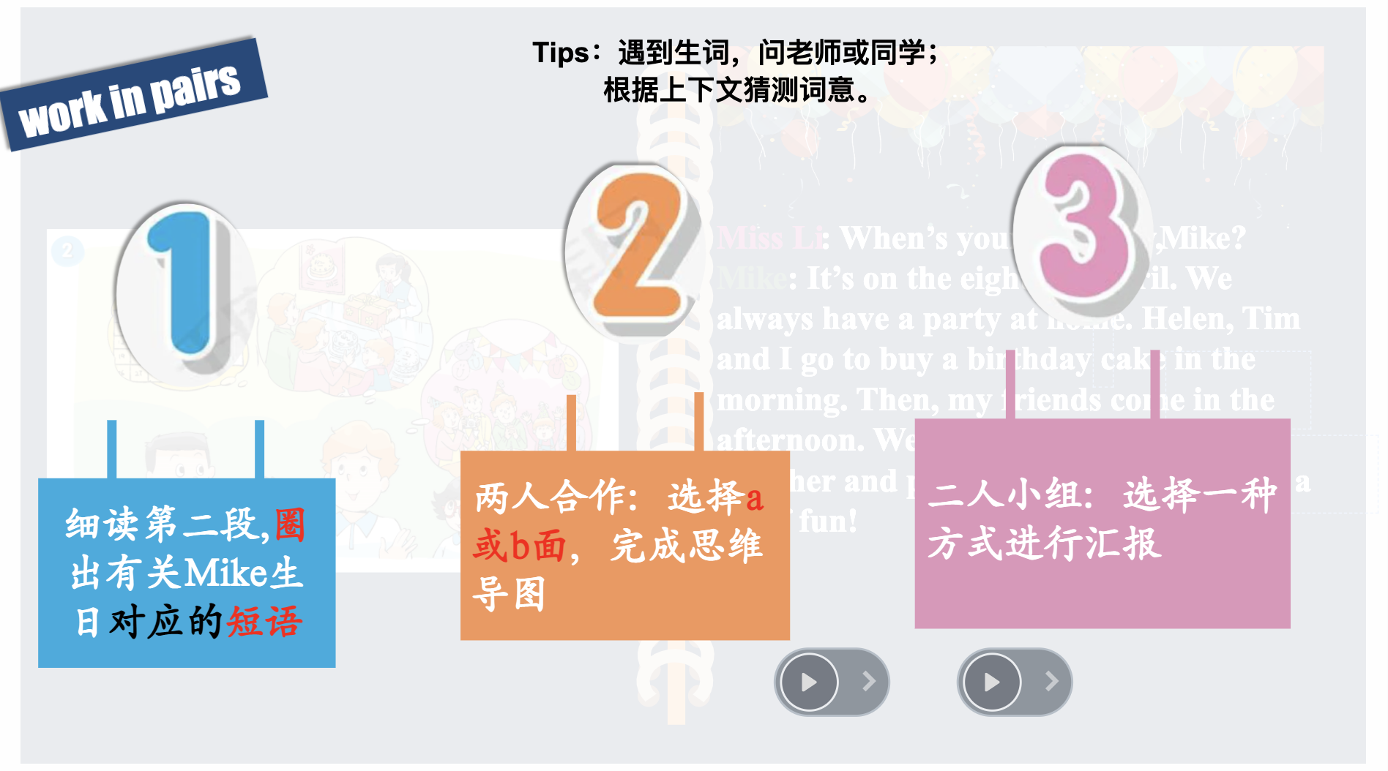  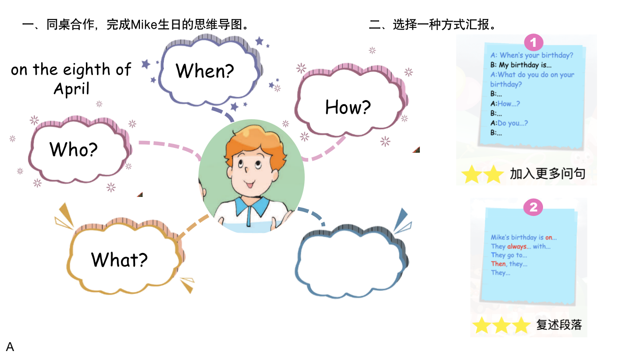  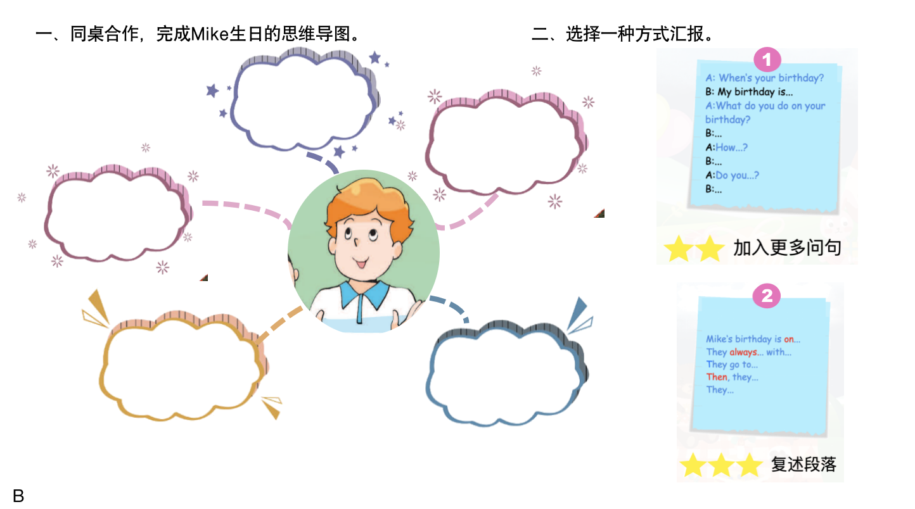  A party.  A cake.  Getting together with friends.  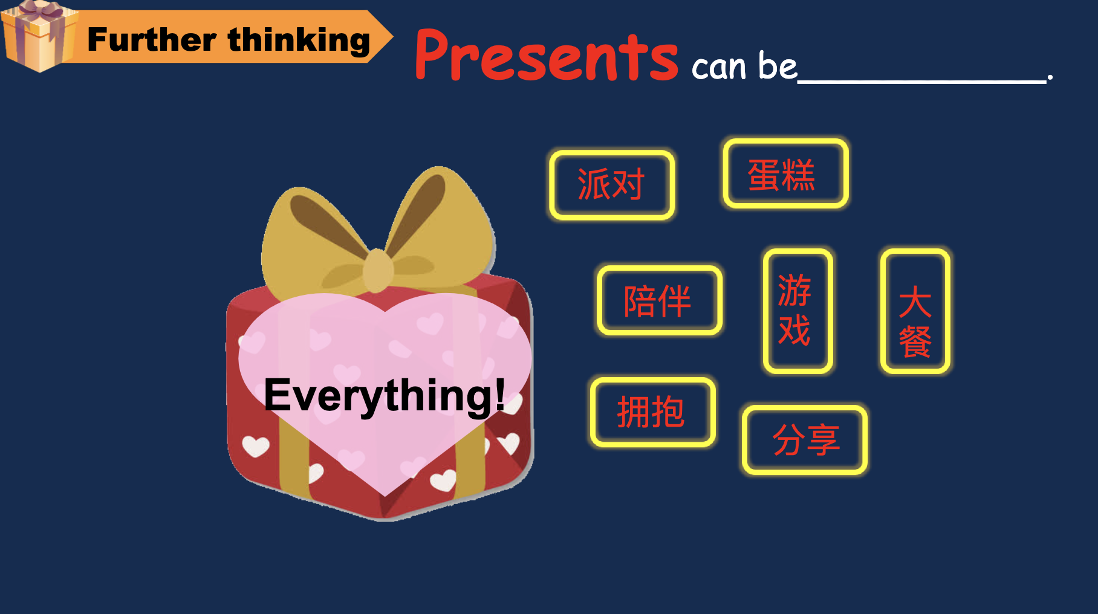  A toy, a doll can be presents.  A big dinner, getting together with families or friends can also be presents.  Presents can be Everything!
Homework
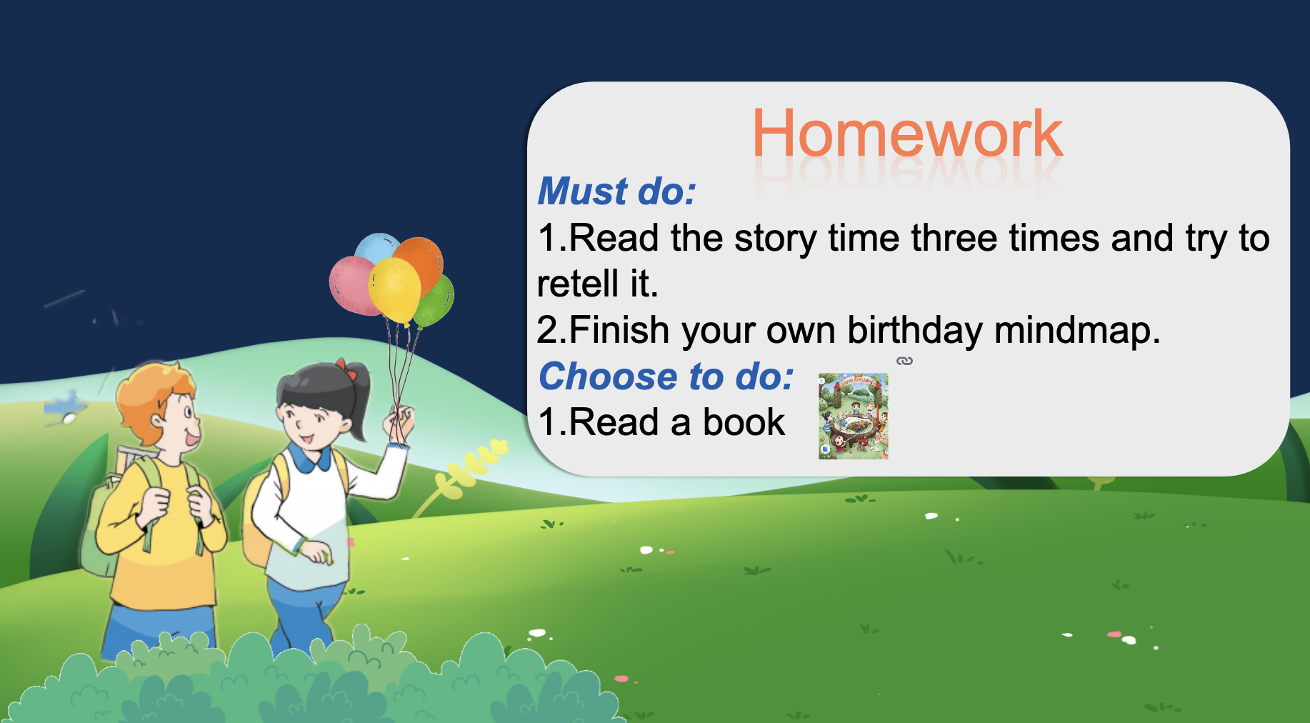

Blackboard design

