三下 Unit 4 Where’s the bird
主备人 | 沈艳 | 课 时 | 第一课时 | 课型 |  | 新授
教学目标 | 1.通过文本阅读、信息梳理等方式，能初步理解和掌握词汇on, under, behind,chair,desk。  2.通过对话交流，学习感知和初步运用句型Where’s ...? It’s on/in/under/behind...谈论物品的位置。  3. 通过跟读模仿，学生能正确理解并朗读对话内容，在教师的帮助和引导下尝试表演对话。  4. 通过story time的学习，学生能爱护动物，爱护大自然。
教学重点、难点 | 学生通过多种方式，能正确朗读、并表演story time,能正确使用本课的核心句型Where’s …? It’s on/in/under/behind… 谈论物品的位置。
教学准备 | 师：PPT 生：预习
教学过程 |  |  |  |  | 备注或修改
Step 1 Warming up
- Greetings
- Enjoy a song: On,in,under.
Ss sing the song together with gestures.
Step 2 Pre-reading
- Let’s guess
T: You know on in under behind, now, look，what's this？
Ss: a box.
T: What’s in my box? Guess?
Let me help you, it’s a toy animal, it can fly, it likes singing.
Ss：A bird. (teach bird)
- Magic show
So it’s a bird, and today Miss Shen will give you a magic show.
Look at the bird. It...
Ss: flies away.
Where’s the bird? Please follow me: Where’s the...?
Ss: Where’s the...?（出示板书句型：Where’s the...?）
Today we’re going to learn Unit4 where’s the bird.
T: So where’s the bird? Let’s say the magic words: Magic! Magic! Go!
Ss: Magic! Magic! Go!
T: Who can tell me where’s the bird? You can say like this: It’s...
S1: It’s on the box.
T: Is she/he right?
T: This time, who wants to be the little magician?
Ss:...
S1: Where’s the bird?
Ss: magic magic go!
S2: It’s under the box.
S1: Where’s the bird?
Ss: magic magic go!
S2: It’s behind the box.
S1: Where’s the bird?
Ss: magic magic go!
T: Can you see the bird?
Ss: No.
T: So where’s the bird?
Ss: maybe it’s in the box. Maybe it flies away.
Step3 While-reading
1.Watch and answer
T: The bird flies away. So let’s try to ask....
Ss: Where’s the bird?
T: So where’s the bird? Let’s watch the story time first.
Q: Where’s the bird? ( )
- It’s in the classroom. B. It’s on the farm.
T: Now, can you tell me where’s the bird?
Ss: It’s in the classroom.
2.Look and say
T: The bird flies into the classroom. How is the bird?
Ss: It’s nice/ How nice...
T: What do the students say? Let’s listen.
Ss: Look, a bird. How beautiful!
T: How can we read the sentence? 用什么语气来读这句话?
- Happy and admiring. B. surprised and regretful
3.Let’s think
T: The little bird is in the classroom. Now let’s think. What’s in the classroom? Can you see a bed in the classroom?
Ss: No.
T: Can you see a closet in the classroom?
Ss: No.
T: So what’s in the classroom?
Ss: chair/desk/blackboard/window/door...
Teach new words: chair, desk.
4.Listen and number
T: And we know the bird flies into the classroom. It likes flying here and there in the classroom. Where does the bird stop?
Let’s listen to the tape and find where the bird is. Then try to number the right order of these pictures.
Before listening, let’s try to see where the bird is in each pictures. That will help you finish the task.
- Let’s check
T: Let’s check your answers together. We will listen to the tape again, when the tape is finish, tell me your answer, OK?
(再次播放听力，与学生一起校对答案)
- T: now let’s learn the story one by one.
- Read and act
T: Let’s look at picture two, first, let’s listen and repeat.
Now, let’s act the dialogue. I will be Mike, I say...and you will be Liu Tao, you say...
Let’s try again.
Ss:...
T: Now, who wants to be Liu Tao? Who wants to be Mike?
Ss:...
T: Great! So this is a dialogue about picture two. I can make a chant about picture two. Listen!
Where’s the bird?
Where’s the bird?
Under the desk.
under the desk.
T: Can you try to sing the chant like me? Let’s have a try.
- Look and say
T: Please look at picture three. Where’s the bird now?
Ss: Behind the door.
T: Great! What does Su Hai say? Let’s listen
Now, let’s read.
Ss: Now, it’s behind the door.
Teach “now”
T: Wonderful! Now, Miss Shen also wants to make a chant about picture three, Who can help me fill in the blanks?
Ss:...
Where’s the bird? Where’s the bird?
Behind the door.
behind the door.
T: Now, let’s follow the rhyme and say the chant.
- Guess and say
T: Now, look at the bird, it flies away. Is it here?
Ss: No, it’s not here.
T: Look at Mike, what else will he say? Ss:...
Let’s listen and imitate
T: Nice! Miss Shen can also make a chant here. Listen!
Where’s the bird? Where, where where is it?
T: So Where’s the bird now?
Ss: It’s on Su Hai’s chair.
T: Can you make a chant for this picture?
On the chair
Now on the chair
T:Let’s say the chant together.
- Imagine and say
T: Now the bird is on Su Hai’s chair. Look! The bird flies away. What can Su Hai and Yang Ling say this time? Let’s imagine.
Ss:...
T: They will say...Can you fill in blanks?
It’s here.
Where is now?
T: Let’s try to read together.
Ss:...
5）Discuss and chant
T: Can you make a chant for picture five and picture six. You can choose one picture you like best. Please look at these two pictures carefully and fill in the blanks.
Where’s the bird? Where is, where is it?
.
Now .
Ss:...
T: Now, let’s try to sing these two chant together.
- Listen and imitate
Step 4 Post-reading
- Happy reading
T: Now, Please open your books and try to read the funny story together. Try to read emotionally.
- Let’s act
- Let’s think
T: We know the bird is in the tree at last, right? Look at the children, how do they feel now?
Ss: Happy.
T: So what will they say to the bird? What will the bird will say to the children? Can you guess?
Ss: Goodbye!/See you next time...
- Let’s imagine
T: The birds maybe say “See you next time” to the children.
The bird maybe wants to make friends to them. So the bird flies here and there again. This time, the bird flies to ...(Mike’s room)
T: What can you see in Mike’s room?
Ss: I can see a sofa/a bed/pencil...
T: We can see many things in Mike’s room, right? Where does the bird stop? Can you make a dialogue between Mike and his dad?
T：The little bird flies here and there. What do you think of the bird?
T: The bird likes us, he wants to make friends with us. So we should love birds too. I hope you can do that after the class.
Step 5 Homework
1.Listen and read the story time correctly, pay attention to your intonation and pronunciation.
2. Make a dialogue between Mike and his father.
教学板书 | 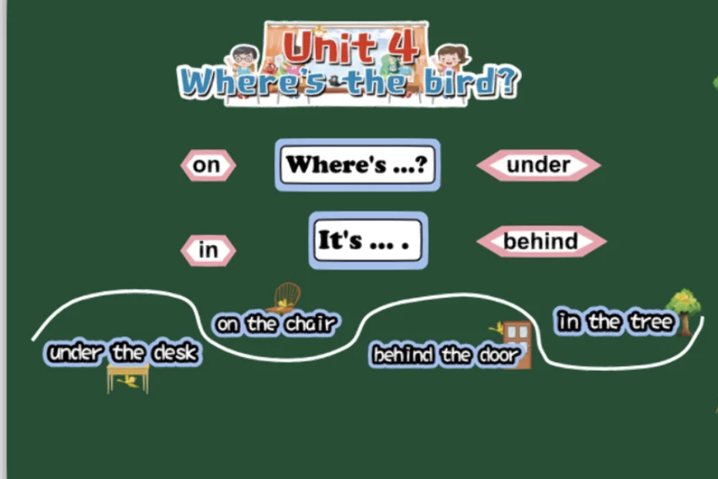
教学反思

