**Unit7 On the farm**

(story time)

**教学目标**

1.通过歌曲环节学习单词duck、pig 和cow及其复数形式。

2.通过学习Story time，能正确理解并朗读对话内容，在教师的引导和帮助下尝试朗读对话、表演对话。

3.能在真实的情景中运用What are these / those? Are these / those…?和日常交际用语Nice to meet you, Mike. Welcome to my farm. 进行交流。

**教学重点、难点**

1． 能听懂、会说、会读、会运用单词：door/ window/ blackboard/ open/ close.

2. 能听懂、会说、会读、会运用句型：Stand up./ Sit down./ I’m sorry./ Come in.

3. 能用open/ close来组成祈使句。

**教学准备**

单词卡片，PPT

**Step1. Lead in**

**1.Guessing game**

T：Here’s a new word.Can you read?You can read this word first.

car far farm

Here are four pictures.Which one is “farm”?Can you try?

1. What can you see on the farm?Let’s have a look.

What’s this?(a dog/a duck/a chicken)

What’s that?(a bird/a cow/a pig)

What are these?(eggs/apples/pears/oranges)

T:From here we know,on the farm there are many yummy food and lovely animals.Would you like to go to a farm?

**Step2.Presentation**

1. Show Mike and Liu Tao

T:Who are they?

S:They are Mike and Liu Tao.

T:They will have a Spring Study to a farm .Let’s go with them.Where are they now?

引出They’re on the farm并揭题

（Teach：they’re =they are)

1. Let’s guess

（1）T:Whose farm is it?Look at the picture.Liu Tao hand in hand with this old man.Guess.

S:Liu Tao’s grandpa.

T:Let’s listen and check.(听对话校对答案）

（2）Choose the correct tone of Grandpa.

帮Grandpa选择正确的语调朗读。

1. friendly（友好地）B.excitedly(兴奋地）

Who can act grandpa vividly?

请生动地表演grandpa？

3.Watch and circle（圈出你所看到的图片内容）

What is on Grandpa’s farm？（圈出在爷爷的农场上有什么？）

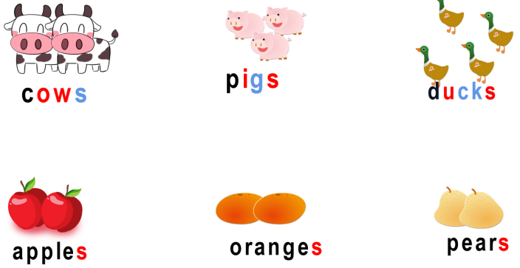

1. Read and underline（打开书，找一找Mike问了哪些问题并用铅笔划出来。）

(1)T:Mike comes to this farm for the first time,so he has some questions to ask.Open your books and underline questions.

What are these?

What are those?

Are these apples?

Are those apples?

Tip（小贴士）:this,these 指近处的人或物;that,those指远处的人或物

1. Let’s chant:These ,these ,what are these?Those ,those ,what are those?

Apples,apples,Are these apples? Apples,apples,Are those apples?

1. Read and match

Grandpa和Liu Tao是怎样回答Mike的四个问题的呢？大声朗读课文，根据所给图片选择合适的答句。

1. Let’s follow
2. Show time :三人一组，分角色表演或朗读课文，看哪组表演得最棒！
3. Think and talk

Do you like Grandpa’s farm？（你喜欢爷爷的农场吗？）

8.Let’s talk

农场正在招聘导游，你愿意帮助Mike的爷爷来给游客介绍农场吗？

A（导游）：Welcome to the farm.

B（游客）: What’s this /that?

A（导游）: ...

B（游客）: What are these/those？

A（导游）: ...

B（游客）：Are these/those...?

A（导游）:...

B（游客）:Oh ,I see,Thank you.

Homework：

1.Read the story time fluently.

2.Design and draw a nice farm,try to describe the farm.

（尝试设计一个新农场，并向大家介绍你的农场。）