**4B Unit 5 Seasons(Period 2)**

2023/4/3 王育铭

Step 1 Warm-up

1. Enjoy a song

2. Song time

What a cute song!Look at the picture, what can he do? He can fly kites(复习).

He can fly kites on a sunny day. So what is a sunny day? Look at the screen.

(PPT展示太阳，guess and say, 新授sunny，板书)

Before singing the song, let’s try to read it.

3. Let’s sing

Do you like sunny days?

I like sunny days too! Look! The sun is shining up in the sky, Let’s sing together to feel the warm sunshine.

In spring, we fly kites. Now look at the two pictures.

Which season is it? It is summer. (gesture) It is hot. Let’s go swimming. OK?

4. Let’s change

Every season has sunny days. What else can we do on a sunny day? Work in groups, use your imagination to make the song different.(展示1组)

Step 2 Revision

1. Let’s review

Sunny days are in different seasons. (seasons)

There are four seasons in a year. They’re spring, summer, autumn and winter.

2. Choose to say

Warm spring, hot summer, cool autumn, cold winter. Let’s choose one to make a poem.

3. Let’s choose

Is the poem beautiful? Yes, it’s really beautiful. But what does it talk about? Think it over. (板书weather, activities, feelings)

To make a beautiful poem, we should write more about the seasons. How can we make it? Let’s play a game first.

Step 3 Fun time

1. Guess and say

Please look at the toy car. “Hot!” Which season is it? Right! It’s summer.

Can you read the sentence?

All these sentences are about the weather. So when we talk about the weather, we can say(板书) It is...季 It is...气

2. Look and say

Different seasons, different weather, and we have different activities. What do you do in different seasons? Look at the picture.

When we talk about activities, we can say(板书) I... I... too.

3. Read and find

Last week, I told you that everybody could be a poet. Mr Wang also wants to be a great poet, so I wrote a poem too. Do you want to read it? Here we go, don’t forget to finish your learning sheet. (提醒按要求完成)

Checking time: 完成板书，新授生词，带读句子

Clothes I wear...

Scenery I can see... leaf leaves

I like...

What a colourful flower! With it, we can make a beautiful poem. But to be perfect, there is one more detail we should pay attention to. What can you find? Think about it. 首字母大写，句号

To make a perfect poem, we should write more aspects and pay attention to the details. OK? Now let’s read the poem together. Is Mr Wang a good poet?

But today Mr Wang is not only a poet, but also a fantastic magician. Are you ready for my magic show? Don’t blink.

The poem became part of my season card! Do you like it? Do you want to make a season card today?

4. Let’s make

Now It’s time for you to make a season card step by step. (Music)

5. Show time

(投影+口头展示，语篇输出，1-2组，灵活机动)

(留下一组同学，内涵挖掘，带领学生用整体的思维看待四季，并且感受在季节更替中自己在马小所留下的成长足迹) Please stay here. You are spring. In Spring, it is warm. We fly kites. Kites fly and fly until the weather is hot. (春夏牵手)Summer comes. Let’s go swimming. We swim and swim till the leaves are not green. (夏秋牵手)It is autumn. But one day, the whole world becomes white.(秋冬牵手) We know winter comes.

But does the story end? No, the new spring is coming!(春冬牵手，围成一个圈)

Spring, summer, autumn, winter, spring, summer, autumn, winter, four seasons make a year. And they will never stop, just like the leaves, (板书完成春叶和秋叶之间的循环往复)from green to yellow, and then they will turn into green again!

Now everybody please stand up, hand in hand like this to feel the seasons change. We met here in Mahang Primary School in a beautiful autumn. Seasons by seasons, we grew up. (PPT呈现卡片和小诗，学生跟读)

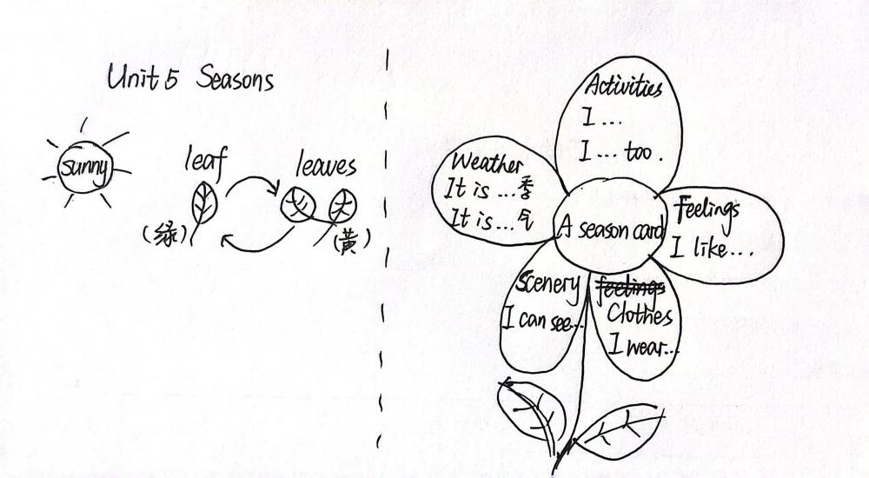Big hands for yourselves! Seasons are the gift of the nature, and the card is Mr Wang’s gift to all of you. Seasons never separate, so do our cards. Four seasons make a year and your cards can make a picture book.(灵活机动After class,) Please make a picture book with your group members and share it with your friends. This is your homework. Am I clear?