初中英语课内外阅读教学设计
学校 | 常州市新北区飞龙中学 | 时间 | 2023.2.28 | 授课班级 | 八8班
授课学校 | 飞龙中学 | 授课教师/课程设计 |  | 倪青
课题 | Black Beauty
教学目标 | - 通过Free talk联系八下Unit1所学的transport相关知识，引入本课阅读书目——Black Beauty。  - 通过浏览小说目录、illustrator分享绘制人物关系图、呈现小说story mountain的五个步骤，培养学生对于文学作品阅读技巧的掌握。  - 在分析五个步骤的过程中，通过问答、圈划、复述、排列、概括等不同的阅读形式，整合小说内容，引导学生积极思考每一步骤带给我们的启示。  - 通过connector和researcher的分享，让学生了解更多有关Black Beauty创作的背景知识，与导入部分呼应的同时联系八上所学有关保护动物的内容，为最后的输出做好铺垫。  - 通过头脑风暴，鼓励passage picker分享自己摘抄的片段，以及从中的感悟。鼓励同学们畅所欲言，激发学生的发散性思维；同时提炼出鉴赏文学作品的五个维度——background-author-characters-plots-theme，深化学生思维的概括性。  - 通过小组合作完成“致信书中人”环节，完成所学内容的内化。同时，鼓励学生在阅读文学作品时，要做到由表入里、由浅入深，联系作者的人生经历和创作的时代背景，深刻探讨小说背后带给我们的启示，从而培养学生良好的文学鉴赏能力，并助其树立良好的价值观念。
重点、难点 | - 深度理解小说文本内容和鉴赏结构。  - 指导学生在细化分析文学作品的基础上形成健康向上的价值观。
Procedure | Teacher’s activities |  | Students’ activities | Feedback & aims
Step1  吸引注意,积累语言 | Free talk:  How do you come to school every day?  - At present, what kind of transport do people use?  - In the past, what kind of transport did people use?  (3)In the old times, what kind of transport did people use if they want to travel faster? |  | Talk about transport at different times. | 联系课本所学知识，通过对于不同时期交通方式的提问，引出cab/carriage这种交通方式，从而引入今天的阅读书目——Black Beauty。
Step2  导出目标,生成结构. | 1.About the content:  Guide the students to look through the titles and have a prediction.  2.About the characters:  Encourage the illustrators to show the flow chart which they drew before class.  3.About the structure:  Present the five steps of creating literature and ask students to match each part according to Beauty’s experiences. |  | Think, predict and answer.  The illustrator give classmates a brief description of Beauty’s owners.  Others listen carefully to obtain the important information.  Discuss in groups and match. | 通过浏览小说目录中首尾两个章节的标题，预测出Beauty一生中的家不止两个。让学生了解在阅读文学作品时，可以通过阅读作品的content，先对整书内容有一个大概的了解，掌握一些关键的基本信息，让学生体悟到这是一种有效的阅读方法。  在课前阅读圈活动中，illustrator绘制好flow chart。在课堂上，illustrator将本组的flow chart分享、叙述给全班同学，从而让大家对Beauty的命运有了更加全面的了解，为下一步教学活动的开展起到了启发、铺垫的作用。  通过上一环节的铺垫，学生已知晓可以将小说情节分成五个步骤。  呈现出创作小说情节的五个步骤名称，引导学生进行匹配。从而引出文学作品中Story Mountain的结构。
Step3  回忆相关知识，初步运用结构。 | - Opening  Present Beauty’s mother’s advice in chapter 1&3.  Enable the students to taste the two paragraphs.  Q: Did Black Beauty follow his mother’s advice?  How do you know?  - Rising action  ①Tell the students that some major events happened in Beauty’s life. Present the Concept Wheel and try to retell the events according to the Concept Wheel.  ②After retelling, ask students what they think of Beauty.  - Turning point  ① Choose some facts from this part, and disorganize these sentences.  ② From these details, what can we learn from Beauty?  - Falling action  ①Encourage the summarizers to share their summary of each chapter.  ② Connector:  The novel Black Beauty is set in the 1860’s. Much about the world has changed during the century. One of the most important changes has been in the transport.  During Black Beauty’s lifetime, the horse was the main way of traveling.  Q1:When and where was the first vehicle invented? Who invented it?  Q2: How long did it take for cars to replace the cab horse?  Q3:What changes did the invention of vehicles bring to us/horses?  - Ending  In the last two chapters, Black Beauty met good men, and it had a happy ending!  Q: What can we learn from Beauty’s ending? |  | Read and taste.  Circle some important verbs or adjectives about Beauty’s qualities.  Think and answer.  Group work.  One student one part.  Think and summarize.  Put the sentences in the correct order.  Check with deskmate.  One student one sentence.  Think and summarize.  Summarizers present.  Others listen carefully.  Connectors raised 3 questions and then searched for some information to share in class.  Others listen carefully and take some notes.  Think and summary. | 呈现Beauty妈妈的忠告，通过提取关键词推测Beauty所拥有的qualities。从而引出Tip 1。  通过Concept Wheel，让学生学会精炼理解文本内容，获取基本事实性信息，概括、整合章节内容，在准备的过程中实现语言和知识的内化。  通过复述环节，让Beauty一生中的three major events再次重现，引导学生积极思考，从中可以获得什么启示，从而引出Tip2。  打乱重要细节句子，引导学生将句子按照正确的顺序排序，旨在考查学生对章节内容细节的把控，同时针对考试新题型加强训练。  通过细节重现，引导学生积极思考，从Turning point这一环节能够获得什么启示，从而引出Tip3。  鼓励Summarizers，一人分享一句总结，讲述Beauty在人生低谷期的遭遇，引发学生同感。  Connectors小组预习课中讨论出三个有关交通方式的问题，课前做好相关信息的收集，课上与同学们分享“交通方式的转变给我们/马带来了什么”。  通过此项活动，完成课内外联结，与导入部分呼应，引发学生深思。  从历经艰辛到终于迎来幸福，引导学生思考Beauty面对人生低谷时期的态度和做法，领悟出tip4。
Step4  呈现刺激性材料，活用结构。 | - About the author  Tell the students Black Beauty is an Autobiography(自传) of a Horse, which means the novel was written in First-person point of view.  Q;What is the function of writing in First-person point of view?  - Watch and connect.  Show the radio about the author, which was made by the researchers before class, to enable others know more about the novel. |  | Solo work.  Think and choose.  Watch and think.  Connect and answer.  Take some notes. | 教师引出该部小说是以马的口吻为第一人称视角叙述的一部自传，引导学生积极思考用第一人称视角写作的功能。  观看课前由researchers调查并制作的有关作者生平经历的介绍视频。引出作者的写作目的：呼吁大家保护动物。  引导学生联系八上所学知识，积极回想保护动物的措施，必要时请connector进行总结补充。通过此环节联系现实生活，加强德育浸润。
Step5  引发期待行为，强化结构 | - Brainstorming  Share the tips that they get from the novel.  - Taste literature from five main aspects.  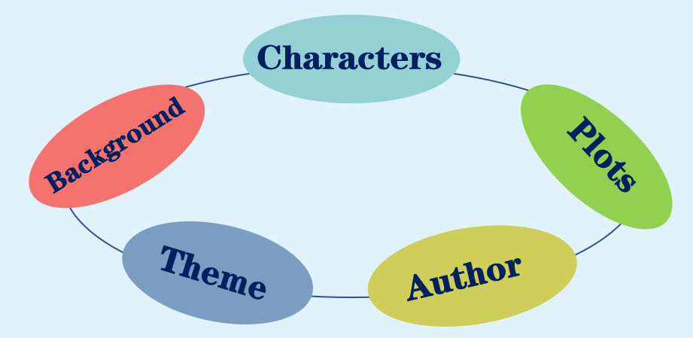 |  | Share,write and stick.  Listen and take notes.  Listen understand and remember. | 通过头脑风暴，鼓励passage picker分享自己摘抄的片段，以及从中的感悟。  鼓励同学们畅所欲言，激发学生的发散性思维，此环节言之有理即可。  整节课从文学作品的五个维度进行赏析，鼓励学生在自我赏析文学作品时，也可参考这五个维度。
Step6  提供反馈评价，巩固结构 | Write a letter to Black Beauty  S1:Introduce the different homes of Black Beauty briefly.  S2:Retell one of the major events in Beauty’s life.  S3:Describe the changes that transport has brought to us/horses.  &The action that we take to protect animals.  S4:Share the tips that you get from the novel. |  | Write, prepare and share. | 本节课最后，通过“致信书中人”环节，巩固并整合所积累的语言和内容，并整体感知、分享。  通过小组合作完成“致信书中人”环节，完成所学内容的内化。同时，鼓励学生在阅读文学作品时，要做到由表入里、由浅入深，联系作者的人生经历和创作的时代背景，深刻探讨小说背后带给我们的启示，从而培养学生良好的文学鉴赏能力，并助其树立良好的价值观念。
Homework:
Required:Polish your writing and post it on your WeChat Moments to recommend Black Beauty to your friends.
Encouraged:
1.Continue writing the story of Black Beauty.
2.Watch and compare the movie with the book and then choose a new book for your next reading plan.

