Unit 4 Road safety
The 1st period
一、教学内容
六下Unit 4 Road safety Story time
二、教学目标：
- 在情景中整体理解Story time的内容。
- 在 Story time 的学习过程中掌握有关道路交通方面的新词 road, light, zebra crossing, pavement, look out for, easily, rules, follow，体会情态动词must及其否定must not 的用法，并能简单区分形容词safe,名词safety及副词safely的不同。
- 能用正确的语音语调朗读Story time。
- 能理解道路安全知识，尝试用英语说说道路交通规则。
- 能牢记过马路的交通规则，树立安全意识。
三、教学重点：
- 能理解道路安全知识，尝试用英语说说道路交通规则。
- 在 Story time 的学习过程中掌握有关道路交通方面的新词 road, light, zebra crossing, pavement, look out for, easily, rules, follow，must，safety，safely。
四、教学难点：
1. 体会情态动词must及其否定must not 的用法，并能简单区分形容词safe,名词safety及副词safely的不同。
- 能牢记过马路的交通规则，树立安全意识。
五、教学准备：课件 作业单
六、教学过程：
Step 1 Pre-reading
- Free talk: T: Boys and girls, I have some good habits. I like reading.
I often read books. I get up early in the morning. I put my things in order. I like sweet food, but I eat a little at a time. I have a bad habit. I often go to bed late.
What about you?
S1:
T: Now, we know some good habits and bad habits.
通过复习前面所学知识，并用游戏的形式导入学习，提升六年级学生的学习兴趣。
Now, let’s play a game about habits, OK? (游戏规则)
Rules:
2. Look at some pictures. (看一些行人、司机图片)
- Look and judge. Are they right? Ss: Yes! \No!
- T：总结We must keep safe.\Road safety is very important.

- Lead-in: T：揭题：Today we are going to talk about “Road safety”.
There are many busy roads in the cities. How can we cross the roads safely?
To keep safe, we must follow some rules.
- T: Do you know any rules?
（让学生表达自己已有的生活经验，了解学生的语言基础。）
Ss: 学生自由说说交通规则eg: We must look for a zebra crossing. We must look at the traffic lights.
Step 2 While-reading （Story time）
- Let’s listen and number. Before listening, these words will help you.
听的环节设计的有点难，学生听起来不太容易理解，可改为观看动画。
（给图片排序）Teach: road , safe, safety, safely, cross, rules
Let’s watch and check the answer.
- Please look, do you find any differences on the roads?
学习课文第一部分
T: How can we cross the roads safely ？Let’s read and try to say.
  - Read freely
  - Try to answer with “first…,then…”
3) Look at the picture. Finish the form:
T: What is green man? What is red man?
Teach: green\red man
What do they mean?
The policeman tells us. Let’s watch and read.
4）Read and imitate the policeman.安排学生模仿一下，训练了学生的读的能力。
T: (总结)That means we can cross the road
That means we must not cross the road.
（总结36页，板书）
- 自读课文，学习课文第二部分并划出答案
这一环节可安排学生多说说，然后让学生多读一读，让输入多一些，为后面的输出做准备。
T: But sometimes you cannot find a zebra crossing near you. How can we cross the road safely?
  - Read freely. And try to get the main information.
  - Underline the answers of these questions.
完成表格信息。
No zebra crossing
Wait on the pavement.
Look out for cars and bikes.
Look left first, then right and then left again
Cross the road with other people.
3. 看图讨论，学习课文第三部分
T: What can you see in the pictures?
What must we not do on the road?
呈现课文第三部分的两张插图(加上一幅奔跑穿过马路的同学)
Ss: Some boys are playing football by the road. A boy is skating\running on the road.
T: Is it safe?
Why?
Ss: Because there are many cars and bikes on the road.
So what rules do you know?
Ss: We must not run or play on the road.
T: We must follow the rules and stay safe on the road!
(总结37页)
4. 整理理解，巩固
1) Watch and repeat.
2) Reading freely.
3) Think and write.( 书上P 38)
Step 3 Post-reading
1. Today we learnt some rules about road safety.
Today，we have a task. We’ll publicize road safety to other people.
Work in pairs.
(我们是小小宣传员。小组合作)此处可让学生先组内读一读，下节课再演。
2. Please remember.
Never forget about safety.
Safety is as simple as ABC--- Always Be Careful.
2. Homework.
1) Read the story time fluently（ Read well ）.
2) Copy the new words and phrases.
2) Collect more rules about “Road Safety.”

七、板书设计： Unit 4 Road Safety
Rule1：We must look for a 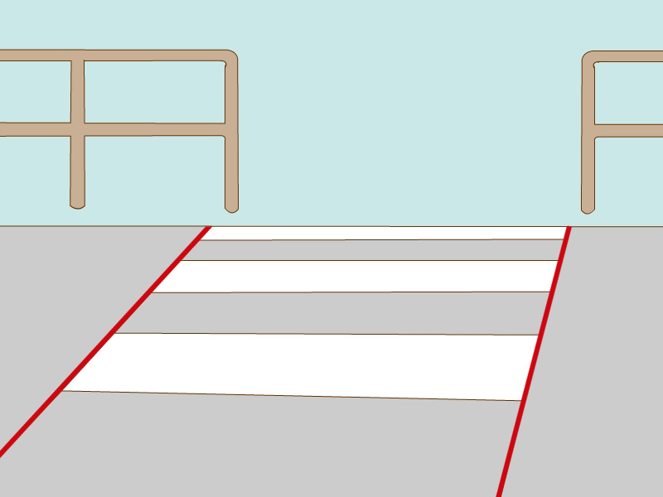 and look at the 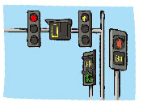.
Rule 2：We can wait on the 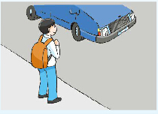 and look out for cars and bikes.
We can also cross the road with 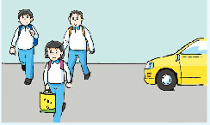.
Please remember:
Rule 3：We must not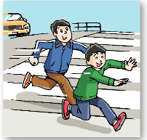 or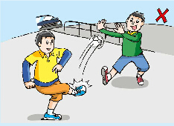 on the road.
教学反思：
本课以Road safety为话题，引出了一些关于交通规则的词组，并引出有情态动词“must,can”的句型。课堂容量大，学生学起来有点吃力。教师的教学设计学要简洁，明了，引导学生从基础语言知识到语言综合知识的运用，引导学生在做事中有目的的学习语言。
The 2nd period
一、教学内容：
六下Unit 4 Road safety Grammar time & Fun time
二、教学目标：
1.能对story time进行自主复习，并认识更多交通标志，掌握安全知识，做遵守交通规则的社会公民。
2.能理解并运用情态动词must及其否定must not（mustn’t） 的用法，复习已学过的情态动词can\should及否定用法。
3.能使用更多关于规则和规定的表达法，如Please… \Don’t …
三、教学重点：
认识更多交通标志，掌握安全知识，做遵守交通规则的社会公民。
四、教学难点：
能理解并运用情态动词must及其否定must not（mustn’t） 的用法，复习已学过的情态动词can\should及否定用法。
五、教学准备：CAI
六、教学过程：
Step 1 Revision
1. Free talk
Talk about some signs on the road.
Traffic lights: green means go, red means stop.
（左转弯标志\ 停车） It means you can turn left\park here.
（禁止左转弯\ 停车标志）Can you turn left\park here? You mustn’t turn left\park here.
- Review the story time
师生互问、生生互问来复习巩固story time的内容，让学生充分练说句型，学生训练的很扎实。
T: What do we learned last lesson?
Ss: Last lesson, we learned some rules.
T: What are the rules? How can we cross the roads safely?
（用图片复习巩固Story time ，强化learning tip）
Ss: Rule 1: First, we must look for the zebra crossing, then we must look at the traffic lights.
T: Sometimes we cannot find a zebra crossing, how can we cross the road?
Ss: Rule 2: We can wait on the pavement and look out for the cars and bikes.
We must look left, then right and then left again.
We can also cross the road with other people.
T: What must you not do on the road?
Ss: We mustn’t play or run on the road, it’s not safe.
Step 2 Grammar time
1.PPT 展示Q: How can we cross the road safely?
What must you not do on the road?
学生根据Story time中的内容进行自由回答,PPT 展示答句。
Rule 1: First, we must look for the zebra crossing, then we must look at the traffic lights and wait for the green man.
Rule 2: We can wait on the pavement and we can cross the road with other people.
Rule 3: We mustn’t play or run on the road.
2.自主发现语法规律：
T：Look at these rules, how can we talk about the rules?(What words do we usually use in the sentences?)
Ss: We usually use can\must do …or can’t\mustn’t do...
We also can use should or shouldn’t do…
教师让学生分小组练说，互相问答来总结情态动词用法的语法规律。通过自主学习的方法来让学生做学习的主人，学生很感兴趣。
T: After these words, we use do or doing?
Ss: do
3.运用语法规律。
T: Can you name some rules?
Ss: We can\should\must… We can’t\shouldn’t\mustn’t … (park\turn left\play\run…)
4.总结语法规律：
描述规则和规定有以下三种句式：can\should\must加动词原形
名词、名词短语
祈使句Don’t…
Step 3 Fun time
1. The policeman knows a lot about the rules on the road.
Let’s play a game about the rules on the road.
2.游戏规则：（Explain the game）
将学生分成五人一小组，仿照Fun time范例，开展“红绿灯”游戏问答，一人演交警，提出问题，指定某人回答，其他人要给予反馈。
3.示范游戏：（make a model）
S1：Red man, stop. Green man, go! What must you do on the road?
S2: I must look out for cars.（可有其他回答）
游戏环节寓教于乐，教师让学生在游戏中分组练说重点句型。学生练说的很好，课堂气氛活跃。
S3: Right.
S1: What must you do on the road?
S4: I must run quickly on the road. （可有其他回答）
S5: No, you mustn’t run quickly on the road!
……
4.小组游戏：（Play the game in groups.）
Step 4 Consolidation
在巩固环节,设计多种活动总结学到的交通规则，学生完成的很好，此环节很关键。
1. Practice
1) Sam, Bobby and Tina want to visit our city-Changzhou.
There are many interesting places in Changzhou: BRT and many parks
Their schedule（日程表） is in the form.
In the morning | The shopping center (Tina)
 | The Dinosaur Park(Sam and Bobby)
At lunchtime | Restaurant(Sam, Bobby and Tina)
In the afternoon | The cinema(Sam, Bobby and Tina)
2) Ask and answer.
Can you tell Bobby and Tina what rules they must follow in different places?
Model:
T: What must Tina do in the library?
Ss: She must keep quiet.
T: What must she not do in the library?
Ss: She must not eat or drink.
3）Work in pairs
Group work
Rule：将学生分成五人一组，仿照Fun time范例，三人分别演Sam, Bobby 及 Tina提出问题，由另外两人演小导游替他们解决问题。
Model:
S1,2：Welcome to Changzhou!
S3, 4, 5: Thank you!
S3: What must I do at the shopping center?
S1: You must put the rubbish in the bin.
S4: What must I do at in the Dinosaur park?
S2: You must be careful.
S5: What must we do in the cinema?
S1, 2: You must keep quiet.
Work in groups
2. Summary
1) Different places, different rules.
We must follow different rules in different places.
You know so many rules in the public places. You should follow these rules.
Step 5 Homework
1. Look for more rules in public places.
2. Write down the rules, the more the better.
七、板书设计：
Unit 4 Road Safety
Can\should\must +do
Danger\Be careful
Don’t…
Red man, stop. Green man, go!
What must you do on the road?
I must… / I must not…
教学反思：
本课时是带有情态动词的特殊疑问句以及带有情态动词的否定句。通过在课文版块的学习，学生已经基本掌握了交通安全规则，学生初步了解了情态动词can 和must的区别，以及它们的否定形式。通过复习第一课时所学内容，让学生自主地发现它们的规律，让学生有一个自主学习、自主思考的时间。然后我让学生找出规律，学生掌握的很好。
然后用在课文中学到的安全规则进行游戏操练，从而更好地掌握新句型和新词组。通过课堂上的反复练说，学生掌握的很好。
The 3rd period
一、教学内容：
Sound time, culture time &cartoon time
二、教学目标:
1. 了解句子重音的作用，并能进行积极的尝试运用。
2. 知晓英国和中国汽车行驶的方向不同，并有兴趣了解更多国家交通规则的异同点。
3.通过Cartoon time的学习，增强分析和提炼信息的能力，并能进行准确的朗读和较为生动的表演。
4. 进一步提升公民素养，知晓交通规则和礼让行人的重要性。
三、教学重点：
1. 通过Cartoon time的学习，提升学生的自主学习能力。
2.了解中西方国家交通规则的异同点。
四、教学难点：
句子重音的理解和尝试运用。
五、教学准备：PPT
六、教学过程：
Step 1 Warm up
1. Greetings: Date/ weather
2. Play a game: (Fun time)
T—Ss in groups
Step 2 Sound time
1. Try to know something about stress.
T: What is the most important rule on the road?
Ss：Red man, stop. Green man, go.
T: Who can read it for us?
S1: Red man, stop. Green man, go.
T: You read ….more loudly. Why?
S1: 突出重点/…
T: In English, we call this “Stress”. It has two functions.
1.体现句子的节奏感和韵律感。
2.突出重点,使听者更容易理解。
So, you need to read some words in a sentence more loudly.
教师让学生体会句子的节奏并找出规律，反复练说体会规律，培养学生自主学习的能力。
2. Learn the rhyme
1) Listen to the rhyme and try to find out the stress.
Learning tip: 在一般情况下，句子中比较重要的词要重读，如名词、动词、形容词和副词等。重读单词的发音听起来相对响亮而且清晰。
2) Check the answers.
3）Read the rhyme.
Follow the tape; Read together; Read in pairs.
4) Try to read some other sentences.
T: How to read them? Please try, you can discuss in groups.
Bobby and Tina go to see their aunt by ‘bus.
There are ‘so many ‘cars on the road.
The bus stops ‘again and ‘again.

Step 3 Cartoon time
T: These sentences are about an interesting story in cartoon time. Let’s enjoy it.
1. Talk about Picture 1.
1) Show Picture 1 to the Ss. Let them try to ask some questions.
先谈论图片，让学生初步预测故事情节。让学生在具体的语境中学习单词并理解意思。
2) Read and answer the questions.
2. Talk about Picture 2.
1) Show Picture 2 to the Ss. Let them try to ask some questions.
2) Read and answer the questions.
3. Talk about Picture 3&4.
1) Read the story quickly and answer the question: How many times does the bus stop?
2) Watch the cartoon, and find out the reasons of stopping the bus.
①The first time
Ss: Because there’s the red man, they must stop the bus.
T: This is the most important rule on the road. When can they go?
Ss: When they see the green man.
T: Do you know more rules on the road?
Ss: We must not play on the road./…
T: We must follow the rules on the road.
②The second time
T: Why do they stop the bus again? Is there a red man, too?
Ss: No, some elephants are crossing the road. They must stop and wait.
T: No, I see. This is another important rule on the road. Who can tell us?
Ss:车辆要礼让行人。
T: Yes, we should give way to pedestrians.
4. Read the text.
1) Listen and pay attention to the stress.
2) Read together.
3) Give a title to the story.
5. Act it.
1) Act the story.
通过表演故事，让学生输出语言，达到学以致用的目标。
2) (接最后一组表演) The bus stops again. What happened? Please imagine and act.
Step 4 Culture time
T: Bobby wants to know more about the rules on the road. The next day, he goes to the library and read some books about them.
1. Show the Ss the book “How to drive in different countries?”
T: Which side of the road do people drive in China?
Ss: They drive on the left side of the road.
T: Do people drive on the left side of the road in all the countries?
Ss: …
2. Read and choose.
Page 1: In the UK, people drive on the left side of the road.
Page 2: In fact, in most of the countries, people drive on the left side of the road. For example: Australia, Japan, Singapore, New Zealand
Page 3: In China, except Hong Kong and Macau, people drive on the right side of the road.
本版块介绍了中英两国不同的道路通行制度。而且又拓展介绍其他国家的道路通行制度及第一个交通灯的由来。学生很感兴趣。
Page 4：In these countries, American, Canada, France, Germany（德国）…, people drive on the right side of the road, too.
1) In ( ), people drive on the left side of the road.
2) In ( ), people drive on the right side of the road.
Australia, China, Japan, America, Canada, English

3.1) Show the Ss the book “The month in history”
First traffic light!
20 October, 1923: People in American first use a traffic light. It is a little different from today’s traffic light. It has two parts. One says“Go” and the other says “Stop”. When people see ‘Go’, they can cross the road.
Safe crossing!
31 October, 1951: People first walk over a zebra-crossing in England. A zebra-crossing is white and black. People can see it easily. People walk over a zebra-crossing when they want to cross the road. This can keep them safe from cars.
2) Read and choose.
1. People first use the traffic light.
A. Chinese B. English C. American
2. The first traffic light has part(s).
A. one B. two C. three
3. People can see a zebra-crossing easily because .
A. it is white and black
B. it is in England
C. many people like zebras
Step 5 Homework:
1.熟读Culture time 和Cartoon time, 试着标出重音。
2.表演Cartoon time, 并进行续编。
3. 通过上网浏览等多种方法，了解更多的交通知识。
七、板书设计:
Unit 4 Road safety
the red man some elephant are crossing…

Bobby头像 Tina 头像
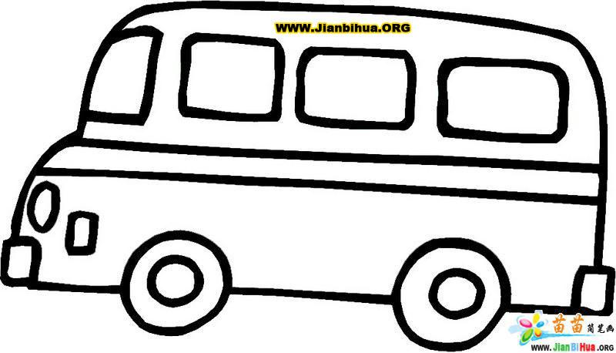
see their aunt
教学反思：
本节课我们不仅复习了交通安全知识，曹联合巩固了情态动词，同时还新授句子里需要重读的知识。通过反复跟读，让学生了解到在陈述句里某些单词需要重读，让学生在读中思，在思中学。含有情态动词的句子及其用法，这部分涉及到的语法点比较多，通过设置悬念、回答问题等方法，激发起学生学习的热情，学生掌握的很好。Culture time版块告诉我们中西方国家不同的道路通行规则。在课本的基础上，我又拓展介绍其他国家的道路交通规则及第一个交通灯的由来，学生很感兴趣。
The 4th period
一、教学内容：
Checkout time & Ticking time
二、教学目标：
1.准确运用句型We must/mustn’t 谈论交通安全；
2.能结合语境，准确运用must, mustn’t, can, can’t.；
3.准确运用含有must, mustn’t 的句型，谈论班级规则等，并尝试写一写，制作成海报。
4.进一步强化规则意识，做一个懂规则，守规则的人。
三、教学重点：
1.准确运用含有must, mustn’t 的句型，谈论班级规则等，并尝试写一写，制作成海报；
2.能结合语境，准确运用must, mustn’t, can, can’t。
四、教学难点：
含有must, mustn’t 的句型的准确表达及正确运用。
五、教学准备：课件、纸、水彩笔等
六、教学流程：
Step 1 Lead-in
1. Greetings: Date/Weather.
2. Revise the story in Cartoon time
Yesterday Bobby and Tina went to see their aunt, they took a bus. But the bus stopped twice, why?
3. PK time.
Talk about the rules on the road and at home. Boys use the sentence: We must….. Girls use the sentence: We mustn’t…
Step 2 Presentation
Read and circle.
1. T: What rules do they need to observe? Please read and circle.
2. Check the answers.
Picture1:
T: The first picture, which pair wants to try?
S1: Can I watch TV?
S2: No, you can’t . You must go to bed.
T: Can you watch TV every day?
S: No, we can’t . We can watch TV at weekends.
3. Discuss the differences between must and can.
(must 表示说话人“不许”和“禁止”某人做某事，有很强的劝告语气。Can表示有能力或有权利做某事。)
Step 3 Writing
T: When we’re at home, we should follow some rules. When we go to school, in order to keep safe on the road, we should follow the traffic rules. When we are at school, we should also follow the classroom rules, right?
1. Match and say:
1) T: What are they doing?
S: They’re talking to each other.
T: What do you want to say to them?
S: You must keep quiet. / You mustn’t talk to each other. / You must listen to the teacher.
  - T: How about other students? Which class rules are the students breaking? Write the numbers in the circles in pairs.
学生完成表格填空。在学生练习完后，教师总结must的用法并举例造句，学生完成的很好。
Classroom rules
1 We must not eat or drink in the classroom.
2 We must keep quiet.
3 We mustn’t play in the classroom.
4.We must not chase（追赶）each other.
5. We must not be late for school.
6. We must not draw on the desks.
7. We must listen to our teachers in class.

3) Check and discussion.
2. Think and write.
1) T: Liu Tao wants to make a poster about his classroom rules. Let’s help him.
Please complete the poster with “must” and “must not”.
Ss: Try to write down the answers.
2) Check the answers.
S1：You mustn’t run in the classroom.
T: It’s easy to bump into someone（撞到别人）.
（教师在学生回答的过程中，注意追问和拓展。）
3. Talk and write.
1) T: I think classroom rules are important for us. So let’s find out our class rules.
First, discuss in groups. Then, write down the rules on the paper. (每位学生写出一条自己觉得最重要的班规。)
2) Make a poster together.
Talk about the rules, choose some of them and stick on the poster.
T: Show us your paper and read it loudly, please.
S1: We must/mustn’t…
T: Is this a good rule?
S1: Yes.
T: Who has the same idea?
3) Let the Ss read their classroom rules together.

4) Take an oath: This is our classroom rules. I will abide by them.
4. Talk about the rules in different places.
T: We have rules on the road, in the classroom. Where else do we have rules?
Ss: We have rules in the library/ in the park…
1) Read, think and match.
T: There’re ten rules. Where do we have them? Please think and match in pairs.
a. In the library b. In the classroom c On the road d. In the park
1. We mustn’t walk on the grass. 6. We must keep quiet.
2. We mustn’t play basketball. 7. We must listen to our teacher.
3. We mustn’t throw rubbish. 8. We mustn’t draw on our desks.
4. We mustn’t eat or drink. 9. We mustn’t run fast on the road.
5. We must wait for the green man. 10. We mustn’t pick the flowers.

② Get the Ss try to say like this: We mustn’t walk on the grass in the park.

2) Show the students some pictures about impolite behaviors.
T: When you are in public places, Please follow the rules, to be a polite student. If you observe some impolite behaviors, do you have courage to warn them? How to warn them? What to say?
此环节是巩固环节，让学生总结交通规则和情态动词的用法。学生总结，教师做指导。
Tips: When we give advice to others, we should pay attention to our tones.
3) Make posters.
To keep our life more beautiful, we need rules. For example, the park rules, the bank rules, the hospital rules, the library rules, family rules and so on. Choose one and make a poster in your team.
Step 4 Homework
1.通过调查、观察等方式，进一步完善相关场所的规则。
2. 依据Ticking time ,自主复习相关知识点。
七、板书设计:
Unit 4 Road safety
Our classroom rules
1.
2.
3.
4.
5.
…

教学反思：
Checkout time版块是读一读，圈一圈，让学生明确区分情态动词can与must, can’t与mustn’t的用法。学生分组活动，完成的较好。Ticking time 版块明确了教学目标，通过练习和操练让学生能很直观地认识到自己的不足以及哪些教学目标的内容学的不够好，养成查漏补缺的好习惯。课后要让学生多模仿并跟读录音，再多做些练习题来进行巩固。
The 5th period
一、教学内容：
本单元的复习及完成补充习题。
二、教学目标：
1. 复习本单元的相关词汇和句型。
2. 完成相关练习。
三、教学重难点:
能正确完成《补充习题》上面的练习。
四、教学准备：
练习纸，补充习题
五、教学过程：
Step 1 Revision
1. Free talk
2. 出示本课对话投影片，学生看图用英文描述。
3. 学生表演故事。
4. 听写单词、词组和重点句子。
复习四会单词和重要句子，让学生默写，复习巩固。
Step 2: Presentation and practice
完成补充习题。
题型：
A Listen and number
B Listen and write
C Look and say
D Read and write
E Look, read and write
F Read and answer
Step 3 Homework
1. Review this unit.
2. Copy and recite the phrases and sentences underlined in this unit.
六、板书设计：
Unit 4 Road safety
You must keep quiet.
You must listen to the teacher.
We must/mustn’t…
can\should\must加动词原形
Red man, stop. Green man, go.
教学反思：
本课是一节复习课，先复习课文，让学生看图用英文描述并表演故事。学生表演的很逼真形象。再让学生听写单词、词组和重点句子来复习巩固。让学生了解、反思自己本单元内容的掌握情况，对薄弱环节及时作出调整。做补充习题时，教师先讲解注意点，让学生抓住关键词，再听听力。大部分学生能正确填写所缺单词，四会单词默写较好，学习气氛浓厚。

