**A lovely family of dolls**

TEENS 初一版第801期

Russia is a big country with a rich culture. Our music, art and literature (文学) are famous all over the world. But when I think of my country, the first thing in my mind is the matryoshka doll.

A matryoshka doll is a set (一套) of dolls made of wood. The doll looks like a Russian girl wearing traditional clothes. However, this girl has a secret - if you twist (扭动) it in the middle, it opens, and you’ll find another smaller girl inside. That girl looks different, but the secret is the same–twist it, and a third doll is inside. A matryoshka doll might have five to ten dolls inside. Each one is different.

When I was a little girl, I had many matryoshka dolls to play with. A friend of my family also made a set of matryoshka dolls with our faces on them–my mom, dad, me and my brother. When I remember my childhood, I always remember that doll. I loved it as it was unique (独特的) and creative (有创造力的).

Now I’m living abroad (在国外), but every time I visit Russia, I bring a few sets of matryoshka dolls back to my friends here–everyone loves them. They are a memorable (有纪念意义的) gift.

By VASILISA SOKOLOVA, 35, Russia

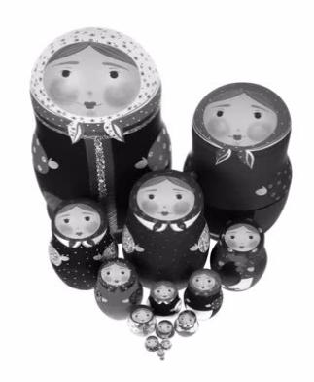

**Different look**

Surprisingly, however, the matryoshka is nearly one hundred years old. The matryoshka doll used to represent (代表) a family, with the bigger one being a father, then the mother and children. The smallest doll was usually a baby. But it changed into all female characters (女性人物) after some time. Today, you can find matryoshka dolls representing pop stars, movie stars and even sports teams!

To their foreign buyers, the matryoshkas continue to represent a dream of ancient Russian peasant beliefs. To Russians, they are little more than just another toy, yet they do embody (体现) a deep love of their nation.

**Oral presentation：**

**Student A:**

Hello, everyone! Our kite looks like ________________________________.

The colours used are ____________________________________ because ____________________________________________________________________.

**Student B：**

The materials(材质) used are ________________________,

as(因为)______________________________________________________________.

**Student C:**

We pick ___________________ ( element A ) because it_______________________  
____________________________________________________________________.

**Student D:**

We also pick ___________________ ( element B) because it____________________  
____________________________________________________________________.