Traditional toy-maker
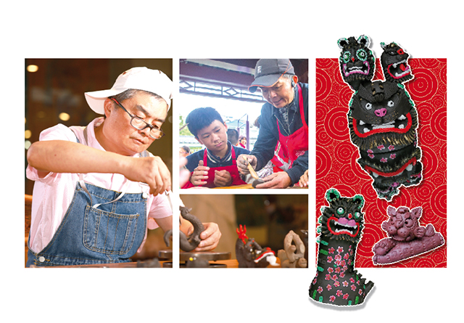
There is a traditional^{①} toy in Zhenjiang, Jiangsu. It looks like a clay toy (泥塑玩具). But it can be used as a whistle (哨子). This toy is called taiping nijiaojiao and it has a history of more than 1,000 years. Its birthplace was Huashan village^{②} in Zhenjiang.
Master’s story
New words:
①traditional adj.传统的 [trəˈdɪʃənl]
②village n.村庄 [ˈvɪlɪdʒ]
③local artists 当地艺术家[ˈləʊkl ˈɑːtɪsts]
④spirit n.精神[ˈspɪrɪt]
⑤several 几个 [ˈsevrəl]
⑥accept v.接受 [əkˈsept]

About 20 years ago, Zhou Baokang first noticed (注意) taiping nijiaojiao during a temple fair (庙会) in Huashan village. As a lover of folk art, he soon became interested in it. He later learned how to make them from local artists^{③}. Now the 60-year-old is an inheritor (传承人) of taiping nijiaojiao.
Zhou loves to make taiping nijiaojiao in the shape of animals, because there is a great space to play. “Even when you make the same animal, you can make different versions (版本) – cute or serious,” Zhou said.
He makes taiping nijiaojiao for the Chinese animal signs (生肖) of each year. This year, while making tigers, he tried to show the spirit^{④}(精神) of the “king of all beasts” through simple details (细节) like big mouths and teeth. At the beginning of 2021, he made a clumsy (笨拙的) ox（牛）. On its round body, there are red plum blossoms(梅花) that stand for spring.
Zhou wants more people to know about the toy. To let more people know the Clay Bark, Zhou Baokang turned his home into an art museum. It is free for people to visit. He also teaches kids at schools how to make them. “At that time, I was only interested in it and wanted to learn. It took me several^{⑤}(几次) visits before I was accepted^{⑥}（接受）.Taiping nijiaojiao looks small, but it carries rich traditional culture（文化）,” Zhou said.

In the face of setbacks^{①}, this skater never gives up^{②}

“He was born to be great ... Jin Boyang defeated^{③} (击败) Jin Boyang”, a CCTV commentator(评论员) said during the Beijing 2022 Winter Olympics^{④}. Why did he say this? Because the 24-year-old Jin has always challenged^{⑤}(挑战) himself. On April 15, he was named a National Outstanding^{⑥}(杰出的) Member of the Communist Youth League of China (CYLC).
At the 2011 Asian^{⑦} championships^{⑧}（亚锦赛）, Jin first caught the attention of the public. He did a triple axel^{⑨} jump (阿克塞尔三周跳) – a difficult move for young figure skaters(花样滑冰运动员). Later, at the 2018 Winter Olympics, Jin finished fourth. This is still China’s best result in Olympic men’s singles.
But after 2018, Jin got hurt^{⑩} and he had to stop training for a while because of the COVID-19 pandemic. After that, Jin didn’t perform（表现）well and people no longer（不再）cheered^{⑪} for（喝彩）him. He didn’t stop working hard. Although Jin didn’t win a medal^{⑫} at Beijing 2022, he got his best score^{⑬} of the season, 179.45 points, in free skating.
“I’ve conquered (征服) myself,” Jin told TEENS. “And I will carry on(继续).” He is planning to compete^{⑭} (比赛) at the 2026 Winter Olympics.
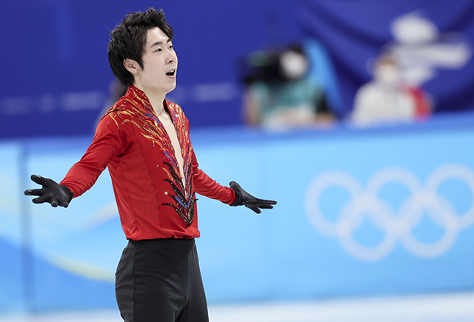
New words:
①setbacks [ˈsɛtˌbæks] n.挫折
②give up 放弃
③defeated [dɪˈfiːtɪd] v.打败
④Olympics [əʊˈlɪmpɪks] 奥林匹克
⑤challenged [ˈtʃælɪndʒd] v.挑战
⑥outstanding [aʊtˈstændɪŋ] adj.杰出的
⑦Asian [ˈeɪʃn] adj.亚洲的
⑧championships [ˈtʃæmpiənˌʃɪps] 锦标赛
⑨triple axel [ˈtrɪpl] [ˈæksl]
⑩hurt [hɜːrt] adj.受伤的
⑪cheer [tʃɪə(r)] v.欢呼
⑫medal [ˈmedl] n.奖牌
⑬score [skɔːr] n.分数
⑭compete [kəmˈpiːt] v.比赛

