**7A U8 Fashion**

**Reading 学案**

**【In-class reading】**

**Task1: Let’s have a class fashion show!**

**Host:** Good afternoon, ladies and gentlemen.

Welcome to ________________ I’m _____________from_____________.

Today we are going to show you__________________________________.

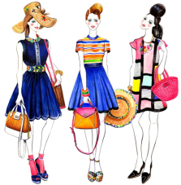 Here comes _______.

**Model1:** Hi , I’m ___________ I’m wearing ____________________________.

My __________ is made of______________ and _________is made

of__________________. I like my clothes because________________.

Do you think I look…?

**Host:** Look! ...is coming.

**Model2:** Hello, my name is ___________.I’m wearing _____________________.

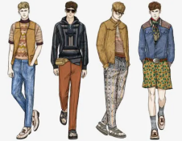My __________ is made of______________ and _________is made

of__________________. I like my clothes because________________.

**Model3:** Hi, my name is ___________.I’m wearing _____________________.

My __________ is made of______________ and _________is made

of__________________. I like my clothes because________________.

I look _______________.

Host: That's all for our show. Thanks for coming.

**【Further reading】**

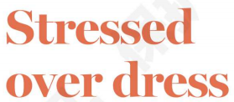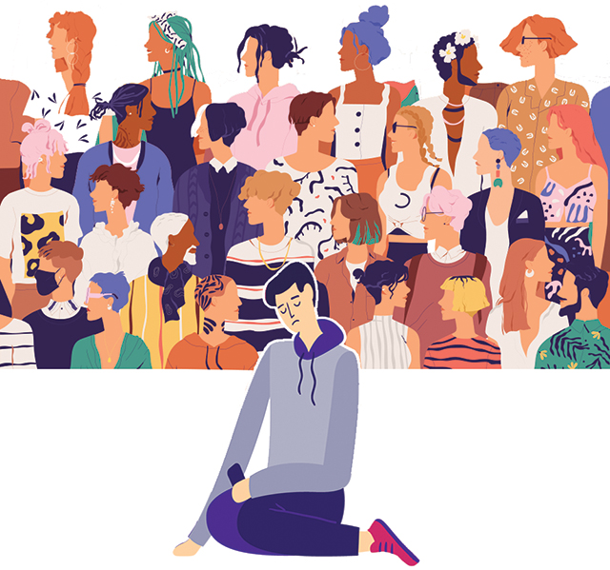

When Liu Jiawei sees people wearing hip-hop (嘻哈) clothes with expensive logos (昂贵的品牌), he can not look straight (直视) at them. “They are so fashionable that I feel like they are going to rap (说唱) a song the next second. This puts my unfashionable self (自己) under great pressure (压力),” said the 14-year-old boy from Jilin.

What Liu is experiencing(经历) is fashion anxiety (焦虑), a recent hot topic online. These days, many people feel anxious (焦虑的) about their outfits (全套服装). They are afraid of being seen as out of style.

A big reason that leads to fashion anxiety is fashion bullying (霸凌), experts said. Fashion advertising (广告) and many TV shows have made our society(社会) care more about how we look. There is a lot of pressure on people, especially teenagers(青少年), to follow the latest trends (趋势). Li Meixi, 12, from Chengdu, Sichuan used to watch the videos of fashion vloggers(视频博主) and read fashion magazines to catch up with the trends. “I want to be as stylish as fashion icons(偶像),” Li said. “But it takes time and energy, and I often give it up for a while.”

Another reason for fashion anxiety, said The Paper, may be a lack of self-confidence (自信). We care too much about how fashionable people look at us. This can make us doubt(怀疑) or even dislike ourselves.

In fact, fashion is always changing. If you’re able to wear something with confidence, you will be the one starting a trend. More importantly, what you wear cannot fully show who you are. What also matters is your personality(性格,品质).

**【New words】**

hip-hop:嘻哈文化 Society [sə'saɪəti]社会

straight [streɪt] 笔直地 Latest [ˈleɪtɪst] 最新的

Pressure [ˈpreʃə(r)] 压力 Trend [trend] 趋势，潮流

Experience [ɪkˈspɪəriəns] 经历 Stylish ['staɪlɪʃ] 时髦的

Anxiety[æŋ'zaɪəti] 焦虑 Icons [ˈaɪkɒn]偶像

Anxious ['æŋkʃəs] 焦急的 self-confidence [self][ˈkɒnfɪd(ə)ns]自信心

Outfits [ˈaʊtfɪts]全套服装 Doubt [daʊt]怀疑

Bullying ['bʊliɪŋ] 霸凌 matter[ˈmætə(r)]有重大影响

Advertising[ˈædvə(r)ˌtaɪzɪŋ]做广告 personality[ˌpɜrsəˈnæləti]个性，品质

**Task2: Let's have a discuss about the question“should we follow the fashion at school and why?”**

I think we __________________________________________________.

Because ____________________________________________________

___________________________________________________________

__________________________________________________________

__________________________________________________________.