牛津初中英语教学设计
学校 | 新北区实验中学 | 时间 | 2022.11.30 |  | 设计 | 钱方亮
课题 | 7A U8 Reading1 The fashion show
教学目标 | - Knowledge aims:  To understand the text and know how to use important words about clothes.  - Ability aims:  To learn and use some expressions about clothes.  - Culture awareness  To understand what the theme of reading means and build up correct value of fashion.
重点、难点 | 1.To improve the students’ reading and speaking skills.  2.To arouse the students’ interest in reading and speaking.
Procedure | Teacher’s activities |  |  | Students’ activities |  |  | Feedback  & aims
Step1  吸引注意,积累语言. | Show a short video about a fashion show. |  |  | Try to know something about the topic. |  |  | It is designed to arouse the students’ learning interest.
Step2  导出目标,生成结构. | - Show pictures and learn the new words  - Read fast and learn the structure. |  |  | Read the new words carefully and answer some questions |  |  | The giving new words and expressions can help to make the reading much easier.
Step3  回忆相关知识，初步运用结构 | - Read carefully and answer questions.  - Show the reading skill.  - Read and put the correct order in the blank.  (1)Different clothe=colors+materials  (2)How they looks  - Introduce the models  What does...show on the catwalk?  Answer different questions about students’ clothes  Summary: They show different styles of clothes. They are fashionable. |  |  | Read the passage carefully and answer some questions. Try to summarize the script. |  |  | This helps the Ss to know about different clothes of students.
Step4  呈现刺激性材料，活用结构。 | - Task: group work  To be a fashion designer and have a class fashion show.  - Further- thinking  Can we wear clothes like these at school? Why？  - Further-reading:fashion anxiety  read and answer questions |  |  | Complete the task. |  |  | This task is designed to enable the students to use some expressions in the article in a simple way.
Step5  引发期待行为，强化结构 | - Group work: discuss “should we follow the fashion at school?  S1:We_______(should/shouldn’t) follow the fashion at school.  S2: Because ...  (money, time, energy, study...)  - Summary: fashion is not only the outer beauty, but also the inner beauty. |  |  | Finish the task |  |  | This task is designed to enable the students to use the useful expressions in a more complicated way in a real situation.
Step6  提供反馈评价，巩固结构 | Homework  Suppose you are going to a fashion show in Paris.Write a short passage about what you see in the show. |  |  |  |  |  | To consolidate what the students have learned in class
板书设计 | 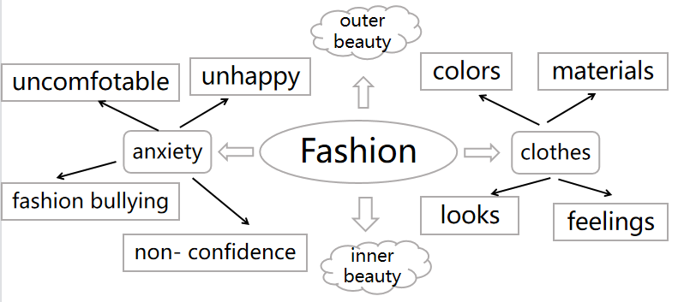  Unit8 fashion reading

