学科 | 英语 | 课题 | 四上Unit 8 Dolls (story time) |  |  | 课时 | 第一课时
主备人 | 陆丽英 | 参与者 | 李清 程筱婷 |  |  | 课件  制作 | 陆丽英
教学  目标 | 1、通过歌曲，学生能够认识并理解身体部位单词。  2、通过游戏，学生能够听懂、会说、会读单词eyes, nose, mouth, ears, hair。  3、通过对比外貌、听录音选择等活动，学生能够理解、会说形容词big, small,  long, short。  4、学生能够准确运用句型His/Her…is/are…来描述外貌特征。  5、学生能综合运用Look at my /our / this/... His /Her ...is/are… His /Her ... and  ... are ... He’s /She’s ... 等句型来描述自己喜欢的洋娃娃。
教学  重难点 | 1、学生能够听懂、会说、会读单词eyes, nose, mouth, ears, hair。  2、通过对比外貌、听录音选择等活动，学生能够理解、会说形容词big, small,  long, short。  3、学生能够准确运用句型His/Her…is/are…来描述外貌特征。
教学  准备 | 1、教师准备：PPT，板书贴，练习单，洋娃娃。  2、学生准备：文具，洋娃娃。
学情
分析
教学过程
教学  环节 | 教师活动 |  |  | 学生活动 |  |  | 调整启示
Step1  Warm up | 1.Greetings.  2.Let’s enjoy a song《My Eyes, Nose, Mouth, Ears》  T: Before singing, we should know the question: What can you hear in the song? OK? |  |  | 1.Know the question.  2.Sing the song together.
Step2 Presentation | 1.Learn the new words:  eyes, nose, mouth, ears  1) T: Boys and girls, what can you hear in the song?  新授单词：eyes(bye), nose(no), mouth(ouch), ears(year)  板贴（图片+单词）贴在黑板上娃娃相应位置；PPT同时出现新授单词。  - T: We can hear these in the song. Let’s read them.  2.Play a game  1) T: OK. Let’s play a game about them. Say the body parts as soon as quickly. Are you ready? Go.  1) PPT show  Review: eyes, nose, mouth, ears  2) T: What’s this? (Show the  picture of “hair” )  Learn: hair (chair)（板书）  3.Look at the doll  T: Oh, what’s this?  T: Yes, they formed a doll, a girl doll. (Follow me, a girl doll)  T: How is the girl doll? She’s very...  T: Look! It’s a girl doll, too. What about this doll? Is this a girl doll?  T: It’s a ...  T: Right, so they’re dolls.  Today, let’s learn<Unit8 Dolls> and enjoy a doll show.  4.Watch and answer  1) T: Look, Yang Ling, Su Hai, Liu Tao and Wang Bing bring some dolls and show them to each other. And I have three questions here:  No.1 How many dolls do they have?  No.2 What are they?  No.3 Which is the girl’s doll?  Let’s watch the cartoon and answer the questions.  2) Watch the cartoon together  3) Answer the three questions.  T: How many dolls do they have?  T: What are they?  One is ... the other is...  T: Which is the girl’s doll? Which one?  5、Listen and circle  1) T: Good job! But, how is the girl doll ? Let’s listen and circle.  2) Listen and circle.  3) Check the answers  a. T: Number 1, her hair is ...  T: Right. The doll’s hair is long. Look at me, my hair is very  long ,too.（指着一个短发女生）What about ...’s hair? Is her hair long?  T: Yes, her hair is short.  Learn: short (for)  T: Now you can describe your own hair.  b. T: Number 2, her eyes are ...  T: Look at my eyes. Are my eyes big, too?  T: Yes. My eyes are small. Can  you describe your partner’s  eyes?  c. T: Number 3, her nose is ...  T: The doll’s nose is small. Now  look at the man’s nose, what  about the man’s nose? His nose  is ...?  T: Yes, he is Cheng Long, he is  a famous star, his nose is big.  And here are some tips:  her，意为“她的”，指女性类形容词性物主代词；  his，意为“他的”，指男性类形容词性物主代词。  Now can you describe Cheng Long’s nose to your partner?  d. T: The last one, the doll’s mouth  is ...  T: Right. Her mouth is small, too. Let’s say it together.  T: Look, her nose is small, her  mouth is small, too. So her nose  and mouth are small. Read it together.  6.Let’s read (1)  T: Let’s read the text of the girl doll. Pay attention to the stress and intonation.  7.Describe the girl doll  T: Well done! Can you describe  this girl doll? Let's work in pairs,  practise how to describe the girl  doll . Show the sentences:  (板贴句子)  8.Self-study  1) T:Good! The girl doll is very beautiful! What about the boy doll ? Do you want to know?  Please open your English books, turn to page 51.  ①Read the text of Page 51. 自读课本51页的对话。  ②Try to describe the boy doll. 尝试描述这个男洋娃娃。  2)T: Look at the boy doll. How do you describe the doll? Show the sentences: (板贴句子)  - T: Great! Look! The boy doll is  wearing the crown. He’s a king now!  9、Let’s read (2)  1) Let’s read and learn again. Pay attention to the stress and intonation.  2) T: Great! There are three ways of reading: Read after a student; read together; read in roles. You can work in four, choose one way to read the story. |  |  | S:眼睛/鼻子/嘴巴/耳朵  Ss read the four new words.  Ss say.  S:头发  S: It’s a doll.  Ss: A girl doll.  S: She’s very nice/ beautiful/ lovely/ ...  Ss: No, it isn’t.  Ss: It’s a boy doll.  Ss know the questions.  Ss watch the cartoon.  S: They have two dolls.  S: One is a girl doll, the other is a boy doll.  S: The girl doll.  Ss listen and circle.  S: Long  S: No.  Ss: My hair is long /short.  S: Big  S: No.  S-S: Your eyes are big /small.  S: Small.  S: His nose is big.  S-S: His nose is big.  S: Small.  Ss: Her mouth is small.  Ss: Her nose and mouth are small.  Ss read after the tape.  After practising,  3 pairs show.  Ss: Yes!  Ss read the test by themselves.  Ss practise to describe the boy doll.  3 pairs show.  Learn the new word: king (sing)  Ss read after the tape.  Ss read in four.  3 teams show.
  Look at this doll.
  Her ... is ...
  Her ... are...
  Her ... and ... are ...
  She’s…
  Look at this doll.
  His ... is...
  His ... are..
  His ... and ... are....
  He’s…
Step3 Consolidation | 1.Enjoy my doll.  1) Listen and draw my doll.  T: Good job. I have a favourite doll, too. Would you like to enjoy my doll?  T: OK.You can take out your exercise paper, listen and draw my doll.  This is my favourite doll.  His hair is black and short.  His eyes are big.  His nose and mouth are big, too.  But his ears are small.  2)Look and compare.  T: Boys and girls, please show your pictures, let’s look and compare. Does the doll you drew look the same as the one I like?  T show the doll (实物a superman doll )  T: You drew very well, but under your crayons, every doll is different. It shows that your ideas are not the same.  3)Enjoy my doll  T: Let’s go on enjoying my doll. Look, I am in black today. What about the Superman? He is in ...  T: Yes. And he can run or fly, so he’s so handsome, right?  T: So I like my doll very much.  2.Enjoy your dolls  T: Just now, I described my doll, can you describe your dolls now?  T: OK! Take out your dolls. Let’s describe your dolls in groups. There are some useful sentences.  3.Emotional sublimation  - Look at the dolls  T: Great! Look at the dolls, they’re different. So each doll has his own character, just like us.  - Look at all of you  T: Now, look at your group photo, all of you are different, too. Every one of you has your own characters. In my heart you are unique.  - Love and trust  T: So I love all of you. Do you love me?  T: We should love each other, we should believe each other, too. And you should believe yourself, you're the best!  T: Face to your partner, Say it loudly to each other: You’re the best!  T: That’s all.You did a good job! Clap your hands for yourselves! |  |  | Ss listen and draw the doll.  Ss show their pictures.  S: Blue.  S: Yes.  S: Yes!  Ss work in four.  2-3 groups show.  S: Yes!  S-S: You’re the best!  Ss clap hands for themselves!
Step4 Homework | 1.Read and imitate Story time.  2.Describe the features of your partner with each other. |  |  | Unit 8 Dolls
板书  设计 | Look at this/our doll.  Her ... is ...  Her ... are ...  Her ... and ... are ...  She’s ...  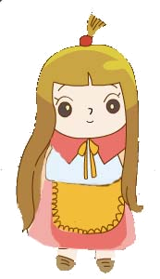  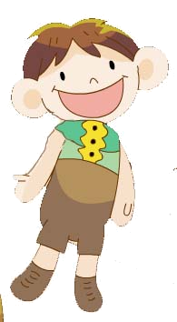  Look at this/our doll.  His ... is ...  His ... are ...  His ... and ... are ...  He’s ... |  |  |  | 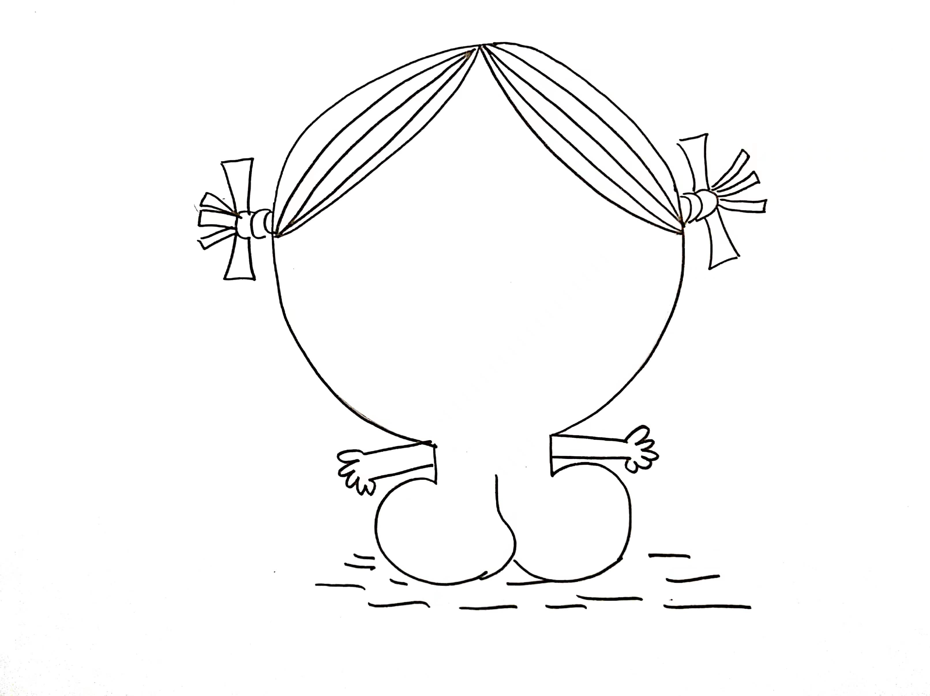
审核人签名：

