学科 | 英语 | 课题 | 六上Unit 8 Chinese New Year |  | 课时 |  | 1
主备人 | 许春香 | 参与者 | 周小钰 |  | 课件  制作 |  | 周小钰  许春香
教学  目标 | （一）知识目标  1、能听懂、会说、会读单词：get，Hong Kong，next week，tangyuan，food，firecracker，fireworks，lion dance，red packet，Chinese New Year’s Eve，Chinese New Year’s Day。  2、能听懂、会说、会读、会写句子：What are you going to do? I’m going to …  （二）能力目标  1、能初步理解并朗读课文。  2、能在理解课文的基础上讲述Anna一家是如何过中国新年的。  （三）情感目标：  1、能了解中国新年和其它国家新年的风俗习惯和差异。  2、能通过学习，抒发爱国情怀，传承中国优秀文化。
教学  重难点 | 1、能听懂、会说、会读单词：get，Hong Kong，next week，tangyuan，food，firecracker，fireworks，lion dance，red packets，Chinese New Year’s Eve，Chinese New Year’s Day。  2、能听懂、会说、会读、会写句子：What are you going to do? I’m going to …  3、能初步理解并朗读课文。
教学  准备 | PPT 板书 绘本
学情  分析 | 本单元的主题是讲述如何欢度一年一度的春节。  1.学生己有的学习经验：  学生对于春节这个话题充满兴趣，对春节的习俗和活动有一定了解。  2.学生可能遇到的问题：  单词的准确发音和句型的灵活交际。
教学过程
教学  环节 | 教师活动 |  |  | 学生活动 |  | 调整启示
Step 1  Warm up | 1.Greetings.  2.Watch a video 揭示课题 |  |  | Watch a video
Step2 Presentation | 1. Game “Red packet”  2. Task1:Listen and answer  T: Good job. We know Chinese New Year is the biggest festival. It’s the most important festival in China. When Chinese New Year is coming, how do you feel?  T: Yes,we are very happy .Look,  Su Hai is very happy today, Why?  Let’s listen.  T: Who is it from?  T: Who's Ann?  T: Where does she live ?  T: Let’s read the background together.  T:What is Anna going to talk in the  email? Can you find it?  Task2：Watch and find  1.T: Anna wrote an email to tell Su Hai that she is going to do a lot of things at Chinese New Year.  When is she going to do these things ?  Task3：Scan and find out Anna’s activities.  1.T: What is she going to do at these different time? Open your books.  T: Do you know? People in Hong kong all buy flowers at Chinese New Year.  Let’s enjoy.  The flowers mean good wishes，rich and honored(花开富贵).  T: They also enjoy watching fireworks.  2.T:Chinese New Year is coming. So,how is Anna?  Task4：Read and imitate.  - Read after the tape.  T: If you are Su Hai, what are you going to do?  2.Retell the passage. |  |  | S: Excited, Happy...  S:Because she gets an  Email.  S: Anna.  S: Su Hai's e-friend  S: In Hong Kong.  S: Chinese New Year.  Watch and find the time.  S: ...  Read and find out Anna’s activities.  Learn the new phrases:  watch a lion dance  get red packets  watch fireworks  Culture time  S: She is very excited.  S: I’m going to ...  Retell the passage.
Step3 Consolidation | 1.T: We know Anna’s plan for Chinese New Year.Now l et’s write a passage about Anna’s plan.  Check the answers.  2.Try to think  T: From this lesson, what do you think of the C hinese New Year?  3.T: Chinese New Year is our important holiday in China.  It’s our Chinese traditional culture.  Enjoy Chinese Festivals, love Chinese culture. |  |  | Write a passage about Anna’s plan  Ss:Fun,exciting,interesting,wonderful,reunion,special…
Step4 Homework | 1.Read Anna’s email about Chinese New Year in Hong Kong.  2.Make your plan for Chinese New Year with your family.  3.Surf the Internet, try to know some about Chinese New Year  customs(风俗) of different places in China.
板书  设计 | Unit8 Chinese New Year  Chinese New Year is coming. Anna is excited! ...She is going to...    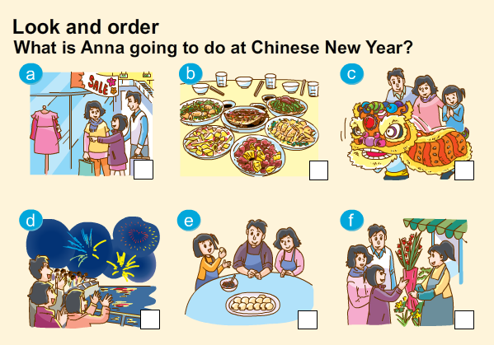  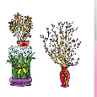  On Chinese New Year’s Day  Tomorrow  On Chinese New Year’s Eve  On the second day of Chinese New Year  