A beginner’s guide to exercise
Teaching aims:
By the end of the lesson, students will be able to:
- Predict the main idea according to the title, subheadings and pictures.
- Understand the benefits of exercise and grasp how to make a exercise plan.
- Encourage them to start exercising and have a sense of protecting themself in sports.

Teaching procedures:
Step one: lead-in
The teacher guides the students to watch a short video shot by students themselves, and asks the students to think about the questions while watching.
- What happened to the boy in the video?
- Why did the boy get injured?

Step two: predicting from the title
The teacher encourages the students to read the title and guess the main idea of the guide from the title, subheadings and pictures. Ask question:
What kind of information do you think the guide will give?

Step three: fast reading-read for the structure.
The teacher asks the students to read the guide quickly and try to analyze the structure of the guide.
(2)_________ to the topic

A beginner's
Four (3)______ of exercises

(1) _____ to exercise
(4)____ on people to take exercises

Step four: detailed reading-read for the detailed information of each tip.
- Understanding the benefits
The teacher guides the students read the paragraph two and design a mind map about the benefits of exercise.
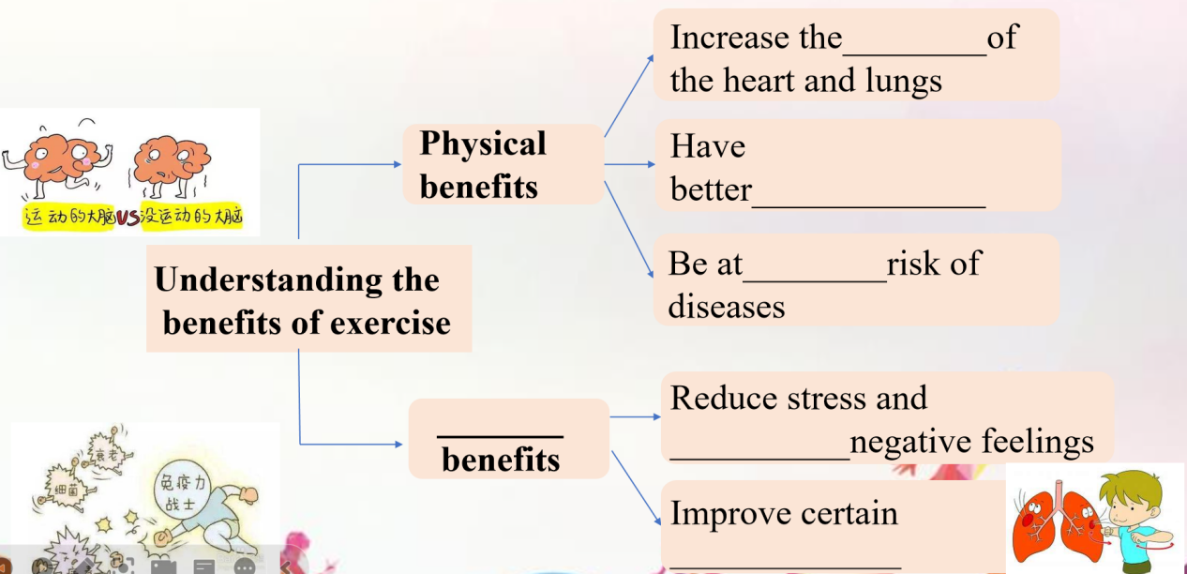
- Planning the exercise routine
The teacher guides the students to read the paragraph three and try to figure out what types of exercise they will enjoy and complete the following table.
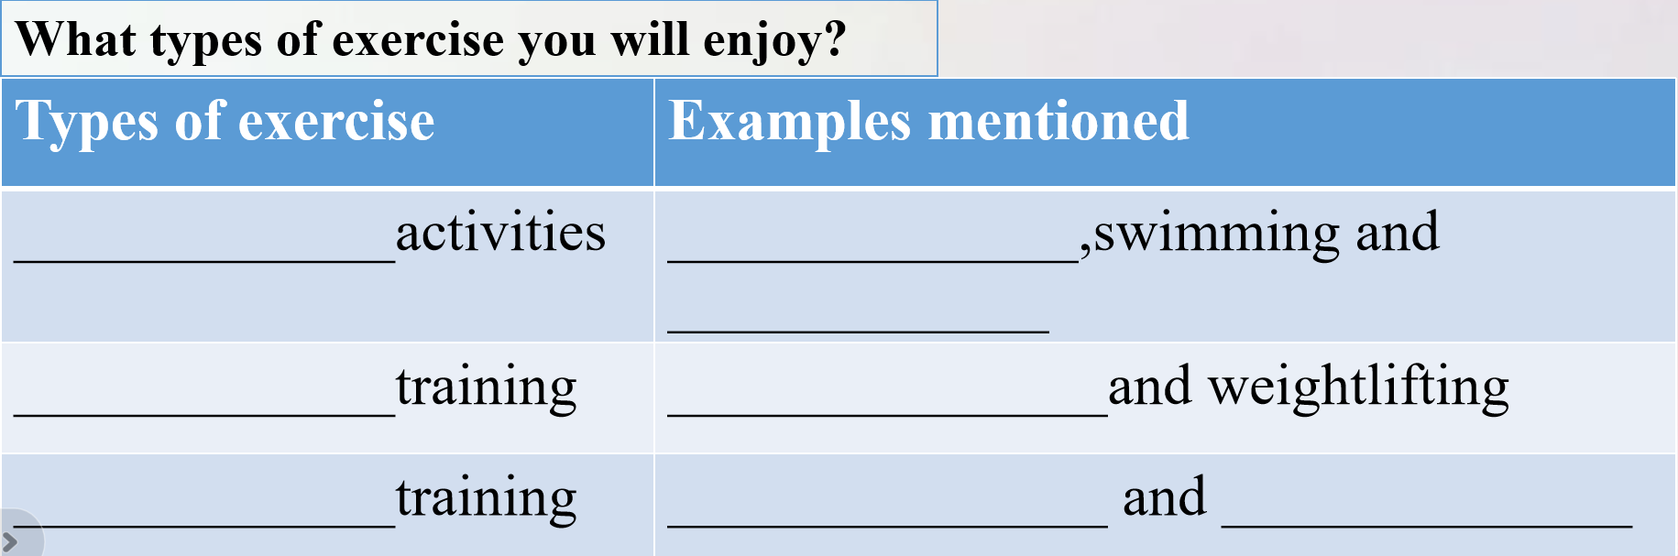
Then the teacher guides the students to find out the advantages of different types of exercise and solve the problem.
Jack, Rose and Mike are planning their exercise routine. The aims of their exercise are listed as follows. Please help them choose one from the following different types of exercise.
a. tai chi b. swimming c. pull-ups
(1) Jack wants to increase his muscle strength.
(2) Rose expects to improve her heart efficiency.
(3) Mike wishes to improve his body flexibility.
3. Eating and drinking right
The teacher divides the paragraph four into three parts: what to eat, when to eat and drink water. Then the teacher guides the students to read the passage and fill in the blanks.
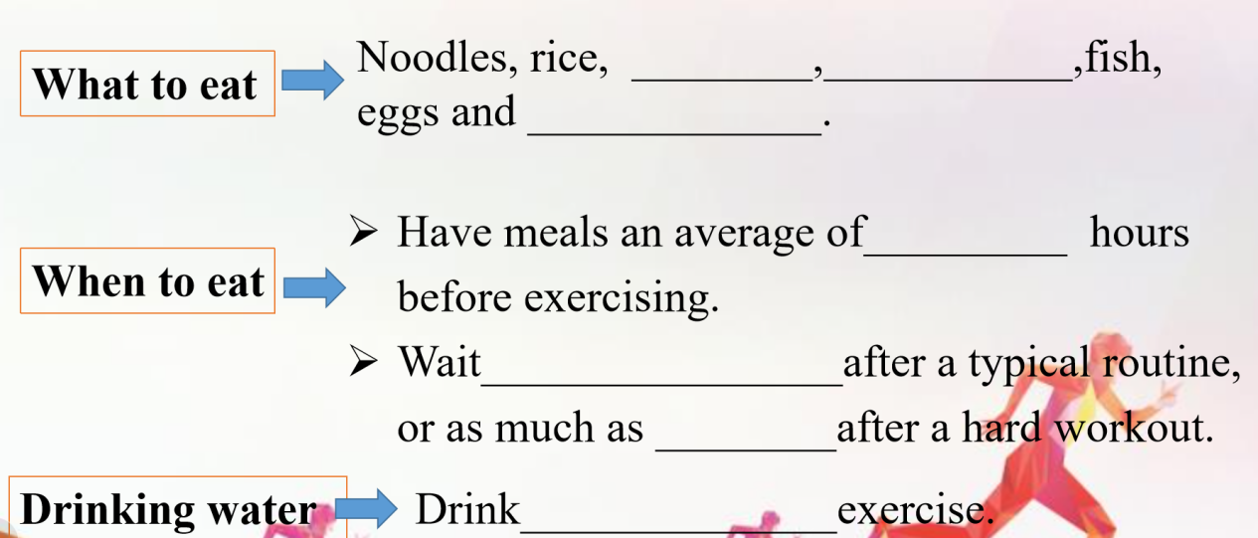4. Avoiding injury
The teacher guides the students to read paragraph five and summarize the ways to avoid injury. And ask question:
What should we do to avoid injury ?(no more than 5 words)
Discussion: the teacher guides the students to discuss the question according to the para. 5.
Can you think other ways to avoid injury?

Step five: post-reading
- Critical thinking: after reading the guide, the teacher encourages the students to think about the questions:
- What is the purpose of the guide?
- What techniques does the guide use for the these purposes? (give examples, ask question, present statistics, make a comparison and quote, which are mentioned in this guide? )
- Role play
The teacher encourages the students to have a role play to review what they have learned before.
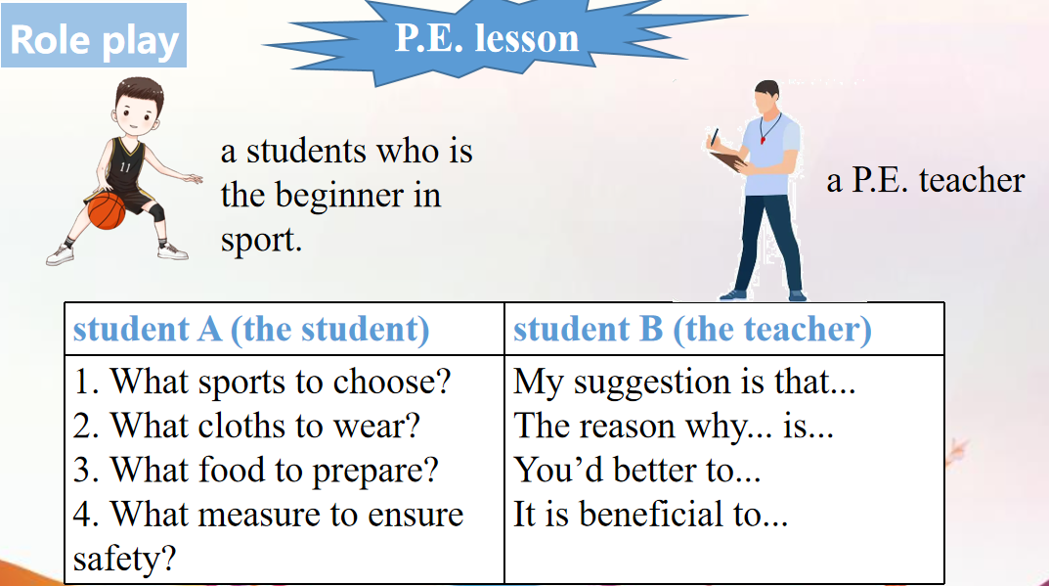
Step six: homework
Writing
假如你是李华，你的外国朋友Jack最近对太极拳感兴趣，想要练习太极拳，希望你能提供一些练习太极拳的指导。请你根据提示给Jack回一封信，回信内容包括：
1. 鼓励和肯定他对太极拳的热爱，介绍太极拳对身心发展的益处：①提高心肺功能。②增强身体柔韧性。③缓解紧张的情绪。④……
2. 提供运动指导：①运动之前喝一点牛奶、豆浆；做好热身活动。②运动中量力而行，不要过量运动。③运动后不要立刻洗澡。④……

