Fun with Yy
备课人 | 沈艳 | 课 时 | Period1 | 课型 |  | 新授
教学目标 | 1.巩固已学的字母音，音素音和rhyme。  2.准确认读字母Yy的音及其音素音。  3.准确认读含有Yy的单词：yo-yo,yam,yarn,yellow等，感受Yy在单词中的读音。  4.通过示范读、跟视频读、表演读、小组读等方式掌握rhyme。  5.能在游戏等活动中感知并初步掌握字母y在CVC结构的单词中的拼读，提升拼读意识和能力，并能运用拼读规律拼读单词。  6. 能够在图片环游的过程中，借助图片的帮助和教师的引导，理解故事大意。  7.在师生交往互动的活动中感受到英语学习的乐趣。
教学重点、难点 | 教学重点：  1.掌握 Yy字母音 、音素音  2.通过多层次的听、读、模仿、小组表演等活动学习rhyme。  3. 在阅读绘本理解故事内容的过程中发现、辨别、梳理字母y的发音，并运用发音规则拼读单词。  教学难点：  - 认读含有字母 Yy 的单词。  2..能运用自然拼读的方法拼读带有字母y的单词。
教学准备 | PPT、字母卡片
教学过程 |  |  |  |  | 备注或修改
Step1. Warm up
- Greetings.
Good morning, class.
Good morning, Miss Shen.
- Sing a letter song
T: You know I like making friends (交朋友). I have many friends. Look! They are coming!
Ss sing the letter song
- Chant with letters
T: These are our old friends. Aa, Ee, Ii, Oo, Uu, they are vowels. The other letters are consonants. Now let’s chant with them.
Ss: 四人小组朗读儿歌，并选择两首(一首元音，一首辅音)表演，记得加入表情和动作哦
Step2. Lead in Yy
T:Look, This is my new friend. She says ‘Hello’ to us Who’s she? Here’s a video, let’s watch it.
T: Who’s she?
S: Yy.
T: Follow me——Yy. （示意学生观察老师的嘴型。）
T: Let’s greetYy.
S1: Hello, Yy!
S2: Hi, Yy!
S3: Good morning, Yy.
Step3.Acting Yy
1.T: Look! This is Big Y, this is small y. Look at me. Let’s do it together!
2.用你的身体摆出大写字母Y的形状吧！可以两人合作哦！一边说一边做动作哦！
Step4.Make friends with Yy
T:Y is my friend, she is wonderful! Do you want to make friends with her? (你想和她做朋友吗？有三个任务哦！想不想试一试？)
- Let's look for Yy.
T: Look! Where's Yy? Let's look for Yy.
T: Can you find Yy in this picture and read it loudly? S: Y.
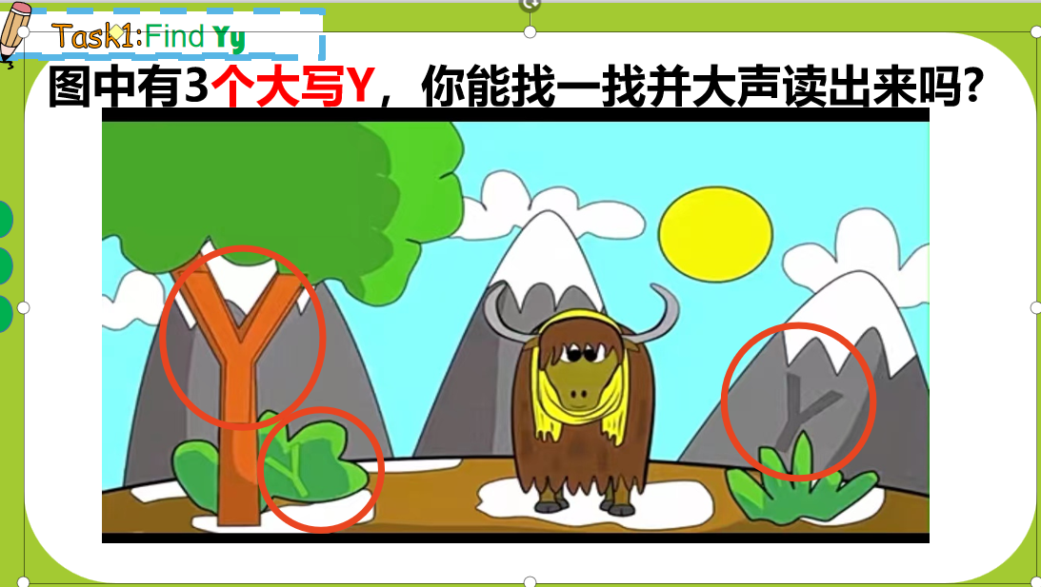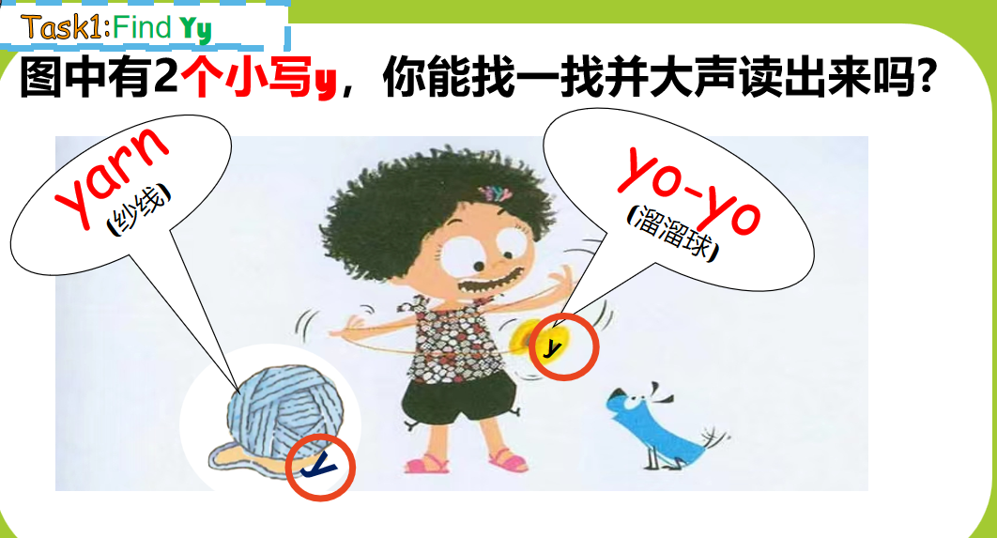
- To learn the words with Yy (yarn,yo-yo).
T: You can find y in this picture. Look! I can see a yo-yo. Look at y, y is for
yo-yo. (教读 yo-yo，加上动作yo-yo.）
T: Listen! Y, y, y, y is for yo-yo.
T: yo-yo is a friend of Yy. Does y have any other friends? Let’s look.
(yarn ，教读 yarn)
Ss: y, y, y is for yarn.
T: Now let's chant together!
(带动作一起说)
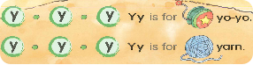
- To learn the sound of Yy
(1)Listen and chant
T: Y-yo-yo, Y-yarn. What does Yy say? Can you guess?
T: Now, let’s listen to a rhyme. What does Y say?
S: Yy says /y/ /y/.
T: Now let’s chant together.
Ss: Y /y/, Y/y/ Y/y//y//y/ ... ...
- Listen and choose
T: What is missing?
S: Y.
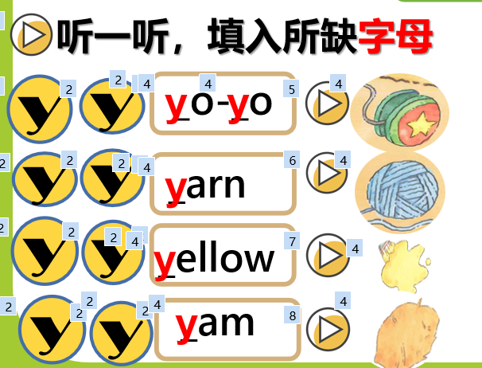
T: Let’s chant together!
Ss: /y//y/yo-yo, /y//y/yarn, /y//y/yellow, /y//y/yam.
4.Rhyme time.
1) T：Look，what’s this?
Ss:yam.
T:What colour is the yam?
S:Yellow.
T:Yes,yellow yellow yam.
T: what can you see in the picture?
Ss: bug
T: Yes, the bug is eating the yam.
T: What does the bug say when eating the yam? Let’s listen.
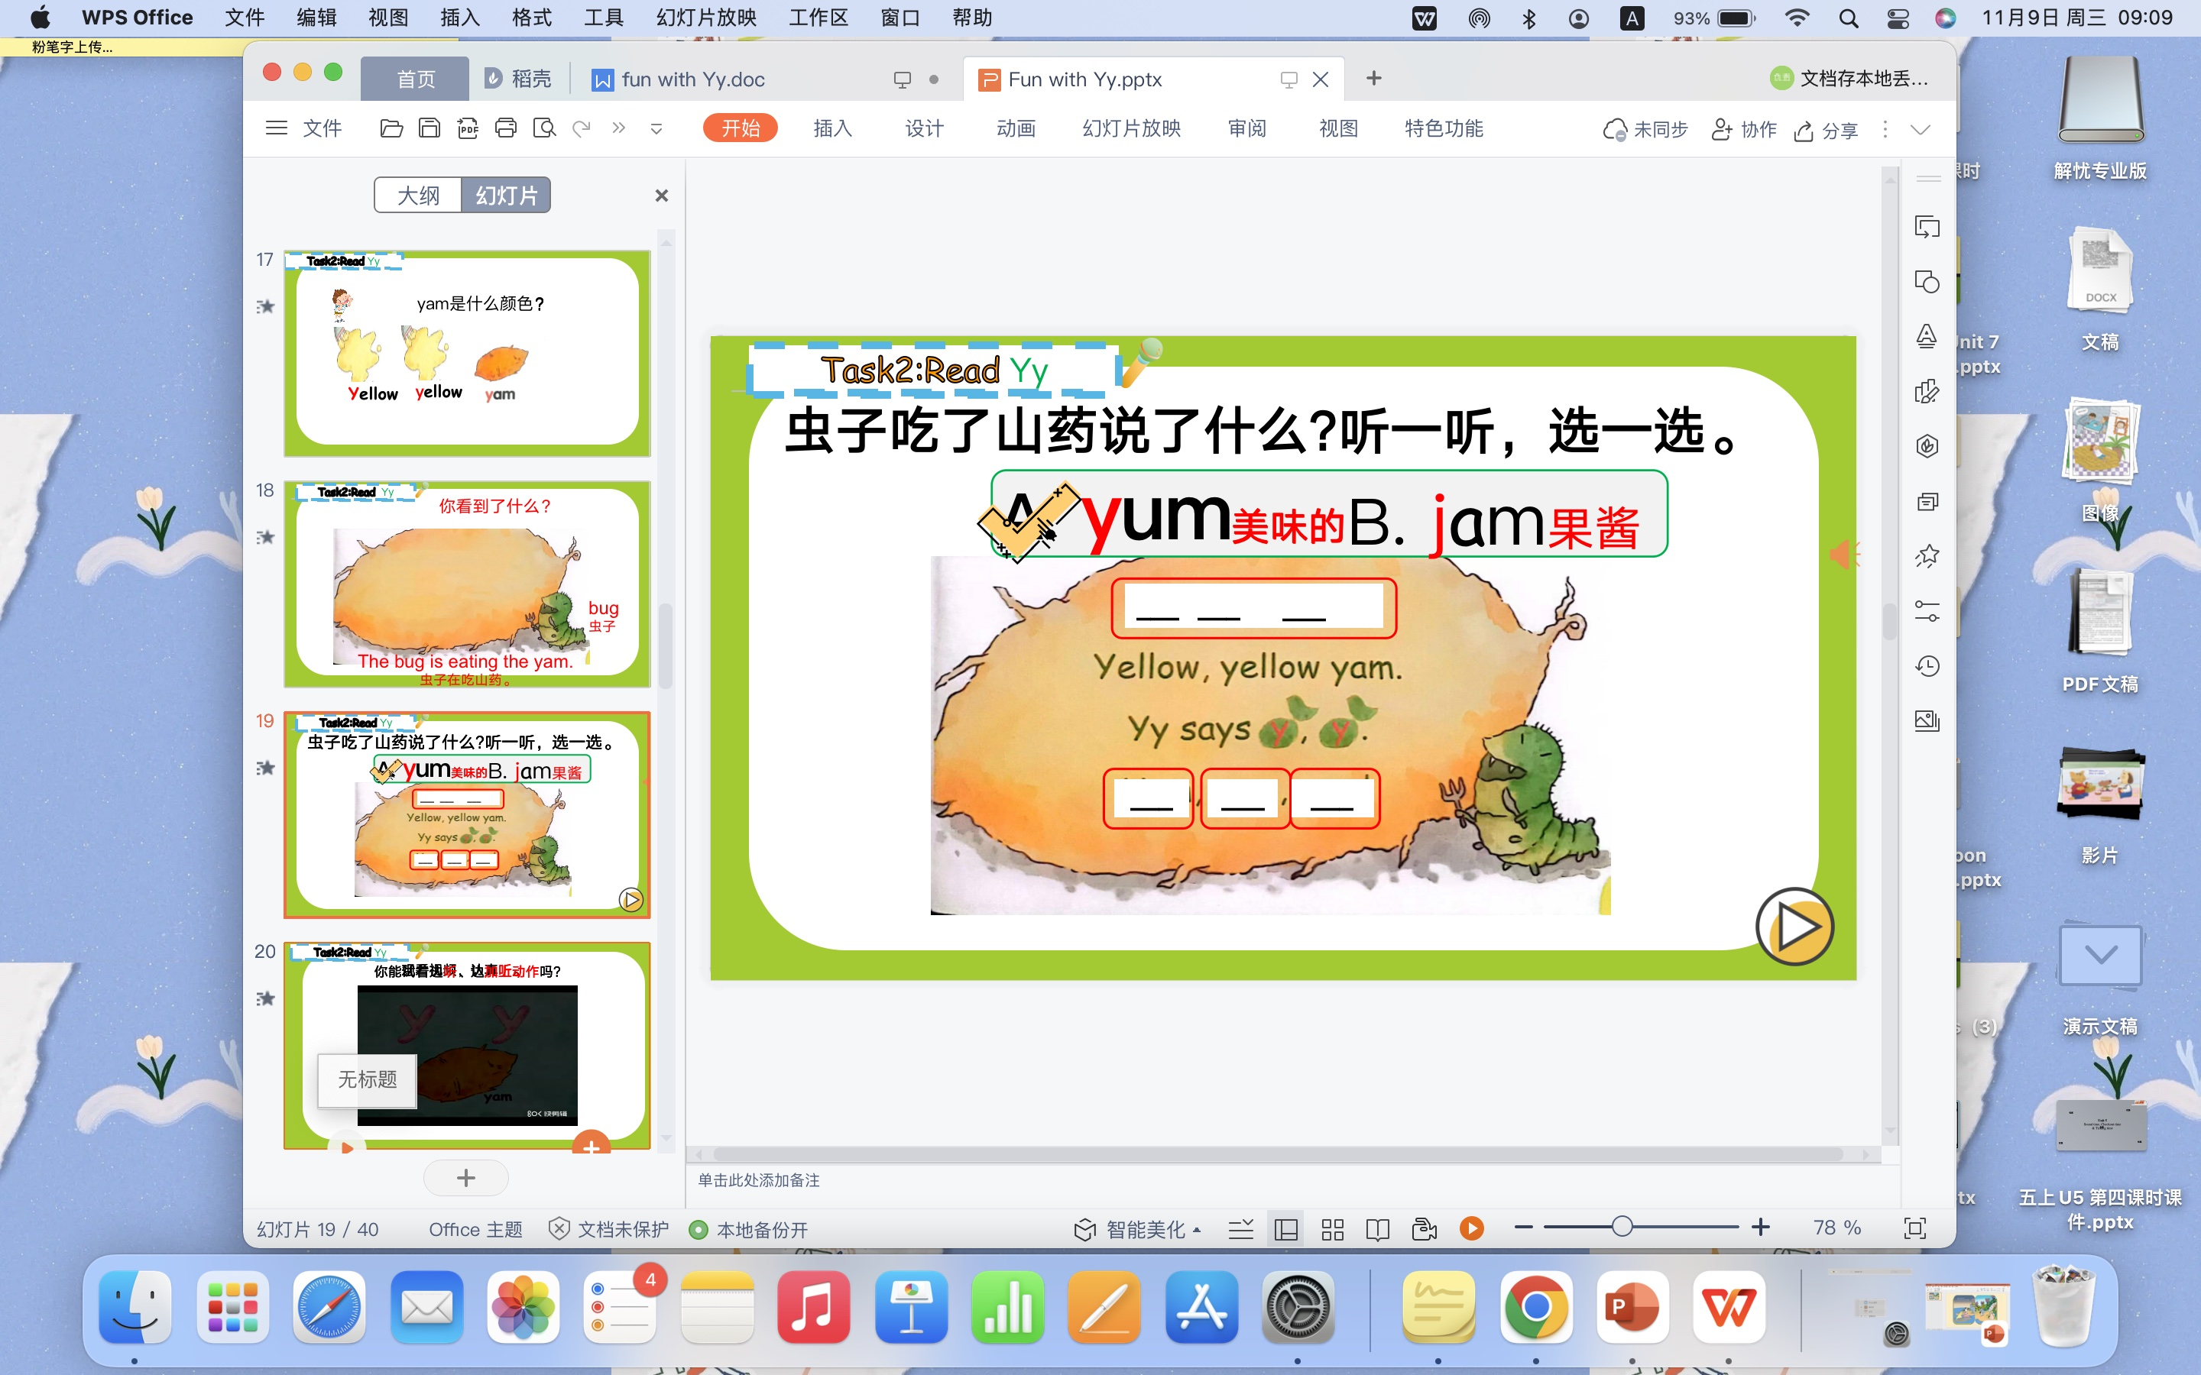

- Say the rhyme with the teacher (和老师一起唱一唱，做一做）
- Say the rhyme in groups (4人一组，唱一唱，做一做）
5. Blending game
(1)T: Cool! Everybody chants well. Would you like to play the blending game with me.?
(2)拿出你的单词卡片和你的同桌拼一拼、读一读吧！
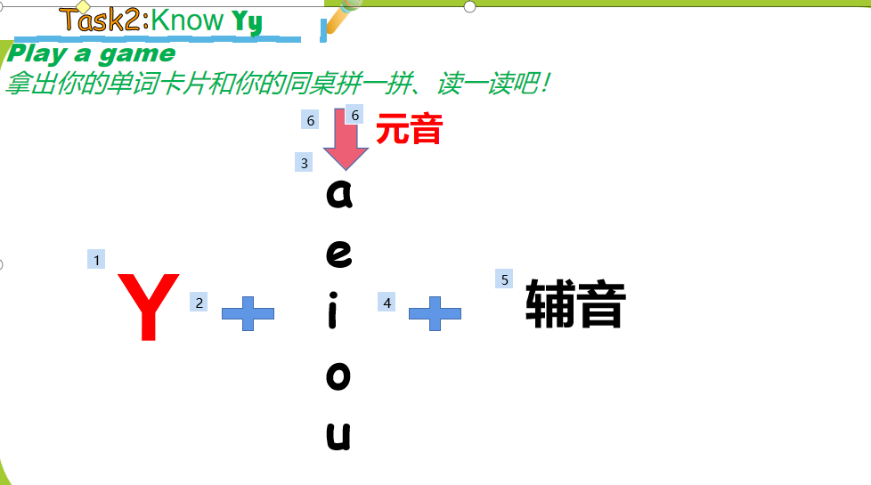
6.Enjoy the story of Yy
1)cover reading
What can you see in the picture?
引出新单词：Maya，yo-yo
Guess:What’s Maya doing?
猜猜：玛雅正在做什么？
Maya is playing with the yo-yo.
(2)What colour is the yo-yo?
引出新单词yellow
3)Watch the vedio
How many places does the yo-yo go?
溜溜球去了几个地方？
S:Five.
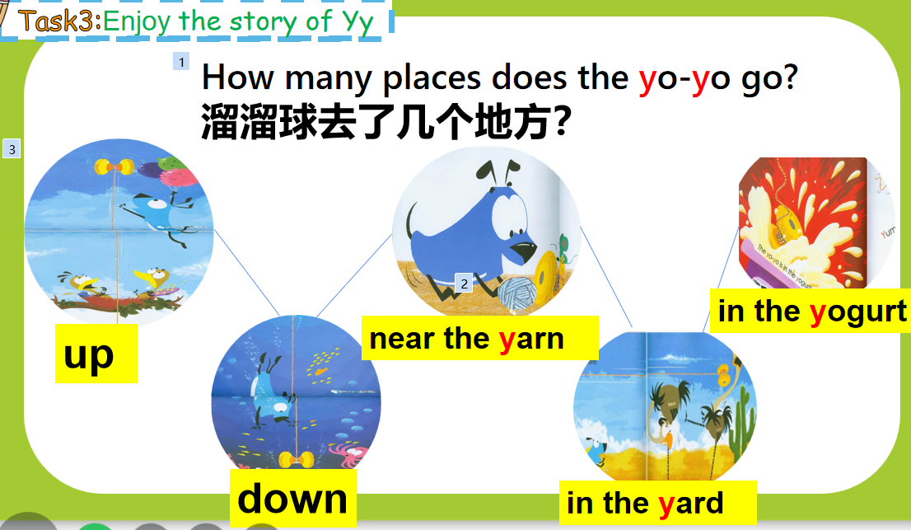
(4)Where does the yo-yo go?
Read the pages one by one
Teach: yarn ,yard,yogurt
(5)Guess：What’s Maya doing now?
猜猜：玛雅在做什么？
Maya is looking for them.
This is such a long journey!
溜溜球可经历了一次长途旅行啊！
Step6 Summary
Step 7: Homework:
- Review the rhyme of Yy
- Find the letter Yy in life.
- Read the picture book of Yy.
教学板书 | 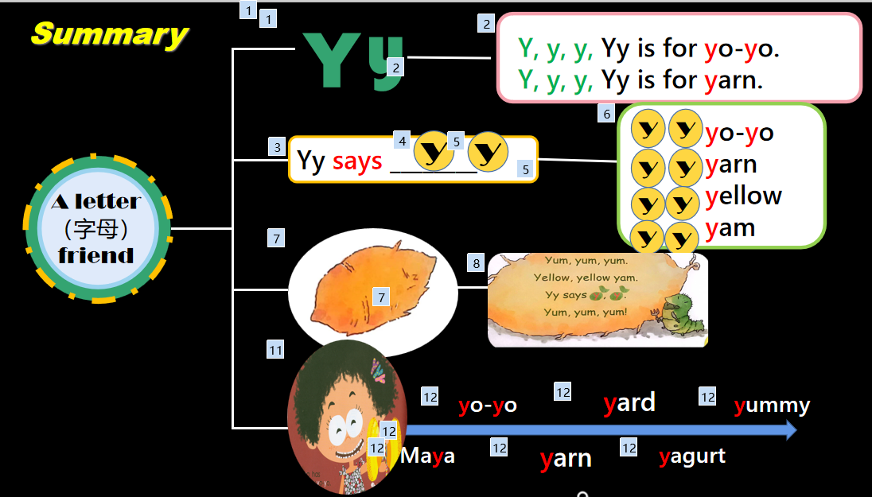
教学反思 | 通过歌曲导入，以旧带新巩固强化之前所学的字母名和韵律歌。由此引入新授字母Yy的字母名，字母音，韵律歌以及相关绘本故事。在教授字母音后，通过拼读游戏，引导学生拼出所学字母合成的新词音，训练学生的解码能力并提高学生“见词能读”的能力。

