Welcome to the unit
Contents: a passage about five senses
Teaching aims:1 students are expected to practice and improve their oral English and share opinions
2.deal with some words for the reading
Teaching procedures:
Lead-in
Present students a box with something in it ,and let them guess what it is in it by touching (candy)?
After the activity , show them the candy .
Is it easy for you to guess ? Possible answer: no,
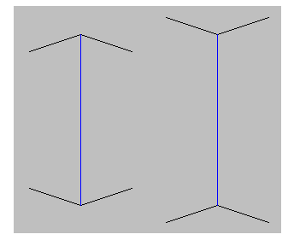
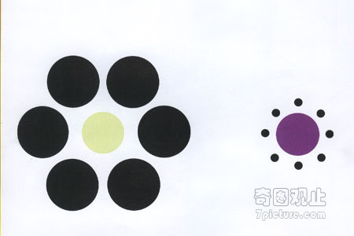
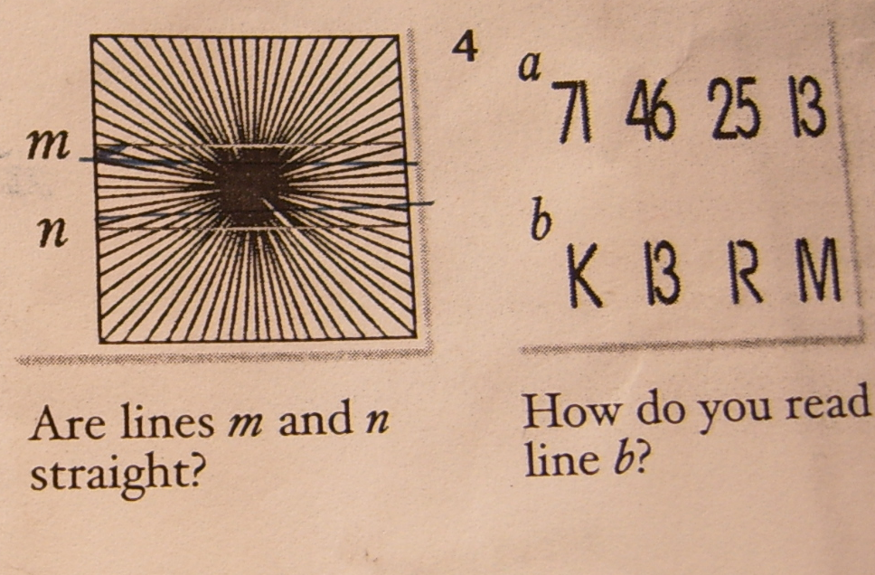
seeing is believing （眼见为实），is it true?

Which line is longer and which circle is bigger? 缪勒莱耶错觉1/2
What can you see? Are lines m and n straight? How do you read line b?
Scan the short passage
1.How many senses do people have and what are they?
2. If you hold your nose when eating , what will happen?
3.Can people with hearing problem understand each other and how?

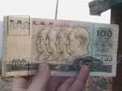
By touching Braille(letters in raised dots)

Discussion
As a blind , what kind of senses does he use most when he wants to read books ? By touching
. What senses do you use more than the others ?
(in class, in the darkness, listen to music, watch movie
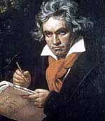
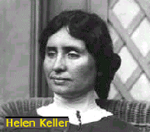
Do you know of any people who have made great achievements even if they have lost one of their senses ? And what achievements ?

Observe these pictures , what do these people have in common?
never give up(desert) themselves ,a hard (rough) time in life, great achievements .)
创设有效情景，部分解决阅读中的关键单词)
关键:是指影响阅读，但又不重点讲解的单词

Reading Period 2-4
Contents: a blind helped a normal woman on a foggy day
Teaching aims: students learn how to comprehend a story better and learn what common elements in a story and how these elements work in a story
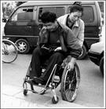
Teaching procedures
What can you see?
If you were here, what would you do?
Lead-in
We always help disabled people , do you think they can help us too in our daily life? Please skim the passage and answer : who helped whom?

Scan the passage
Finish Part C1 and Part C2 to get a better understanding of the text.
Reading
Read the text following the tape recorder to correct their pronunciations
Fill the form to get a better understanding of reading strategy
Consolidation
Get students to complete Part E to make them more familiar with the text
Homework
Finish Part A & Part B on Page 90 workbook
Reading language points Period 3-4
She sensed that she was being watched by a tall man in a dark coat.
sense n. 官能, 感觉, 判断力, a sense of hunger. 饥饿的感觉
v.t.（及物动词）To become aware of.感觉：意识到感觉
Although she said nothing, I could sense her anger.
He sensed his students were bored though they listened politely.
To grasp; understand.理解；领会 make sense 有意义，Observe v.t 动词 观察 observe a child‘s behavior.
观察一个孩子的行为
观测： observe the orbit of the moon. 观测月球的轨道
遵守：遵守 observe the terms of a contract. 遵守合同的条款 The train is still in sight. 还能看得见那列火车.
The house was out of sight behind a wall. 房子被墙遮住看不见了
lose one‘s sight,失明 have good, poor sight, 视力好、 差等
Reach out 伸展，伸出：（将身体的一部分）伸展开或拉开；延伸：reached out an arm. 伸出一只手臂
Reach n延伸, 区域, 河段, 范围, (车子前后轴的)联接杆, 横风行驶vt.到达, 达到, 伸出, 影响= get to, arrive in \at
vi.达到, 延伸, 伸出手, 传开
He couldn't reach the shelf. 没法够着书架= the shelf is out of his reach \ the shelf is in his reach.
The tall mountain reaches to the sky.
She wonder if the bus would still be running .
Wonder n.奇迹, 惊奇, 惊愕 vt.对...感到惊讶, 惊奇, 想知道
vi.惊讶, 怀疑 adj. 非凡的, 奇妙的
the seven wonders of the world 世界七大奇观
saw the wonders of Paris; 看见巴黎的奇迹；
Wondered what was going on. 想知道正在干什么
still adj.静止的, 静寂的adv.还, 仍, stand still.站立不动Now she wanted to run, but fear held her still 一动不动
She sat perfectly still while I explained the reasons.
Once out in the street , she walked quickly towards her usual bus stop. Once conjunction
Once out in the street =when she was out in the street.
Once (it was ) seen, it will never be forgotten
The truth is that the fog is too thick for the bus run that far.
That =so\this , to modify an adjective or adverb表示程度
Don’t take what she said that seriously .
Never stay out this late again.
The weather might be better there and you might be able to get a taxi
可结合上学期语法中的 must的用法 ---对不同时态的猜测
Must be \ be doing\ do \have done 采用对比讲解的方法
Polly found herself staring up at a man standing with his hand resting on her arm.
stare at v. 凝视, 盯住 stare into v.凝视
Don’t stare at people like that ;it’s not polite.
He sat quietly staring into the distance , thinking of her words.
Watch out for the step here.
Watch out To be careful or on the alert; take care.戒备：提防或戒备；注意 look out (for something )
“Watch out!”he shouted ,but it was too late –she had fallen from the chair.
word power
Contents: parts of speech & describing the weather
Teaching aims: make students know parts of speech and how to describe different kinds of weather
Teaching procedures:
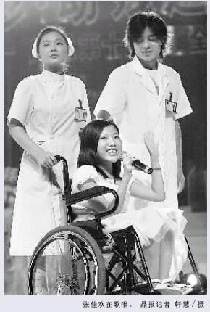
通过特定的情景让学生感知到
一词多性的特征

Can I help you?
No, thank you for your help

Brainstorm
Make students show more such examples and make sentences with them.
如：Polly left work early. We should work hard everyday
Exercises
1.Ask students to complete individually the table in Part A. After checking the answers .let students make sentences with these words of different parts of speech
2.Make students complete the report with the words in box.
house , cause , increase , answer

The air sometimes smells very bad. Do you know what __1____ this ? One __2_____is traffic. Does anyone have an __3__ to the problem of global warming ? So far even scientists can’t ___4____ this question. In some countries you can see people without ___5__sleeping on the streets . It’s hard to _6___all the people who need homes . In some other countries , the price of food __7______every year. Poor people often have to go hungry because they can’t afford the ____8_____.
Describe the weather
What’s the weather like today? What does these signs mean?

Do you have any other words to describe the weather?
Read the conversation to find more words to describe the weather

Look at the symbols of different kinds of weather
drizzly下毛毛雨的, mist薄雾, overcast阴天的,
tornado龙卷风, occasional cloudy periods
Complete the second speech bubble according the pictures.
morning
morning (16)

Here is the weather forecast for tomorrow ,
it will be __________,
_____and _______ in the morning

Grammar and usage Period 6-7
Grammar and usage
Teaching aims: make students know noun clauses
I like English.
主语 谓语 宾语
若主语和宾语是个句子，就称为主语从句和宾语从句
Whoever breaks the law will be punished.
It was good news that everyone got back safely
I want to know what has happened.
The problem remains unknown
主语 谓语系动词 表语
若表语是个句子，就称为表语从句
The problem is whether Polly can find her way .
The truth is that he is fit for the job .
定义：名词性从句就是句子担任名词性的成分，如主语，宾语，表语，同位语。它包括主语从句、宾语从句、表语从句和同位语从句
1. 主语从句 1）What he said is true.
2）When they will arrive is not known yet.
3That he succeeded in doing the experiment was encouraging.
4）Whether he will accept the invitation remains a secret.
5）It is important that we should learn English well
宾语从句
（1）I don't know if he has done the work.
（2）Did he say (that )he liked football ?
3）They expected(that) they would be given another chance.
（4）The girl told me she had longed to visit China.
表语从句
（1）The question is whether we have enough time to do the experiment again.
（2）His greatest wish was that someday he would become a general.
（3）His suggestion was that we should discuss the plan carefully.
（4）My question is when they can finish the work
同位语从句
（1）You have no idea how eager they are to know the result.
（2）He made a suggestion that the work should be given to him.
（3）Have you heard the news that PremireWen visited our school last Friday
（4）The fact that he got full mark in the composition made his parents very happy
名词性that – 分句
作主语：that-分句作主语常用it结构，将分句置于句末
It was obvious that the driver could not control his car.
It seems unlikely that she will refuse the offer.
可将that-分句于句首
That the driver could not control his car was obvious.
That she will refuse the offer seems unlikely
That- 用作宾语
The boy dreamed that he was flying to the moon. Did you know (that) John had agreed ?
That- 从句作表语
The fact is that he didn’t notice the car .Our belief is that things will improve.
That-从句作同位语
News that the professor will visit our school has come.
They had to face the fact that the nearest filing station is thirty kilometers away.
He got up late with the result that he missed the morning train.
What –引导的分句，在句中起句词词组的作用
作主语
Why she did this is not known. It is strange how they did it.
Who was responsible for the accident in not yet clear.
It is not clear who was responsible for the accident.
作宾语
I can’t imagine what made him act like that.
Could you tell me who built the tall iron tower in Pairs ?
Please explain why this is impossible
We don’t know when she’ll come.
作表语
This is what he told us at the meeting . That is where Lu Xun once lived
That is why he likes the place so much.
The problem is not who will go but who will stay.
作同位语
Have you any idea how soon they are coming ?
I have no idea how much of scholar he is .
My original question why he did it at all has not been answered.

Exercise : finish Part A and Part B on page 11 to consolidate noun clauses
Task Telling a story period 8-9
Contents : learn 3 skills through 3 steps
Teaching aims: students learn how to plot a story , prepare a surprise ending and improve the language for storytelling .
Teaching procedures :to achieve the aim of “learn how to learn ”by the way of “do to learn” 通过“做中学”方法达到“学会如何学的目的”
Period 8
Contents: plotting a story
Teaching aims: students learn how to plot a story &write a beginning of a story as well as improving listening
Teaching procedures :
Do you like stories and what kinds of stories are you favorite?
What are the common elements in a story?
Exposition : beginning , who ,where, when , why?
Complication: middle, come across the problem
Resolution : end, how to solve the problem
Finish the Part A &Part B to consolidate the skills
Part A: time order – how to arrange events
Part B: 根据位置和以上要素确定所属 (E/C/R)的部分

Listen to the tape recorder to complete a checklist and get the missing information
Note : 听力材料对学生来说可能有些 过难，以填空形式让学生填写，但要围绕主题，便学生能写下所缺的信息并做出来 。
Write the beginning of the story with the information getting from part b
Period 9
Contents: identifying different elements of comic strips&
using adjectives and adverbs in stories
Teaching aims: prepare a surprise ending & learn the skills of telling a story effectively by using pictures of bubbles
Present 4 pictures with bubbles and captions and explain them to students
Make up a story about the 4 pictures effectively with these bubbles and caption and let them present their story
Go through the comic strip and label the the different ways of adding words ,(speech ,thought ,caption
Read the guidelines and write the correct bubbles and complete the captions for each picture.
Complete the story in Part A by drawing a sixth picture and writing a caption and add thought , speech , sound bubbles
Note: 从学生的作品中选出一幅作为样品
Make students underline all the adjectives &adverbs in the captions .
Why do we use these words in a story and how do we use them?
Read the guideline of how to use adj.&adv?
Complete the exercise on page 16 to consolidate the skills
Read the guideline and fill in the blanks with the adjectives and adverbs in the box
Write the last paragraph of the story using the sixth picture
With a surprising ending 刚才的样品
Present the stories students wrote and let them decide which is the best
Ask students how to tell your stories vividly(生动地)?
Tone of voice, body language, loudness, eye contact, rhythm, hand movement, facial expressions , stress
Homework

Each group practices telling the stories they wrote and have a competition in the next period.

project
Contents: an article about shark senses
Teaching aims: 1.encourage the students to work out a TV show working together in English 2. Consolidate “reading strategy ”
Teaching procedures
Lead-in
People have five senses :sight,hearing,taste, smell, and touch
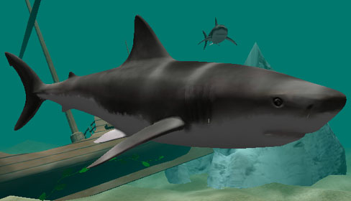
Do animals have senses ? What senses does a dog have?
What do you know about shark senses ?

Animals have developed their
own unique senses to survive
their environment over the
long process of evolution
Skim the passage and answer the question
What senses does a shark have? See in the dark, smell blood far away
How many types of sharks are mentioned? (400)
What will do to avoid shark attack?
Scan the passage again and find more information about shark
Para1 : 400 types , 30 kinds attack humans
Para2 : life habit – do not feed on humans
Para3: 3 types of shark attack &how to avoid danger
Para4: the reason for increasing shark attack
Para 5: 3 tips on what to do if a shark attacks
Para 6: stay calm when meeting a shark
How will you write a TV show form the passage they have learnt about animals’ senses ?
Information : history , present situation , kinds , size , life habit , Ways to present: writing , picture, video
some unique senses , even tips about these animals
Producing a TV show
Planning : 1, divided the class into several groups 2, choose animals Name ,sense , food , habit , size , kinds , myths , type of show etc
Preparing: 1.Search for information from zoo, books, the Internet, animal documentary 2.Take notes of the needed information 3. Discuss together to decide the useful information 4.focus on how the animal uses its senses and how to present the information
Producing: Work on different part of the TV show; Put each part together ; Read ,write carefully , correct the mistakes and add new ideas
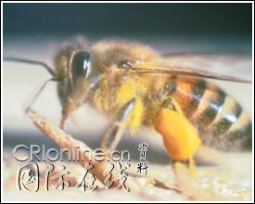
Presenting: Each group presents TV show by turns by showing and narrating : Discussion and competition
Some information about bees :
Name: 蜜蜂
Size:工蜂16—18毫米
Habit :随季节不同有明显的迁徙习性
和过群体生活的昆虫
Senses : 视觉 Food : 花粉
Myths : 如何传递信息Usage :
如果飞回来的蜜蜂先飞一个圆圈，然后转一方向，再飞一个圆圈，像圆圈舞；那么，这便是报告：“在距巢50米以内的地方有食物。如果侦察蜂先飞一个半圈，然后直飞回来，在另一个方向又飞半个圈，形状有点像一个横写的“8”字”，直飞时，腹部末端还不停地摆动着，像摇摆舞。如果这种摇摆舞跳得很慢，每分钟跳八个“8”字，尾部摇摆的次数很多，就是报告：“花蜜在离巢6千米处。蜜蜂的舞蹈动作，不仅能报告花蜜距巢远近，还能指示花蜜所在的方向。如果跳摇摆舞时，蜜蜂头朝上，则是说：“朝太阳的方向飞去，能找到花粉。”反之，则是报告：“在背向太阳的地方可以找到食物。
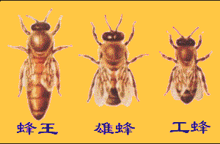
”

蜂群通常由两种性别的三种类型蜜蜂个体组成，
即蜂王、工蜂和雄蜂，
这三种类型蜜蜂，在养蜂学中统称为"三型蜂
蜜蜂具有一般昆虫的形态特征，体躯分节，分别集合
为头部、胸部和腹部三个体段。在部分体节上着生成
对的附肢，附肢也分节。外骨骼的体壳支撑和保护蜜蜂的
内部器官。体表密生绒毛，具有护体和保温作用。特别在
寒地越冬结团的蜂群，蜜蜂绒毛保温意义尤为重要。头部
和胸部的绒毛呈羽状分叉(图)，这对蜜蜂采集花粉和促进植
物授粉具有特殊的意义。蜜蜂体表有些空心状与神经相连
的毛是蜜蜂的感觉器官。
蜜蜂才是天才的“建筑师”
蜜蜂授粉可减少农药化肥的施用
蜜蜂授粉对维护农业生物多样性、稳定性具有重要生态功能

Self-assessment

Write some words and phrases they learned in this unit

