常州市小学生英语歌咏比赛获奖曲目歌词

We Are The Happiest People

We are so happy, very, very happy. 我们很高兴，非常非常高兴。
We are so young and so sweet. 我们多年轻又多可爱。

We are so happy, very, very happy. 我们很高兴，非常非常高兴。
Just like the flowers that bloom. 就像盛开的花儿。
We are so kind and gentle. 我们多仁慈又多温和。
We are so friendly and true. 我们多友好又多真诚。
We are so happy, very, very happy. 我们很高兴，非常非常高兴。
Just like the flowers that bloom. 就像盛开的花儿。

DO—RE—MI 多来咪

Let’s start at the very beginning.

让我们从头开始来学习，

A very good place to start.

从这儿开始真有趣，

When you read, you begin with ABC.

你要念书就要先学ＡＢＣ，

When you sing, you begin with Do Re Mi, Do Re Mi .

你要唱歌要先学多来咪，多来咪

Do Re Mi the first three notes just happen to be.

多来咪，从这三个音符开始学起

Do Re Mi, Do Re Mi, Do, Re, Mi, Fa, So, La, Ti .

多来咪 ，多来咪，多，来，咪，发，索，拉，梯。

(旁白：Let’s see if I can make it easier. )

Do- a deer a female deer, Re， a drop of golden sun,

“多” 是小鹿多灵巧，“来” 是金色阳光照，

Mi- a name I call myself, Fa，a long long way to run ,

“咪”是我把自己叫，“发” 是向着远方跑，

So- a needle pulling thread. La – a note follow So,

“索”是穿针又引线，“ 拉”这音符跟着 “ 索”，

Ti- a drink with jam and bread.

“梯”是饮料和面包，

That will bring us back to Do.

它把我们带回 “多”。

Do，Re，Mi，Fa，So，La，Ti，Do，So，Do.
多，来，咪，发，索，拉，梯，多，索，多。

Click Go The Shears
Down by the board the old shear stands,
Clasping his shears in his thin bony hands.
Fixed is his gaze on a bare bellied joe.
Glory if he gets her worm the makes the ringer go.
Click go the shears boys, click, click, click, click,
Wide is his bow and his hands move quick,
The ringer looks around and is beaten by a blow,
And curses the old snugger with the bare bellied job.
（该歌曲译文与英文歌词有很大出入）

剪羊毛（中文版）

河那边草原呈现白色一片，好像是白云从天空飘临，你看那周围雪堆象冬天，这里我们在剪羊毛，剪羊毛，洁白的羊毛象丝绵,锋利的剪子咔嚓响，只要我们大家努力来劳动，幸福生活一定来到，一定来到。
绵羊你别发抖呀你别害怕，不要担心你的旧皮袄，炎热的夏天你用不到它，秋天你又穿上新皮袄,新皮袄，洁白的羊毛象丝绵,锋利的剪子，咔嚓响，只要我们大家努力来劳动，幸福生活一定来到，一定来到。

Jingle Bells

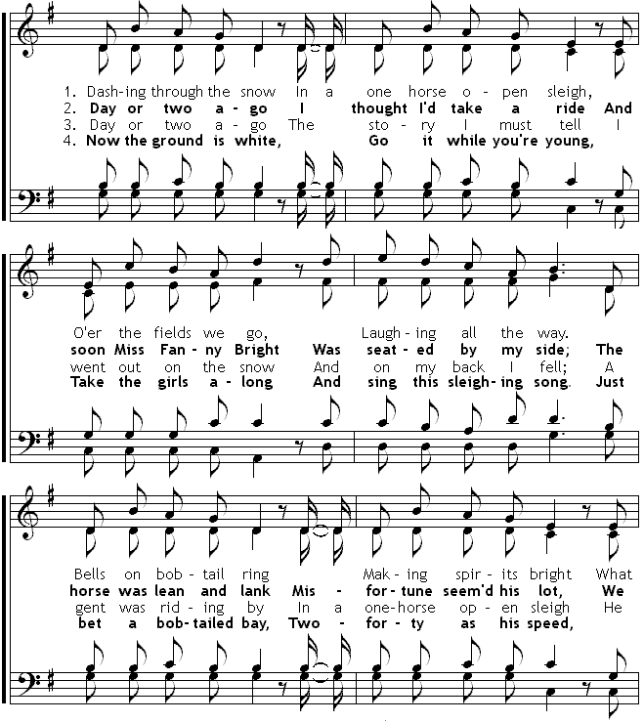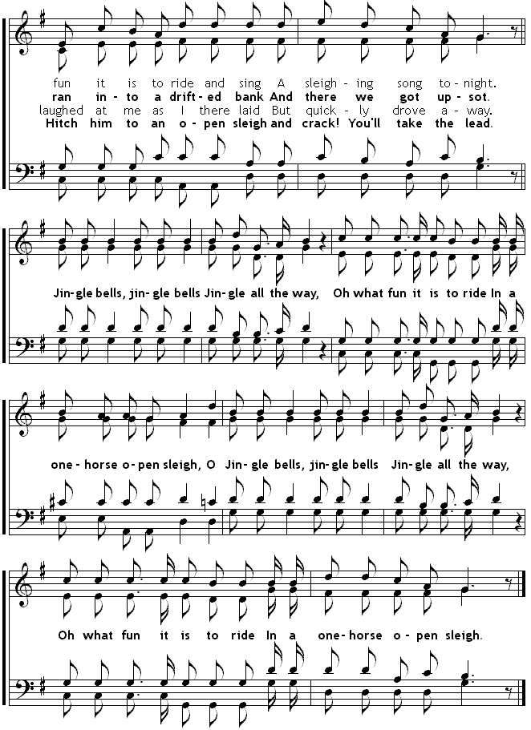

Blue Christmas
I’ll have a blue Christmas without you.
I’ll be so blue thinking about you.
Decorations of rod on a green Christmas tree.
Won’t mean a thing if you are not here with me.
I’ll have a blue Christmas that’s certain.
And when that blue heartache starts hurting.
You’ll be doing all right with your Christmas of white.
But I’ll have a blue, blue Christmas.

Santa Lucia （桑塔.露琪亚）
See where the star of eve. Beams gently yonder.
看晚星多明亮，闪耀着金光。
See where from wave to wave, soft breezes wander.
海面上微风吹，碧波在荡漾。
Come, then, eve night is dark, come to my bounding bark.
在这黑夜之前，请来我小船上。
Santa Lucia. Santa Lucia.
桑塔.露琪亚, 桑塔.露琪亚。

Lightly Row
Lightly row, lightly row. Over the glassy waves we go.
Smoothly glide, smoothly glide, on the silent tide.
Let the winds and waters be mingled with our melody.
Sing and float, sing and float, in our little boat.
中文歌词：
轻轻摇，轻轻摇，船儿水中漂啊漂；
轻轻摇，轻轻摇，船儿漂啊漂。

微风吹动水面，涌起一阵波涛，
欢歌声，笑语声，在水面缭绕。

Skip to my low
Lost my partner what’ll I do? 失去了我的伙伴，我该怎么办？
Lost my partner what’ll I do? 失去了我的伙伴，我该怎么办？
Lost my partner what’ll I do? 失去了我的伙伴，我该怎么办？
Skip to my lou, my darling. 跳到我这里， 我的好朋友。
Lou, lou, skip to my lou. Lou, Lou, 跳到我这里，
Lou, lou, skip to my lou. Lou, Lou, 跳到我这里，
Lou, lou, skip to my lou. Lou, Lou, 跳到我这里，
Skip to my lou, my darling. 跳到我这里， 我的好朋友。

I’ll get another one partner, you. 我要寻觅另一个伙伴，那就是你。

I’ll get another one partner, you. 我要寻觅另一个伙伴，那就是你。

I’ll get another one partner, you. 我要寻觅另一个伙伴，那就是你。
Skip to my lou, my darling. 跳到我这里， 我的好朋友。
Lou, lou, skip to my lou. Lou, Lou, 跳到我这里，
Lou, lou, skip to my lou. Lou, Lou, 跳到我这里，
Lou, lou, skip to my lou. Lou, Lou, 跳到我这里，
Skip to my lou, my darling. 跳到我这里， 我的好朋友。

Can’t get a red bird, a blue bird’ll do? 昔日朋友离你去，眼前友谊要珍惜。

Can’t get a red bird, a blue bird’ll do? 昔日朋友离你去，眼前友谊要珍惜。

Can’t get a red bird, a blue bird’ll do? 昔日朋友离你去，眼前友谊要珍惜。
Skip to my lou, my darling. 跳到我这里， 我的好朋友
Lou, lou, skip to my lou. Lou, Lou, 跳到我这里，
Lou, lou, skip to my lou. Lou, Lou, 跳到我这里，
Lou, lou, skip to my lou. Lou, Lou, 跳到我这里，
Skip to my lou, my darling. 跳到我这里， 我的好朋友。

Jingle Bells
We Wish You a Merry Christmas
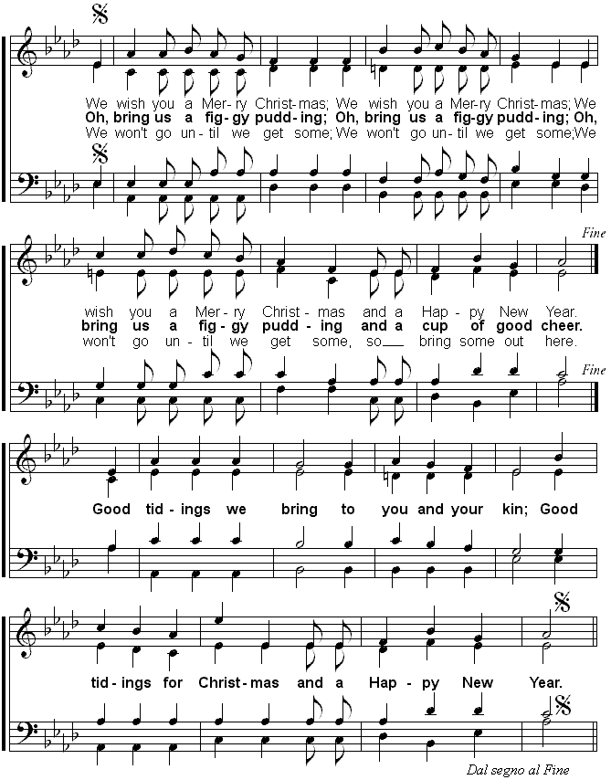

Old MacDonald
Old Macdonald had a farm, E-I-E-I-O
And on his farm he had a cow, E-I-E-I-O
With a "moo-moo" here and a "moo-moo" there
Here a "moo" there a "moo"
Everywhere a "moo-moo"
Old Macdonald had a farm, E-I-E-I-O
Old Macdonald had a farm, E-I-E-I-O
And on his farm he had a pig, E-I-E-I-O
With a (snort) here and a (snort) there
Here a (snort) there a (snort)
Everywhere a (snort)
With a "moo-moo" here and a "moo-moo" there
Here a "moo" there a "moo"
Everywhere a "moo-moo"
Old Macdonald had a farm, E-I-E-I-O
Old Macdonald had a farm, E-I-E-I-O
And on his farm he had a horse, E-I-E-I-O
With a "neigh, neigh" here and a "neigh, neigh" there
Here a "neigh" there a "neigh"
Everywhere a "neigh, neigh"
With a (snort) here and a (snort) there
Here a (snort) there a (snort)
Everywhere a (snort)
With a "moo-moo" here and a "moo-moo" there
Here a "moo" there a "moo"
Everywhere a "moo-moo"
Old Macdonald had a farm, E-I-E-I-O
...mouse..."squeek"
...porcupine..."oo-ah"
...cold...(sneeze)
...joke..."ha-ha"
If You're Happy and You Know It
If you're happy and you know it clap your hands (clap, clap)
If you're happy and you know it clap your hands (clap, clap)
If you're happy and you know it and you really want to show it
If you're happy and you know it clap your hands (clap, clap)
If you're happy and you know it stomp you're feet (stomp, stomp)...
If you're happy and you know it nod your head (mmm hmm)...
If you're happy and you know it whistle a tune (whistle)...
If you're happy and you know it click your tongue (click, click)...
If you're happy and you know it snap your fingers (snap, snap)...
If you're happy and you know it shout hooray, HOORAY!...
If you're happy and you know it clap your hands (clap, clap)...

Auld Lang Syne
Should auld acquaintance be forgot
And never brought to mind?
Should auld acquaintance be forgot
And days of auld lang syne?
Chorus
For auld lang syne, my dear,
For auld lang syne
We'll tak' a cup o' kindness yet
For auld lang syne.
We twa hae run about the braes
And pu'd the gowans fine
But we've wander'd mony a weary foot
Sin' auld lang syne.
We twa hae paidl't in the burn
Frae morning sun till dine
But seas between us braid hae roar'd
Sin' auld lang syne.
And surely ye'll be your pint stoup
And surely I'll be mine
And we'll tak' a cup o' kindness yet
For auld lang syne.

Silent Night
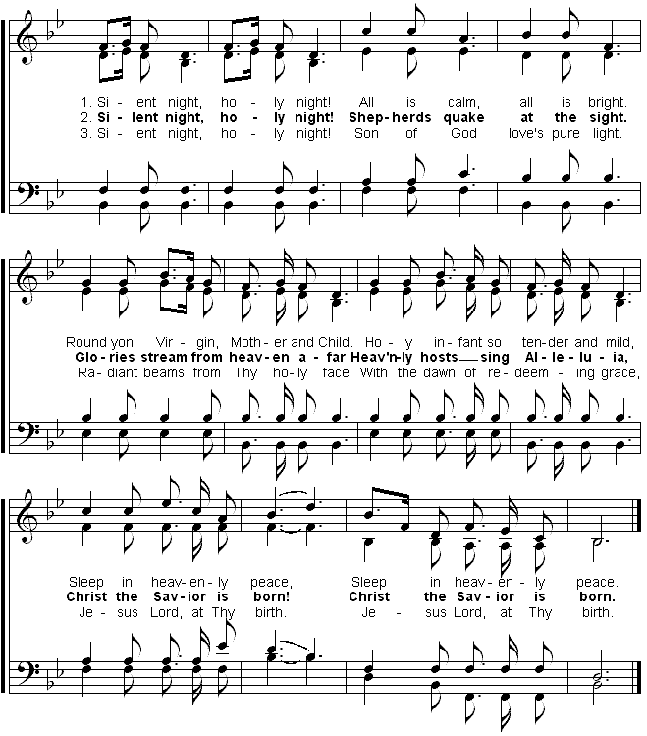
Whatever Will Be Will Be

When I was just a little girl, I asked my mother what will I be.
Will I be pretty? Will I be rich? Here's what she said to me.
Queh Sera Sera. Whatever will be wll be. The futher's not ours to see.
Queh Sera Sera. Whatever will be wll be.

When I grew up and fell in love, I asked my sweetheart what lies ahead.
Will we have rainbow day after day , here's what my sweetheart said.
Queh Sera Sera. Whatever will be wll be. The futher's not ours to see.
Queh Sera Sera. Whatever will be wll be.

Now I had children of my own, they asked their mother what will I be.
Will I be handsome? Will I be rich? Here's what she said to me.
I tell them tenderly.Queh Sera Sera. Whatever will be wll be.
The futher's not ours to see.Queh Sera Sera. Whatever will be wll be.
Queh Sera Sera.

Can You Feel The Love Tonight ?  There's a calm surrender  To the rush of day  When the heat of the rolling world  Can be turned away  An enchanted moment  And it sees me through  It's enough fot this restless warrior  Just to be with you  And can you feel the love tonight?  It is where we are  It's enough for this wide-eyed wanderer  That we got this far | And can you feel the love tonight  How it's laid to rest?  It's enough to make kings and vagabonds  Believe the very best *  There's a time for everyone  If they only learn  That the twisting kaleidoscope  Moves us all in turn  There's a rhyme and reason  To the wild outdoors  When the heart of this star-crossed voyager  Beats in time with yours

