Stephen Hawking
The Worlds Greatest Living Physicist
Fact File
Date of Birth : 1942
Country of Birth : UK
Major Discoveries : Theories on the origin of the Universe
Writing by the Scientist :
A brief history of time : From the Big Bang to Black Holes (1995)

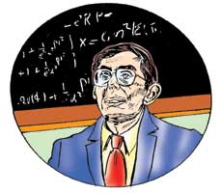
Stephen Hawking decided to become a scientist when he was 8 or 9 years old. By the time he was 14, he had narrowed down his field of interest to mathematics and physics. After obtaining a first class honours degree from Oxford University, he decided to do his Ph.D. study at Cambridge. It was at Cambridge that the disease that was to make him a physical wreck first manifested itself. He began bumping into things. His hands trembled and he found it difficult to tie his shoelaces. His parents took him to a specialist who, after subjecting him to a battery of tests, announced that he had a rare ailment known as motor neuron disease. Victims of the disease usually do not live very long and Hawking, who was 21 years old at the time, was told that he might not live to see his 25th birthday. He was plunged into despair and lost interest in his work. His despondency lasted two years. Then he realised that death was not imminent and he began to fight back the crippling ailment. He obtained his Ph.D. in 1966, married, had children, and slowly began to make a name for himself in his chosen field of study, Cosmology, the study of the Universe.
In 1988, he wrote a book in which he put down some of his ideas about the formation and ultimate destiny of the universe. It was titled 'A Brief History of Time'. It became a best-seller, and brought him fame and fortune.
Today Hawking is confined to a wheelchair and he cannot even speak without a synthesizer, but his mind remains unaffected. To doctors, he is a medical curiosity; to scientists, he is a pathbreaker in the study of the universe — some have even described him the 'world's greatest living physicist'.

