Unit 2(8B)
Teaching procedures of Reading 1
Objectives of Reading I
1. To read a letter about a holiday in Japan
2. To expand vocabulary to talk about traveling
3. To identify specific details by practicing
1. Leading
a. Show the students the picture of Disneyland
b. There is also a Disneyland in Asia“Sanrio Puroland” in Tokyo of Japan.
2. Introduce the background information of Sanrio Puroland.
3. Learn the new words and expressions with the help of the pictures and the model sentences.
cute indoor shiny march wave clap hands scream crown
parade sushi
4. Visiting Sanrio Puroland
a. Sandy visited Sanrio Puroland during the Spring Festival. She wrote a letter to Millie about it. Skimming（浏览） the whole letter and ask for the teacher’s help if you have any questions.
b. Listen, read and choose the right answer.
( ) 1. Sandy spent _____in Sanrio Puroland.
A. a whole day B. three days
( ) 2. What did Sandy buy for Millie?
A. a toy cat B. a lovely purse
( ) 3. Did Sandy’s father go to Hello Kitty’s house with Sandy?
A. Yes, he did B. No, he went to buy souvenirs.
( ) 4.When did they watch the parade?
A. in the morning B. in the afternoon
( ) 5.Where did Hello Kitty jump out from?
A. a nice car B. a large gift box
( ) 6.Where are they going to visit tomorrow?
A. the city center B. Sanrio Puroland
5. Complete the conversation
Sandy is back in Beijing. She is showing some photos to May. Please complete their conversation with your partner.
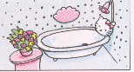
Sandy: Sanrio Puroland is a famous___________ in Japan. I visited Hello Kitty’s house there. Look at these photos.
May: What is this?
Sandy: This is Hello Kitty’s bathroom.
Everything there was so ______.
May: Oh, It’s Hello Kitty. She’s so beautiful.
Sandy: Yes, we were watching a _________there. The performers wore different _________.We were clapping our hands while they were __________across the park. It was the best part of the day.
May: That sounds great.
6. T or F questions
( ) 1. Sandy and her parents went on a trip at Sanrio
Puroland of Japan.
( ) 2. Sandy spent two days in Sanrio Puroland.
( ) 3.The sitting room of Hello kitty’s house looked so nice and cute.
( ) 4.Sandy’s mother bought some souvenirs for her cousin.
( ) 5.Sandy has bought a lovely handbag for Millie.
( ) 6.Mother bought sushi for Sandy at Sanrio Puroland for lunch.
( ) 7.When Hello Kitty jumped out of the gift box, all the people got excited.
( ) 8. Hello Kitty wore a shiny red dress and waved to people during the parade.
( ) 9.Sandy has taken lots of photos there.
( ) 10.Sandy’s family would have sushi and other Japanese food for breakfast.
7. Talk about the pictures
What did Sandy and her parents see and do at Sanrio Puroland.
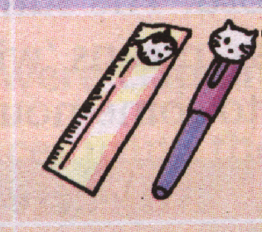

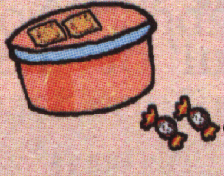
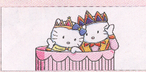


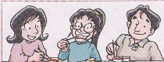
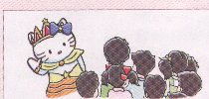

*After students practice talking about the pictures, they can identify more details of the letter.
8. Homework
a. Read the new words and Sandy’s letter after the tape for 15 minutes.
b. Try to retell the letter with the help of Sandy’s photos.
c. Look for more information about Sanrio Puroland on the Internet.

