海淀区高三年级第二学期期中练习
英 语 2008.4
本试卷分第Ⅰ卷(选择题)和第Ⅱ卷(非选择题)两部分。第Ⅰ卷l至10页，第Ⅱ卷11至12页。共150分。考试时间120分钟。
注意事项：
1.答试卷第Ⅰ卷时，每小题选出答案后，用2B铅笔把答题卡Ⅰ上对应题目的答案选中涂满涂黑，黑以盖住框内字母为准。如需改动，用橡皮擦除干净后再选涂其它答案项。在试卷上答题无效。
2.答试卷第Ⅱ卷时，必须用黑色字迹的签字笔按题号顺序答在答题卡Ⅱ的答题区域相应位置内，未在应的答题区域作答或超出答题区域作答均不得分。在试卷上答题无效。
第Ⅰ卷(选择题，共115分)
第一部分：听力理解(共两节，30分)
第一节(共5小题；每小题1.5分，共7.5分)
听下面5段对话。每段对话后有一道小题，从每题所给的A、B、C三个选项中选出最佳选项。听完每段对话后，你将有10秒钟的时间来回答有关小题和阅读下一小题。每段对话你将听一遍。
1. When will the man meet his uncle?
A. At 9:55. B. At 10:05. C. At 10:15.
2. What does the woman want to have?
A. Ice water. B. Coffee. C. Tea.
3. Who was injured in the accident?
A. No one. B. A baby. C. Three women.
4. What is the girl going to do during the weekend?
A. See a film. B. Make a plan. C. Prepare for a test.
5. Where are the speakers?
A. At a shop. B. At a bank. C. At a hotel.
第二节(共15小题；每小题1.5分，共22.5分)
听下面6段对话或独白。每段对话或独白后有几道小题，从每题所给的A、B、C三个选项中选出最佳选项。听每段对话或独白前，你将有5秒钟的时间阅读每小题。听完后，每小题将给出5秒钟的作答时间。每段对话或独白你将听两遍。
听第6段材料，回答第6至7题。
6. How many reasons does the girl give for taking up singing?
A. Two. B. Three. C. Four.
7. What do the girl’s parents want her to be?
A. A musician. B. A singer. C. An actress.
听第7段材料，回答第8至9题。
8. Why does the man make the telephone call?
A. To make an appointment. B. To ask for information. C. To get some advice.
9. What is the man advised to do in the end?
A. See the doctor at once. B. Wait for a few days. C. Put some ice on his injury.
听第8段材料，回答第10至12题。
10. What will the woman do on Friday evening?
A. Visit her doctor. B. Go to a concert. C. Have dinner with the man.
11. What is the relationship between the two speakers?
A. Close friends. B. Brother and sister. C. Doctor and patient.
12. When does the conversation take place?
A. On Tuesday. B. On Wednesday. C. On Thursday.
听第9段材料，回答第13至15题。
13. What does the girl think of her Spanish teacher?
A. Talkative. B. Annoying. C. Boring.
14. Why does the girl like her history class?
A. The teacher often rewards the students.
B. The history tests are always easy.
C. She finds history interesting.
15. What can we learn from the conversation?
A. The girl is unlikely to be allowed out.
B. The father is content with his daughter.
C. The girl didn’t receive her report card.
听第10段材料，回答第16至17题。
Study the map. Then, listen to the conversation and choose the right answers.
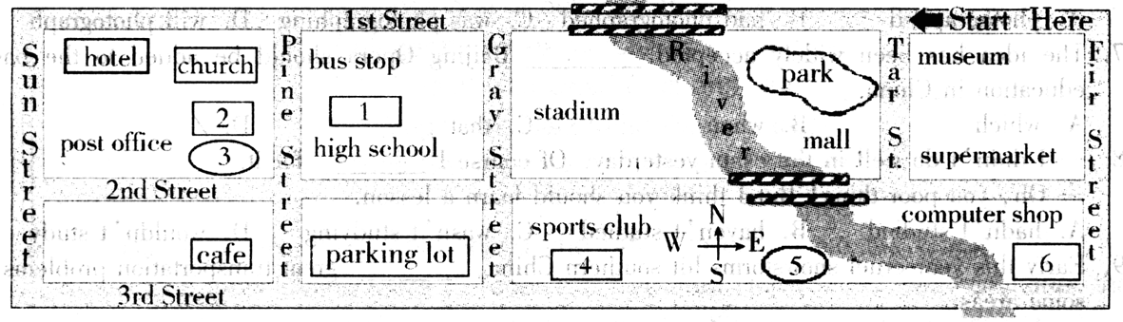
16. Where is the movie theater?
A. 1. B. 2. C. 3.
17. Where is the restaurant located?
A. 4. B. 5. C. 6.
听第11段材料，回答第18至20题。
18. What are the high temperatures for most of the state on Friday?
A. 85 to 90 degrees. B. 91 to 95 degrees. C. 96 to 99 degrees.
19. What is Saturday evening’s weather forecast for the state?
A. Light showers over the entire state.
B. Cold and windy over the state.
C. Some rain in parts of the state.
20. What can be done on Sunday evening?
A. Appreciating the moon.
B. Watching the star shower.
C. Collecting rocks and metals.
第二部分：知识运用（共两节，45分）
第一节 单项填空（共15小题；每小题1分，共15分）
从每题所给的A、B、C、D四个选项中，选出可以填入空白处的最佳选项。
例:It’s so nice to hear from her again._______, we last met more than thirty years ago.
A. What’s more B. That’s to say C. In other words D. Believe it or not
答案是D。
21. Although _______ badminton is my favorite sport, I am not _______ very good player.
A. the; a B. the; the C. /; a D. /; the
22. — You ran into Mr. Li! How did that happen?
— Well, _______ of us was looking where we were going. We came around the corner at the
same time.
A. neither B. either C. both D. none
23. — Kate is complaining again.
— She has a good job and plenty of money. What _______ does she want?
A. best B. better C. most D. more
24. One more week, _______ we will finish all the tasks completely.
A. but B. and C. so D. or
25. The man didn’t admit _______ anything at the store when he was questioned by the police.
A. to steal B. having stolen
C. to have stolen D. having been stealing
26. When she realized I _______ her, she quickly made a pose, smiling.
A. photographed B. had photographed C. was photographing D. will photograph
27. The idea has been widely accepted _______ Beijing Opera should be added to the basic
education in China.
A. which B. when C. that D. /
28. — I didn’t do well in the exam yesterday. Of course I _______ for it.
— Oh, you poor thing! But I think you should learn a lesson.
A. hadn’t studied B. haven’t studied C. wasn’t studying D. wouldn’t study
29. Early this year cruel snowstorms hit southern China, _______ great transportation problems in
some areas.
A. causing B. caused C. to cause D. having caused
30. There are a few spelling mistakes; _______, it’s quite a good essay.
A. all in all B. above all C. if so D. even so
31. — I am not going to play football this year, Mum.
— That’s music to my ears. I was so afraid you_______.
A. will be hurt B. would get hurt C. had got hurt D. were hurt
32. — It was a red light, William. You _______ the car.
— Sorry. I didn’t see it.
A. must stop B. should stop C. must have stopped D. should have stopped
33. Failure is never pleasurable, but it can make a positive contribution to your life ________ you
learn to use it.
A. since B. once C. until D. unless
34. — Where did you get to know the professor over there?
— It was at the workshop _______ we did research together two years ago.
A. that B. there C. which D. where
35. Most stores say that they daren’t _______ prices _______ for fear of losing their customers.
A. put; up B. set; up C. make; up D. turn; up
第二节 完形填空（共20小题；每小题1.5分，共30分）
阅读下面短文，掌握其大意，从每题所给的A、B、C、D四个选项中，选出最佳选项。
Learn to Meet Challenges
My classmates called me “the alien”, and they avoided me like the plague (瘟疫). As a young boy, I 36 from a serious skin disease, which filled my arms with scars. The true 37 of my condition, however, was social: I lived a life of loneliness.
Doctors predicted that I would never fully recover, but my parents encouraged me to hope for the future, teaching me that any difficulty could be overcome. I therefore took a/an 38 role in fighting against my disease, trying many medications and herbs, and my health 39 greatly before I graduated. I realized that my personal 40 had led to this improvement. I regained self-confidence and made many friends at school.
Years later, 41 my personal battle against disease, I learned a great deal about 42 by overcoming difficulties.
I joined the Culture Club as a Special Event Director. I 43 a group of six students in organizing various activities. I was the most advanced ESL student among the group, so I considered myself the most capable. But I quickly learned my 44 .While preparing for our firstpresentation, I was 45 with my team members and often rejected their 46 .I performed most of their tasks myself, allowing them to 47 me only with small details. As a result, the presentation was not very successful. The setback 48 me, and I spoke of it to the club’s director. She responded that she 49 my ability to succeed in the future. This comment filled me with 50 , for I realized that I had never trusted my own team members. 51 they were weak in English, they had many valuable talents. I immediately 52 my policy, allowing my team members to choose the tasks they desired and to complete them on their own. For our program, we had many meetings, which gave 53 to many good ideas. Most importantly, the atmosphere among us improved dramatically. We were 54 and eager to devote time to the program, and I learned what true leadership is.
My experiences 55 improved my ability to handle challenging situations.
36. A. judged B. suffered C. prevented D. separated
37. A. pain B. sign C. value D. meaning
38. A. important B. different C. leading D. active
39. A. developed B. improved C. increased D. removed
40. A. joy B. goal C. will D. life
41. A. over B. like C. for D. in
42. A. ability B. quality C. leadership D. friendship
43. A. taught B. found C. managed D. followed
44. A. mistake B. method C. effort D. right
45. A. satisfied B. familiar C. patient D. strict
46. A. desires B. talents C. ideas D. tasks
47. A. remind B. guide C. show D. help
48. A. discouraged B. disturbed C. encouraged D. educated
49. A. adopted B. admired C. trusted D. tested
50. A. surprise B. delight C. pride D. hope
51. A. As B. If C. Because D. Although
52. A. deleted B. changed C. regretted D. considered
53. A. birth B. hand C. gift D. rise
54. A. crazy B. happy C. successful D. independent
55. A. instantly B. indirectly C. unusually D. undoubtedly
第三部分：阅读理解（共20小题；每小题2分，共40分）
阅读下列短文，从每题所给的A、B、C、D四个选项中，选出最佳选项。

A
There were two things in the world that Ghagra Geeta Bali hated. The first was the way, Rani, the domestic help, combed her hair. The second was, you guessed it, her name. She hated her name so much that she prayed to god every night: Dear god, let me be born again. So I can have a name like Rita or Preeti. A short, smart one-word name.
On Tuesday, Ghagra Geeta Bali and her mother went for their usual shopping. There was a long queue of children just outside the record store. They went closer to look. It was yet another scheme to sell a few audio cassettes. Everyone who bought a cassette qualified for the scheme.
In this case, the artist whose songs were featured on the cassette was a young sensation called Malik Faridabadi, a great favorite with teenagers. Ghagra Geeta Bali was no exception.
A friendly young man was writing down the names of the people who wanted to participate in the scheme. Out of this long list Malik would pick one name, and the chosen one would get to meet him, plus of course, win many freebies (赠品).
But when her mother asked her to participate, Ghagra Geeta Bali said no. She didn’t want to, speak out her name in front of so many people and make herself the butt (笑料) of amusement. But mothers being mothers, she just went up to the man and told him in firm tones: “Please enter my daughter’s name. It is Ghagra Geeta Bali.”
“It is what?” the man asked, naturally a little taken aback.
“G-h-a-g-r-a G-e-e-t-a B-a-l-i. There she is,” she replied while pointing to her daughter. The crowd standing around also turned to stare. All Ghagra Geeta Bali wanted then was for the earth to open up and swallow her.
That did not happen. But the following week she received a call. It was from the recording company that had announced the scheme. And they told her that she was the chosen one.
“It is all because of your name,” said the public relations man who had called. “Mr Faridabadi took one look at it in the list and said that he couldn’t wait to meet the brave girl bearing it.”
56. Ghagra Geeta Bali didn’t like her name because_______.
A. it would bring her a lot of trouble
B. it was too long and not beautiful
C. it would make her angry
D. it was too ugly and dull
57. When the girl saw the crowd turn to stare at her, she felt_______.
A. scared B. shocked C. embarrassed D. disappointed
58. What is the message of the story?
A. Mother’s love makes all the difference.
B. Children should always trust their parents.
C. One should be brave to meet anything strange.
D. Something that one thinks is bad may turn out good.
B
Are you always busy?
Is your schedule hectic?
Do you sometimes forget to take time to eat?
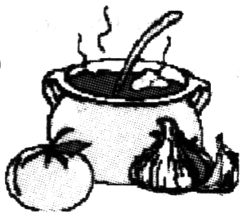
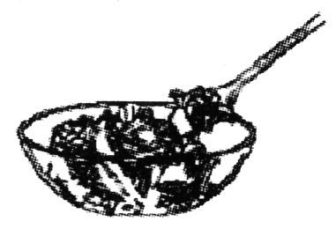
If you answered “yes” to any of these questions, then you need
QUICKEATS
HEALTHY EATING THAT FITS
YOUR DAILY ROUTINE.
Vacuum-sealed meals for people on the go!
Nutritious, Iow-sugar, Iow-fat, well-balanced meals in a convenient pocket!

They don’t spoil!
Are you in the mood for a hot meal? Or do you prefer a cold dish instead?
Hot or cold, Quickeats are delicious and the tempting taste will have you
believing you are eating a home-cooked meal. A variety of meals are already
available at leading grocery stores in your area.

Try our Red Hot Quickeats!
(Heat in a microwave for 3 minutes.)
Stew with Garden Vegetables
Barbecued Chicken and Rice
Creamy Ham and Noodles

Choose one of our Cool Blue Quickeats!
(Refrigerate for extra coldness, if desired. )
Yogurt with Dried Fruit and Nuts
Vegetable Salad and Pasta Salad
Tuna Salad and Whole Wheat Crackers
Quickeats are reasonably priced and ready to eat. Take the coupon (优惠券)
below to a participating store to receive a free Red Hot or Cool Blue container that
will fit neatly in your backpack, briefcase, or shoulder bag and keep your Quickeats
meal hot or cold until you’re ready to eat it. Each container holds up to 4 Quickeats.
If you have questions or suggestions, please contact our national office:
Neavest Inc. , P. O. Box 90210, Lexinet, VA
or call 1-888-293-3151
√One Free container for Quickeats with the purchase of one Quickeats meal.

59. This advertisement is designed especially for those who________.
A. like eating in restaurants B. have little time
C. prefer home-cooked meals D. want to save money
60. What information CAN’T we get from the advertisement about Quickeats?
A. Different kinds. B. High quality. C. Exact prices. D. Good taste.
61. Which of the following can be cooled in a refrigerator before eating according to the ads?
A. Pasta Salad. B. Dried Fruit. C. Noodles. D. Nuts.
62. What can we learn from the advertisement?
A. Get one Quickeats container and you’ll have four Quickeats to eat.
B. Take one coupon and you can eat freely in a participating store.
C. Buy one coupon and you’ll get a free Quickeats.
D. Buy one Quickeats and you’ll get a container.
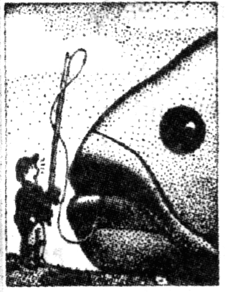
C
Can you imagine a catfish bigger than a boy? There are more than 1,000 kinds of catfish; 28 species are found in the United States’ lakes and rivers. This huge family has some mighty strange members. Let’s meet a few.
Walking catfish. Nature’s feisty little catfish, found in southern Florida, has an extra lung for breathing on dry land. When its swimming hole dries up, the walking catfish waddles on stiff forward fins in search of another lake or stream. If an enemy attacks, the fish flares (展开) its top and front fins and leaps at the attacker to scare it off.
Armored catfish. This catfish has heavy, bony plates protecting its body. The shell makes the fish difficult to bone. To cook it, throw the fish whole into a fire. When it is done, break it open for eating. Some armored catfish are found in Florida, but the 100-pounders live in South America.
Rounding out the family of strange catfish are talking catfish, which make growing sound when you pull them from the water; climbing catfish, which move quickly up shore brush in search of food; electric catfish, which can deliver a mild shock; and blind catfish, which settle in the inky blackness of underwater caves. Blind catfish find food through taste buds in their eight whiskers (须).
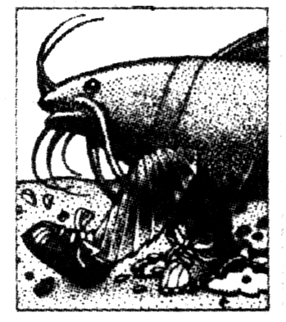
Most catfish have four whiskers on the upper jaw and four on the lower jaw. Sensory holes on these whiskers help the fish smell and taste food even in the muddiest of water. The United States does not have catfish anywhere near the size of those in South America. But in some large U.S. rivers, blue and flathead catties do top 100 pounds.
Most of the catfish you are likely to catch will be much smaller, about frying pan size. When you catch one, remember that the top fin and the forward fins have poison glands (腺) at their bases. They can give you painful wounds. (...)
63. The purpose of the passage is to ______.
A. encourage readers to go fishing for catfish
B. inform readers of the world’s largest catfish
C. describe the unusual characteristics of catfish
D. explain different ways to catch a variety of catfish
64. The author talks about the way of cooking an armored catfish to show that______.
A. it has heavy and bony plates
B. it’s hard to cook and eat
C. it has too many bones
D. it’ s poisonous inside
65. Which is NOT mentioned about catfish in the passage?
A. Its eating habits. B. Its living conditions. C. Its whiskers. D. Its size.
66. What may be continued in the last paragraph?
A. The author’ s love for catfish.
B. Where else to catch a catfish.
C. The origin of the name “catfish”.
D. The safest way to handle catfish.
D
l 1-year-old Courtney Thompson was so passionate about gymnastics that she would practice five hours a day until her arms were sore and her elbows swollen. She rarely complained about her tough schedule, and for good reason. Courtney was ranked the best gymnast in the state for her age, and she dreamed of going to the Olympics. But on January 12th, 2005, while practicing a routine exercise, she felt an unbearable pain in the left elbow. The medical examination then revealed a severe injury, resulting in an immediate surgery, and a slow, painful recovery.
What happened to Courtney Thompson is a red flag in America’s growing epidemic of youth sports injuries. Across the country, younger and younger athletes are injuring themselves in the pursuit of sports achievement. The U.S. Consumer Product Safety Commission reports that 2.8 million Americans aged 5 through 24 received medical treatment for a sports-related or recreation-related injury in 2003. Severe injuries that used to be limited to professionals are now showing up in high school and even junior high athletes.
There are many reasons behind the outbreak in sports injuries, but most experts agree on one: the extreme culture of organized youth sports. Gone are the days when children played a variety of games on playgrounds. Child kidnapping and street crime have ended casual neighborhood athletics in many places, leading parents to enroll their children in organized sports under the watchful, though demanding, eyes of adult volunteers and coaches. And movies like Friday Night Lights glorify the thrill of victory for young athletes with single-minded dedication to athletic achievement.
From high school gyms to county ball fields, 41 million children younger than 19 participated in organized youth sports in 2005, according to the latest research by the National Council of Youth Sports. The figure represents a 25 percent increase since 1997.
第Ⅱ卷(共35分)
第四部分：书面表达(共两节，35分)
第一节 情景作文(20分)
目前，家长开车接送孩子上下学已成为一个普遍现象，人们对此做法褒贬不一。下面是就此现象所做的问卷调查结果。
请根据下列图表提示，描述被访者的看法。
注意:1.词数不少于60。
2.文章的开头已经给出。
3.可以适当增加细节，以使行文连贯。
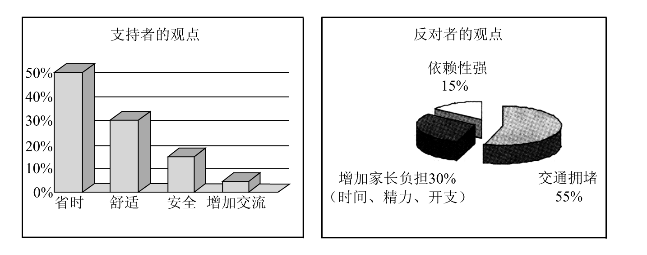
Nowadays it’s a common phenomenon that parents drive their children to school and back home, which causes a heated discussion. A survey has just been conducted about it, and the findings are as follows.
________________________________________________________________________________________________________________________________________________________________________________________
____________________________________________________________________________________________
- 开放作文（15分）
请根据下面提示，写一篇短文。词数不少于50。
In your English class, you are asked to describe the following picture and explain to your classmates how you understand it.
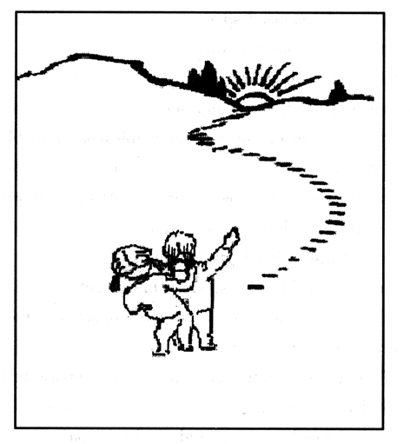
________________________________________________________________________________________________________________________________________________________________________________________
____________________________________________________________________________________________
Parental involvement in youth sports has also made childhood games less about having fun and more about training and competing for the top spot, landing a college scholarship or launching a promising career. Hoping to nurture the next Michelle Kwan or Apolo Ohno, some parents guide their children into specializing in one sport. But the repetitive training required to master a sport places enormous stresses on bones and muscles that are still developing.
67. The passage is mainly about_______.
A. children's participation in organized sports
B. the main causes of the youth sports injuries
C. the way to train children in organized sports
D. the common occurrence of youth sports injuries
68. The underlined part “red flag” in the second paragraph most probably means“_______”.
A. warning B. problem C. symbol D. mark
69. Why is the number of sports injuries among children in America growing?
A. Because of their increasing fondness for sports.
B. Because children are not professional enough for sports.
C. Because more children are seeking for sports achievements.
D. Because of the involvement of the parents and more organized sports.
70. We can learn from the passage that_______.
A. about 10.25 million youngsters participated in organized sports in 1997
B. parents give limited chances for children to choose their sports
C. serious injuries often happened to young students in the past
D. Courtney Thompson will never become a famous gymnast
E
Many children first learn the value of money by receiving an allowance (pocket money). The purpose is to let children learn from experiences at an age when financial mistakes are not very costly.
The amount of money that parents give to their children to spend as they wish differs from family to family. Timing is another consideration. Some children get a weekly allowance. Others get a monthly allowance.
In any case, parents should make clear what, if anything, the child is expected to pay for with the money. At first, young children may spend all of their allowance soon after they receive it. If they do this, they will learn the hard way that spending must be done within a budget. Parents are usually advised not to offer more money until the next allowance.
The object is to show young people that a budget demands a choice between spending and saving. Older children may be responsible enough to save money for larger costs, like clothing or electronics. Many people who have written on the subject of allowances say it is not a good idea to pay your child for work around the home. These jobs are a normal part of family life.
Paying children to do extra work around the house, however, can be useful. It can even provide an understanding of how a business works.
Allowances give children a chance to experience the three things they can do with money. They can share it in the form of gifts or giving to a good cause. They can spend it by buying things they want. Or they can save it.
Saving helps children understand that costly goals require sacrifice. You have to cut costs and plan for the future. Requiring children to save part of their allowances can also open the door to future saving and investing. Many banks offer services to help children and teenagers learn about personal finance.
A savings account is an excellent way to learn about the power of compound interest.
Compounding works by paying interest on interest. So, for example, one dollar invested at two percent interest for two years will earn two cents in the first year. The second year, the money will earn two percent of one dollar and two cents, and so on. That may not seem like a lot. But over time it adds up.
71. Giving an allowance, parents should consider all the following EXCEPT_______.
A. how much the child should get each time
B. whether the child has made a budget
C. where the money really goes
D. how often a child can get it
72. According to the passage, how can a child learn to have a budget?
A. Through their own experiences.
B. Through parents’ instruction.
C. By spending allowance.
D. By receiving allowance.
73. The author of the passage holds the opinion that_______.
A. what children learn by handling allowances may be beneficial in the future
B. children can learn to set up their own business with their allowances
C. keeping allowances in the bank is the best choice for children
D. it is not a good idea to pay children to do housework at home
74. The underlined words “compound interest” in the passage probably means_______.
A. increasing curiosity to learn how to make more money
B. stronger power to hold one’s attention to saving money
C. money paid by the bank on your original money and the gain from it
D. the sum of money that you earn from keeping your money in the bank
75. What is the best title for the passage?
A. Be Generous To Pay Your Children
B. Be Wise To Avoid Financial Mistakes
C. Saving Allowances Does Good To Children
D. Allowances Help Children Learn About Money

