练习：书面表达 命题人：张亚贤 命题单位：常州市小河中学
- 根据下图，请以“Three Ways of Communication”为题，写一篇100字左右的作文。请写出每一种方法的好处。

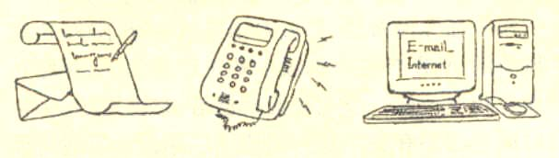

答案： Three Ways of Communication
Communication has been playing an important part in people’s life. There are many ways of communication. Of them all, mail, telephone and computer are most commonly used.
Writing letters is one of them. People use written words to exchange information, ideas and thoughts. Although slow, mail is the cheapest means of communication. The second type is telephone. With telephone, people use sound to communication and they can hear each other even if they are far apart. With computer is fast and easy. By means of computer, people send e-mail to each other.
In a word, mail, telephone and computer help to bring people all over the world closer.

- 请根据下列图画，以“The Way to Keep Healthy”为题，用英语写一篇短文。
注意： 1.短文必须包括所以图画的内容，可以适当增加细节，使内容连贯。
2.词数120左右。

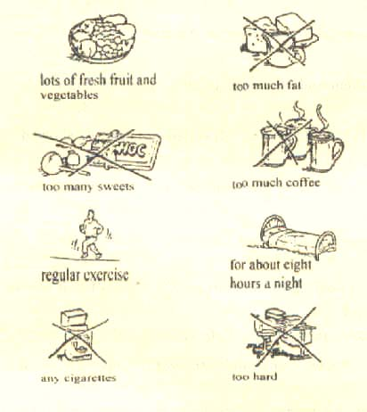
答案： The Way to Keep Healthy
It’s very important for us to keep healthy in our everyday life. Here is some advice for you to follow.
First you should have a healthy diet. It’s necessary to eat enough fresh fruit and vegetables, because they contain all kinds of vitamin that you need every day. But do not eat too much fat, such as cheese, butter or anything too fatty. Too many sweets can do harm to your teeth. So you had better not eat too many sweets or chocolates and keep off coffee.
Good habits can help you keep fit. Doing regular exercise is certainly a good way to ensure your body healthy. After a day’s work, an eight-hour sleep is needed. And avoid working or studying too hard. Remember smoking can damage your health, so never smoke.

书面表达： 命题人：查君蕾 命题单位：武进横林中学

A

请你根据以下提示（但不必拘泥于此），写一篇短文，谈一谈你对高中生假期打工的看法。
利 | 弊
可以挣钱补贴自己的费用 | 会分散精力，影响学习
可以学到书本以外的知识 | 对所挣的钱使用不当会导致坏习惯
可以丰富生活阅历，了解劳动价值 | 会培养拜金思想
…… | ……
注意：短文应包含所有的内容；可以适当增加细节，使短文连贯；词数100 左右。

B
假定你是某中学学生李华。最近，你班同学正在参加21世纪英文报的一个讨论。本次话题为：父母的收入有没有必要让孩子知道？请你给报社写一封信，说明你的观点和理由。
注意：1、信的开头已经为你写好
2、词数100左右

Dear editor,
I’m writing to tell you about my opinion on whether children should know their parents’ income..

答案：

A
More and more students are doing part-time jobs today. There are many advantages in students doing part-time jobs. Besides earning some money to support themselves, they can learn a lot to which cannot be learned from textbooks. They will learn to get along with different kinds of people, get useful working experiences and learn the value of labor.
However, there are also some disadvantages. For example, too much work may cut into students’ study time when they should get the best out of their school life and lay a good foundation of knowledge for their future work. Another disadvantage is that money earned, if not properly used, may lead to some bad habits, or even greed.
Good or bad, it is not easy for students to get part-time jobs in China now. to change the situation, the society should develop a fresh look at students doing part-time jobs and provide them with opportunities in applying what they learn in the classroom to the real life situation of our society.

B

Suggested Answer 1
Dear editor,
I’m writing to tell you about my opinion on whether children should know their parents’ income.
In my view, I think children should know their parents’ income since it will help them understand how hard their parents have to work to support their family or to be successful, no matter how much they earn. Thus they’ll study harder and won’t waste money any more buying or doing anything that their parents can’t afford. So it helps to increase their sense of thriftiness. What’s more, they’ll also learn to make the best use of the money they have. Besides, knowing their parents’ income improves their sense of responsibilities for their family. They’ll learn to share their parents’ trouble by doing whatever they can to help with the housework and so on. And all these, I think, are of great importance and help to our future life.
Yours sincerely
Li Hua

Suggested Answer 2
Dear editor,
I’m writing to tell you about my opinion on whether children should know their parents’ income.
In my view, I think it unnecessary for the children to know their parents’ income. If they know their parents earn enough to support their family, they may not study hard since they think they needn’t worry about their future. It is said especially that when their parents have a relatively high income, most children easily form a wasteful habit. On the other hand, if the children know that their parents cannot earn enough for the family and the children’s education, the chances are that they’ll worry a lot about their family, which will surely have a very bad effect on their study at school, since this makes it impossible for them to focus on their study. What’s worse, always having to worry about their future may be too much for the children still studying at school and it may do great harm to the children’s character.
Yours sincerely
Li Hua

[注] 本文为开放性作文，允许学生自由发挥，答案仅供参考。

供稿人 青龙中学 陈兵花
某英文报“读者来信”专栏正在就高三学生家长是否应该为孩子购置电脑这一话题开展讨
论。有赞同的，也有反对的。请你向该报编辑写一封英文信，发表你的观点。
注意：
1、下面的提示可能会帮助你构思：
more information
improve English
learning software (学习软件)
enjoy oneself…

computer games
short-sighted
waste of money
fail the exams…
- 不必根据上面的提示逐条写作，可合理地自由发挥。
- 词数100左右

参考答案：
Dear editor,
With the development of technology, computers are being used more and more in our daily life.
Perhaps, you think one should buy a computer to help study. Because computers are helpful in our English learning and also there are piles of learning software we can use.
I’m a student of Senior Three. I don’t think we should buy a computer. As I know, those who have computers in my class are spending too much time on computer games. If we don’t put our hearts into our study, we might fail the college entrance examinations. Besides, if we get a computer and don’t make full use of it, it’s just a waste of money. So I insist we not buy a computer now. Don’t you agree?

A reader (129 words)

