端午节和复活节
端午节和复活节的来历
Dragon Boat Festival is on the fifth day of the fifth lunar month. It's about Qu Yuan, a minister during the Warring States Period. He loved his country so much, that after hearing that his country had been defeated, he fell into despair and threw himself into the Miluo River.

According to Western religion, three days after he was killed, he came back to life and rose from the dead. People commemorate this at a festival called Easter. The egg symbolizes his new life.
主编：周闿岑
指导老师：周红梅
复活节是最古老最有意义的基督教节日之一。它庆祝的是基督的复活，世界各地的基督徒每年都要举行庆祝。复活节还象征重生和希望。时间是春分月圆后的第一个星期日。
复活节是基督教纪念耶稣复活的节日。传说耶稣被钉死在十字架上，死后第三天复活升天。每年在教堂庆祝的复活节指的是春分月圆后的第一个星期日，如果月圆那天刚好是星期天，复活节则推迟一星期。因而复活节可能在3月22日至4月25日之间的任何一天。
端午节是古老的传统节日，始于中国的春秋战国时期，至今已有2000多年历史。源于纪念屈原，传说屈原死后，楚国百姓哀痛异常，纷纷涌到汨罗江边去凭吊屈原。渔夫们划起船只，在江上来回打捞他的真身。有位渔夫拿出为屈原准备的饭团、鸡蛋等食物，“扑通、扑通”地丢进江里，说是让鱼龙虾蟹吃饱了，就不会去咬屈大夫的身体了。人们见后纷纷仿效。一位老医师则拿来一坛雄黄酒倒进江里，说是要药晕蛟龙水兽，以免伤害屈大夫。后来为怕饭团为蛟龙所食，人们想出用楝树叶包饭，外缠彩丝，发展成棕子。

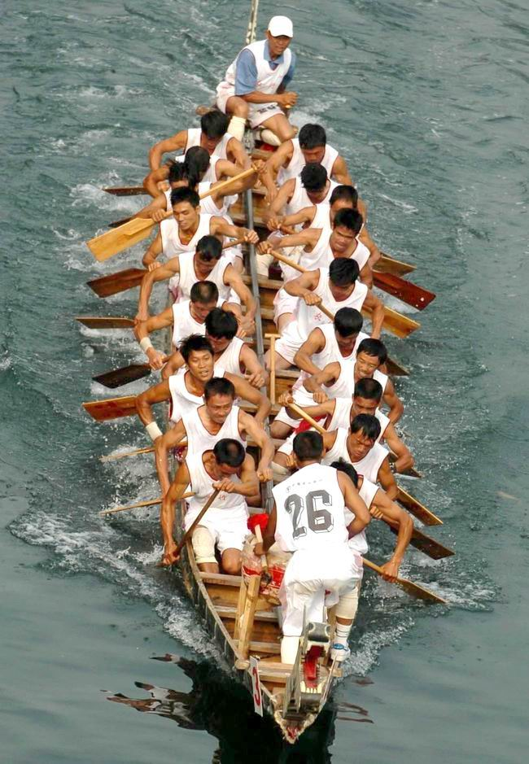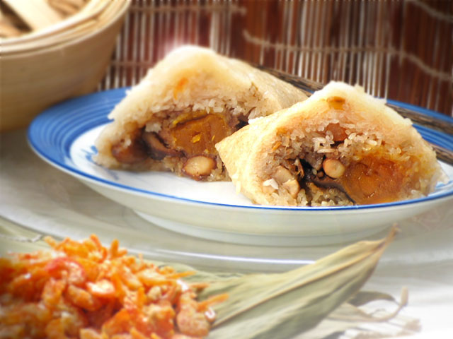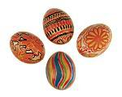
As Qu Yuan was loved so much by the people, fishermen rushed out in long boats, beating drums to scare the fish away, and throwing zong zi into the water to feed braver fish so that they would not eat Qu Yuan's body. Starting from that time to this day, people commemorate Qu Yuan by holding Dragon Boat Races and by eating zong zi.

