2004年英语中考模拟试题
第Ⅰ卷
- 听力（共24小题；每小题1分，满分24分）
A) 根据你所听到的句子选出相应的答语。每句读一遍。
1. A. No news is good news. B. I’m pleased to hear that. C. I’m glad to help you.
2. A. It’s a pleasure. B. That’s right. C. That’s OK.
3. A. You can go there by bus. B. It’s not far from here. C. Go down this road.
4. A. In London. B. In Beijing. C. In New York.
B) 听下面10段对话。每段对话后有1个小题，从题中所给的A、B、C三个选项中选出最佳选项。每段对话读一遍。听完每段对话后，你都有10秒钟时间回答有关小题和阅读下一个小题。
5. What is the man going to do?
- Turn on the radio. B. Turn off the radio. C. Turn up the radio.
6. What does the man mean?
- She didn’t listen to him carefully.
- She listened to him carefully enough.
- She won’t listen to him.
7. What day is tomorrow?
A. Tuesday. B. Wednesday. C. Thursday.
8. When did the man arrive?
A. At 6:35. B. At 5:55. C. At 5:45.
9. How is their English?
- They both know much about it.
- Neither of them knows much about it.
- Either of them knows much about it.
10. How much is around-trip ticket?
A. 1000 yuan. B. 1500 yuan. C. 2000 yuan.
11. Which place did the girl win?
A. First. B. Second. C. Third.
12. What would the man like to drink?
A. A cup of tea. B. A cup of coffee. C. A glass of water.
13. How much is the woman’s dictionary?
A. 30 yuan. B. 20 yuan. C. 10 yuan.
14. How many times has the man been to China?
A. Once. B. Twice. C. Three times.
C) 听下面三段对话或独白。每段对话或独白后有几个小题，从题中所给的A、B、C三个选项中选出最佳选项。每段对话或独白读两遍。听每段对话或独白前你将有时间阅读各小题，每小题5秒钟；听完后，各小题将给出5秒钟的答题时间。
听第1段材料，回答第15—17题。
15. When did Mary move into a new house?
A. Not long ago. B. Last Friday. C. Many days ago.
16. How will Tom and Alice get to their friend’s home?
A. By bike. B. By car. C. On foot.
17. What time will the party start?
A. At 7:10. B. At 10:07. C. At 6:50.
听第二段材料，回答第18—20题。
18. How long has the man had the computer?
A. Two days. B. One day. C. Two weeks.
19. Where did the dialogue happen?
A. In a shop. B. At a factory. C. In a school.
20. How soon can the computer be repaired?
A. At least a week. B. At least a month. C. At least three weeks.
听第三段材料，回答第21—24题。
21. Who are often killed while crossing the road?
A. Only old people. B. Only children. C. Old people and children.
22. A car can’t stop quickly if it is going too fast, can it?
A. Yes, it can. B. No, it can’t. C. Yes, it can’t.
23. What is the only safe way to cross the road?
A. To look right. B. To look left. C. To look right and left.
24. What can we do if the traffic lights are red?
A. To run. B. To walk quickly. C. To wait.
- 单项选择（共16小题；每小题1分，满分16分）
从ABCD四个选项中，选出可以填入空白处的最佳答案。
25. —You forgot to close the door.
—Oh, ________. I’ll go and do it.
A. so did I B. so I did C. nor did I D. neither did I
26. —Call me as soon as you get there.
—_____________.
A. I must B. I should C. I can D. I will.
27. —He’s never stolen anything before, _____ he?
—_______. It’s his second time to be taken to the police station.
A. hasn’t; Yes B. has; Yes C. has; No D. is; No
28. —My English is _______.
—Don’t worry. I’ll do all I can _____ you.
A. poor; help B. well; to help C. poor; to help D. bad; help
29. —What do you think of his talk?
—He ______ much but I _______ nothing.
A. spoke; listened B. said; listened to C. said; heard D. talked; hear
30. —Have you _____ to Hawaii before?
—Yes. It is better than any other _____ in Australia.
A. gone; beach B. been; beaches C. gone; beaches D. been; beach
31. —Is the maths problem difficult?
—Yes. _____ few students worked __________.
A. Only; out it B. Too; out it. C. Very; it out D. Quite a; it out
32. What ___________ it is to go surfing in ______ weather!
A. a great fun; so fine B. a great fun; such a fine
C. great fun; so fine a D. great fun; such fine
33. —Did you go to Li Lei’s birthday party?
—No, I ____________.
A. am not invited B. don’t invite him C. wasn’t invited D. haven’t invited
34. We’re told _________ waste paper everywhere. It’s our duty ______ our school clean and tidy.
A. not throw; keep B. not to throw; to keep
C. to not throw; to keep D. not to throw; to keep
35. —Can I come this evening or tomorrow morning?
—_____ is OK. I’m free today and tomorrow.
A. Either B. Neither C. Both D. None.
36. —Nice to see you. I _________ you for a long time.
—I ______ in Beijing. I’ve just come back.
A. hadn’t seen; am B. haven’t seen; was
C. didn’t see; will be D. haven’t seen; shall be
37. The cars made in Japan are much cheaper than _____ made in America.
A. ones B. those C. that D. it
38. Every morning, we are asked _______ taken our temperatures.
A. if we have B. if have we C. if we had D. if had we
39. —It’s a nice car. ______ have you been in it?
—Just to Shanghai.
A. How much B. How long C. How soon D. How far
40. —Excuse me. Do you have a table for two?
—I’m sorry, _____ there aren’t any seats now. Would you mind waiting for a while?
—_______.
A. but; Of course B. and; Sure C. but; Certainly not D. so; Certainly
- 完型填空（共10小题；每小题1分，满分10分）
阅读下面短文，掌握其大意，然后从41—50各题所给的四个选项中，选出一个最佳答案。
There was a woman in Detroit, who had two sons. She was worried about them, especially the younger one, Ben, because he was not doing well in school. Boys in his class made jokes about him because he seemed so __41__.
The mother ___42___ that she would herself have to get her sons to do better in school. She told them to go to the Detroit Public Library to read a book a week and do a book report for her.
One day, in Ben’s ___43___, the teacher held up a rock (岩石) and asked if anyone knew it. Ben put up his hand and the teacher let him ___44___. “Why did Ben put up his hand?” his classmates wondered. “He ___45___ said anything. What could he possibly want to say?”
Well, Ben not only ___46___ the rock, but also said a lot about it. He named other rocks in its group and even knew ___47___ the teacher had found it. The teacher and the students were ___48___. Ben had learned all this from doing one of his book ___49___.
Ben later went on to the ___50___ of his class. When he finished high school, he went to Yale University and at last became one of the best doctors in the United States.
41. A. clever B. hard C. slow D. quick
42. A. seemed B. decided C. wondered D. told
43. A. class B. room C. office D. lab
44. A. think B. leave C. ask D. answer
45. A. always B. ever C. quickly D. never
46. A. found B. played C. knew D. heard
47. A. whether B. what C. where D. why
48. A. afraid B. surprised C. worried D. unhappy
49. A. pictures B. exercises C. shops D. reports
50. A. top B. end C. back D. front
- 阅读理解（共10小题；每小题2分，满分20分）
阅读下面短文，然后从51—60各题所给的四个选项中，选出一个最佳答案。
A
Don’t circle your plate with your arms. If you do so, you will become the focus (焦点) of the table. Everyone would wonder, “Is there anything wrong with the food?” This may give a wrong message that you don’t like the food or something like that.
Don’t push the plate back when finished. Leave it where it was. Do you want to let the hostess (女主人)know that you’ve just done a labour?
Don’t lean (倚靠) back and say “I’m through” or “I’m full”. Just put the fork and knife across the plate. That’s all.
Don’t cut up everything before you start to eat. Cut only one or two bites (块) at a time.
Never take a huge mouthful of anything. Do you want to show how hungry you are? Don’t do that. It’s not so good.
It’s never good to reach across the table for anything. If the thing you want is not at hand, simply ask the nearest person for help, like “Mrs. Smith, could you pass me the dish?”
51. If you are at table and circle your plate with your arms, other people will think _________.
A. you don’t like the food B. the food isn’t good for you
C. there is something wrong with the food D. all above
52. After finishing dinner, you should _____________.
- put the fork and knife across the plate
- stand up and leave the table
- say “I’m full”
- say “Thank you”
53. If you want a dish far from you at table, you should ______________.
- stand up and reach across the table for it
- leave your seat to get it
- sit there until others help you
- ask the nearest person for help
B
Coffee has been a part of people’s lives for thousands of years, and today it is still one of the most favourite drinks in the world. Many people in the world begin their busy day by drinking a cup or several cups of coffee. They have always said that a cup of coffee in the morning helps them begin their day in the right way. So they say a cup of coffee is necessary for them in the morning.
Do you know what in the coffee makes our bodies and brains (脑) active? It is caffeine.
Caffeine may increase a person’s mental and physical abilities (精力和体能). For example, two cups of coffee will make you breathe faster and augment body heat (热量). All this makes your heart beat faster, and doctors warn that this may be a little dangerous.
Caffeine is found in tea, coffee, chocolate and some other foods. A little caffeine is probably not harmful, but too much caffeine can make people nervous and sleepless.
54. A good title(题目) for this passage is ___________.
A. Coffee Is Harmful B. Coffee and Tea
C. Caffeine and Health D. Caffeine Is Useful
55. The word “aument” means _________.
A. increase B. drink C. stop D. make less
56. From this passage, we may know that drinking a cup of coffee late at night might __________.
A. give you a headache B. make you fall asleep
C. keep you awake D. be dangerous
C
We all enjoy the beautiful show of colours as leaves change each autumn. But did you ever wonder how and why this happens?
Leaves are nature’s food factories. Plants take water from the ground through their roots (根) and take carbon dioxide (二氧化碳) from the air. Plants use sunlight to turn water and carbon dioxide into glucose (葡萄糖). Glucose is a kind of sugar, which plants use as food for energy (能量) and growing.
The way plants turn water and carbon dioxide into sugar is called photosynthesis (光合作用).
A chemical called chlorophyll (叶绿素) helps photosynthesis. It gives plants their green colour. As summer ends and autumn comes, the days get shorter and shorter, and trees “know” to begin getting ready for winter.
During winter, there is not enough light or water for photosynthesis. Trees rest during this time and live on the food they store during the summer. They begin to shut down their food-making factories.
As the green chlorophyll disappears (消失) from the leaves, we begin to see yellow and orange leaves. Small amounts (少量) of these colours have been in the leaves all along. We just can’t see them in the summer, because they are covered up by the green chlorophyll.
The bright reds and purples (紫色) we see in leaves are made mostly in autumn.
In some trees, like maples (枫树), glucose is caught in the leaves after photosynthesis stops. Sunlight and the cool nights of autumn turn this glucose into a red colour. The brown colour of trees like oaks (橡树) is made from waste left in the leaves.
It is the mixture (混合物) of all these things that makes the beautiful colours we enjoy during autumn.
57. The leaves of the trees in autumn turn yellow because of the short of ____________.
A. water and carbon dioxide B. glucose and energy
C. sunlight and water D. sunlight and carbon dioxide
58. Photosynthesis is a way that ___________________________.
A. plants change water and carbon dioxide into sugar
B. plants turn water and carbon dioxide into sugar with the help of sunlight
C. plants use glucose as food for energy and growing
D. chlorophyll is a great help
59. Which of the following is NOT true?
- When autumn and winter come, the days get shorter and shorter.
- During winter trees rest and live on the food they store during the summer.
- During winter small amounts of yellow and orange colours are kept in the leaves all the time.
- Trees begin to stop making food in summer.
60. This passage tells us __________________.
- all the plants can grow well with the strong sunlight
- there are all kinds of plants on the earth
- all the colours of the leaves aren’t made from chlorophyll
- maples and oaks have the same reason as other trees for the change of colours
第Ⅱ卷
五、单词拼写（共10小题；每小题1分，满分10）
  - 根据句子意思，用括号中所给词的正确形式填空，每空格填一词。
61. Someday you’ll find a foreign language a bridge to a lot of __________ (know).
62. There are over 5,000 ________ (live) languages in the world.
63. The mother didn’t know why her daughter was crying _________ (noise).
64. Things in Iraq (伊拉克) seemed to be going from bad to ________ (bad).
65. The Spring Festival is the most important holiday in _________ (east) countries.
  - 根据句意及汉语提示，在下列各句空缺处写出各单词的正确形式，每空格填一词。
66. Let’s go ________ (冲浪), shall we?
67. Are you ________(激动) about going to high school?
68. Thank you for _________(借) me your dictionary.
69. It was surprising that the boys’ team was _______ (打败) by the girls’.
70. Could you cut the pear into two ________(半)?
六、短文填空（共10小题；每小题1分，满分10分）
根据短文内容及所给首字母填写所缺单词，每空格填一词。把答案写在下面的横线上。
More and more middle school students in Beijing are getting shorter sleeping time.
Most students sleep f___71___ than nine hours every night, because they have m___72__ homework to do. Some homework is g__73___ by school teachers, and some by p___74___. Also, some students don’t know how to s__75___ the time. They are not careful enough while d___76___ their homework, so it takes them a lot of time. Some students have to get up early every morning on w____77____ to get to school on time by bus or bike. It can be a long way from home to school.
Schools and parents should c___78___ down some of the homework so that the children can e__79___ not less than nine hours of sleep every night for their h___80___.
七、根据所给中文完成句子翻译（共8小题；每小题1分，满分8分）
81．入世后，中国的发展开始与世界同步。
The development of China and the world started ______________________ after China joined the WTO.
82．老师要求我们按时交作业。
We are _______________________________ by the teacher.
83．学英语最好的方法是尽可能地多说。
The best way to learn English is ______________________________________.
84．据说比尔·盖茨是世界上最富有的人。
Bill Gates is _________________________ in the world.
85．无论他说什么，我都不相信他。
No _____________________, I don’t believe him.
86．你查出是谁干的吗？
____________________________ who did it?
87．中国是一个历史悠久、人口众多的国家。
China is a country ______________________________.
88．新中国是1994年10月1日成立的。
New China was ________________________________.
八．书面表达（共1小题；满分12分）
要求：（1）根据图示写一则日记，描述五月一号，星期六，天气晴， 你与同学在踢足球时，你突然跌倒及以后所发生的情况。
（2）语句通顺，时态正确。词数：60—80。格式已写好。
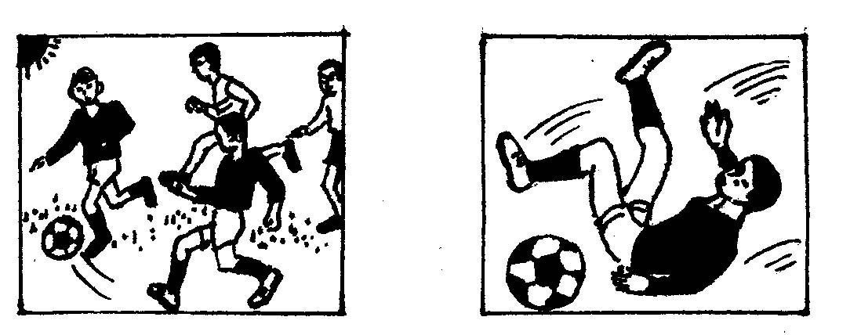

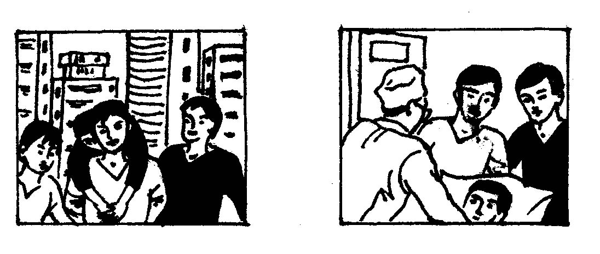

May 1 Saturday Fine
It was Saturday afternoon. ___________________________________________________________________________________________________________________________________________________________________________________________________________________________________________________________________________________________________________________________________________________________________________________________________________

听力内容及参考答案
听力内容
A) 根据你所听到的句子选出相应的答语。每句读一遍。
1. I haven’t heard from her for a long time.
2. I’m sorry I have lost your book.
3. Which is the way to No. 1 Middle School?
4.Where will the Olympic Games be held in 2008?
B) 听下面11段对话。每段对话后有1个小题，从题中所给的A、B、C三个选项中选出最佳选项。每段对话读一遍。听完每段对话后，你都有10秒钟时间回答有关小题和阅读下一个小题。
5. W: The music is too loud. I can’t hear what you said.
M: Sorry, madam.
6. W: You speak too fast for me to catch your words.
M: But you must listen to me carefully.
7. W: What day is tomorrow?
M: Yesterday was Tuesday.
W: Thank you.
8. W: When does the film begin?
M: At a quarter to six. But when I got to the cinema, it had already been on for ten minutes.
9. W: Do you know much about English?
M: No, I don’t. What about you?
W: I don’t, either.
10. W: What’s the price of the flight ticket?
M: 1000 yuan one-way.
11. W: I was in the 100-metre race.
M: Did you win?
W: No, Lucy and Lily ran faster than me.
12. W: Would you like a glass of milk or a cup of tea?
M: Either.
W: Here you are.
13. W: How much is your dictionary?
M: It’s twenty yuan.
W: Mine is much cheaper than yours.
14. W: Is this your first visit to China?
M: No, I came here in 1980 and 1990.
C) 听下面三段对话或独白。每段对话或独白后有几个小题，从题中所给的、、、三个选项中选出最佳选项。每段对话或独白读两遍。听每段对话或独白前你将有时间阅读各小题，每小题5秒钟；听完后，各小题将给出5秒钟的答题时间。
听第1段材料，回答第15—17题。
W: Could I speak to Tom, please?
M: Speaking. Who’s that?
W: Hi, Tom. This is Mary. I have just moved into a new house. It’s in Rose Garden. I’m having a party this Friday evening. Could you come?
M: I’d love to. Congratulations!
W: Thanks. Please drive Alice to my home together.
M: No problem. When will it start?
W: Ten to seven.
M: OK. We’ll arrive there on time..
W: See you then.
M: See you.
听第二段材料，回答第18—20题。
W: Good afternoon. Can I help you?
M: Yes, please. I bought this computer the day before yesterday, but there is something wrong with it. Last night it just couldn’t work. I can’t use it now.
W: Let me see. It seems as if it hasn’t been used in the right way. Maybe I have to send it back to the factory and have it repaired.
M: OK. How long do I have to wait before I can get it back?
W: At least one month, I think.
听第三段材料，回答第21—24题。
People are often killed while crossing the road. Most of them are old people and children. Old people are often killed because they usually can’t see or hear very well. Children are often killed because they are careless. People should look and listen before they cross the road. A car, a truck or a bus can’t stop very quickly if it is going very fast. It will travel many metres before it stops. People don’t always know this. They think a car can stop right away. The faster a car is travelling, the longer it takes to stop. It’s difficult for people to know how fast a car is travelling. The only safe way to cross the road is to look at both sides, right and left. The correct way to cross is to walk quickly when the traffic lights turn green. It’s not safe to run.
参考答案：
  - 听力（共24小题；每小题1分，满分24分）
A) 1. A 2.C 3.C 4.B
B) 5.B 6.A 7.C 8.B 9.B
10.C 11.C 12.A 13.C 14.C
C)15.A 16.B 17.C 18.A 19.A
20.B 21.C 22.B 23.C 24.C
  - 单项选择（共16小题；每小题1分，满分16分）
25.B 26.D 27.B 28.C 29.C
30.D 31.C 32.D 33.C 34.D
35.A 36.B 37.B 38.A 39.D
40.C
  - 完形填空（共10小题；每小题1分，满分10分）
41.C 42.B 43.A 44.D 45.D
46.C 47.C 48.B 49.D 50.A
  - 阅读理解（共10小题；每小题2分，满分20分）
51.D 52.A 53.D 54.C 55.A
56.C 57.C 58.B 59.D 60.C
  - 单词拼写（共10小题；每小题1分，满分10分）
61.knowledge 62.living 63.noisily 64.worse 65.eastern
66.surfing 67.excited 68.lending 69.beaten 70.halves
  - 短文填空（共10小题；每小题1分，满分10分）
71.fewer 72.much 73.given 74.parents 75.save
76.doing 77.weekdays 78.cut 79.enjoy 80.health
  - 中译英（共8小题；每小题1分，满分8分）
81.to be neck and neck
82.asked to hand in our homework on time
83.to speak it as much as possible
84.said to be the richest man
85.matter what he says
86.Have you found out
87.with a long history and a large population /which has a long history and a large population
88.founded on October1,1949
  - 书面表达（共1小题；满分12分）
One possible version:
May 1 Saturday Fine
It was Saturday afternoon.Some boys and I were playing football on the playground.We were playing happily when one of them pushed me hard.Unluckily,I fell over and hurt my leg badly.I was so painful that I couldn’t get up.When the others saw this,they helped me stand and carried me to the hospital at once.As soon as we got there,the doctor looked over my leg carefully.Then he said that it was nothing serious.He told me to stay in bed for several days and have a good rest.

