七夕节和情人节的文化差异
the differences between Qixi Festival and Valentine’s Day
Teaching class： 八（3）
Teacher：周红梅 teaching place: 多媒体教室
Teaching steps
Part 1 Presentation
Do you like some festivals? Ok, let’s see!
Show some pictures of festivals:
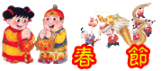
SS answer: Chinese New Year Spring Festival
Chinese Lunar New Year

Lantern Festival on the 15th day of the first lunar month

Mid-Autumn Festival, on the 15th day of the 8th lunar month
the Double Ninth Festival (Old People’s Day)
on the 9th day of the 9th lunar month
Part 2 Qixi Festival
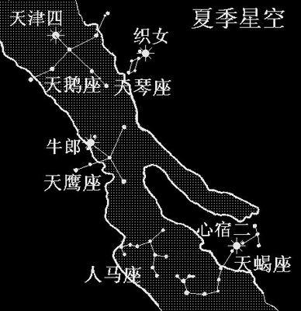 1 Show this picture, T asks: You can see some stars in the sky at night in summer, look at the picture, what festival can you think of?
SS: Qixi Festival.
T: When is Qixi Festival?
the seventh day of the seventh lunar month
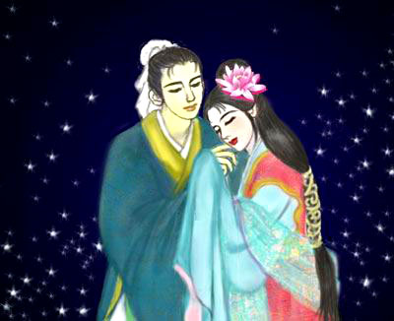Who are they?
They are Niulang and Zhinu.

2 Do you know the origin /'ɒridʒin /（起源） of this festival?
Tell them the origin of this festival:
Learn the passage.
A long long time ago, there was a poor cowherd [ 'kaʊhɜ:d ] 放牛者, Niulang. He fell in love with Zhinu, “the Girl Weaver". She was the most beautiful girl in the whole universe. Unfortunately, the King and Queen of Heaven were angry to find out that their granddaughter had gone to the world of Man and taken a husband. So the couple was separated[ 'sepəreit ] 分开by a wide river in the sky and can only meet once a year on the seventh day of the seventh lunar month.
In ancient times, the Double－Seventh Day was a festival especially for young women. Girls, no matter from rich or poor families, would put on their holiday best to celebrate the annual [ 'ænjuəl ] 每年的meeting of the cowherd and the Girl Weaver. Parents would place an incense [ in'sens ] burner点香in the courtyard and lay out some fruit as offerings. Then all the girls in the family would kowtow to Niulang and Zhinu and pray for ingenuity [ .indʒi'nju:iti ]智巧.
Most girls would pray for outstanding sewing or cooking skills. In the past these were important virtues[ 'və:tju: ] 美德for a woman. Girls and women would gather together in a square and look into the star－filled night sky. They would put their hands behind their backs, holding needle and thread. At the word “Start”, they would try to thread the needle. Zhinu, the Girl Weaver, would bless the one who succeeded first. Most girls hoped to have a good marriage.
The ladies would also show off their fried cookies made in many different shapes. One of the cakes was called Qiao Guo. They would invite the Girl Weaver to judge [ dʒʌdʒ ]判断 who was the best. Of course, Zhinu would not come down to the world because she was busy talking to Niulang after a long year of separation [ sepə'reiʃən ] 分离.These activities gave the girls and women a good opportunity to show their skills and added fun to the festival.
Today’s Qixi Festival
Chinese people nowadays, especially those who live in the city, no longer hold such activities. Most young women buy their clothes from shops and most young couples share the housework.
The Double－Seventh Day is not a public holiday in China. However, it is still a day to celebrate the annual meeting of the loving couple, Niulang and Zhinu. Many people consider the Double－seventh Day the Chinese Valentine's /'væləntain/ Day.
Part 3.T/F Questions:
(1).( ) Qixi Festival is a very new festival.
(2).( ) The seventh day of the seventh lunar month is Qixi Festival.
(3).( ) The Double－Seventh Day is not a public holiday in China.
(4).( ) Niulang and Zhinu met each other twice a year.
(5).( ) In ancient times, Qixi Festival was a festival especially for young men.
(6).( ) Chinese people nowadays, especially those who live in the city, no longer hold such activities.
Part 4 Do you know any western festivals?
Show some pictures, talk about the festivals and the time.
 Christmas Day December 25th
 April Fool’s Day on April, 1
 Valentine’s Day on February, 14
Part 5 Valentine’s Day
- It is a festival for lovers, all lovers unmarried and married.
- On this day people send roses and cards to the people they love. they will give presents to each other, especially the chocolate.
- On February 14
- They sometimes put their love message in a heart-shaped box of chocolates, or a bunch [ bʌntʃ ]一束of flowers tied with red ribbons [ 'ribən ]丝带 . Words or letters may be written on the flower-covered card, or something else. Whatever the form may be, the message is almost the same —“ Will you be my valentine?” The symbol of valentine is a picture with a Heart and Cupid [ 'kju:pid ] [罗神]丘比特[爱神]armed with bow and arrow. Many universities, high schools hold sweethearts’ Ball for the young students to celebrate Valentine’s Day.
Part 6 choice
People send roses and cards to the people they love.
- Valentine’s Day
- Halloween’s Day
- Mother’s Day
Part 7 Dialogue
Suppose you are a reporter . Now you are chosen to interview the foreign teacher John about Valentine’s Day . Make up a dialogue with your partner. One acts the role of the reporter, and the other acts the role of John. The dialogue can begin like this:
Reporter (R): Good afternoon, everyone. Today, we have a foreign guest in our programme. He is our foreign teacher John. Hello, John.
John (J): Hello. I’m glad to be here!
R: Good afternoon. Welcome to China. Today we have a topic about Valentine’s Day . So would you like to introduce Valentine’s Day to us? …
J: …
Give Ss some minutes to prepare, then ask some pairs to act it out.
Part 8 So What are differences between Qixi Festival and Valentine’s Day ?
Summary
Festival | Qixi Festival | Valentine’s Day
Date | the seventh day of the seventh lunar month | on February, 14
Special Food  or gifts | Qiao Guo | flowers, cards, chocolate
Purpose | hope to have ingenuity and a good marriage | show love between lovers
Part 9 Topic
- Do you agree festivals can help us understand our history and culture? How do they help us understand our history and culture ?
Ask them to talk about this topic, then act it out.
Part 10 Argument:
Nowadays more and more festivals have been created in my cities for different purposes, such as developing local economy, making the city well known, etc.
What positive [ 'pɔzətiv ] 正面的 and negative effects do festivals have on us?

