A版
本期导读


七夕节

- 七夕节由来
- 情人节漫谈
- 两种节日对比

刊号：CZCYYY-001 主编：常州市朝阳中学周红梅2007/8/04

A long long time ago, there was a poor cowherd[ 'kaʊhɜ:d ] 放牛者, Niulang. He fell in love with Zhinu, “the Girl Weaver[ 'wi:və ] ". She was the most beautiful girl in the whole universe [ 'ju:nivə:s ]宇宙. Unfortunately, the King and Queen of Heaven were angry to find out that their granddaughter

七夕

had gone to the world of Man and taken a husband. So the couple was separated[ 'sepəreit ] 分开by a wide river in the sky and can only meet once a year on the seventh day of the seventh lunar month.

幽默是生产快乐的奶牛，肚子里总得有点活气，而幽默就是负责供给的大气筒。

戚君

幽默是一把金钥匙，它能打开心中苦闷的锁。 杨楠 幽默好比咖啡中的糖少了不行，多了也不行。

由来

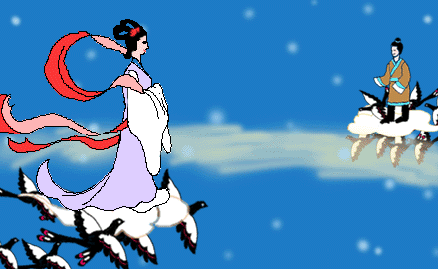

由来

七夕
Most girls would pray for outstanding sewing or cooking skills. In the past these were important virtues[ 'və:tju: ] 美德for a woman. Girls and women would gather together in a square and look into the star－filled night sky. They would put their hands behind their backs, holding needle[ 'ni:dl ]针and thread[ θred ] 线 . At the word “Start”, they would try to thread the needle. Zhinu, the Girl Weaver, would bless祝福 the one
who succeeded first. Most girls
hoped to have a good marriage.
由

In ancient times, the Double－Seventh Day was a festival especially for young women. Girls,no matter不管from rich or poor families, would put on their holiday best to celebrate the annual [ ‘ænjuəl ] 每年的meeting of the cowherd and the Girl Weaver. Parents would place an incense [ in’sens ] burner点香
in the courtyard and lay out some fruit as offerings供 品. Then all the girls in the family
would kowtow to Niulang and
Zhinu and pray祈祷for ingenuity
[ .indʒi'nju:iti ]智巧.

来


Do you agree festivals can help us understand our history and culture?

How do they help us understand our history and culture ?

。
B版

情人节漫谈

讨 论
•It is a festival for lovers, all lovers unmarried and married.
•On this day people send roses and cards to the people they love. they will give presents to each other, especially the chocolate.
•On February 14





They sometimes put their love message in a heart-shaped box of chocolates, or a bunch [ bʌntʃ ]一束of flowers tied with red ribbons [ 'ribən ]丝带 . Words or letters may be written on the flower-covered card, or something else. Whatever the form may be, the message is almost the same —“ Will you be my valentine?” The symbol of valentine is a picture with a Heart and Cupid [ 'kju:pid ] [罗神]丘比特[爱神]armed with bow and arrow. Many universities, high schools hold sweethearts’ Ball for the young students to celebrate Valentine’s Day.

Dialogue
Suppose you are a reporter . Now you are chosen to interview the foreign teacher John about Valentine’s Day . Make up a dialogue with your partner. One acts the role of the reporter, and the other acts the role of John. The dialogue can begin like this:

练



You are the best！
练
Reporter (R): Good afternoon, everyone. Today, we have a foreign guest in our programme. He is our foreign teacher John. Hello, John.
John (J): Hello. I’m glad to be here!
R: Good afternoon. Welcome to China. Today we have a topic about Valentine’s Day . So would you like to introduce Valentine’s Day to us? …

J: …

