常州市初中英语教学研讨课教学设计模版
教学题目 | 《牛津初中英语》被动语态复习课
教学内容 | 1. 本课是完成《牛津初中英语》8B第四单元语法，即现在完成时的被动语态，一般将来时的被动语态，情态助动词的被动语态以及被动语态习题中常见的错误的复习课。这节课主要是通过对常州环境的变化，中国花博会已经做好的准备、还没有完成的准备和作为志愿者能够做的事情这条主线的讨论，从而完成被动语态的复习。  2. 学生通过对常州环境变化的讨论，引出被动语态的复习。  3. 学生通过对中国花博会已经完成的准备的了解，复习现在完成时的被动语态。  4. 学生通过了解有关中国花博会还没有完成的事情，复习一般将来时的被动语态。  5. 学生通过讨论作为志愿者应该做的事情，复习情态助动词的被动语态。  6. 学生在完成各种时态被动语态的概念和结构复习之后，完成相关练习。在完成练习的过程中，巩固知识。  7. 学生通过“一站到底”的游戏，完成一定数量的练习，从而达到再次巩固知识的目的。与此同时，加强小组成员之间的合作。  9. 最后，学生利用本节课所复习的知识，完成一段文章，文章的内容是有关第八届花博会的。
教学对象 | 1.对象是八年级的学生，学生掌握知识，尤其是被动语态这么难的知识，的能力有高有低，他们需要在教师的帮助下形成知识系统。  2. 八年级的学生在课程变难、变多的情况下，渐渐是去了学习的兴趣。  3. 八年级的学生在词汇和句型方面有了一定的积累，再加上这节课本身是新课基础上的复习课，教师要抓住这个优势，充分调动他们的积极性，活跃课堂气氛，做好组织者和引领者，让他们在交流和合作中巩固知识。
教学目标 | 1. 知识目标：以一般现在时，一般过去时的被动语态引领一般将来时，现在完成时和情态助动词被动语态以及易错点的复习。  2. 技能目标：提高学生合作、归纳和灵活运用知识的能力。  3. 情感目标：了解家乡的重大事件，唤起学生热爱家乡，改变家乡的热情。
教学策略 | 1. 任务型教学策略：  围绕教学目标引导学生回忆、总结已学内容。学生在此过程中激发学习的兴趣，体验成功的喜悦；且培养学生小组合作意识和自主学习的能力。  2. 活动性课堂策略：  复习课是比较枯燥的，把枯燥的内容融入各种活动，让学生寓学于乐。在整节课的活动中，都以学生为主，教师只是一个指导者。且学生是以小组为单位，在合作的基础上品尝成功的喜悦。  3. 多元评价策略：  在整节课中，采用多元评价策略。这其中包括老师的正面引导和鼓励，学生的自我评价和自我纠正，小组之间的互评与互纠等。
教学过程
教学步骤 | 所用时间 | 教师活动 | 学生活动 | 设计说明
Step 1  Review the grammar in Unit 3 to lead students to today’s class. | 2’ | Check the students’ homework to lead the students to today’s class. | Some students stand up and then say their answers to the questions out. | 通过前一天的家作，帮助学生复习第三单元的被动语态。与此同时，引导学生进入今天的复习课。
Level One (28’)
Step 2  Presentation | 2’ | 1. Talk about the environment in the past and the present to tell the students why the Chinese government will hold the 8th China Flower Expo in Changzhou.  2. Show three pictures to the students and then ask them to finish the exercises below the picture. | 1. Listen to the teacher carefully and then learn one new expression: the 8th China Flower government.  2. Look at the pictures and then try to finish the exercises. | 开花博会是常州今年的一件大事，学生对此比较了解。通过图片，再加上下面简单的练习，学生比较容易上手，同时也比较感兴趣。
Step 3  Conclusion | 1’ | Show the sentences again and then let the students conclude the passive voice in present perfect tense. | Look at the sentences and then conclude the structures of the passive voice in present perfect tense. | 学生通过刚刚的训练是有可能总结现在完成时的被动语态的。学生自己总结，印象可能更加深刻。
Step 4  Exercises | 4’ | Show the students three exercises about the 8th China Flower Expo and other four exercises to let the students finish. | Listen to the teacher carefully and then try to finish the exericses correctly. | 学生通过练习再次巩固现在完成时的被动语态。
Step 5  Presentation | 2’ | Show the pictures to the students and then ask them to combine the phrases into a sentence. | Look at the pictures and then try to combine the phrases into a sentence. | 学生通过看图片，了解句子的主题。通过给予的时间状语了解句子的时态。最后组成一组一般将来时的被动语态的句子。
教学步骤 | 所用时间 | 教师活动 | 学生活动 | 设计说明
Step 6  Conclusion | 1’ | Ask the students to conclude the structure of the passive voice in simple future tense. | Try to conclude the structure. | 学生通过完成上述练习，能够再次回忆起一般将来时的被动语态。
Step 7  Exercises | 4’ | Ask the students to play a game. First tell the students the simple rule of the game and then organize the game. | Play a game. | 学生通过一个竞赛游戏，既能巩固一般将来时的被动语态，又能从中拿到奖品，还能给小组加分。
Step 8  Presentation | 3’ | 1. Ask the students to read four sentences from the students.  2. Ask the students to turn the active voice into the passive voice. | 1. Read the sentences.  2. Turn the active voice into the passive voice. | 在这个环节中，学生通过四个句子，可以了解自己能够，应该，可以，和必须为花博会做点什么。与此同时，通过改写句子，复习情态助动词的被动语态。
Step 9  Conclusion | 1’ | Ask the students to conclude the passive voice with modal verbs. | Conclude the structure of the passive voice with modal verbs. | 学生通过练习，总结情态助动词的被动语态。
Step 10  Exercises | 4’ | Ask the students to finish exercises from the senior high school entrance examination. | Finish the exercises. | 学生通过完成简单的中考链接题进一步地掌握情态助动词的被动语态。
Step 11  Presentation. | 6’ | 1. Show some exercises to the students.  2. Ask the students to finish them.  3. Show the idea about them and let them read.  4. Finish another one exercise. | 1. Look at the exercises carefully and then discuss in groups.  2. Finsh the exercises.  3. Read the ideas.  4. Finish another one exercise. | 这个环节需要学生的睿智。学生既要完成练习，还需说明为什么。与此同时，根据规则，再次完成练习。学生可以从这些练习中掌握被动语态中常出现的错误。
Level 2（5’）
Step 12  Game | 5’ | 1. Show the rules to the students.  2. Ask the students to do exercises. Others in | 1. Listen to the teacher carefully.  2. Choose one student from each group. | 这个游戏是一站到底的改良版。开展这个游戏的目的有两个，一是通过综
教学步骤 | 所用时间 | 教师活动 | 学生活动 | 设计说明
 |  | groups to help.  3. Estimate. | 3. One student from each group can take part in competition and others can help. | 合题，学生能够再次巩固知识；二是这是一个团队合作的游戏，在这个游戏中可以培养学生的团队精神。
Level 3(8’)
Step 13  Writing |  | 1.Ask the students to write something about the 8th China Flower Expo. Tell them to use the passive voice.  2. Estimate. | 1. Write the article.  2. Estimate. | 这节课的目的是为了让学生更好地运用被动语态，最后的写作就是对他们的检验。
Homework | 1. Review the passive voice.  2. Finish the exercises in papers.
板书设计 | The Revision of the Passive Voice  The passive voice in present perfect tense: have / has been done  The passive voice in simple future tense: will be done / am, is , are going to be done  The passive voice with modal verbs: can / may / must / should be done  Group 1  Group 2  Group 3  Group 4  Group 5  Group 6
教学反思
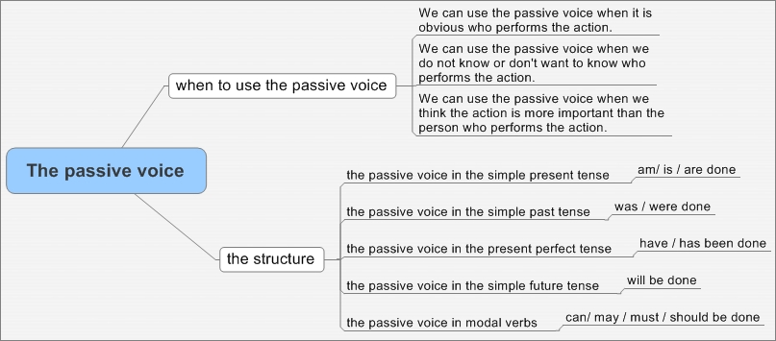

注⑩：
将下列句子改成被动语态：
1. Tom gave me a book.
2. We always keep the classroom clean.
3. We often hear her sing.
（ ） Those books _______ well. They are the best sellers of this year.
A. are sold B. sell
C. have been sold D. have been selling
（ ） How nice the music ________! I have never heard a better piece.
A. sounded B. is sounded
C. is sounded to be D. sounds
（ ）Seeing him rush into the room with tears in his eyes,I asked him what___.
A.would happen B.had happened C.happened D.was happened.
( ) Great changes___ in the past ten years in China.
A. took place B. have taken place C. were taking place D. had taken place

