<https://article.xuexi.cn/articles/index.html?art_id=7291402036755736187&t=1610527625276&showmenu=false&study_style_id=feeds_opaque&source=share&share_to=copylink&item_id=7291402036755736187&ref_read_id=2fd5fe94-5d6a-4148-8a23-a4265718e74c_1665904236874>

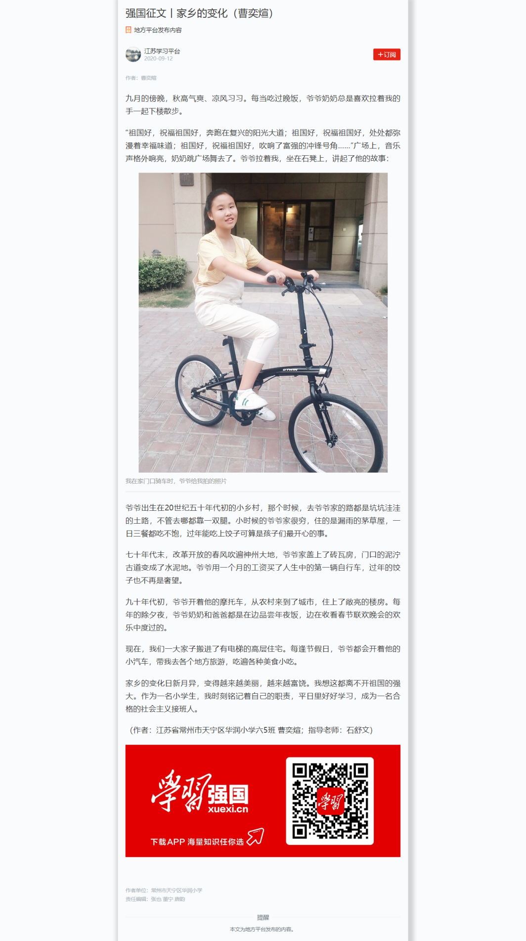

<https://article.xuexi.cn/articles/index.html?art_id=10689524810548626019&t=1623396598650&showmenu=false&study_style_id=feeds_default&source=share&share_to=copylink&item_id=10689524810548626019&ref_read_id=1599fb8f-d535-408d-8553-df84f24b159d_1665904143883>

