范 导 式 教 学 设 计 方 案
学校 | 虹景小学 |  |  | 学科 | 英语 | 班级 |  | 六3 | 人数 |  | 42
课题 | Unit7 Protect the Earth |  |  | 教时 | 1 | 执教 |  | 唐晓军 | 日期 |  | 9.5
一、教学目标
1.通过交流四个热点环境话题：water, energy, trees, plastic pollution，让学生体会环境污染和生态破坏形势严峻，以及人类浪费资源的现象。
2.通过环境问题让学生感知地球环境问题，激发学生保护地球的热情。
3.围绕Why should we ...?和How should we...?两个关键问题，并运用句型We should...为保护地球提供具体的建议。
4.通过概括保护地球的原因和措施(Why & How)，形成结构化文本，并能根据导图准确、连贯复述。
二、制定依据：
1、教材分析
本单元主题内容为“人与自然”，主题群为“环境保护”，子主题内容为“人与自然相互依存，践行绿色生活理念”。就主题意义而言，旨在通过对此话题的讨论引导学生紧密联系生活实际，热爱地球，保护地球。当前，全球面临着资源短缺、环境污染、生态破坏三大危机。作为地球小公民，教师应引导学生通过探讨本单元话题“保护地球”，从书本迁移到实际生活，让学生在语篇理解和体验中意识到人与自然互相依存的关系，从而培养学生热爱、保护地球的意识，践行绿色生活的理念，勇于担当，积极作为。

- 学生分析
班级学生经过三年的英语学习，大部分学生学习兴趣较高，上课发言积极，表达能力较强，愿意与他人进行合作交流。学生通过学习Unit5 Signs 和Unit 6 Keep our city clean 已经对一些公共场所的文明行为习惯及保护城市环境的知识有一定的了解，对于应该做什么或不应该做什么有了一定的辨别能力。顺着文明行为、生态环境的这一主线进入本单元的保护地球环境的主题对于学生来说并不突兀，是一个知识的升华与拓展。由于这些话题比较贴近现实生活，因此学生在理解和接受上存在的难度不是很大，教师在教学时除了对语言知识的训练之外在情感态度上进行提升，通过对地球日、世界环境日等文化了解让学生能形成保护地球从我做起的意识。

教 学 过 程
教学环节 |  | 教 师 活 动 |  |  |  |  | 学 生 活 动 |  |  | 设 计 意 图
开放式  导入 |  | 真实性情境 | 1.Greetings  T: Good morning, boys and girls.  I have lots of hobbies, can you  guess what are my hobbies?  T: I like riding bikes best, but why?  Yes, because it’s very “green”  (PPT the picture of Pm.2.5)  T: why should we ride bikes?  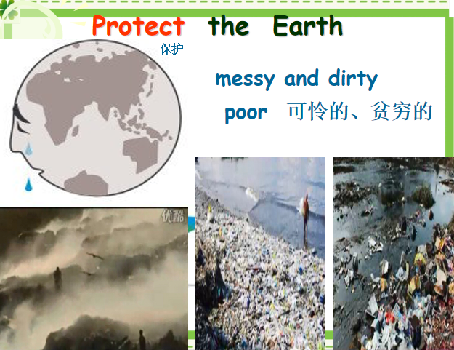 |  |  |  | S:Good morning.  S: Do you like singing?  S: Do you like swimming?  S: Do you like…?  S: Because I think it’s very healthy.  S: Because of the PM2.5 |  |  | 了解地球一些相关现状，使学生产生急需保护地球的紧迫感。同时为下文铺垫，引出主题Protect the Earth。
核心过程  推进 |  | 发展性任务 | 1.What’s the matter with our Earth?  Yes, the PM2.5 is so heavy, now let’s watch a video called our home, please watch it carefully and tell me what things can you see in this video?(play the video)  T: Yes, and also this  (PPT presents the plastic bags and plastic bottles. )  T:So today we’re going to learn  “Protect the earth”.  2.T:First, Let’s listen to the story and  circle the problems.  (1)What problems are mentioned in the story?  T: You did a good job, boys and girls. Now let’s listen to the tape again and tell the names of each story.  T: Did you get it? Let’s check.  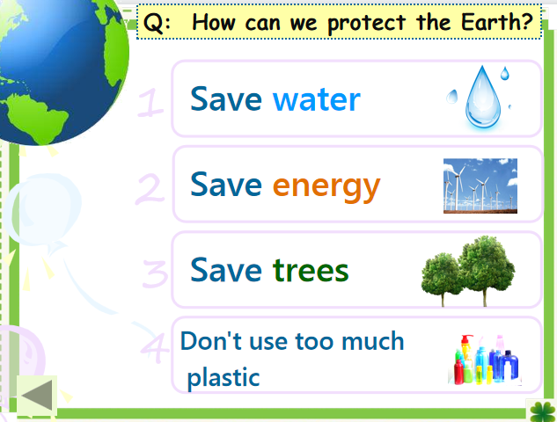  (2)T: Well done, boys and girls, now let’s try to fill in the blanks.  Energy comes from ____and____  Teach oil and coal  (PPT oil and coal)  _____ comes from the trees  Teach wood.  T:Now let’s read and judge,  please read it by yourselves.  ① Water is useful, so we should not waste it. ( )  ②We use water to clean the things every day. ( )  ③There is much water in many places. ( )  ④We should not reuse the water.  ( )  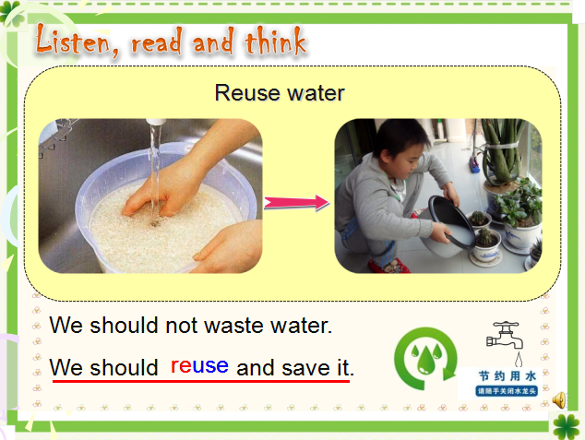  (4)T:Now we know water is useful, boys and girls, but why should we protect it and how?  Please read and learn.  用直线画出原因(Why do we save water?)  虚线画出方法(How do we save water?)  (5)T: Wonderful, boys and girls, now let’s listen to the tape and read after it.  2.Save energy  T: Now we know water is useful, what about energy? Please read and choose.  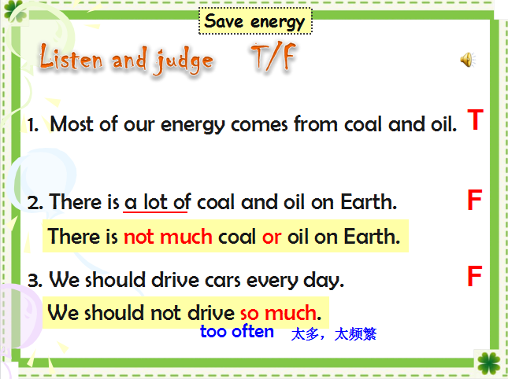  T: Now let’s find out why should we save energy and how to save it. 用直线画出原因(Why do we save energy?) 虚线画出方法(How do we save energy?)  T: Yes, so I think we can ride bikes, now let’s listen to the tape and read after it.  3. Save trees  T: Now we know water and energy are important, what else?  What do you want to know about “Save trees?” You can talk with your mates.  T: Perfect, now let’s try to fill in the blanks, boys and girls.  ____ comes from trees. We use ____ to make tables, chairs and many other things. We _____ cut down ______ trees because trees help ________.  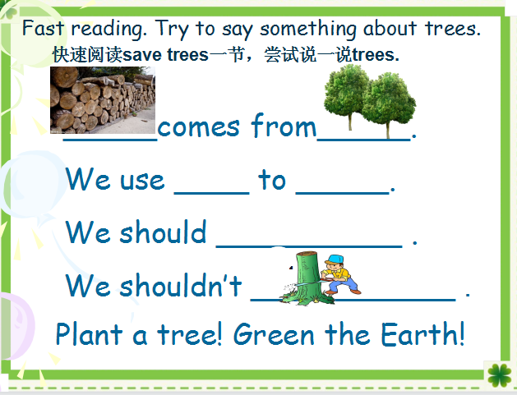  4. Don’t use too much plastic  T:Now boys and girls, wood comes from trees, does the plastic come from the trees?  T: So what do you know about plastic? You can have a group discussion.  T: Good, now let’s listen and  answer, what can we use plastic to make?  Should we use too much plastics?  So what can we use? Please have a group discussion.  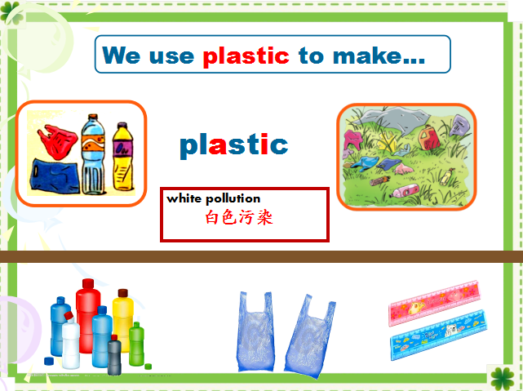  T:Yes, we should not use too many plastic, paper is better, now let’s read after the tape.  T: Now please get into a group and use the given words to say sth. about plastic.. |  |  |  | Ss: Watch and answer:  S:I can see some animals,  they’re in danger.  S2:I can see some air pollution  S3:I can some water, they’re  dirty.  S4:I can see the trees, they’ve  been cut down.  S5:The earth is in danger.  Animals are in danger/  Water is in danger….  S: The problem is water.  S2: Trees are the problems.  S3: We should save energy.  S4: And plastic.  S1: The first is save water  S2:The second is save energy.  S3: Next is save trees.  S4:Don’t use too much plastic.  Learn: oil and coal  Learn: wood  Read it by selves.  S1:Water is useful，so we should not waste it. ( T )  S2:We use water to clean the things every day. ( F )  S3:There is much water in many places. ( F )  S4:We should not reuse the water. ( F )  S1:Water is useful. In many places, there is not much water.  S2:We should reuse and save it.  Ss: Listen to the tape and read after it.  S1:Most of the energy comes from___B___.  A. water and soil. B. coal and oil.  S2:We should _____ and we should not __.  A.save energy; drive so much B.drive so much; save energy  S:Because there is not much coal and oil on earth.  S2:We should not drive so much because cars use a lot of energy.  Ss:Listen to the tape and read after it.  S: They’re trees.  S1:Where does wood come from ?  S2:Wood comes from trees. We use wood to make tables,chairs  and many other things.  S3:We should not cut down trees.  S4:Why should we not cut too many trees?  S5: Because trees help keep the air clean.  S: I know plastic bags  S2: I know plastic bottles.  S3…  S1:We use plastic to make bags and bottles.  S2: But use too much plastic is bad for our earth. We should not use too many plastic bottles or bags.  S: We should use paper bags  S2:We should use glass bottles.  S3: We should use….  Ss: Read after the tape.  Ss: Discuss in groups. |  |  | 通过以(What --why--How )  为主线整体感知，理解掌握带着问题,观看课文，找出文中所提的几个措施。为以下的精读课文提供语言支架。  创设真实的情景，通过How can we...?大问题让学生感知并重视全球环境问题，初步了解保护地球环境应该与不应该做的事。  完成判断对错，从而获取课文一些细节信息。同时提炼出关键词。  再读课文，进一步获取How to do?的详细信息并内化输出。  以Save energy为例，用Why和How引导学生在阅读中用不同记号划出答案，渗透方法。  小组合作，自主提问，提取文本结构和信息，并反馈。教师收集信息，聚类板书给予指导。  在活动体验中，学生了解plastic，并能理解并运用语言We can use...  To make...让学生了解更多的White pollution让他们意识到合理使用塑料的重要性。
 |  | 多元化意义协商 | 1.Read the story.  T:OK, it’s time for reading, you can read by yourselves or get into a group.  2.Retell the story.  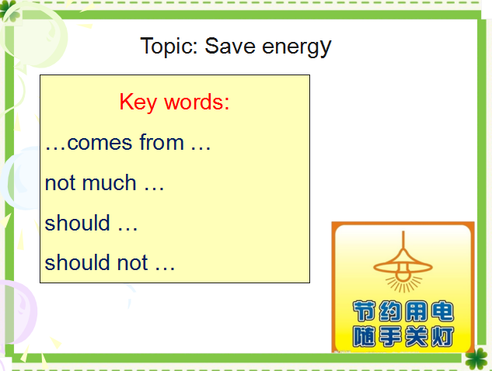  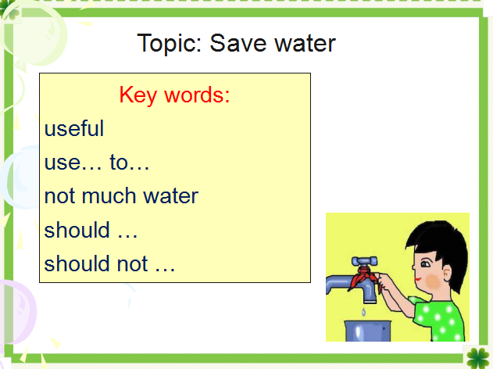  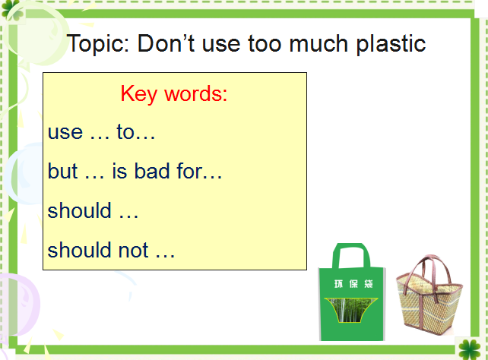  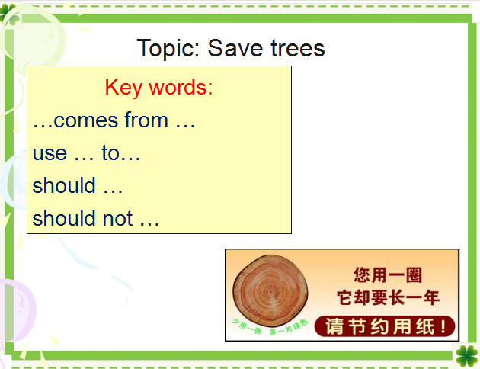 |  |  |  | Ss: Read after the tape  Ss: Retell the story  ★语音、语调准确  ★★语音、语调准确，表达流畅  ★★★语音、语调准确，表达流畅，动作自然 |  |  | 学生能梳理文本结构，根据板书准确、连贯复述文本。并小组合作，模仿结构，初步运用关键语言。
开放式  延伸 |  | 创造性应用 | T:“Protect the earth” speech time is coming, here are the tips, boys and girls,  小组合作,每组选择文中的一个小主题.(可以借助板书）  Why should we …?  We should/shouldn’t..  切合主题，提出保护口号.  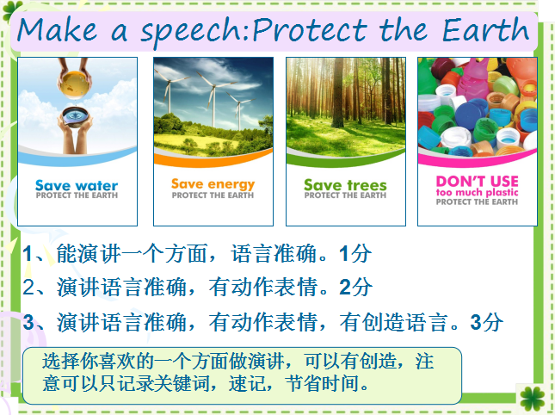 |  |  |  | Ss:We should protect the earth because she is our mother.  The earth is our home.  We should/shouldn’t...  We can reuse... |  |  | 聚焦了四个热点环境话题：water,energy, trees,plastic pollution, 并运用句型We should(not)...为保护地球母亲提供具体可行的建议，培养学生作为地球主人的责任感。
作业设计 |  | 1.Listen to the tape and read after it for at least five times.  2.Try to retell the story.  3.Finish the exercises book. |  |  |  |  |  |  |  | 通过听说读背进一步巩固所学的内容。
板书设计 |  | 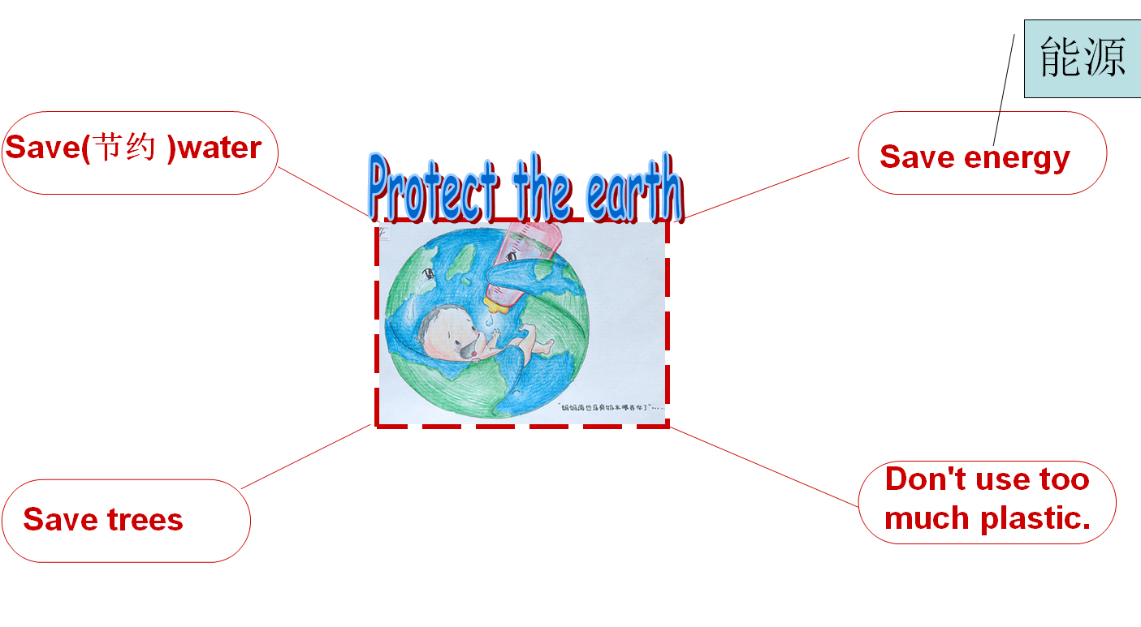  We should/ We should not use…  We can reuse….
教学反思 |  | 本单元Story time以一般现在时分别描述了全球四个热点环境话题，water, energy, trees，plastic pollution。通过Why should we...?和How should we...?两个大问题让学生感知并重视全球环境问题，初步了解保护地球环境应该与不应该做的事情。  范导式教学倡导积极的课堂对话，因此我设计四大环节，采用教结构用结构的方式，给学生对话提供语言支架，鼓励学生运用本单元核心句型交流“保护地球”的环保理念，并能够有条理地介绍保护地球环境的措施，深入对“保护地球”的意义理解和践行，帮助学生明确保护地球的意义（The Earth is our home.)。  另外在开放式延伸环节，借助语言输出框架和语言提示，帮助学生表达保护地球的各种行动措施，为Cartoon time进行“倡议书”书面表达做好铺垫。

