范 导 式 教 学 设 计 方 案
学校 | 常州市虹景小学 |  |  | 学科 | 英语 | 班级 |  | 三（3） | 人数 |  | 30
课题 | U3 My friends (Checkout Time) |  |  | 教时 | 4 | 执教 |  | 英语 | 日期 |  | 2020.9.10
一、教学目标
1.通过字母儿歌、联系实际、游戏等方式，复习巩固Hh，Ii，Jj，Kk的音、形、义。
2. 通过复习cartoon，学生能再次巩固he和she所指不同之处。并通过整体感知、观察图片、预测故事等方式，在新的情境中能准确运用He's/She's...He’s/She’s my friend.等句型，并丰富相关表达。
3. 通过本单元学习，能联系实际，流利通顺地用一段话介绍自己的朋友。
4. 通过阅读绘本My friends, 了解文本内容，引导孩子感受朋友之间的情感。
二、制定依据：
1、教材分析
本单元话题为：My friends，设计了老师放学后，Yang Ling和Mike在回家途中分别向各自的父母介绍对方的场景。主要语言功能是引导学生掌握如何向老师、家人、朋友道别，以及运用She’s … She’s my friend. He’s … He’s my friend向他人介绍自己的朋友。
- 学生分析
学生在前两个单元已经学习了Good morning. Good afternoon. Hello. Hi.等问候语，也学习了自我介绍的句子I’m …。因此，教师可以引导学生在介绍自己的朋友时把这些内容有机滚入，通过新旧知识的有机整合，形成小语段Good morning./ Good afternoon. / Hello. / Hi. I’m … She’s … She’s my friend. He’s … He’s my friend, too.适度加强对学生语言表达的纵向和横向的拓展。
教 学 过 程
教学环节 |  | 教 师 活 动 |  |  |  |  | 学 生 活 动 |  |  | 设 计 意 图
开放式  导入 |  | 真实性情境 | Play the video and lead students enjoy a song Friends  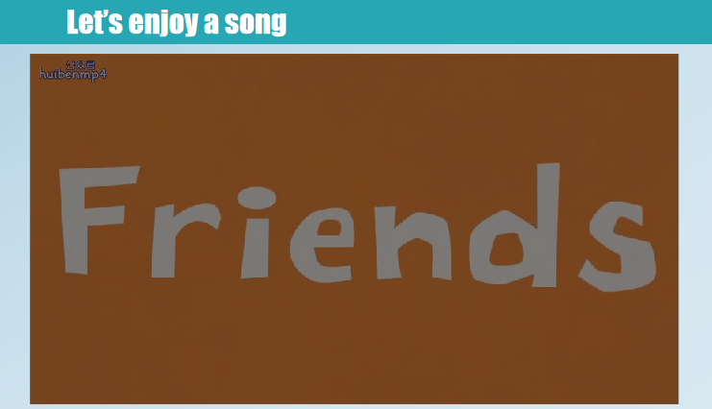  - Lead Ss to talk:What’s the song about ?  - Show the three tasks about Friends.  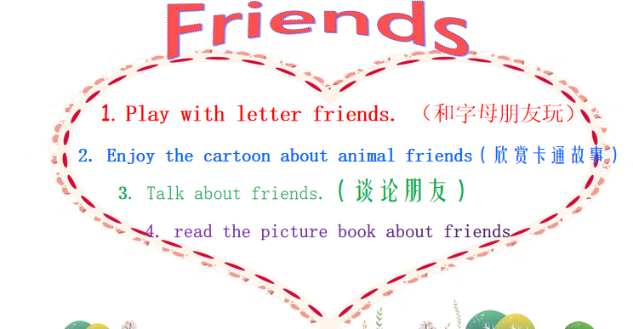 |  |  |  | Enjoy the song.  - Say sth about the songs:It’s about friends.  - Know the three tasks of today’s lesson |  |  | 通过歌曲欣赏，引入主题friends，并营造英语学习氛围，创设真实性情境。  通过主题导入，引导学生自由表达，并通过给学生设定任务，让学生明确本课的目标。
核心过程  推进 |  | 发展性任务 | - Lead Ss to learn the first part: Play with letter friends  - Show the letter song  T: We have learned the letter song. Let’s review it.  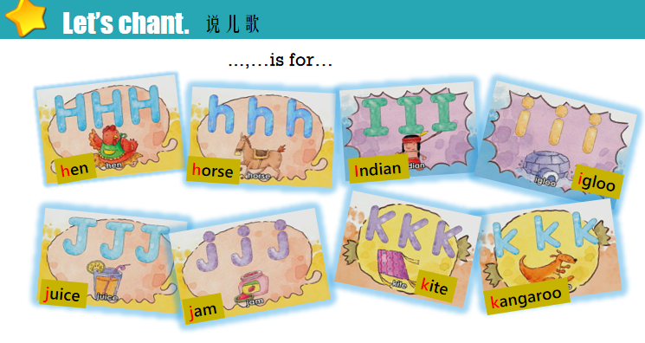  - Play a game magic eyes and let Ss say the letters loudly.  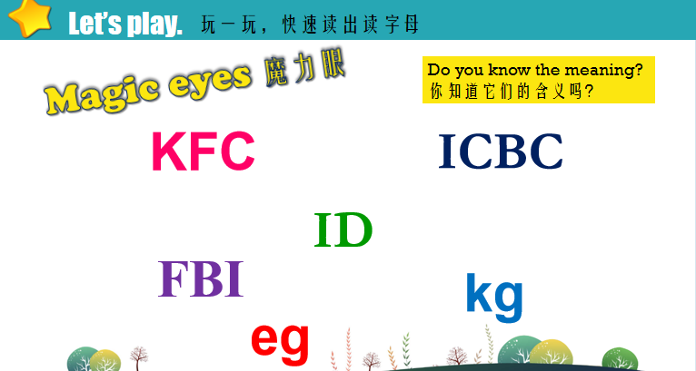  - Ask students to write down the letters and their neighbours.  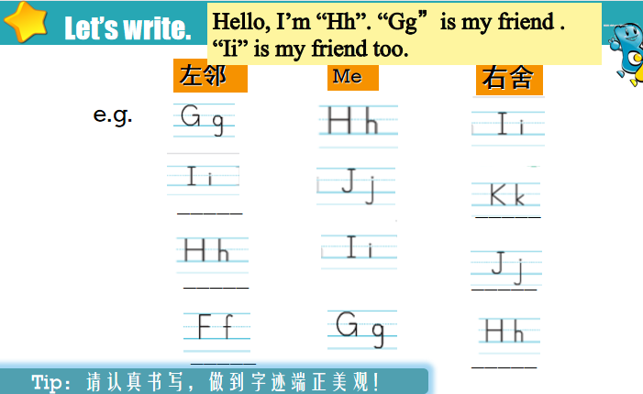  - Lead students to listen and circle.  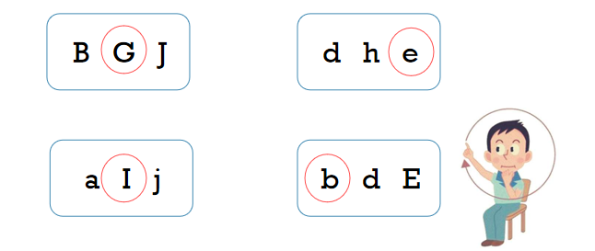 |  |  |  | - Learn the first part: Play with letter friends  - Sing the letter song.  Chant the song.  - Say the letters loudly.  - Write down the letters and their neighbours.  - Listen and circle. |  |  | 通过歌曲、游戏、书写等方式，全方位地复习所学字母，巩固对字母的掌握。
 |  | 多元化意义协商 | - Lead Ss to learn the second part:Enjoy the cartoon about animal friends  - Show the picture of Bobby, Sam and Tina. Lead Ss to answer about the picture:  Who is he?  Who is he?  Who is she?  What does Bobby say in cartoon time?  What else can he say to introduce Tina?  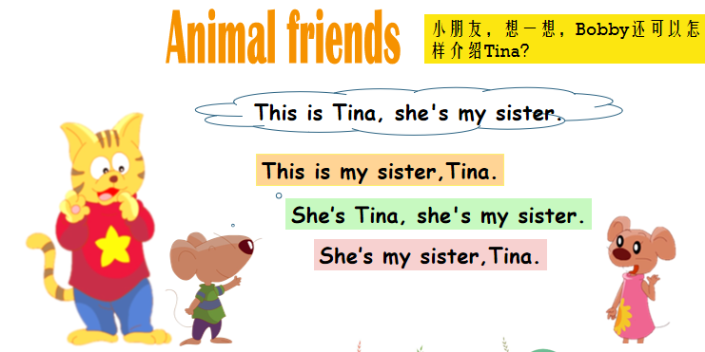  - Lead students to enjoy the cartoon and dub it.  - Show students another scene: the next day. Let students guess how will Bobby introduces his sister and friends to Sam.  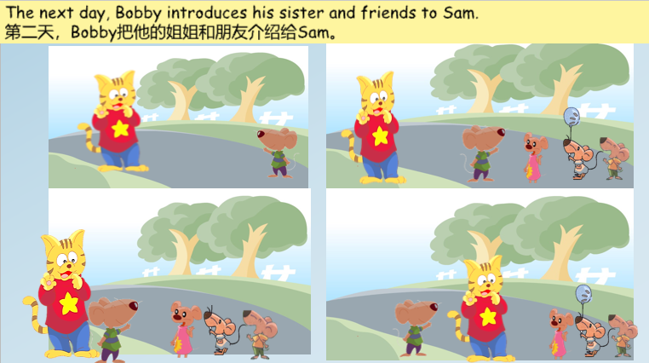  - Lead Ss to learn the third part: Talk about friends  - Show Ss the picture of Liu Tao and lead Ss to discuss with their partner:  Who are Liu Tao’s friends?  Do you know?  - Show the scene: Liu Tao is introducing his friends to his father. Lead students to fill in the blanks.  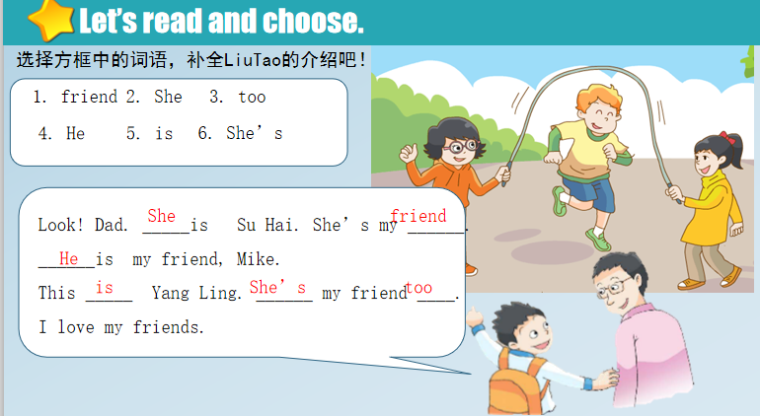  - Ask students to talk about their own friends  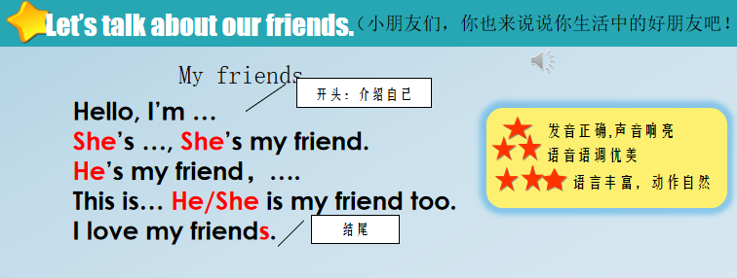 |  |  |  | - Learn the second part: Enjoy the cartoon about animal friends  - Look at the picture and answer the questions  S: He’s Sam.  S: He’s Bobby.  S: This is Tina, she’s my sister.  S1:This is my sister Tina.  S2:She’s Tina.She’s my sister.  S3:She’s my sister Tina...  - Enjoy the cartoon and dub it.  (3)Look at the picture and discuss with the partner.  S1: She’s Tina. She’s my sister.  S2: She’s my friend Ann.  ...  - Learn the third part: Talk about friends  - Look at the picture and discuss with their partner.  S1: Maybe Yang Ling,  S2: Maybe Mike...  - Look at the picture and fill in the blanks.  (3). Talk about their own friends.  S1: He’s .../She’s...  S2:This is my friend... |  |  | 通过观察图片，让学生回忆cartoon time 所学内容，并通过开放性问题，引导学生联结之前所学句型，学会整体运用知识。  教师通过发展型任务，引导学生想象，预测文本内容，培养学生看图、编对话的能力。  通过引导学生观察图片，描述图片，培养学生的观察能力与表达能力，从预测文本到验证文本对话，学生的学习更有层次，更丰富。  从课本回归到学生生活，通过开放性问题，引导学生结合自己的生活进行自由表达，培养学生发散思维与表达能力。
开放式  延伸 |  | 创造性应用 | Lead students to read the picture book about friends  （1）Lead Ss to know the cover.  Ask: Who are they?  Guess:What are they talking about?  （2）Ask Ss to watch and find（P1-5）:  Who are their friends?  - Ask Ss to Guess :  How will they introduce their friends?  - Ask Ss to read and check（P1-5）.  - Ask: What happened between the  friends？（P6-10）  - Ask: What do his friends say?  What will you say/do?  Why?  - Lead Ss to read the story.  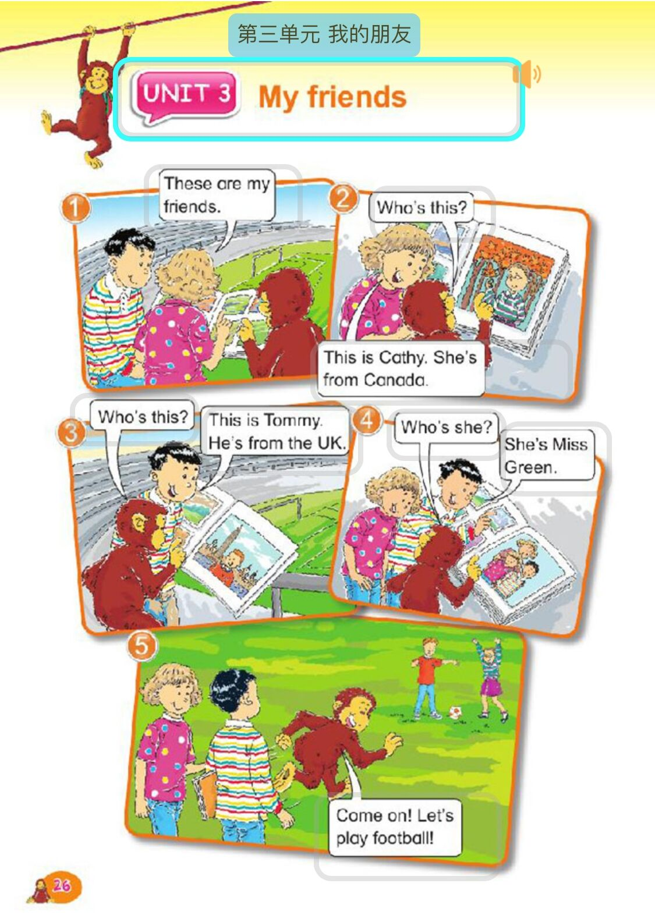  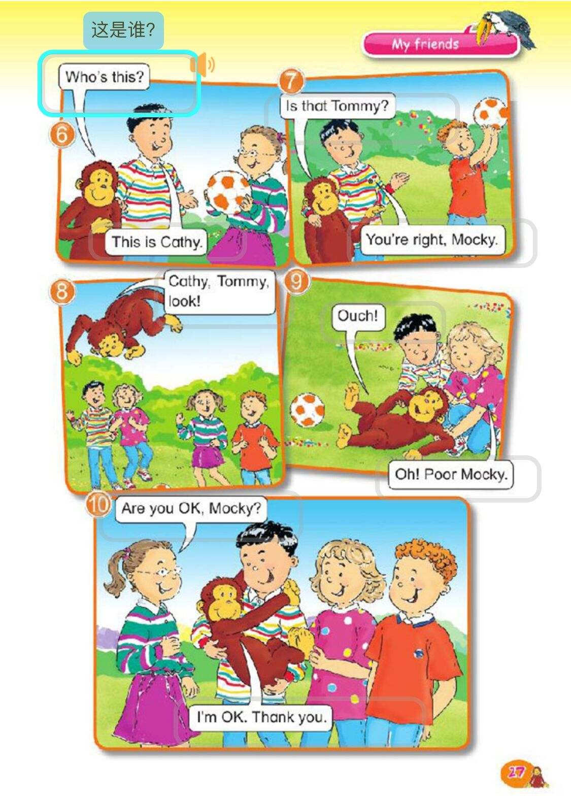 |  |  |  | Listen and answer.  “Friends”  Read and find.  Try to guess.  Play football.  Mocky is naughty.  He hurts.  What’s wrong?  Are you OK?  I love my friends.  Read the story. |  |  | 通过引导学生观察图片，描述图片，培养学生的观察能力与表达能力，从预测文本到验证文本对话，学生的学习更有层次，更丰富。  通过开放性问题升华主题，创造性地运用本课的知识点，明白拥有朋友的意义。
作业设计 |  | - Try to introduce friends to your family.  - Write down more combination of letters in life.  - Read the picture book.
板书设计 |  | 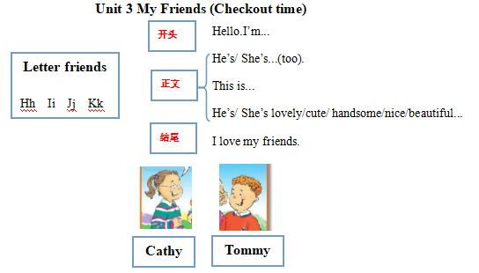
教学反思 |  | 本课以My friend为主题，以letter friends和animal friends为基础，your friends 和a picture book about friends为依托，通过创设真实性情境，从课本回归到学生生活。利用绘本，拓展了He’s/ She’s lovely/ cute/ handsome/nice/beautiful...等句型。同时最后拓展环节通过让学生自己来介绍自己的朋友，让学生创造性地运用今天所学的句型设计，以此提供给学生更多的操练机会和充分展示的空问，引导他们将学习内容和自己的实际生活相结合，加大了语言的输出量，从而达到学以致用的目的。  此外一些需要改进的地方是：语音语调方面，教授新单词时一定要注意培养学生静听、细看、再模仿的习惯，当学生朗读单词时，老师一定要注意观察学生的口型，以便及时纠正错误读音。对于语调的培养，可以采用升降符号、手势语来吸引学生的注意及模仿。同时有些学生对于he和she的发音掌握的还不是很到位，易发错，要多次强化与训练。

