学科 |  |  | 英语 | 主备教师 | 陆丽英 | 授课时间 | 5 月 20 日
课题 |  |  | Unit8  Our dreams | 课时安排 | 第一课时 | 课型 | Story time | 授课班级 |  | 六2
三维目标 | 知识目标 |  | 1.能听懂、会说、会读和会拼写单词: dream, future.  2.能听懂、会说、会读单词care about, astronaut, spaceship, football player,World Cup, dancer, pianist, come true.  3.能听懂、会说、会读和会拼写句型：What do you want to be in the future? I want to (be)…  4.通过课文重点语言知识点的学习，能理解课文内容，能自然流畅地朗读课文和复述课文。  5.通过话题的讨论学习,引导学生树立正确的价值观.
三维目标 | 能力目标 |  | 通过课文重点语言知识点的学习，能理解课文内容，能自然流畅地朗读课文和复述课文。
三维目标 | 情感目标 |  | 通过话题的讨论学习,引导学生树立正确的价值观.
教学重难点 |  |  | 1.正确掌握，灵活运用将来时句型表达于真实情景中。  2.能理解，正确朗读，表演Story time。
教学资源 |  |  | 课 件
教师精讲 |  |  |  |  |  | 学生活动 |  |  | 调整与思考
Step 1 Pre-reading.  1. Sing a song<Dream it possible>.  This is Anna, when she was a child, she has a dream, she wants to be a pianist. She plays the piano hard every fifteen years. Then she became a great pianist.  - Play a game: Read the words loudly and find his friend as quickly as possible! write —writer  drive— driver teach —teacher  work—worker sing—singer  play—player dance—dancer  Step 2While-reading.（Story time）  1. Listen and circle.  Circle all the jobs mentioned in the tape.  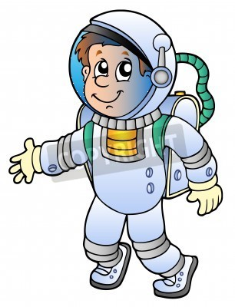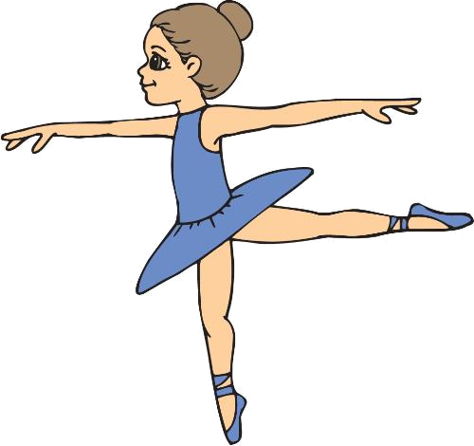  astronaut dancer waiter writer  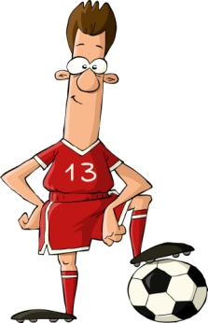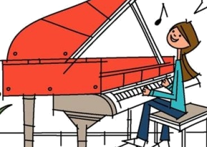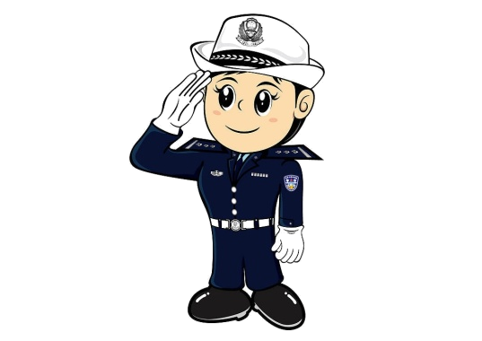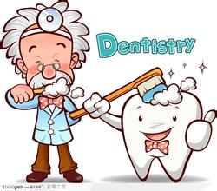  football player pianist policewoman dentist  2. Read and match.  …wants to be a/an…  3. Read and underline.  4. Read in different ways.  Step 3 Post-reading  1. Think and write.  Miss Li is writing about her students’ dreams. Complete her notes.  Mike wants to be . He wants to take care of children’s teeth. Su Hai wants to be .Yang Ling likes .She wants to be .Nancy is good at writing. She wants to write stories for .Liu Tao likes sport. He wants to be and play in the world Cup.Wang Bing has a big dream. He wants to be and fly to .  2. Draw mind maps.  3. Further study:  4.Summary  Every dream has its trace.  5.Do you have dreams?  Write down your dreams. Share your dreams.  Go on talking about the students’ dreams  Step 4 Consolidation  1. Further study:  Go on talking about the students’ dreams  2. Homework. |  |  |  |  |  | 学生一起唱英文歌曲<Dream it possible>.通过了解这首歌曲主人公Anna的故事，教授新单词dream, pianist.  学生玩连连看游戏，复习职业类单词。  根据watch and match的结果，复述their dreams，并根据复述内容生成表格，为下面的自主阅读做准备。  通过自读，完成填空等多层次递进学习课文。
  Who | What | Why
  Mike
  Wang Bing
  Liu Tao
  Su Hai
  Nancy
  Yang Ling
作业设计 |  | Homework.  1.Read the text after the tape three times and try to recite it.  2.Copy the new words and phrases four times.
板书设计 |  | Unit 8 Our dreams  Mike dentist care about  WangBing astronaut fly a spaceship to …  LiuTao football player play in the World Cup  SuHai dancer dancing makes  Nancy writer write stories for  YangLing pianist music makes  A: What do you want to be in the future?  B: I want to be a/an….

