王婵公开课教案
教 学  内 容 | Unit 5 Amazing things---Reading(1) | 课 型 |  | New
目 的  要 求 | (1) To introduce the style of the story.  (2) To identify specific meanings by scanning the text.  (3)To predict meanings of specific words from the context.  (4)To summarize key points of a story by reading. | 应 准  备 的  教 具  等 |  | PPT
重 点  难 点 | To summarize key points of a story by reading.
教学设计与过程
学习目标 | 学 生 学 习 活 动 |  | 教师组织、指导
Step 1  Warm up&Lead-in  Step 2  Presentation  Pre-reading  While-reading  Post-reading  Step 3 Feedback  Step4 Retell  Step5 Consolidation  Step6 Language points  Step 7 Homework | Warm up&Lead-in:  Warm up：  - Enjoy a short video to lead in the main topic of last period:Amazing things.  - Have a revision about important language points.  Lead-in：  Think about these questions:  Are there any ghosts in the world?  Are you afraid of ghost?  Enjoy a short video.  The new words are:  as usual reply leave wonder search weak  Listen to the tape and analyse the structure of the text.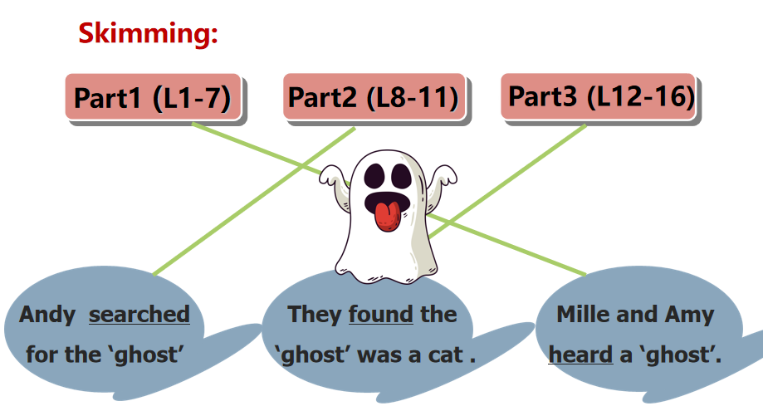  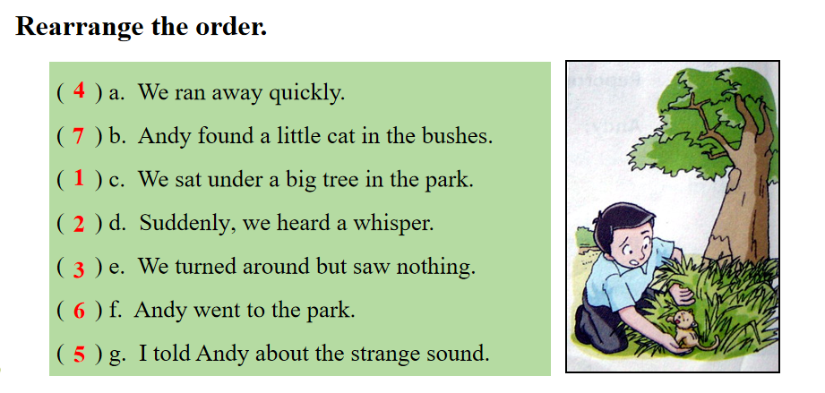  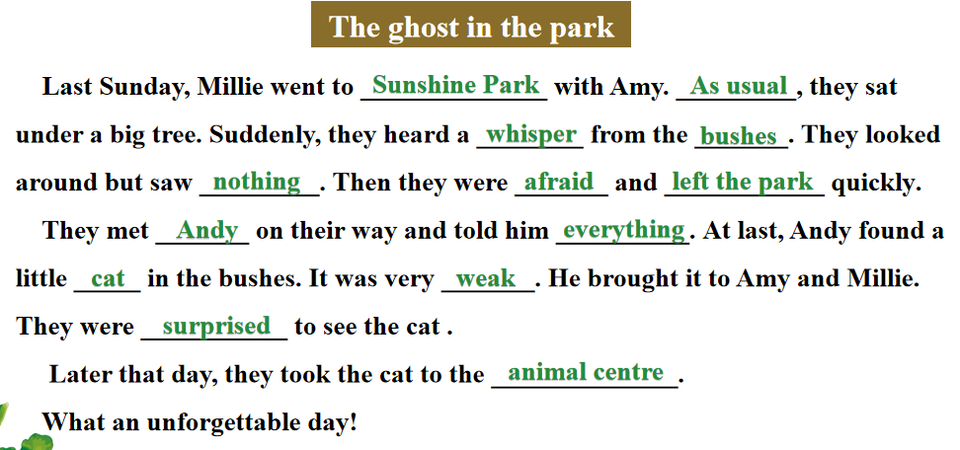  Try to retell the story.  - Sunshine Park...Sat down  - Whisper...left...quickly  - On their way home...met Andy  - Searched bushes  - Took...the animal center  Finish the blanks on ppt.  Explain the language points  - as usual  a usual thing/an unusual story  2.suddenly =all of a story  3.whisper  in a whisper/in whispers  4.hear sb. do/doing  5.turn around/on/off/up/down/to/into/out  6.leave/left  7.on one’s way home  8.What happened?  What happened to sb.?某人发生什么事？  - Memorize all the important language points.  - Finish your notes carefully.  - Finish Exercise Book P60-61. |  | Ask the students to enjoy a short video about Pepper .  Enjoy a short video to lead in ghost.  To check if the students can remember the words they learned .  Listen to the tape carefully.  Discuss with the partners and solve the problem.  Ask the students to read the text by themselves and finish the task.  The teacher asks the students to make a dialogue with the hints.  Explain important language points carefully  &  The teacher asks the students to make notes carefully.
板  书  设  计 | 7B Unit5Amazing things-Reading(1)  - Sunshine Park...Sat down  - Whisper...left...quickly  - On their way home...met Andy  - Searched...bushes  - Took...the animal center

