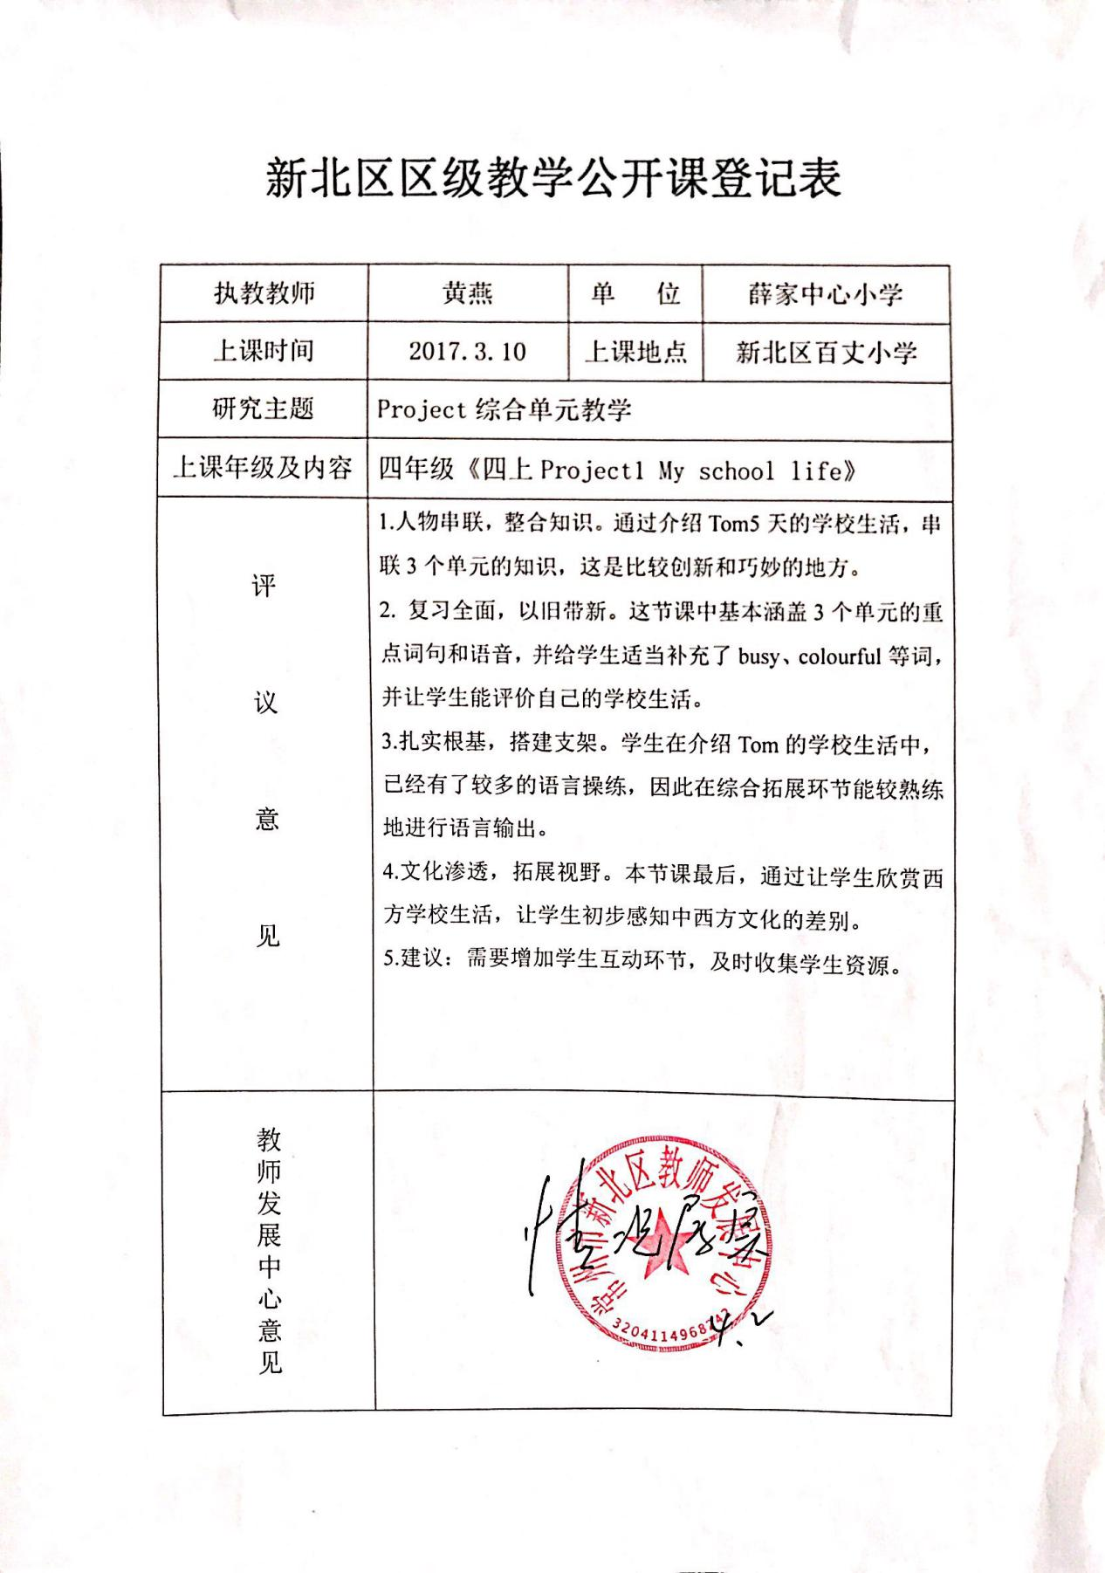

论文一览表

|  |  |  |  |  |
| --- | --- | --- | --- | --- |
| 序号 | 课题成员 | 题目 | 发表刊物或评比组织部门 | 时间 |
| 1 | 黄燕 | 《语篇和语境视角下的教材重组—以四下Project 1 My school life为例》 | 《新课堂》 | 2017.05 |
| 2 | 黄燕 | 《小学英语Project单元教材重组研究—以四下Project 1 My school life省级评优课为例》 | 《考试周刊》 | 2017.09 |
|  |  |  |  |  |
|  |  |  |  |  |
|  |  |  |  |  |
|  |  |  |  |  |
|  |  |  |  |  |
|  |  |  |  |  |
|  |  |  |  |  |
|  |  |  |  |  |
|  |  |  |  |  |
|  |  |  |  |  |
|  |  |  |  |  |
|  |  |  |  |  |
|  |  |  |  |  |
|  |  |  |  |  |
|  |  |  |  |  |
|  |  |  |  |  |
|  |  |  |  |  |
|  |  |  |  |  |

区级市级公开课一览表

|  |  |  |  |  |
| --- | --- | --- | --- | --- |
| 序号 | 课题组老师 | 执教内容 | 级别 | 时间 |
| 1 | 黄燕 | 四下 《Project 1 My school life》 | 区级 | 2017.03 |
|  |  |  |  |  |
|  |  |  |  |  |
|  |  |  |  |  |
|  |  |  |  |  |
|  |  |  |  |  |
|  |  |  |  |  |
|  |  |  |  |  |
|  |  |  |  |  |
|  |  |  |  |  |
|  |  |  |  |  |
|  |  |  |  |  |
|  |  |  |  |  |
|  |  |  |  |  |
|  |  |  |  |  |
|  |  |  |  |  |
|  |  |  |  |  |
|  |  |  |  |  |
|  |  |  |  |  |
|  |  |  |  |  |
|  |  |  |  |  |
|  |  |  |  |  |
|  |  |  |  |  |
|  |  |  |  |  |