常州市新北区徐文娟名教师成长营年度考核B12汇总表
序号 | 时间 | 内容 | 页码
1 | 2021.06 | 束燕姣执教黑布林绘本阅读微课《The dark in the box》学习强国江苏学习平台 | 3
2 | 2021.06 | 戴潇潇执教黑布林绘本阅读微课《The fisherman and his wife》学习强国江苏学习平台 | 4
3 | 2021.10 | 肖洁上市级公开课五上《Unit 5 What do they do?》 | 5
4 | 2021.01 | 孙丹萍上区级公开课五上《Project 2 Our friends》 | 6
5 | 2021.03 | 徐文娟上区级公开课绘本《The fisherman and his wife》 | 7
6 | 2021.04 | 肖洁上区级公开课五下《Unit 4 Seeing the doctor》 | 8
7 | 2021.04 | 薛林上区级公开课五下《Unit 5 Helping our parents》 | 9
8 | 2021.04 | 储丽娟上区级公开课六下《Unit 5 A party》 | 10
9 | 2021.04 | 孙丹萍上区级公开课五下《Unit 7 Chinese festivals》 | 11
10 | 2021.05 | 戴潇潇上区级公开课六下《Unit 8 Our dreams》 | 12
11 | 2021.05 | 戴潇潇上区级公开课绘本《The fishman and his wife》 | 13
12 | 2021.05 | 陈玲上区级公开课绘本《Mother!Dear Mother》 | 14
13 | 2021.05 | 王晴晴上区级公开课六下《Unit 6 An interesting country》 | 15
14 | 2021.05 | 吴悦上区级公开课六下《Unit 5 A party》 | 16
15 | 2021.06 | 陈玲上区级公开课五下《Unit 8 Birthdays》 | 17
16 | 2021.06 | 管静亚上区级公开课四下《Unit 6 How are you?》 | 18
17 | 2021.06 | 陆燕上区级公开课四下《Unit 5 seasons》 | 19
18 | 2021.06 | 孙丹萍上区级公开课五下《Unit 8 Birthdays》 | 20
19 | 2021.10 | 王晴晴上区级公开课四上《Unit 5 Our new home》 | 21
20 | 2021.10 | 江颖上区级公开课五上《Unit 6 My efriend》 | 22
21 | 2021.11 | 黄燕上区级公开课四上《Unit 4 I can play basketball》 | 23
22 | 2021.11 | 张妍上区级公开课四上《Unit 6 At the snack bar》 | 24
23 | 2021.11 | 束燕姣上区级公开课五上《Unit 6 My efriend》 | 25
24 | 2021.11 | 管静亚上区级公开课四上《Unit 6 At the snack bar》 | 26
25 | 2021.12 | 芮梨上区级公开课四上《Unit 7 How much？》 | 27
26 | 2021.12 | 张欢上区级公开课六上《Unit 8 Chinese New Year》 | 28
27 | 2021.12 | 周敏颖上区级公开课六上《Unit 8 Chinese New Year》 | 29

束燕姣执教黑布林绘本阅读微课《The dark in the box》学习强国江苏学习平台
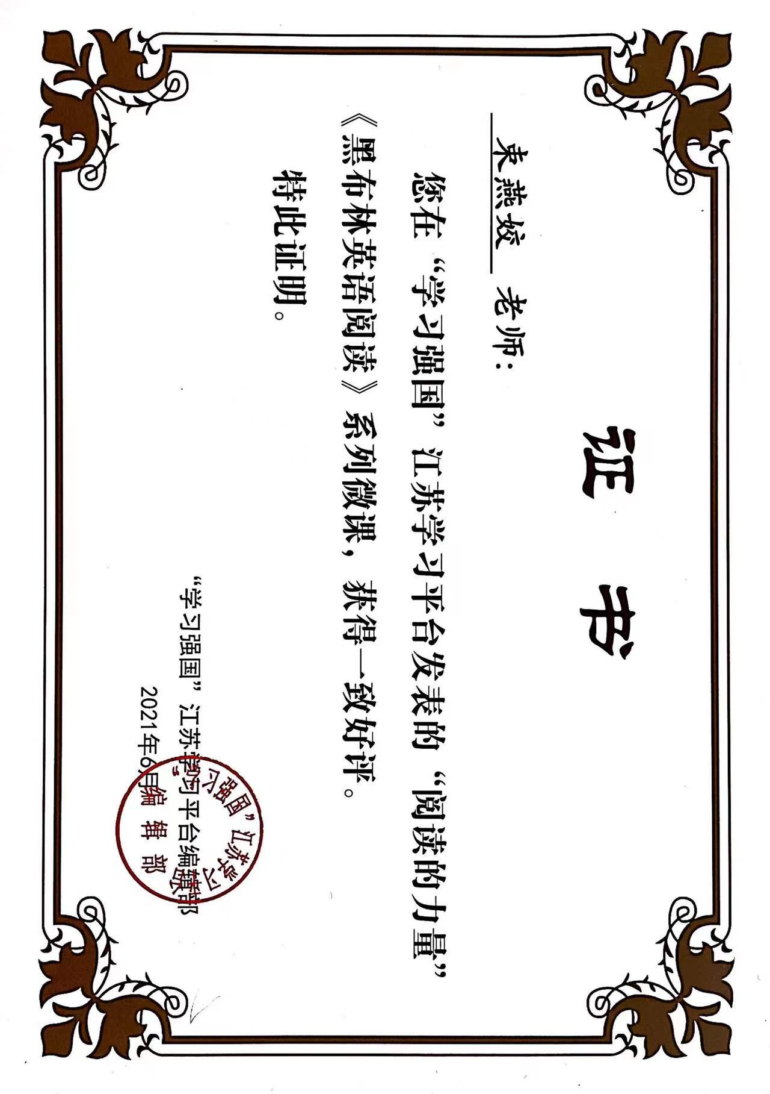

戴潇潇执教黑布林绘本阅读微课《The fisherman and his wife》学习强国江苏学习平台
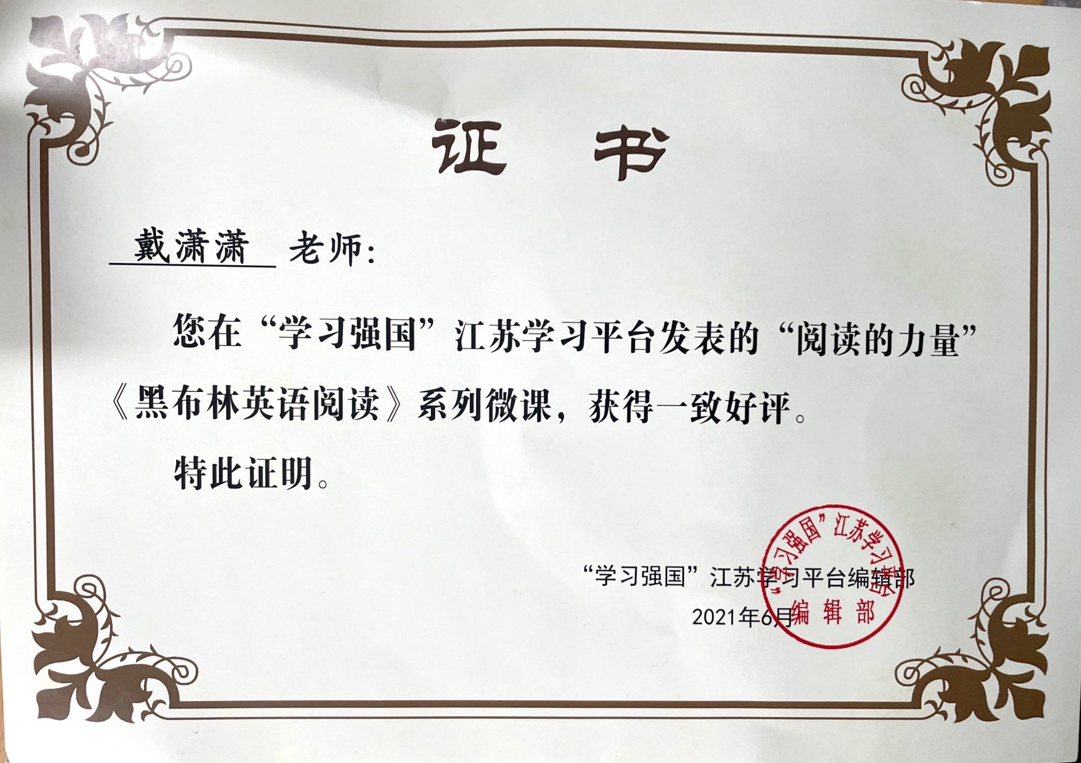

肖洁上市级公开课五上《Unit 5 What do they do?》
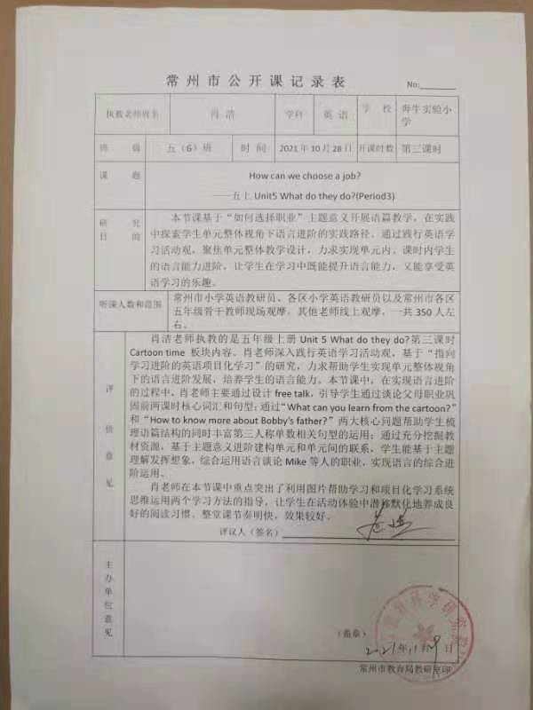
孙丹萍上区级公开课五上《Project 2 Our friends》
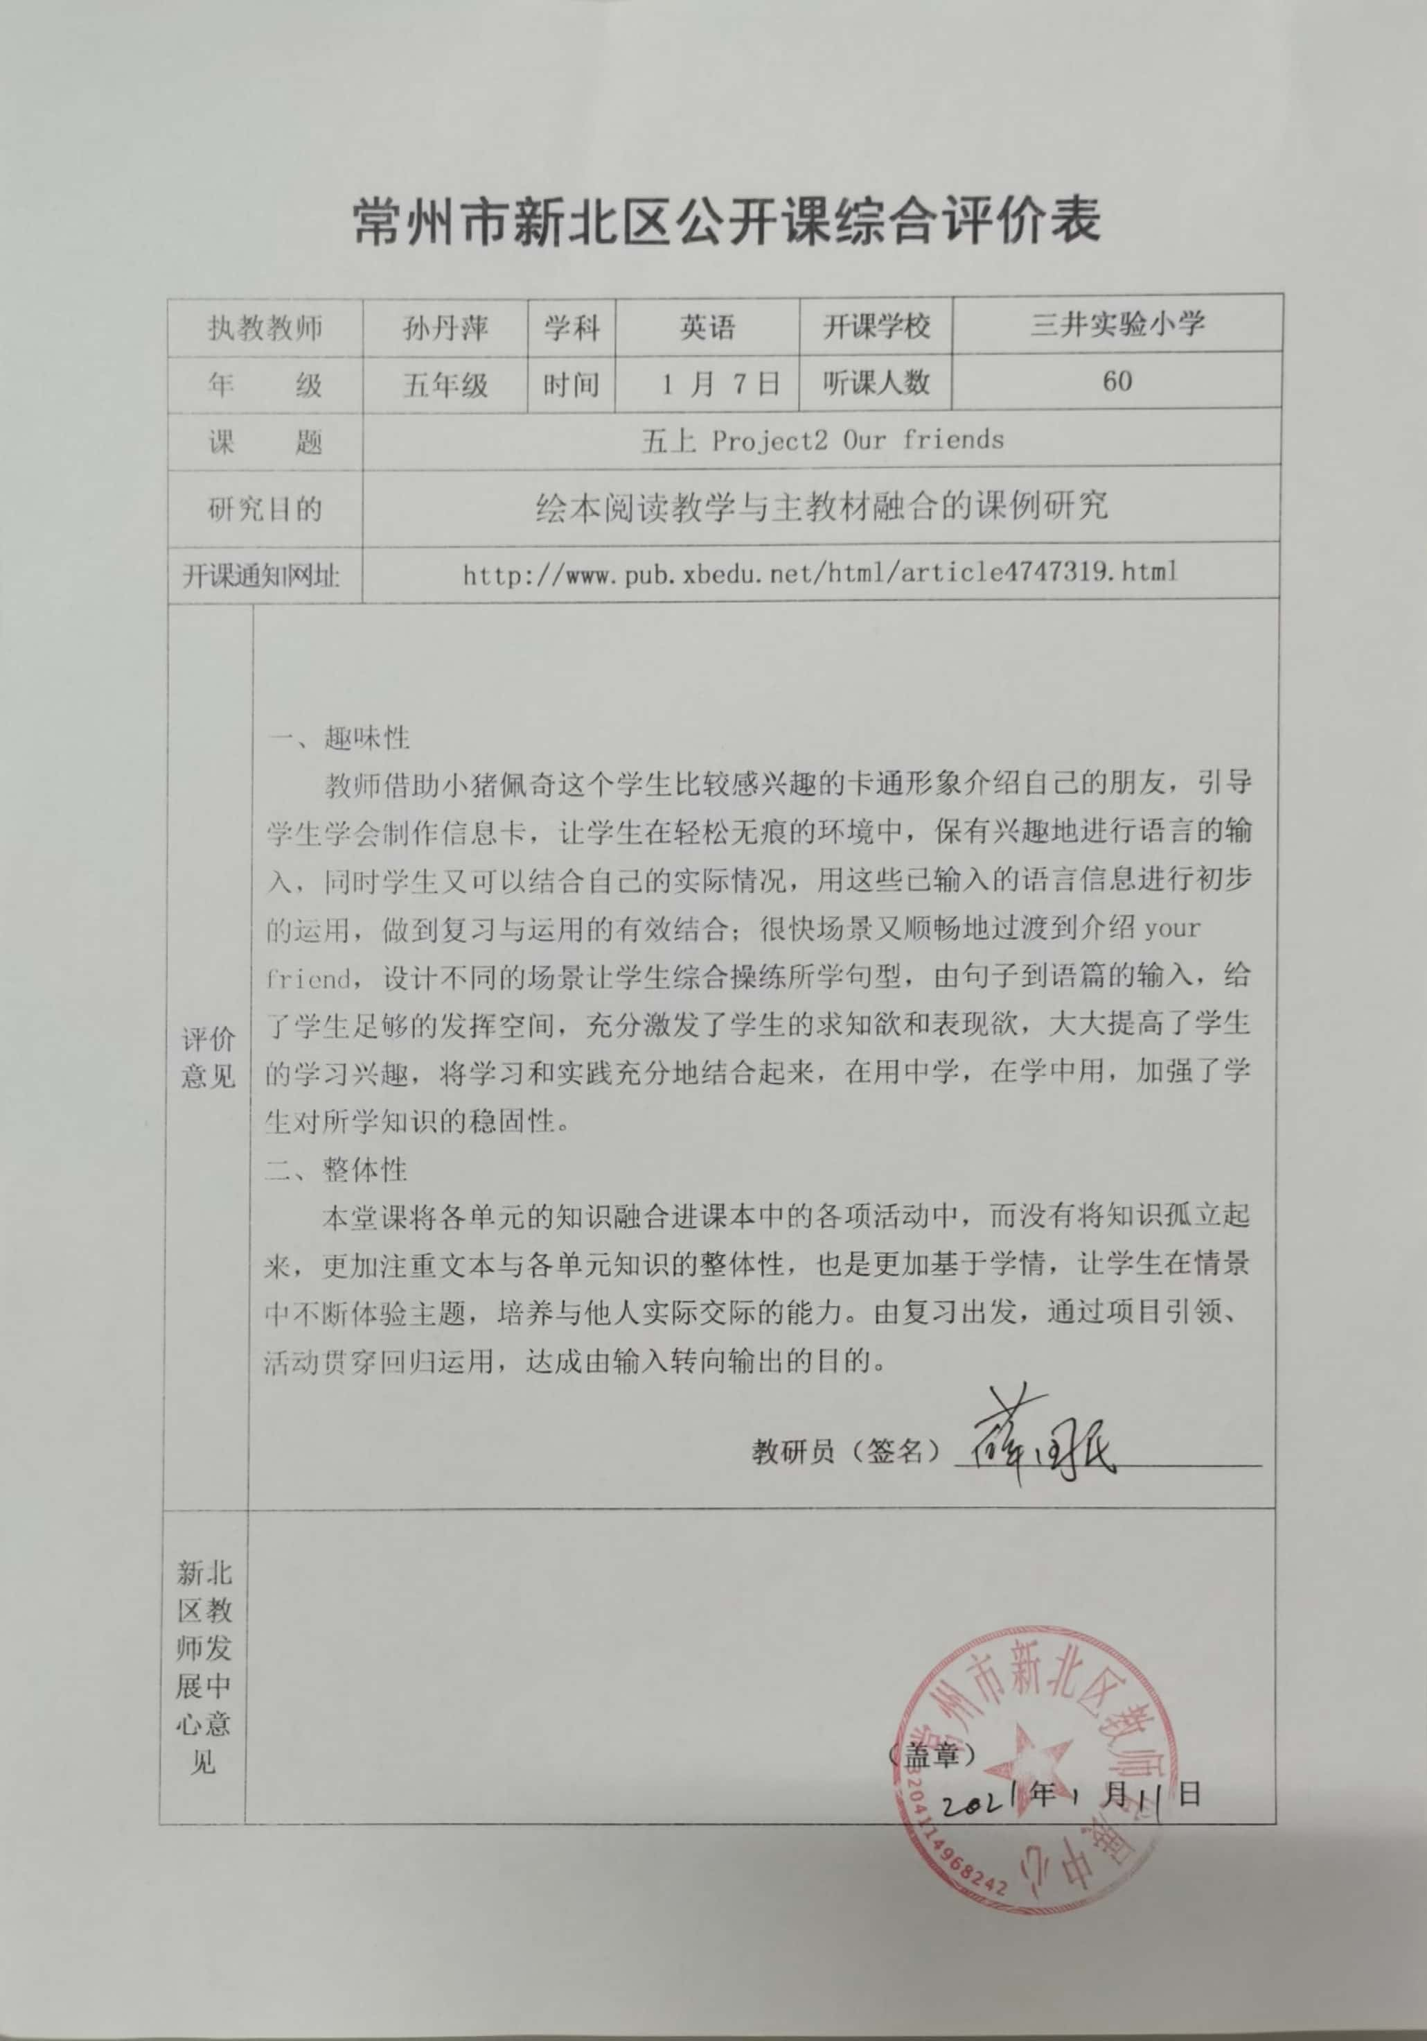

徐文娟上区级公开课绘本《The fisherman and his wife》
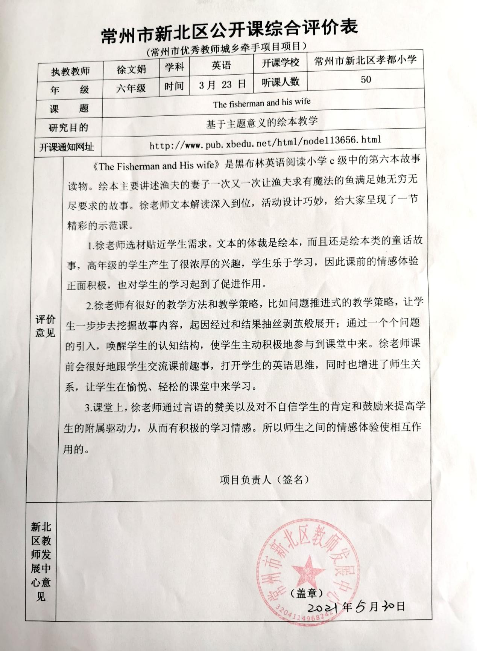

肖洁上区级公开课五下《Unit 4 Seeing the doctor》
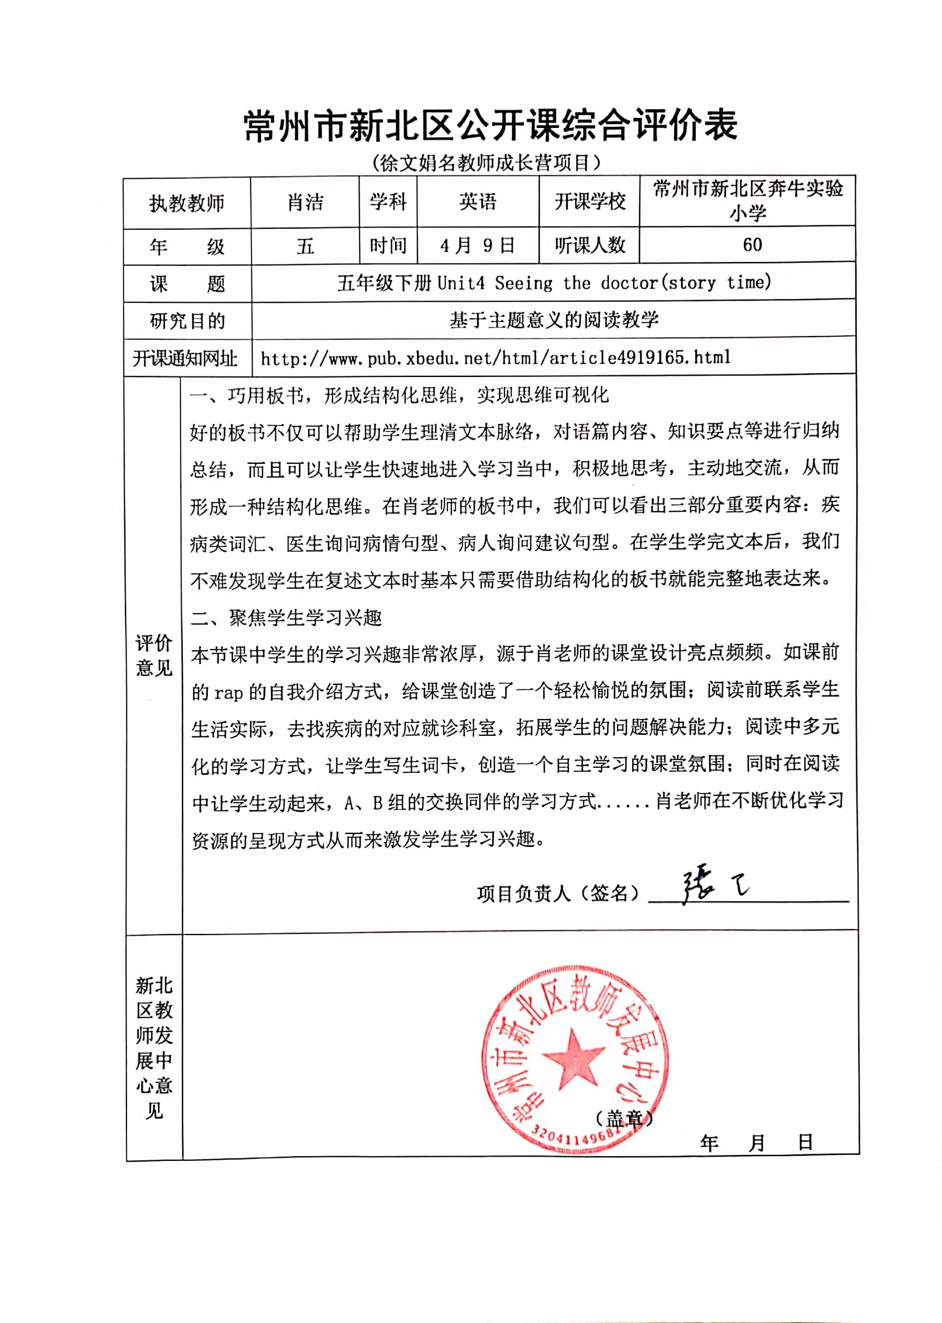

薛林上区级公开课五下《Unit 5 Helping our parents》
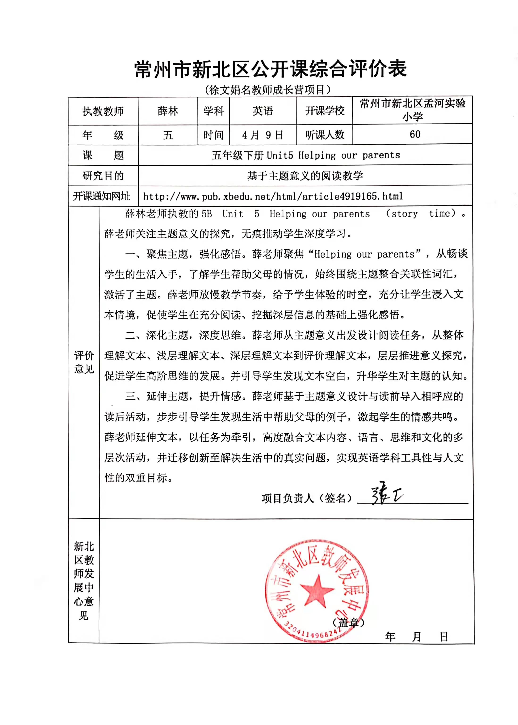

储丽娟上区级公开课六下《Unit 5 A party》
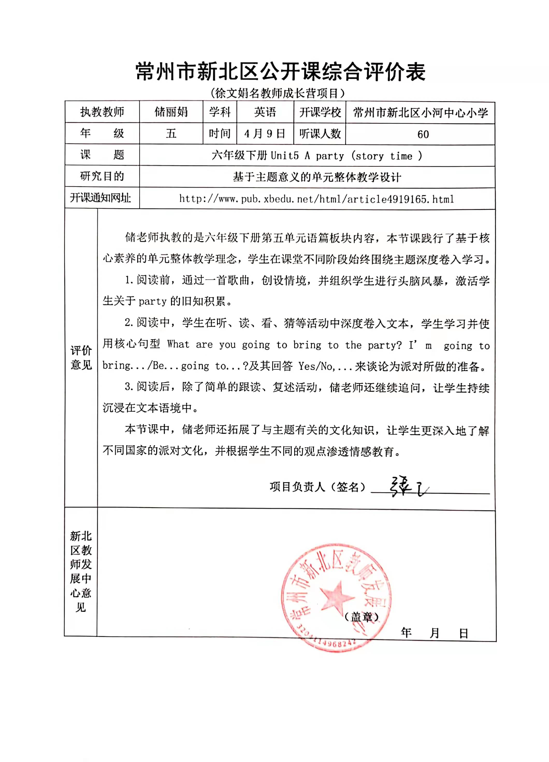

孙丹萍上区级公开课五下《Unit 7 Chinese festivals》

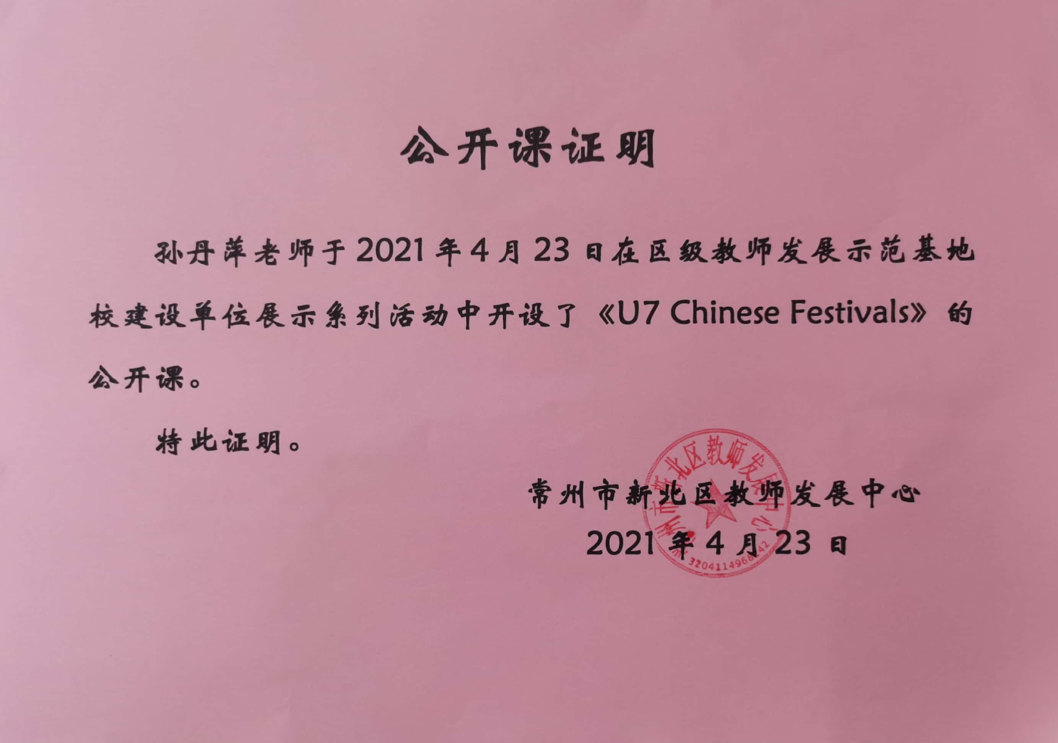

戴潇潇上区级公开课六下《Unit 8 Our dreams》
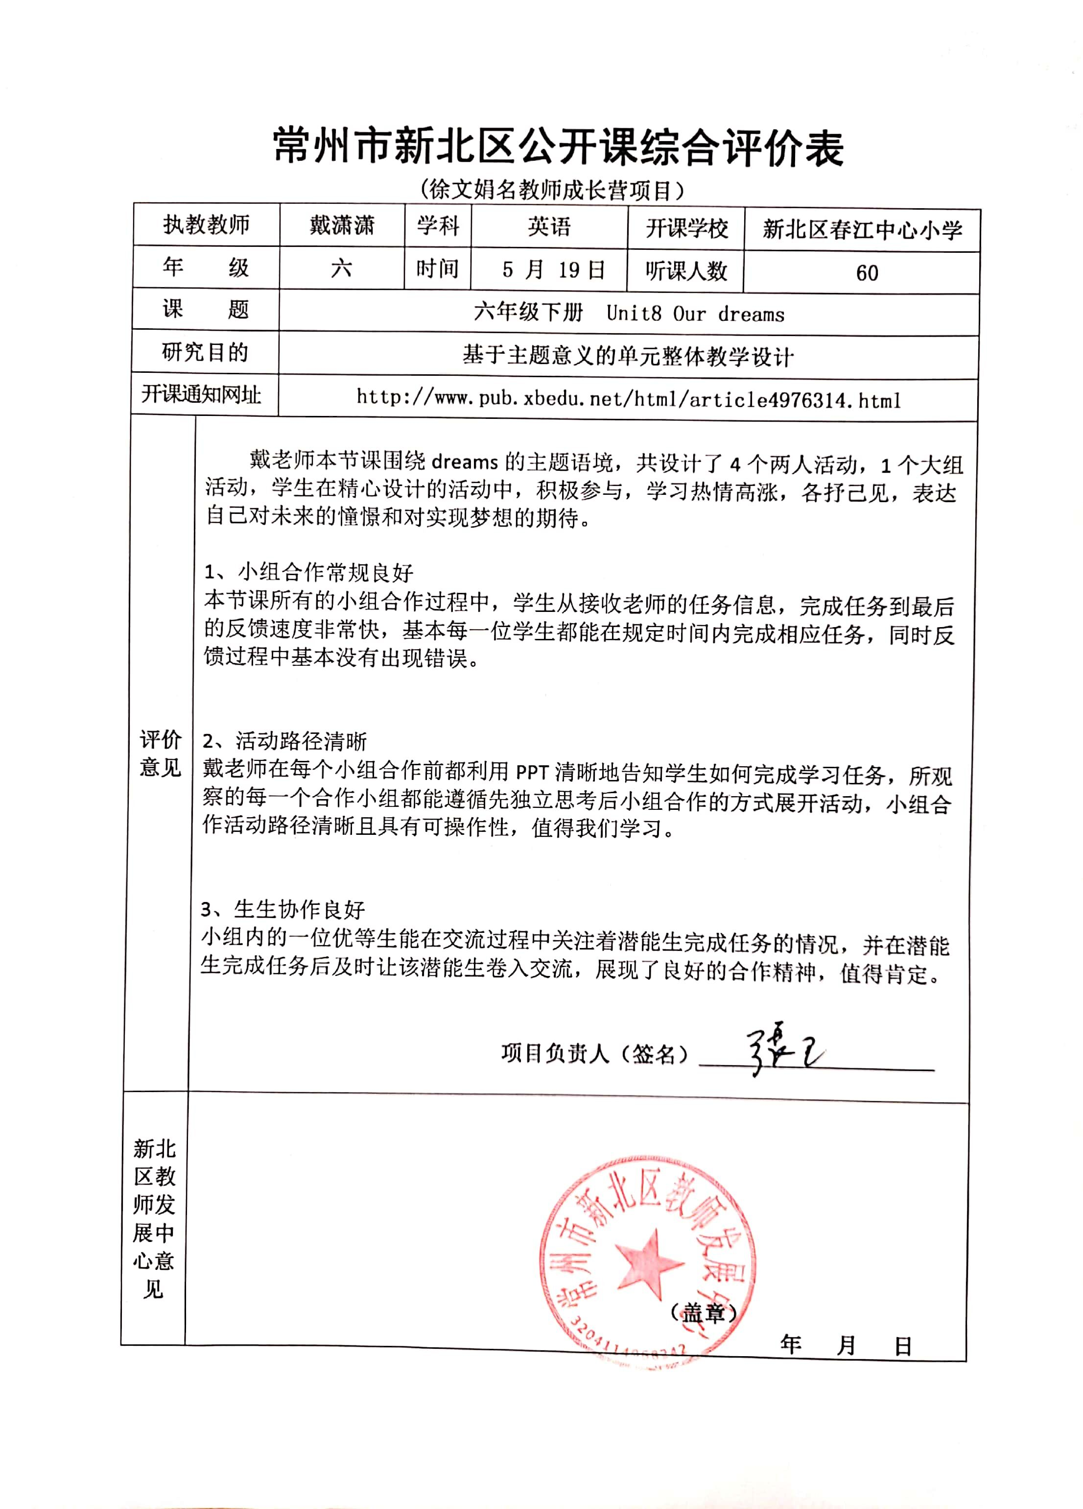

戴潇潇上区级公开课绘本《The fishman and his wife》
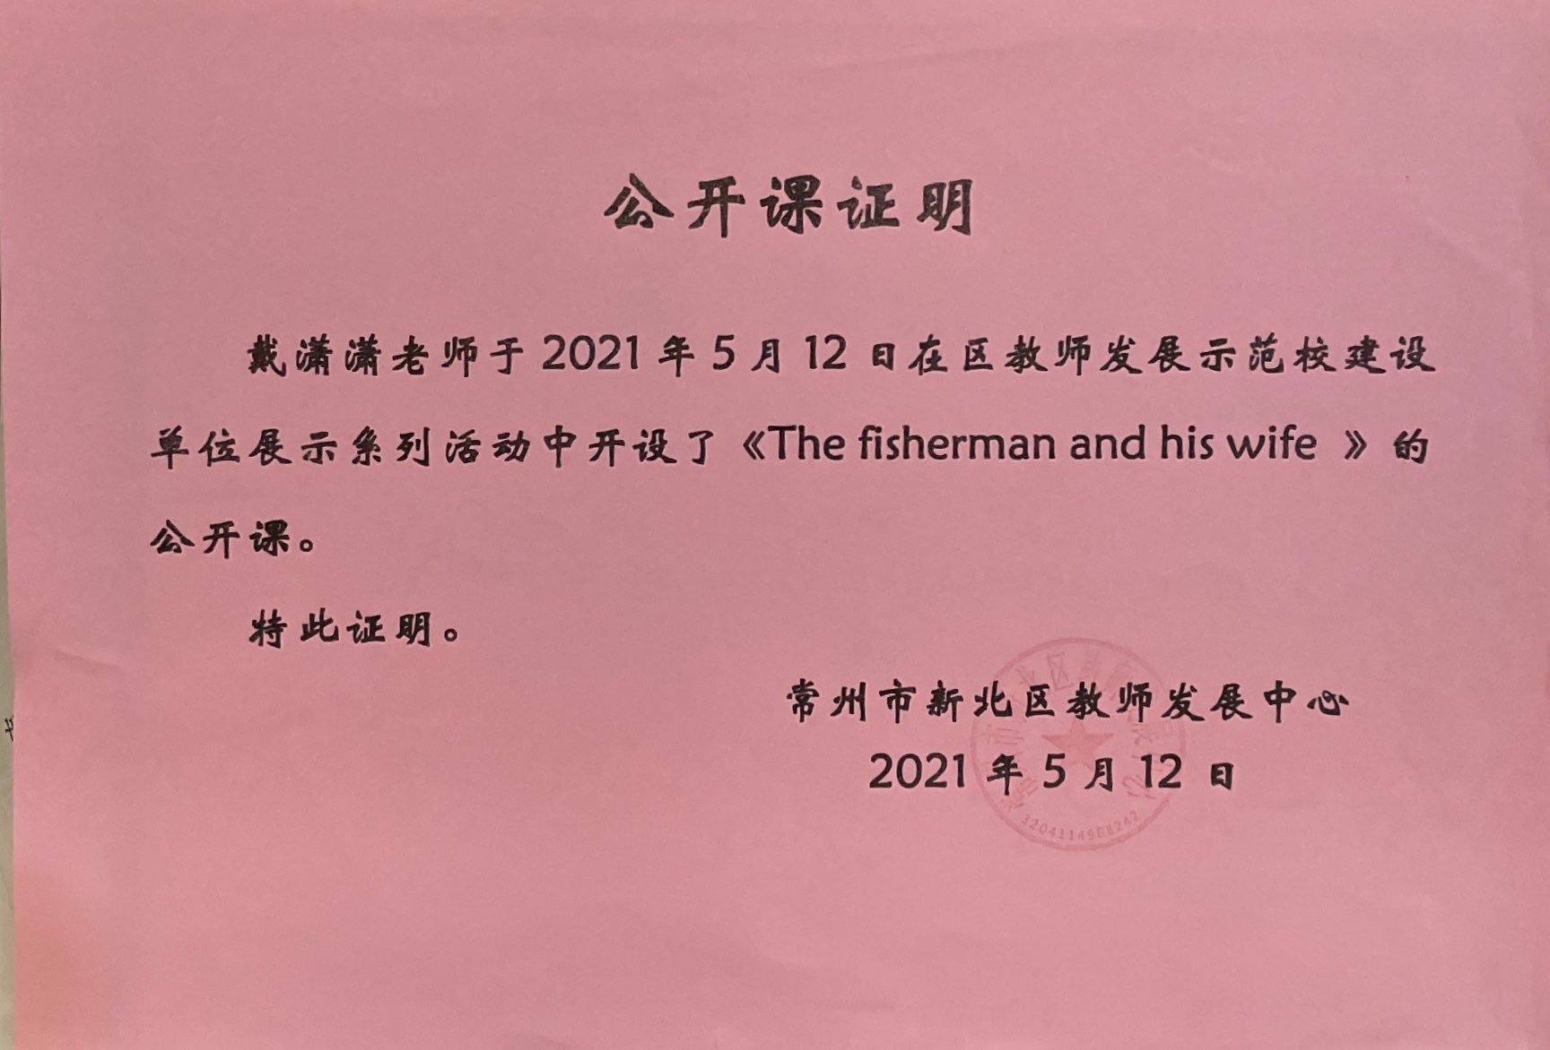
陈玲上区级公开课绘本《Mother!Dear Mother》
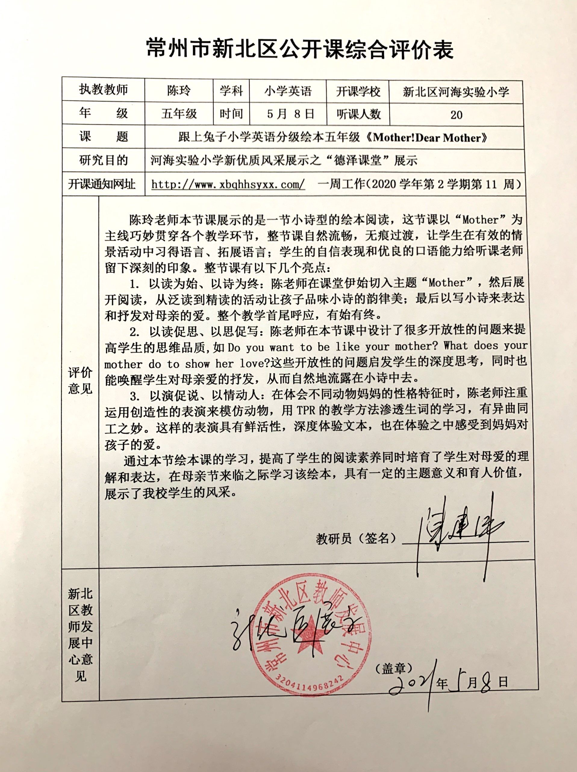

王晴晴上区级公开课六下《Unit 6 An interesting country》
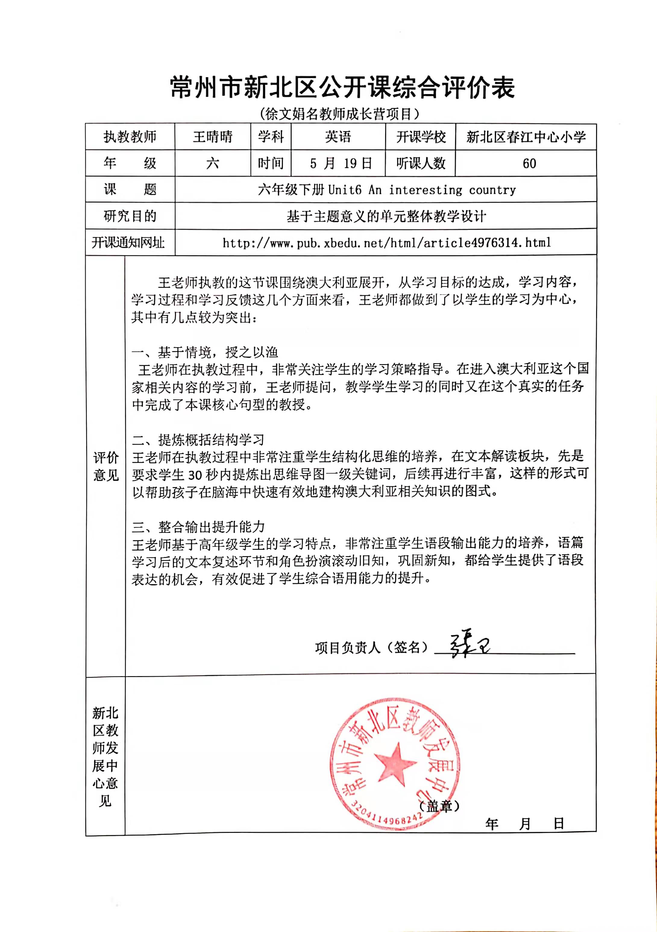

吴悦上区级公开课六下《Unit 5 A party》
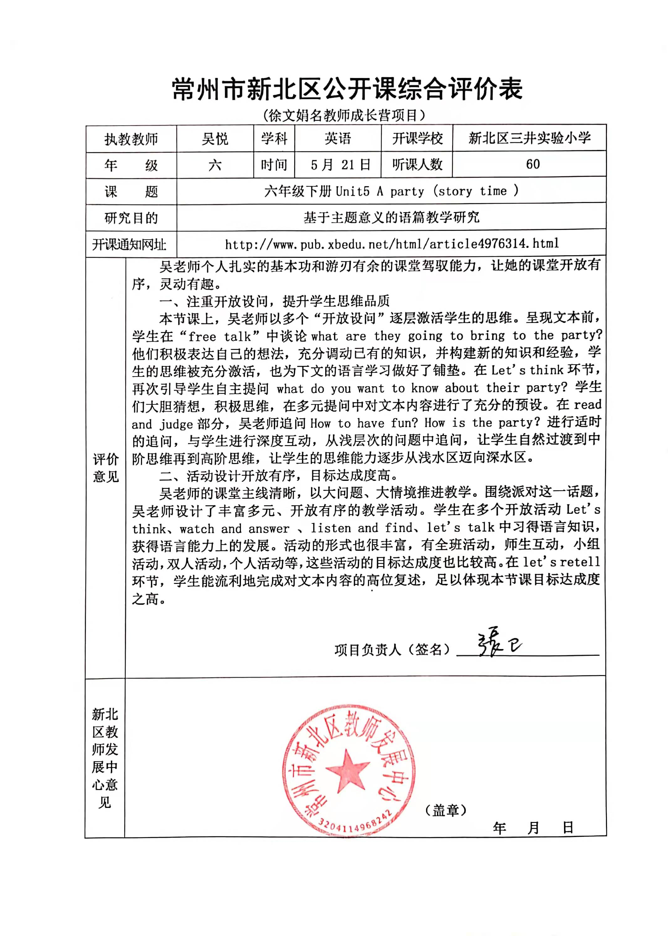

陈玲上区级公开课五下《Unit 8 Birthdays》
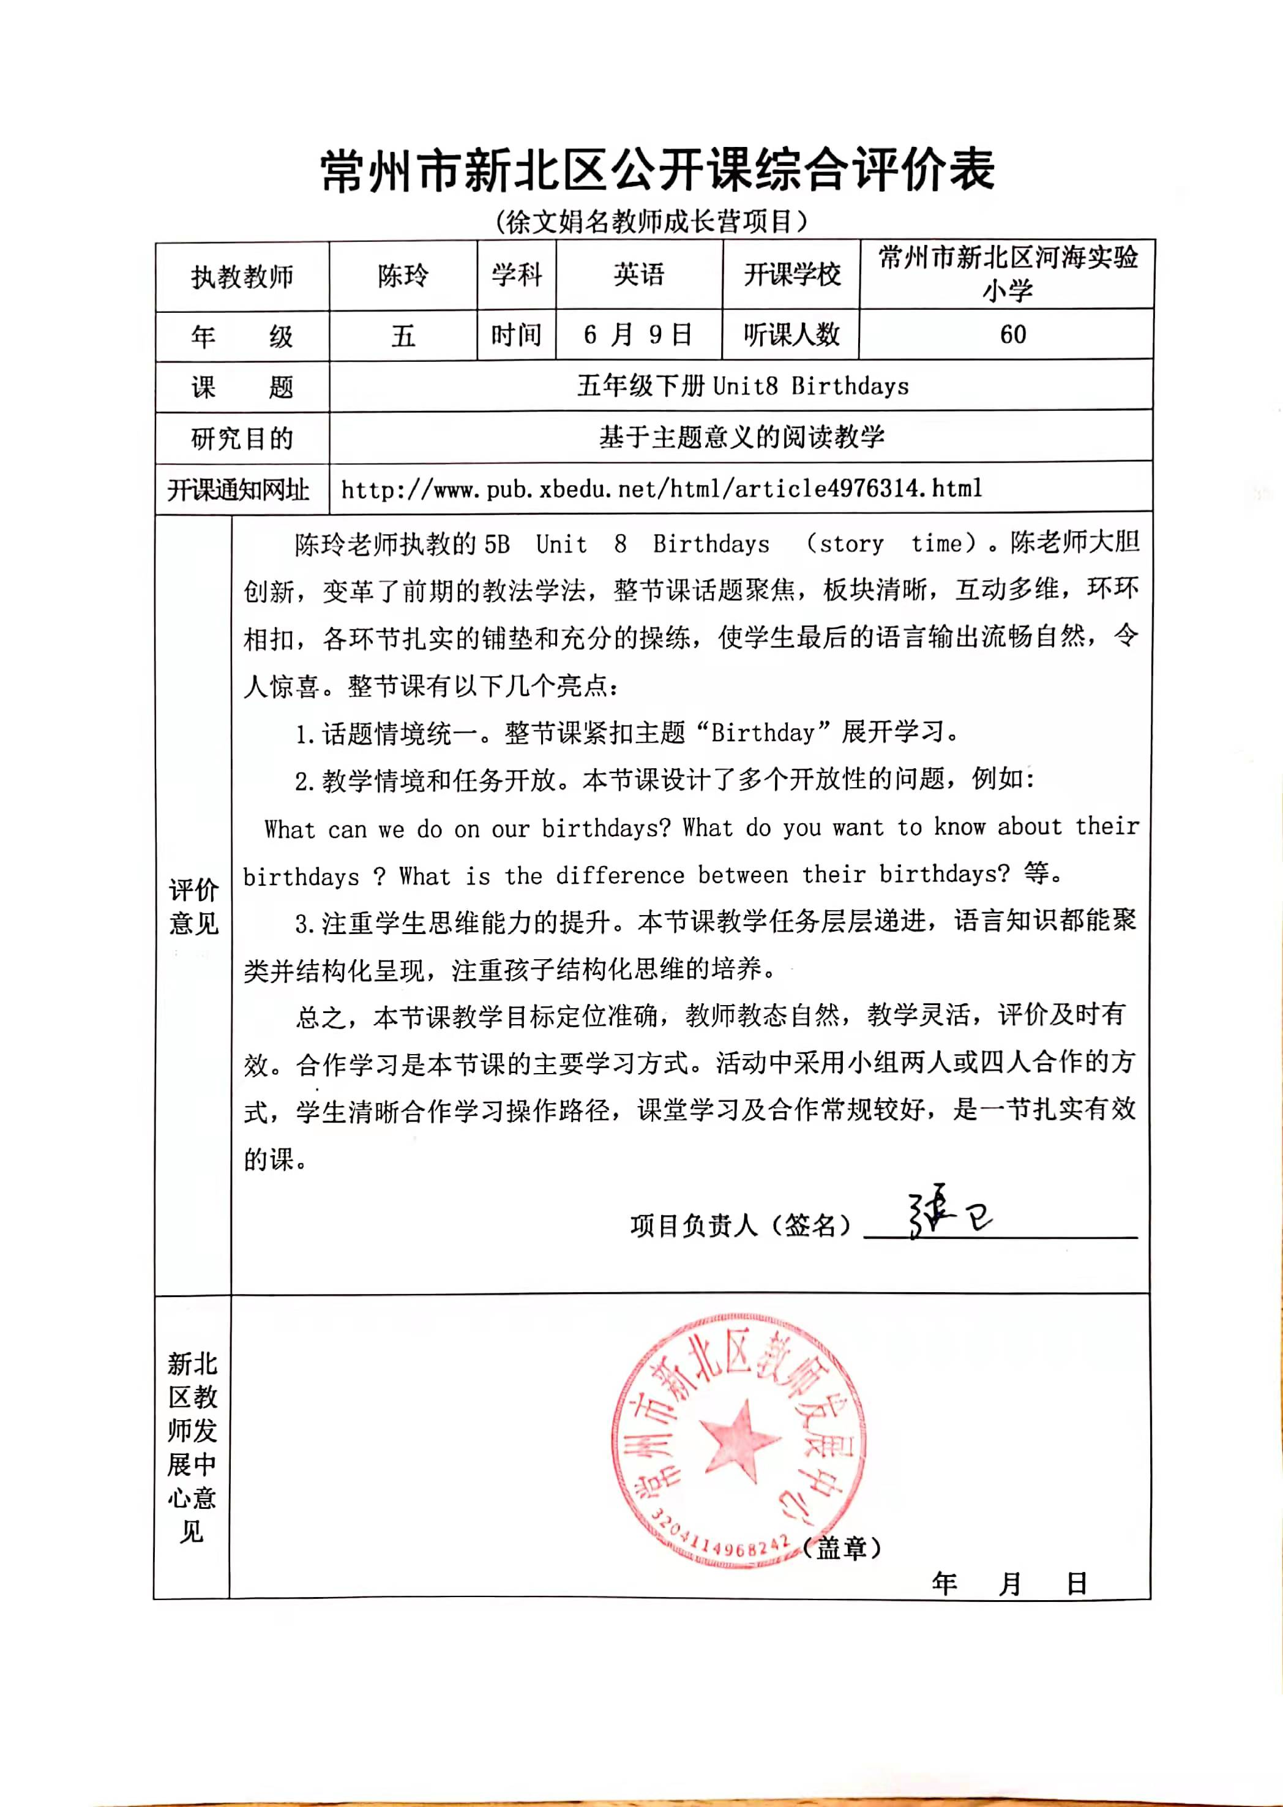

管静亚上区级公开课四下《Unit 6 How are you?》
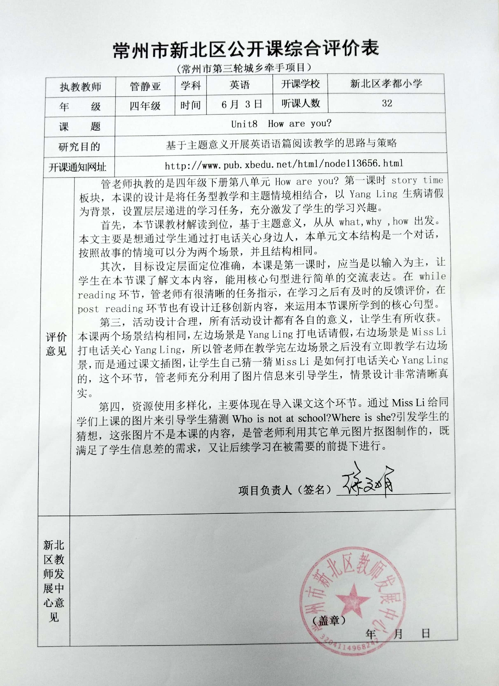

陆燕上区级公开课四下《Unit 5 seasons》
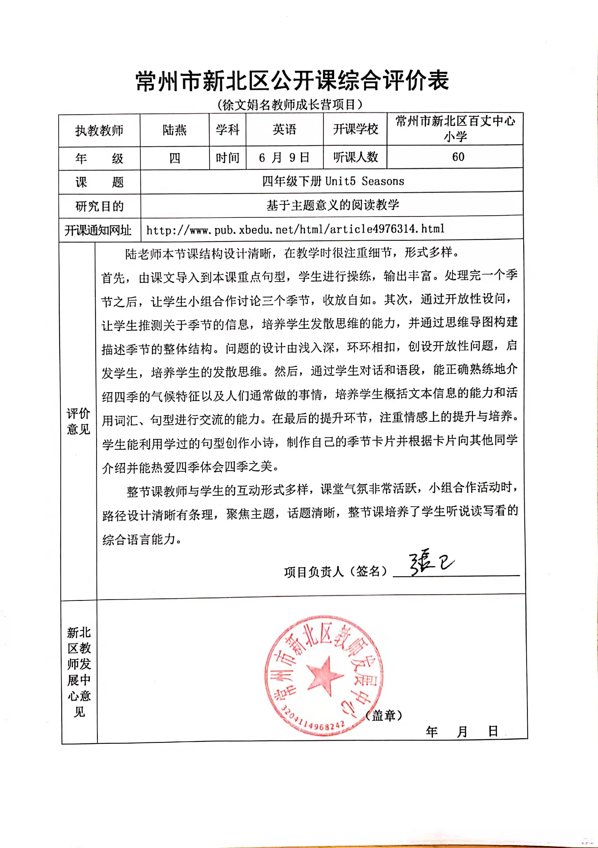

孙丹萍上区级公开课五下《Unit 8 Birthdays》
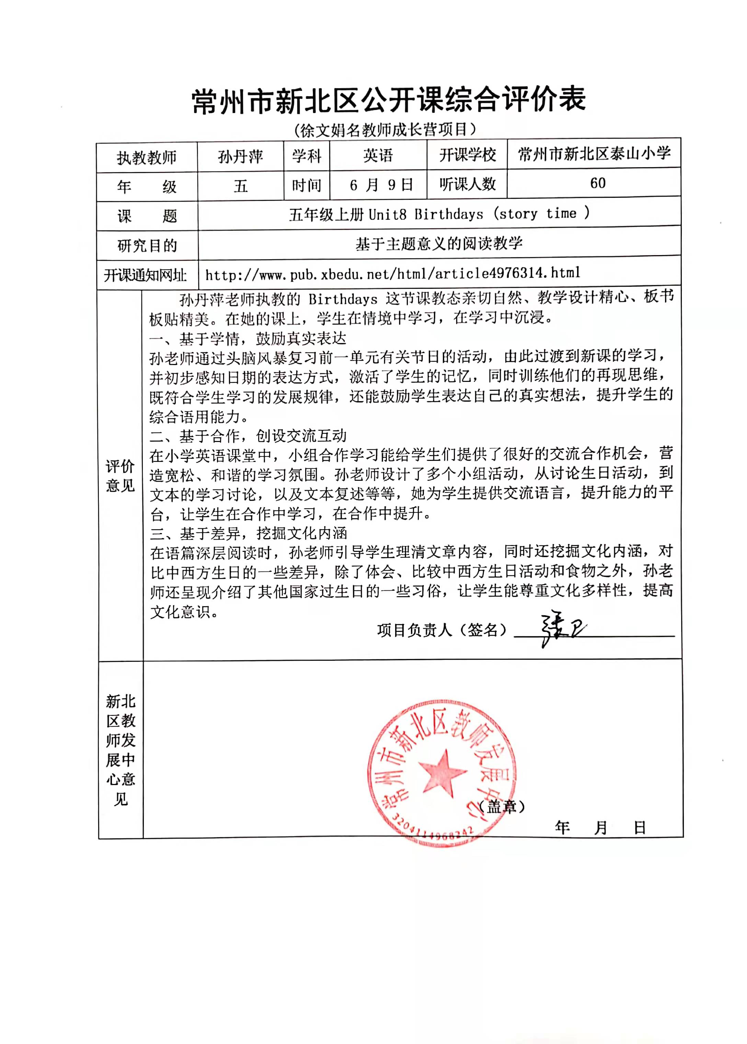

王晴晴上区级公开课四上《Unit 5 Our new home》
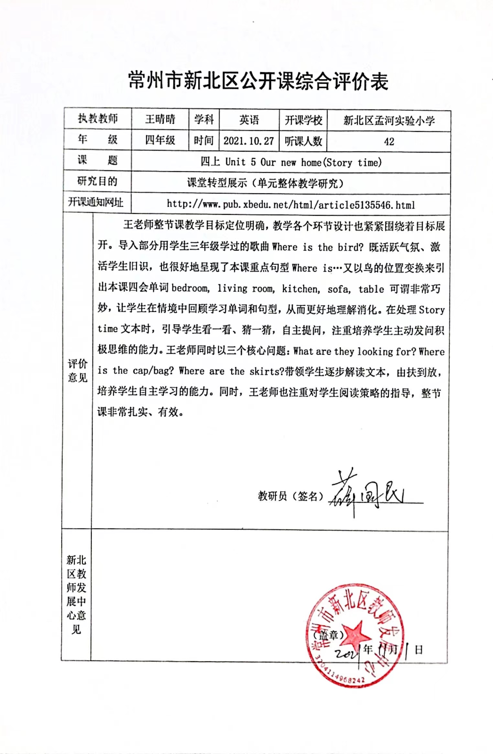

江颖上区级公开课五上《Unit 6 My efriend》
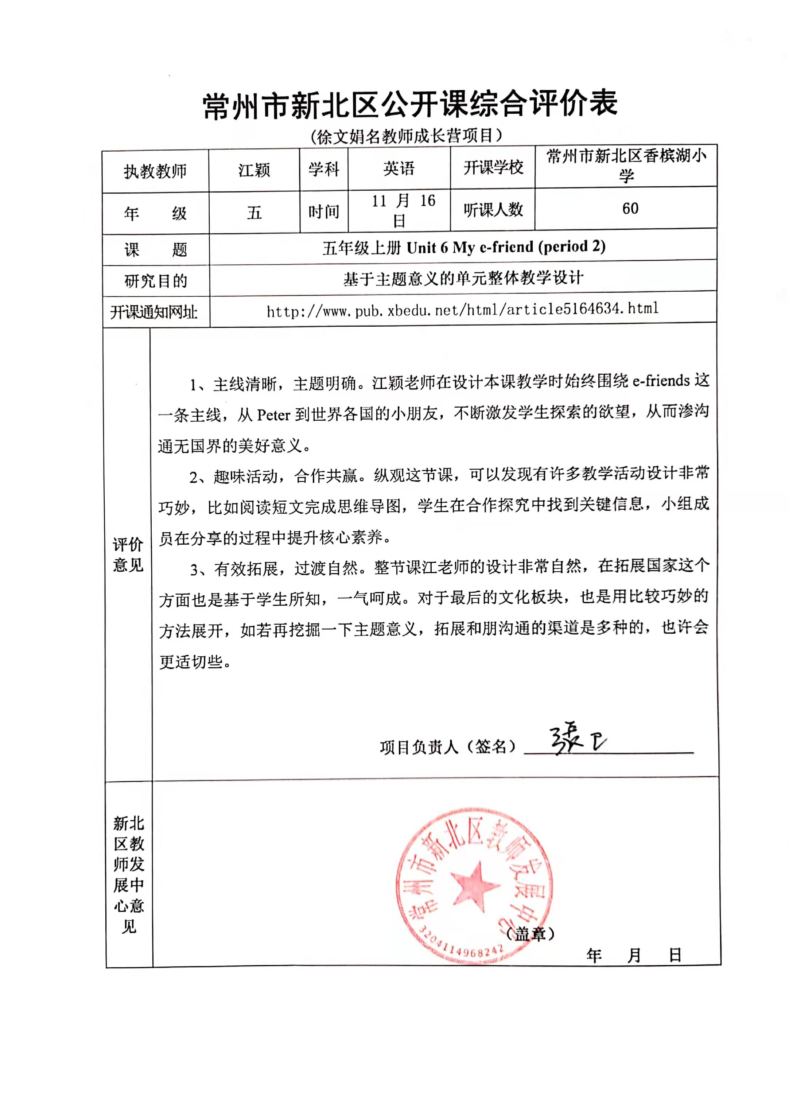

黄燕上区级公开课四上《Unit 4 I can play basketball》
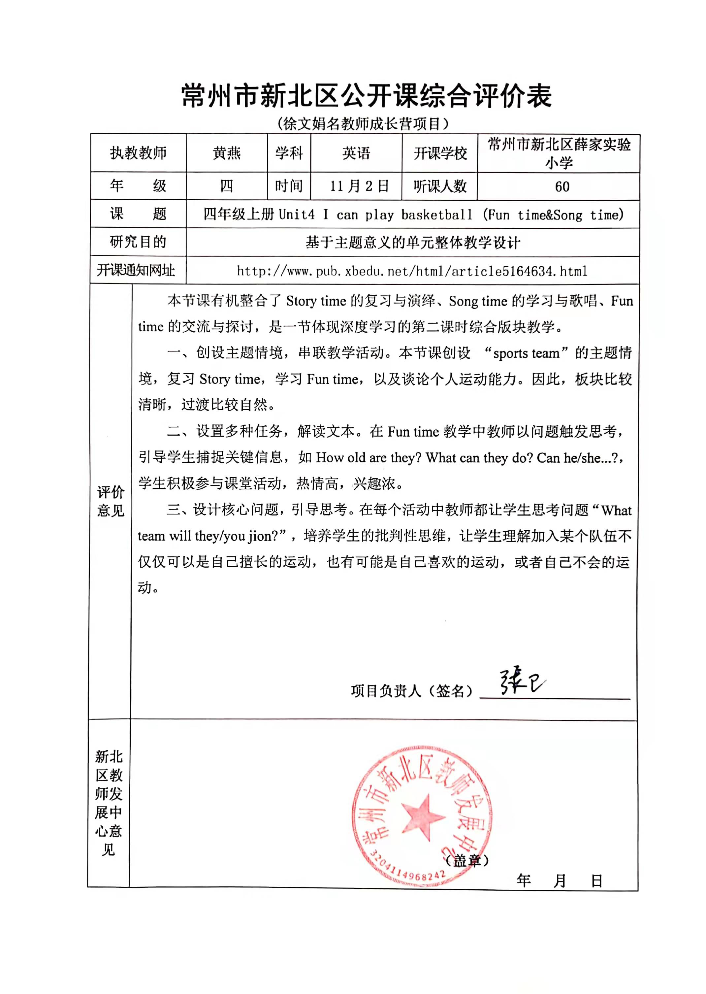

张妍上区级公开课四上《Unit 6 At the snack bar》
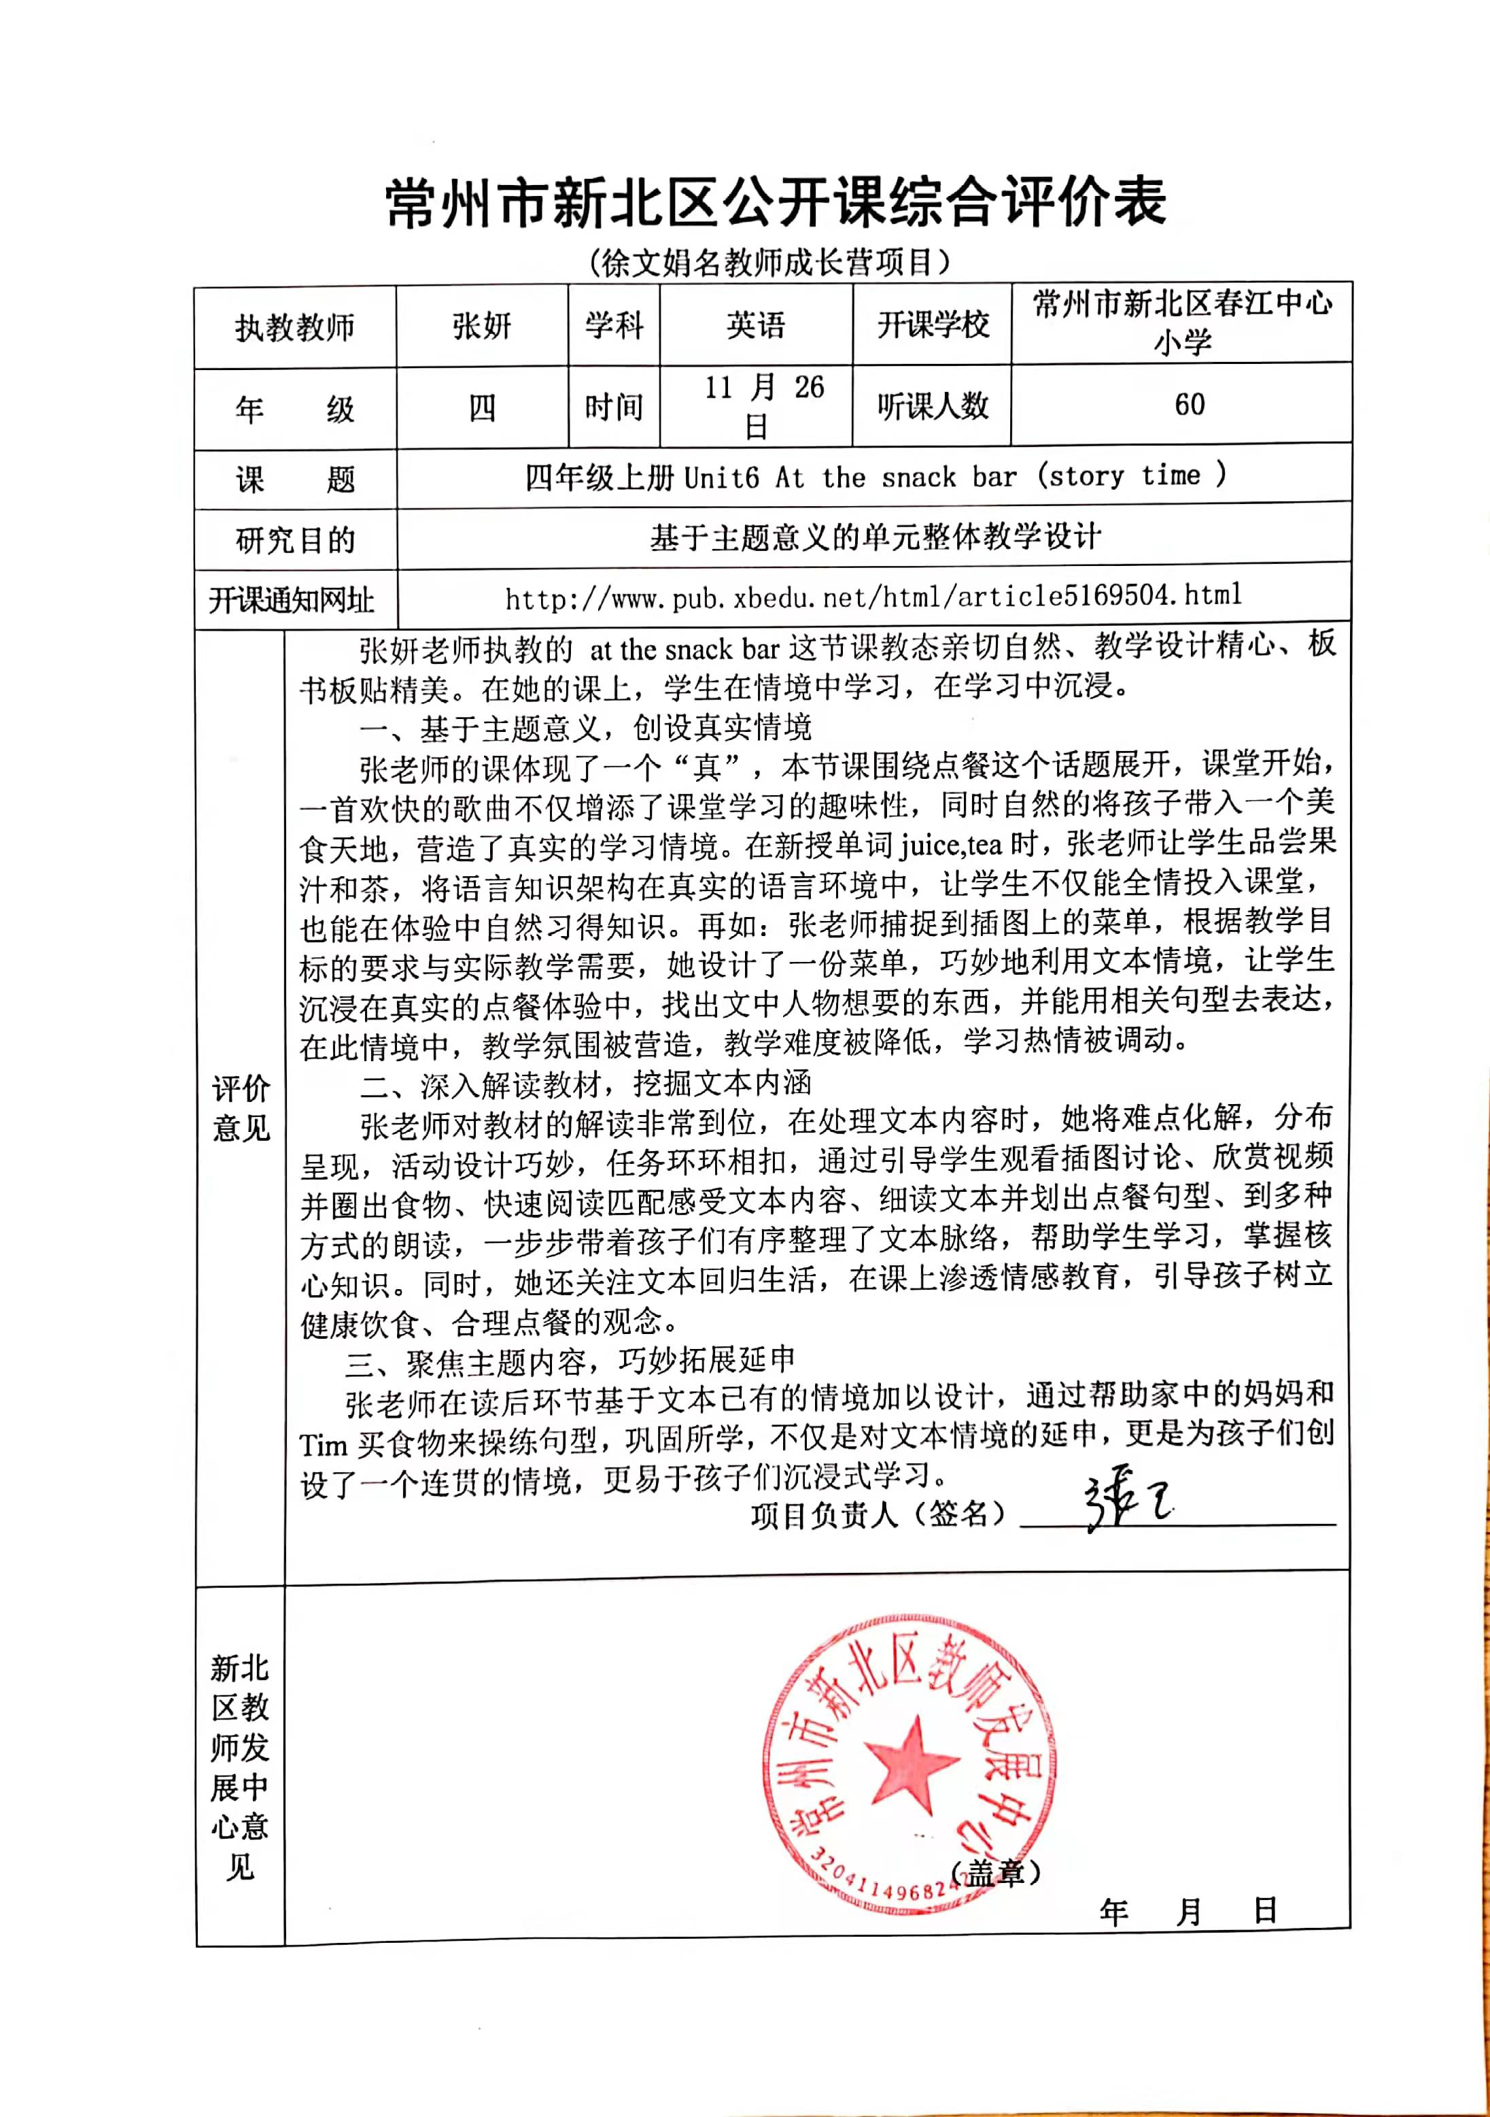

束燕姣上区级公开课五上《Unit 6 My efriend》
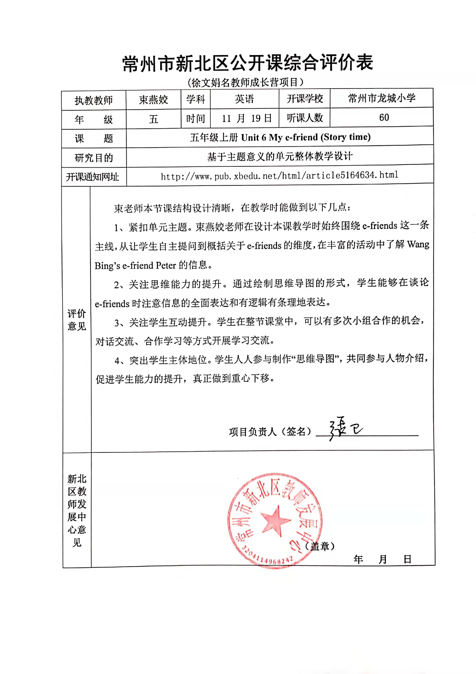

管静亚上区级公开课四上《Unit 6 At the snack bar》
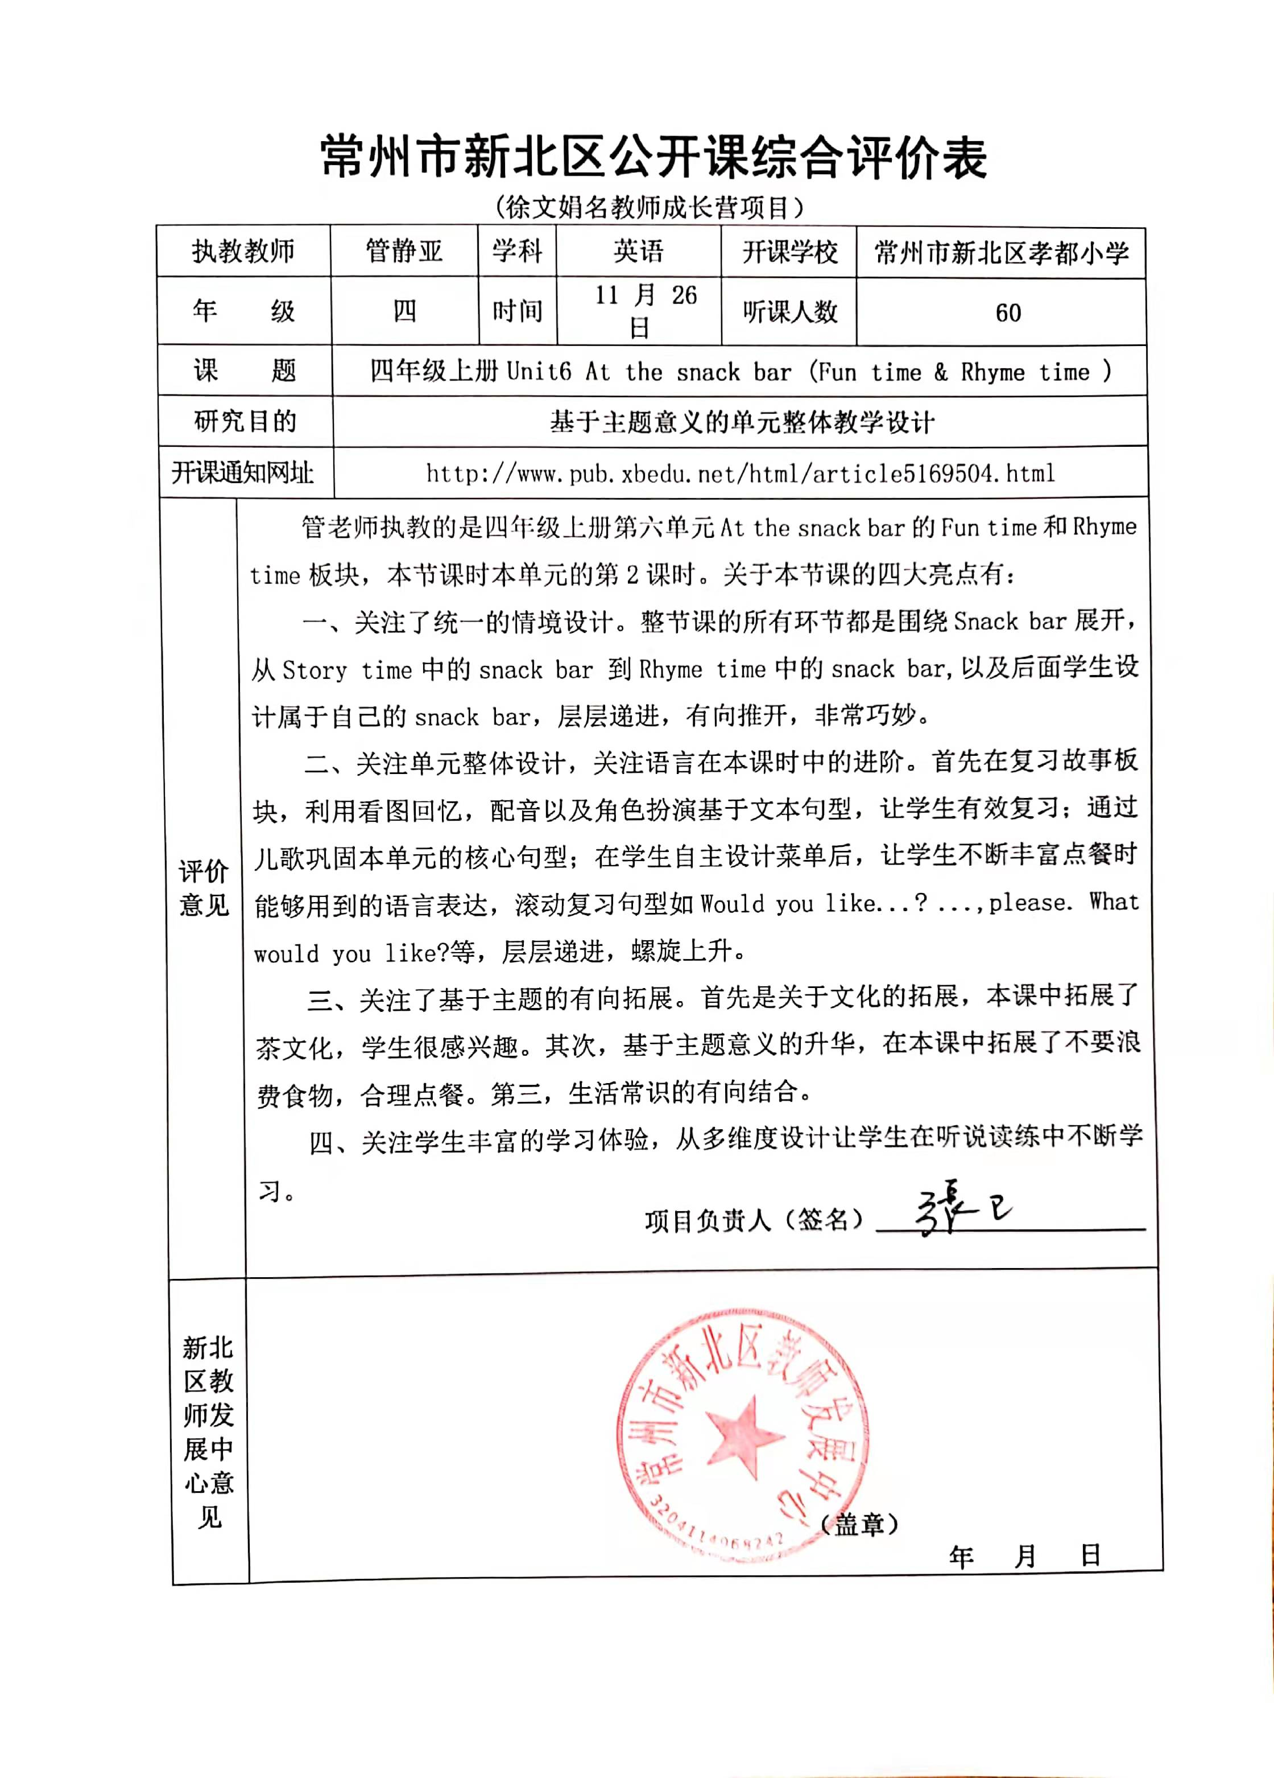

芮梨上区级公开课四上《Unit 7 How much？》
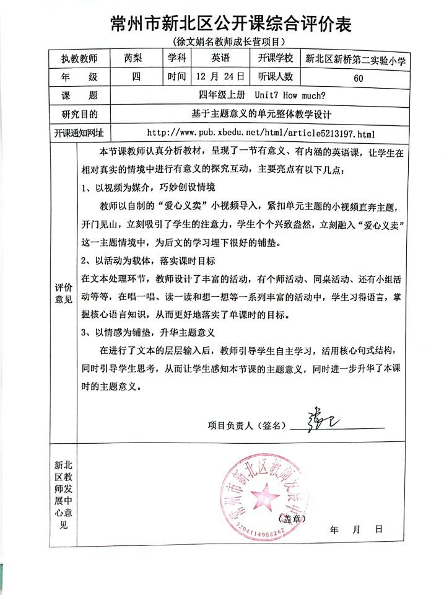
张欢上区级公开课六上《Unit 8 Chinese New Year》
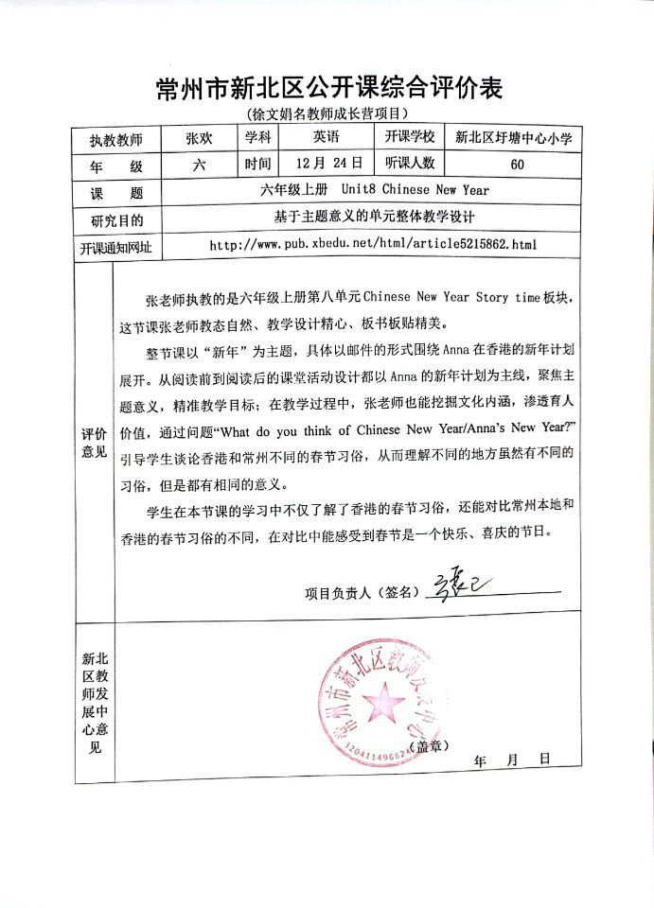
周敏颖上区级公开课六上《Unit 8 Chinese New Year》
