第一批录取名单公示网址：

<https://mp.weixin.qq.com/s?__biz=MzI2MTE5OTAzMw==&mid=2247485161&idx=1&sn=8eddc3ad50a52d551e03e0e4fd79ba46&chksm=ea5f433fdd28ca29e68abd7374f82166b96a027108f2bd2d6c1cb07422b93a551b0a28d89c5a&mpshare=1&scene=23&srcid=1203259M9MtjIXmRg0JgjivU&sharer_sharetime=1638525901452&sharer_shareid=5bd7f666bf8bb9412ba537dc9efb73c0#rd>

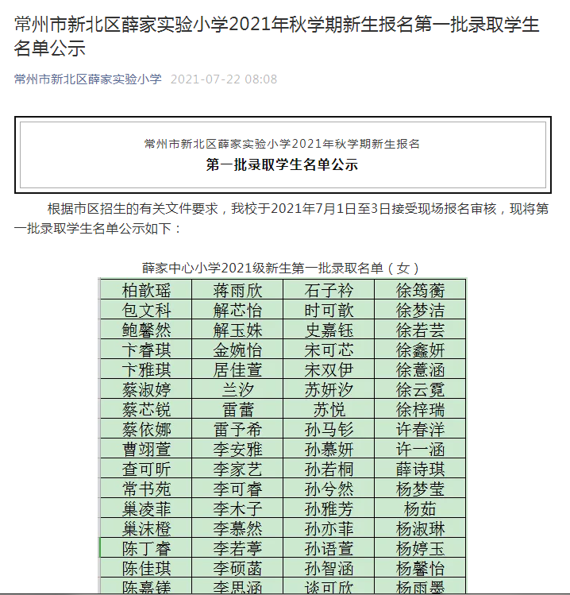

第二批录取名单公示网址：

<https://mp.weixin.qq.com/s?__biz=MzI2MTE5OTAzMw==&mid=2247485167&idx=1&sn=2db83640295b98b455a536684429ca1c&chksm=ea5f4339dd28ca2fc5b3a224762f497f2f87775d1cddea79f74a0f131aa1e1d095294bfc32fd&mpshare=1&scene=23&srcid=1203OrOPMhrnHzkf02L2veKP&sharer_sharetime=1638525913840&sharer_shareid=5bd7f666bf8bb9412ba537dc9efb73c0#rd>

