交往互动式教学设计
课题 |  | Unit4 Then and now |  |  |  | 教时 |  | 第一课时
 |  |  |  |  |  | 日期 |  | 9月 21 日
教学目标：  1.听说读单词then and now ,e-book, mobile phone, newspaper, radio, telephone, e-friend, anywhere,并能运用于语句中。  2.掌握动词过去式的发音及用法，会说…years ago,…could/ could not…Now,…  3、能通过观看视频、阅读文本等方式理解文本内容，形成思维方法；  4.能正确地理解并朗读文本内容，用创新的方式演绎对课文的理解，提高了合作能力和创新能力；  5、能借助文本，尝试谈论自己家庭生活的变化；  6.通过过去和现在的对比，感受到e时代给生活带来的巨大改变，从而深切感受到社会的进步。 |  |  |  |  |  |  | 重 点  与  难 点 |  | 教学重点：能正确地理解并朗读课文内容，在教师的引导和帮助下尝试复述课文内容.  教学难点：能了解社会的变迁，能正确使用一般过去时和一般现在时谈论过去和现在的事情。
Teaching Procedures
Time | Steps |  |  | Teacher’s activities | Learners’ activities |  |  |  |  | Purpose, Feedbacks &Aims
5  min | Step 1  Warming-up  吸引注意，积累语言 |  |  | Say something about my special friend:mobile phone.  Say something about the life 20 years ago. | Know something about the teacher life |  |  |  |  | 通过交流信息工具在生活中的运用学习新词，达成目标1
25 | 核心过程 |  | Step2  Pre-task  导出目标，生成结构 | 1.compare the teacher’s then and now.  2.Ask the students to say something about the their then and now. | 1.Know somethings about the teacher’s then and now  2.show the stuents’ then and now  Work in pairs:  Then, I was ...I could...  Now,I am ...  I can .... |  |  |  |  | 对比教师过去和现在的生活，呈现核心词汇和核心句型，学生交流自己六年前后的生活。达成目标2
25 |  |  | Step3  Task 1  回忆相关知识，初步运用结构 | - Talk about Mike’s family and try to know the change of the time with the help of the text.  - Guess: What are the changes about Mike’s family?  Organize the pair work and class work,write on the blackboard.  - Listen and tick: What are the changes?  Write more on the blackboard. | 1.Talk about Mike’s family and find the change of time:  Six/twenty/thirty years ago.  - Guess the changes about Mike’s family in pairs, then say in class.  - Watch the vedio and know more about the changes about Mike’s family.  Look at the blackboard and read. |  |  |  |  | 通过文本预测和观看视频，理清文本脉络，整体了解过去和现在的生活的变化。达成目标3.
25 |  |  | Step4  Task 2  呈现刺激材料，活用结构 | - read and write on Page38.  - watch in groups and try to help them when they need  - Ask some of the students write on the blackboard.  - Check on the blackboard and focus on some new words.  2.Read the story time.  随机指导 | 1.Read and write  Group work:  (1)Read and write on Page38;  (2)Read the answer in groups, help each other.  (3)check and read together.  2.read the stroy time. |  |  |  |  | 通过细读文本、同桌交流、全班反馈、等方式进一步理解文本内容。 通过朗读进行强化，同时梳理文本结构。达成目标3.
25 |  |  | Step5  Task 3  引发期待行为，强化结构 | 1.choose one person to act in pairs.  2. Changes: the way to contact people/ get news/ make friends/do shopping. | 1.read and act.  (1)choose one way to show（方式自选）  2.sum up with the help of the teacher. |  |  |  |  | 通过表演体现学生对文本的理解，为学生搭建语言创造的平台。达成目标4.
10  min | Step6  Post–task  提供反馈评价，巩固结构 |  |  | 1.Topic: changes of my family.  (1)show my topic: changes of my family.  (2)Organize the students to talk in pairs.  2. Watch the vedio: E-time  3. Homework:  (1)read the story time.  (2)write the topic: changes about my family. | 1.Understand the teacher’s model and talk about it in pairs.  Show in class.  - Watch the vedio: E-time  3. homework |  |  |  |  | 结合文本谈论自己家庭生活的变化。达成目标5.  通过观看视频，感受E时代给我们生活带来的巨大变化，达成目标6.
板书设计 |  |  |  | 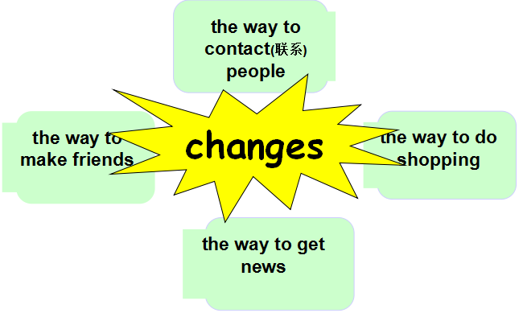  Unit4 Then and now

