Unit 1 The Olympic Games
Lesson 1
Modern Olympic Games began in Athens, Greece in 1896. They are an international sports competition and are held every four years in a different city. Players from different nations compete against each other.
There are two types of Olympics: the summer Olympics and the winter Olympics. Until 1992 they were both held in the same year, but since 1994, they have been held alternately in every even-numbered year. For example, the 19th winter Olympics were held in 2002, and the 28th summer Olympics took place in 2004.
As is known, the 2008 summer Olympics has been held in Beijin, China successfully.
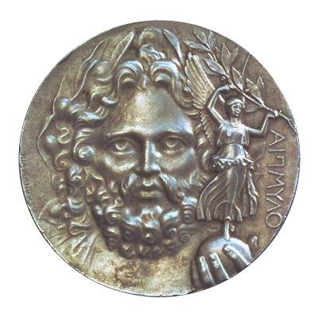

Lesson 2
The Olympic Flag and Rings
The Olympic Flag, with five interlinked rings on it, is the official symbol of the Olympic Games. Baron Pierre de Coubertin(皮埃尔.德.顾拜旦男爵 现代奥运会倡导创办人被誉为 “奥运之父”) designed the flag around the year 1920. in his words, (用他的话来说,他说) “These five rings represent the five parts of the world. This is a real international emblem.” The interlocked rings represent the unity of the five continents of Africa, America, Asia, Europe and Oceania.
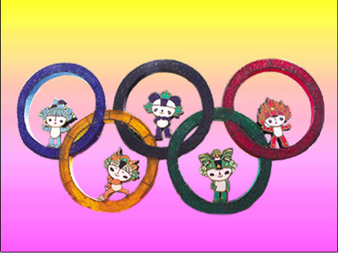
The colours of the rings are ---from left to right ---blue, yellow, black, green and red. The plain white background symbolizes the peace throughout the games. The five colors of the rings do not represent any single continent. They were chosen because at least one of them is found on the flag of every nation. The Olympic flag made its first appearance at the twentieth Olympic Games in Antwerp(安特卫普,比利时港市), Belgium.

Lesson 3
After years of waiting, it is official:Beijing will host the 2008 Olympic Games. Now the long years’ aspiration to host the Games has turned into reality.
The preparations for the 2008Games will require striving to widen roads, clean up the Olmpic Village, thus the young and talented will be offered more oppoutunities.
As China is preparing to play host to the world, learning English is becoming more important to us Chinese.
That China is to hold the 2008 Olympic Games shows that it is now a powerful and beautiful country. The responsibility of making our country more beautiful lies with us all, and it’s high time for us to get to work!
----Adapted from 21st Century
July19, 2001
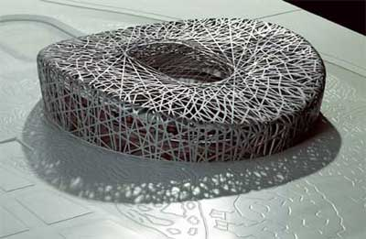

Lesson 4
The emblem of the Beijing Olympic Games
When people hold the Olympic Games, they always make an emblem. The emblem of the Athens Olympic Games in 2004 is a white circle of oliver branches in the sky.
Athens is developing a spirit of peace. An officer said, “while in time. We would like the message from the Athens Games to help countries come together and solve their problems.”
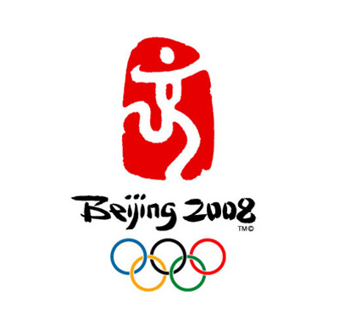
The 29th summer Olympic Games was held in Beijing, China. And China also make a seal as the emblem of the Beijing 2008 Olympic Games. The emblem has a single Chinese character on a red seal and means “ Chinese seal –dancing Beijing”. Below it, there are the words “Beijing 2008”. The character in the emblems is “Jing”. It means “capital” of China and it is also like a runner or a dancer. The running figure of the emblem shows the spirit of the Olympics –faster, higher and stronger.

Lesson 5 Fuwa
Like the Five Olympic Rings from which they draw their color and inspiration, Fuwa will serve as the Official Mascots of Beijing 2008 Olympic Games, carrying a message of friendship and peace--and blessings from China--to children all over the world.
Beibei is the Fish, Jingjing is the Panda, Huanhuan is the Olympic Flame, Yingying is the Tibetan Antelope and Nini is the Swallow. When you put their names together--Bei Jing Huan Ying Ni--they say "Welcome to Beijing," offering a warm invitation that reflects the mission of Fuwa as young ambassadors for the Olympic Games.
Beibei
The fish stands for the blue Olympic ring. Among Fuwa, she is known to be gentle and pure, Strong in water sports. In China, fish and water stand for harvest. So Beibei carries the blessing of prosperity.
Jingjing
Jingjing represents the black Olympic ring. He makes children smile--and that’s why he brings the blessing of happiness wherever he goes. Jingjing is good at weight sports. His headdress means human get on well with nature.
Huanhuan
Huanhuan is the big brother. He is a child of fire. He is in the center, he carries the Olympic spirits. He is the most warmhearted and outgoing of the five and he represents the red Olympic ring.
Yingying
Yingying is smart and moves quickly. Like all antelopes, he is strong in track and field events. Yingying represents the yellow Olympic ring. Choosing the antelope shows that China wants a green Olympics.
Nini
Nini stands for the green Olympic ring. She is as happy and joyful as a swallow. She is strong in gymnastics. Nini’s golden wings stand for the sky. She brings good luck wherever she flies.

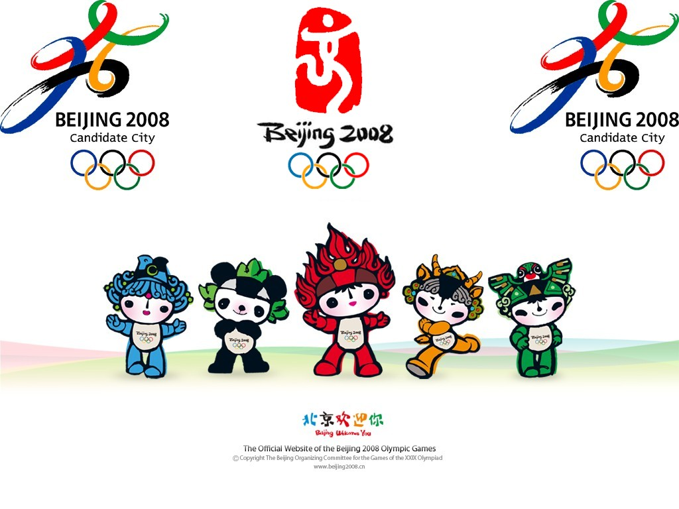

Lesson 6 The knowledge of Olympic Games
1． When was the first Olympic Games held? 第一次奥运会是何时举行的？ [B.C.776 公元前776 ]
2、.Where was it held? 第一次奥运会在哪里举行？
Olympia, Greece 希腊/奥林匹亚城
3、Who could not compete in the ancient Olympics? 什么人不可以参加古代奥运会？C. women 妇女
A. men B. boy C. women
4、At that time, what prizes did Olympic victors get? 古代奥运会上获胜的选手能得到何种奖励？A.
A. a crown made from olive leaves B. money C. a medal
A.一个由橄榄树叶做成的桂冠 B.钱 C.奖牌
5、Where did people get the Olympic flame for the first Olympic games?
第一次奥运会人们从哪里采集奥运圣火？Olympia奥林匹亚城
6、What was used to light the torch at that time? 那时侯用什么点燃火炬？The sun’s rays. 阳光
7、What does the torch relay stand for? 火炬传递意味着什么？
Spirit, knowledge and life知识，生命和精神
8、When did the Olympic Torch Relay begin? 奥运火炬传递从什么时候开始？ B
A．1942 B.1952 C.1962
9、How many days will the torch relay last at the 28th Olympic Games?
第28界奥运会火炬传递将持续多少天？78 days
10、How many torchbearers will take part? 多少火炬手将参与这次传递？3600
11、When will the Athens Olympic torch relay begin ?
2008奥运火炬的传递在什么时间举行？Mar.25,2008
12、Where will the torch relay begin ? 火炬接力起点在哪？Where will it end? 终点在哪？Olympia奥林匹亚; Beijing 北京
13、what do the five interlocked rings stand for? 奥运的五环标志是什么含义? Africa, America, Asia, Australia and Europe./the five continents.
14、What are the colours of the five interlocked rings? 五环的颜色是什么？ Blue, black, red, yellow and green
15、The Olympic motto is "Swifter, Higher, Stronger." Please put it into Chinese. 奥林匹克格言”更快、更高、更强”
16、What is the most important thing in the Olympic Games? 奥林匹克运动会的信条是什么？“not to win but to take part” 重要的不是取胜，而是参加
17、What is the Olympic Spirit? 什么是奥运精神？
The Olympic Spirit is the spirit of mutual understanding, friendship, solidarity and fair play. 奥运精神是: 理解, 友爱, 团结和公平.
18、Who is the founder of the modern Olympic Games? 现代奥运的发起者是谁？ Coubertin 顾拜旦
19、When was the first modern Olympic Games held? 第一届现代奥运会是什么时候举行的？1896
20、Where was the first modern Olympic Game held? 第一届现代奥运会在哪举行？Athens.雅典
21、What do the winners receive at the modern Olympic games ?
现代奥运会获胜者会受到何种奖赏？
Gold, silver and bronze medals 金牌, 银牌和铜牌
22、How often are the Olympic games held? 奥林匹克比赛多少年举行一次？ Every four years
23、How many Olympic Games have been held? 28 Games
24、What happens in the Opening and Closing Ceremonies of the Olympic Games? 开幕式和闭幕式有什么节目？Music,singing, dancing and fireworks. 音乐，歌曲，舞蹈，焰火。
25、What does IOC stand for? IOC代表什么？
IOC: the International Olympic Committee (June 23, 1894,Paris)
国际奥委会，于1894年6月23日在巴黎成立。
26、Where is it located? 座落在哪里？
In Lausanne(洛桑), Switzerland 瑞士的洛桑。
27、Who is the first Chinese member of IOC? 国际奥委会的第一位中国成员是谁？Wang Zhengting 王正廷
28、How many Chinese have been elected as IOC members?
共有多少位中国人被选为国际奥委会成员？
Before 1949,the Liberation of China, three Chinese were elected as IOC members. Kong Xiangxi(1939)was a famous one. 在1949年解放以前有三位，其中孔详熙是最有名的一位。
After the 1970s, four Chinese from the sport world were elected as IOC members. He Zhenliang is the most famous. 70年代以后，体坛有四位中国人被选为其成员，何振梁是最有名的一位。
29、What time can the marathon date back to? 马拉松可以追溯到何时？ It can date back to the 5th century B.C.能追溯到公元前5世纪。
30、What was Marathon then? 那时马拉松是什么？
It was a small town about 26 miles from the city of Athens in Greece.
31、Where did the marathon come from? 马拉松运动的起源是什么？
It came from the story in the 5th century B.C. how a herald named Phidippides ran the 26 miles from Marathon to Athens to announce the Greek victory and died on the spot.
它起源于公元前5世纪雅典长跑运动员费迪皮迪兹的故事，他以传令官的身份从马拉松到雅典跑了26英里宣告希腊在战争中的胜利，最后却牺牲生命。
32、What’s the distance the modern Olympic marathon covered? 现代奥林匹克马拉松全程有多长？Approximately 26 miles 大约26英里。
33、How long does it take for athletes to finish? 运动员要花多长时间跑完全程？It usually takes over 2 hours for athletes to finish.
34、When did China begin to take part in the Olympic Games? 中国何时起开始参加奥运会？China took part in the Olympic Games in 1928.
35、Where did China begin to take part in the Olympic Games? 中国在何地开始参加奥运会？In Holland.在荷兰
36、In what sports do we Chinese do best? 中国人最擅长哪些运动项目？Badminton,(羽毛球) Diving,(跳水) Table tennis(乒乓球) Weightlifting(举重)
37、Who was China’s first medallist? 谁是中国第一个金牌获得者？
Xu Haifeng 徐海峰
38、Who won the most gold medals at the Olympic games in Chinese history? Deng yaping and Fu Mingxia.
39、Name five sports that will be included in the 28th Olympic games? 说出至少五种奥运会比赛项目
baseball; basketball; boxing; table tennis; diving, swimming, swimming and water polo棒球，篮球，拳击, 乒乓球, 跳水、游泳, 水球,
40、What is the Beijing Olympic slogan? 北京申办奥运会的口号是什么 New Beijing, New Olympic. 新北京，新奥运
41、What is the official emblem of Beijing 2008? 2008年北京奥运会的官方会徽是什么样的？"Chinese Seal-Dancing Beijing"
42、 What does it stand for? 它象征着什么？
It stands for the name of the host city and represents a particularly significant Chinese style. 象征主办城市北京和重要的中国特色。
43、Name one of the four meanings of this emblem. 说出其四层含义之一
- Chinese culture, - the color of red China
- Beijing welcomes friends from all over the world
- to challenge the extreme and achieve the perfect and promote the Olympic motto of "Citius, Altius, Fortius (Faster, Higher, Stronger).
这一设计有以下四层含义：
-----中国文化 -----红色中国 ----- 北京欢迎来自世界的朋友
---- 挑战极限，挑战自我，“更快，更高，更强”。
44、会徽由奥运五环色构成，形似一个打太极拳的人形。图案如行云流水，和谐生动，充满运动感，象征世界人民团结、协作、交流、发展，携手共创新世纪；表达奥林匹克更快、更高、更强的体育精神。
Emblem
The emblem resembles a person doing "taiji" (Tai Ch'I), symbolizing gracefulness, harmony, vitality and mobility as well as unity, cooperation, exchange and development.
45、When will be the Opening date and Closing date for the 29th Olympic Games? Aug.8,2008- Aug.21,2008
46、Which Country will hold the 29th Olympic Games? 由哪个国家主办第29届奥运会？China
47、How many competition venues will there be in Beijing for the 29th Olympic Games? 第29届奥运会将有多少比赛场地？37

Unit 2
Lesson 7 Teachers’ Day
Teachers' Day is on September 10th every year. Teachers are the greatest people in the world, I think, because they teach us how to write and read. The most important is that they teach us how to be a real man. They are also kind to everybody and they don't want anyone to fall behind others. They always get on very well with their students, and they are our best friends. When students are in trouble, they can help them in time.On the day we usually give our teachers cards to show our thanks.

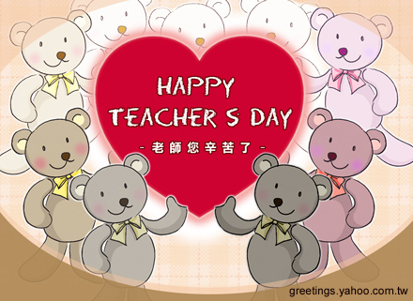

Lesson 8
We need a holiday to honor think about those instructors who impacted your life. The teacher who inspired you into a position of leadership. The teacher who dared you to be a pilot. The teacher who directed you to be a computer programmer. The teacher who tapped into your creativity and encouraged you to be a writer. The teacher who struck a cord for the start of your music career. The teacher who planted the seed for your new business, medical, or legal career. The teacher who gave you the confidence to excel in sports, and to deal with the difficult problems and people you were sure to encounter. This holiday is Teachers' Day! 我们需要一个节日往返报和思考把我们的生命变得丰富和坚强得教师们。无论您是一位政府官员、一位飞行员、或者是一位计算机程序员、更或者您是一位音乐家、商人、医生、律师、体育运动员，您都应该清楚地明白，这一切都离不开 教师们的努力。 这个节日就是教师节。
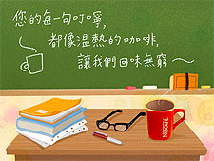

Lesson 9
Teachers' Day in Singapore（新加坡的教师节)
On 31st August, was a day like any other schooldays, except that the teachers, instead of being bogged down by assignments were besieged by gifts, flowers and cards from the ever-grateful students. The hall was beautifully decorated with colourful balloons and streamers. The Class Chairman and Vice-Chairman were given the honour to invite the teachers personally to the hall. With each teacher's arrival, the students roared and cheered for them. The concert comprised of dances and song performances that were all put up by our very own talented students! The audience even crooned to the rhythm of the songs. Our students also 'boogied down' with slick dance steps while the Balinese dancers impressed all with their delightful costumes and grace. The culmination was of course the last item that was put up by some teachers. They sang a song entitled, "I love to teach the world to sing". It was very heart warming and the performance received the loudest applauds from the audience.
8月31日，仍是一个需要到学校的日子，但是教师们在这一天将被倍受感激的学生们送来的礼物、鲜花、贺卡包围。礼堂被彩色的气球和横幅装的富丽堂皇。每个班级的主席和副主席很荣幸地去邀请他们的老师。每一位老师的入席都伴随着学生们的兴高采烈的呼声。音乐会全部由该校有才能学生的歌舞表演组成。台下的听众跟着歌声低声吟唱。巴厘岛的舞女们展示着自己的节日盛装的优雅身姿，同时学生们也翩翩起舞。音乐会的高潮是当然是最后一个节目，一些教师将合唱他们的歌曲"我要教会世界去歌唱"。真挚的表演获得了观众们最高的喝彩。
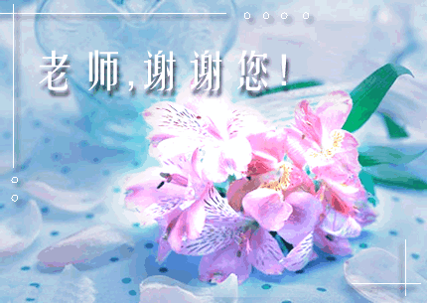

Lesson 10
Third Sunday in June
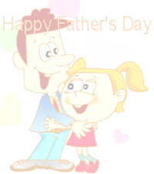
The United States is one of the few countries in the world that has an official day on which fathers are honored by their children. On the third Sunday in June, fathers all across the United States are given presents, treated to dinner or otherwise made to feel special.
Regardless of when the first true Father's Day occurred, the strongest promoter of the holiday was Mrs. Bruce John Dodd of Spokane, Washington. Mrs. Dodd felt that she had an outstanding father. He was a veteran of the Civil War. His wife had died young, and he had raised six children without their mother.
In 1909, Mrs. Dodd approached her own minister and others in Spokane about having a church service dedicated to fathers on June 5, her father's birthday. Since then, fathers had been honored and recognized by their families throughout the country on the third Sunday in June.
When children can't visit their fathers or take them out to dinner, they send a greeting card or visit their fathers if they lived apart.. Traditionally, fathers prefer greeting cards that are not too sentimental. Most greeting cards are whimsical（奇形怪状的，异想天开的）so fathers laugh when they open them. Some give heartfelt thanks for being there whenever the child needed Dad.

