“扶贫”从身边做起，从小事做起

"Poverty alleviation" starts from the side and from small things!

——“可持续发展•隔代共学互学大学堂”龙小系列报道之三

"Sustainable Development • Intergenerational Learning and Mutual Learning University Hall" The third of Long Xiao Series Report

通过前期的共学、互学和讨论交流，一个个“扶贫”的小点子在孩子和老人的脑中逐渐清晰、成型。

Through the pre-communicating, mutual learning and discussion exchanges, the small ideas of "poverty alleviation" gradually became clear and formed in the minds of children and the elderly.

许竟同学首先在群里发言，他爸爸联系了祥龙社区的“青鸟志愿者”团队，一起去社区慰问“贫困家庭”，欢迎愿意参加的同学和老人一同前往。丁小明校长觉得这项活动很好，“扶贫”就应该从身边做起，从小事做起。她立即和许竟爸爸、“青鸟志愿者”团队戌警官取得了联系，商量好了活动的时间、地点和要求，然后在群里组织报名和捐款。不一会儿，群里报名接龙的人数就达到了26人，有孩子、家长和老人，共计捐款1950元。

Classmate Xu Jing first spoke in the group. His father contacted the "Blue Bird Volunteer" team in the Xianglong community and hoped to go to the community to console the "poor families". At the same time, students who are willing to participate are welcome to go with the elderly. Principal Ding Xiaoming feels that this activity is very good. "Poverty alleviation" should start from the side and start from small things. She immediately contacted Xu Jing's father and the "Blue Bird Volunteer" team's police officer, discussed the time, place and requirements of the event, and then organized registration and donations in the group. After a while, the number of people in the group who signed up for Solitaire reached 26, with children, parents and elderly people, who donated a total of 1950 yuan.

5月4日上午，在班级家委会会长葛益铭爸爸的带领下，4位家长一起去超市购买了大豆油、香蕉、苹果等慰问品。下午一点半，23名同学、8位家长、3位老人，和“青鸟志愿者”团队的叔叔阿姨们在学校门口集合、分组。丁校长讲清活动的目的和要求后，大家就开始分头行动了。

On the morning of May 4, under the leadership of the father of the class family committee Ge Yiming, four parents went to the supermarket to buy soy oil, bananas, apples and other condolences. At 1:30 in the afternoon, 23 classmates, 8 parents, 3 seniors, and the uncles and aunts of the "Blue Bird Volunteer" team gathered and grouped at the school gate. After President Ding clarified the purpose and requirements of the activity, everyone began to act separately.

本次慰问的10户“贫困家庭”，分别居住在四个小区，大多为独居老人，身边无子女。有两户是孤寡老人，两户老人患有重病，其中一人为癌症。

The 10 "poor families" in this condolences live in four communities, mostly elderly people living alone, with no children around. Two households are elderly widows. Two elderly households are seriously ill, and one of them is cancer.

大家分成10组，一路步行前往。虽说是初夏，但气温却达到了31℃，恰似大家火热的心情。来到慰问家庭，孩子们主动向老人问好，并送上慰问礼物。有的孩子看到老人家里脏乱，赶紧主动帮助打扫卫生。有的孩子熟练地帮老人捶背、捏腿，老人脸上乐开了花。还有的为老人表演节目，更多的是和老人亲热地交谈，请他们讲小时候贫困的故事，帮扶不忘学习和劳动，真是一举多得！

Everyone was divided into 10 groups and walked all the way. Although it was early summer, the temperature reached 31 ℃, just like everyone's hot mood. When they came to condolences to the family, the children took the initiative to say hello to the elderly and sent gifts of condolences. Some children saw the old man's house dirty and quickly took the initiative to help clean it. Some children skillfully help the old man beat his back and pinch his legs. There are also performances for the elderly, more of which are intimate conversations with the elderly, asking them to tell stories of poverty when they were young, and helping them not forget to study and work.

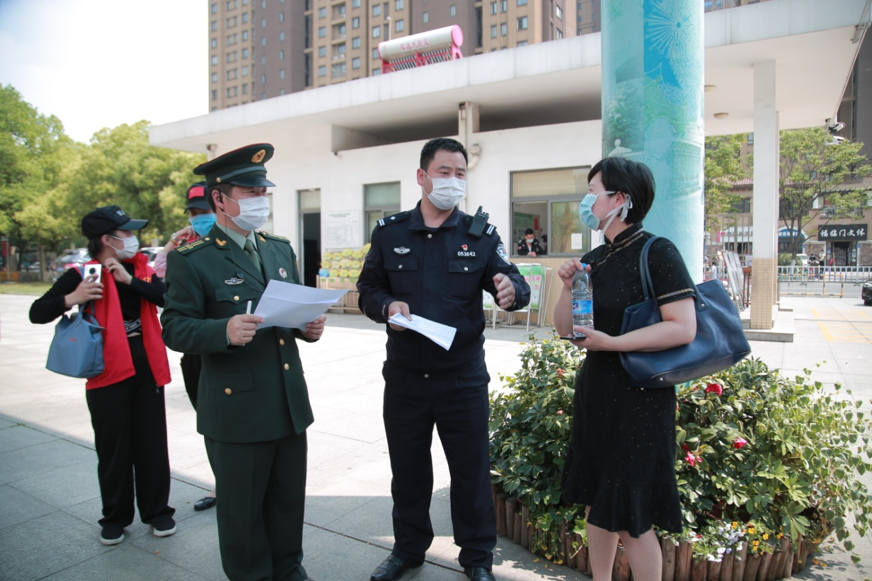

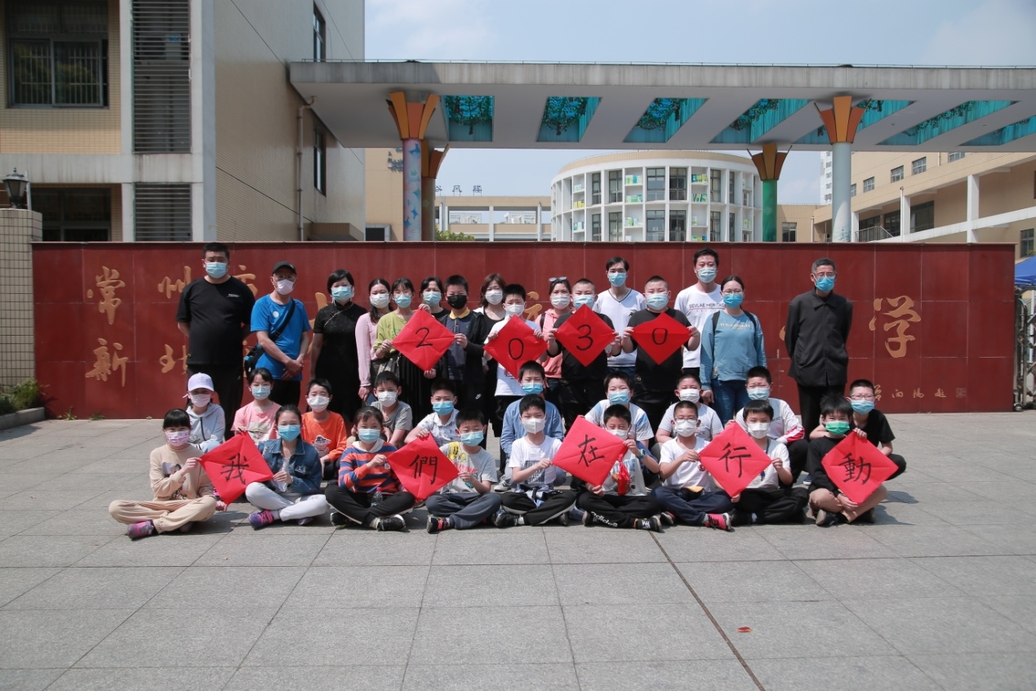

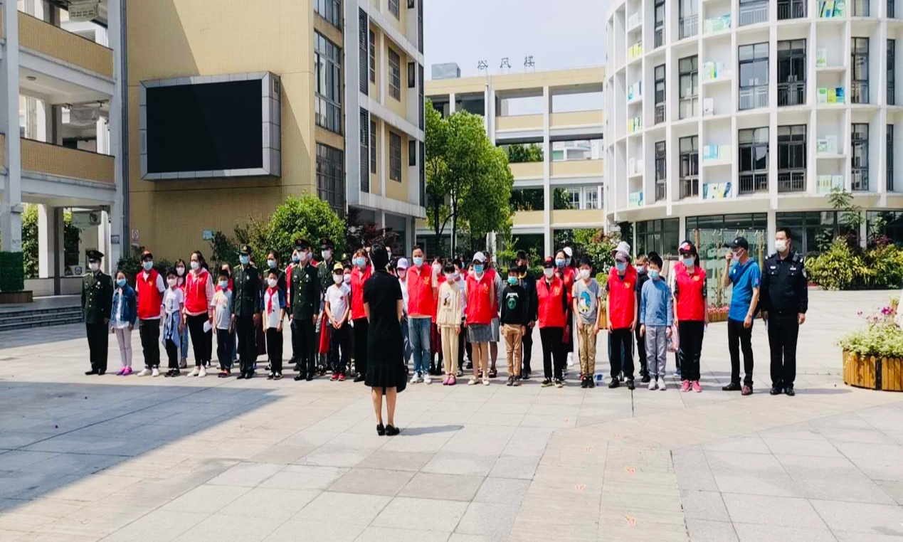

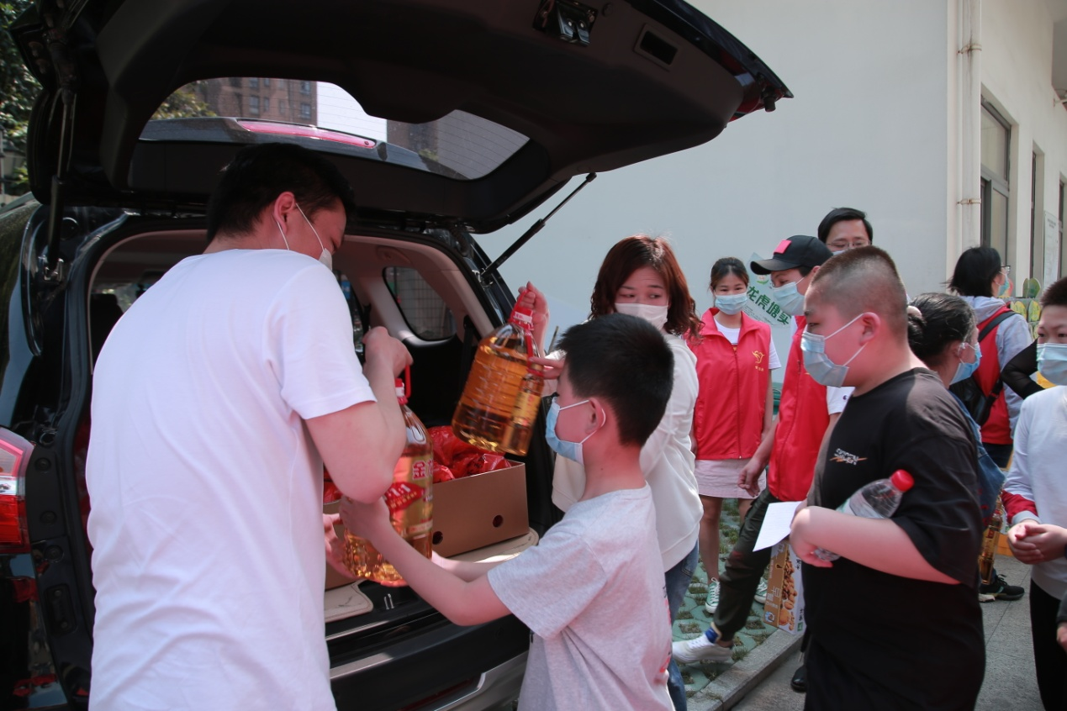

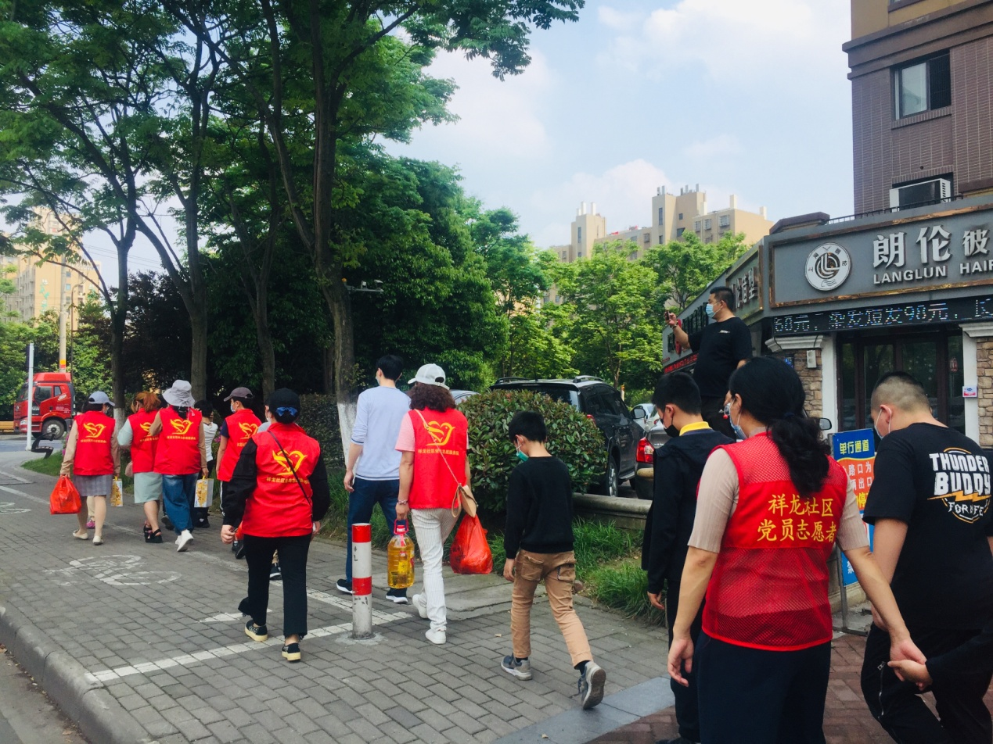

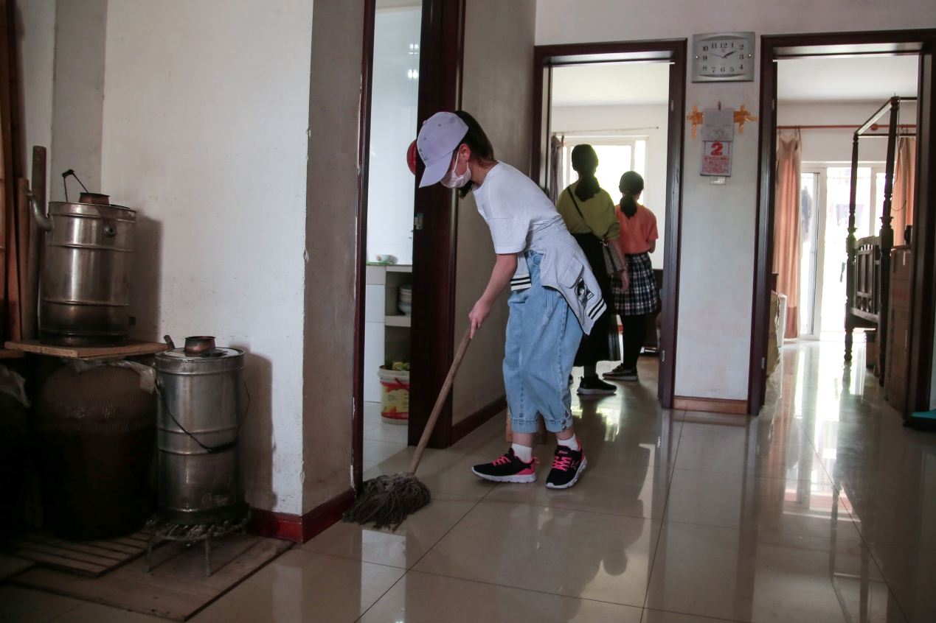

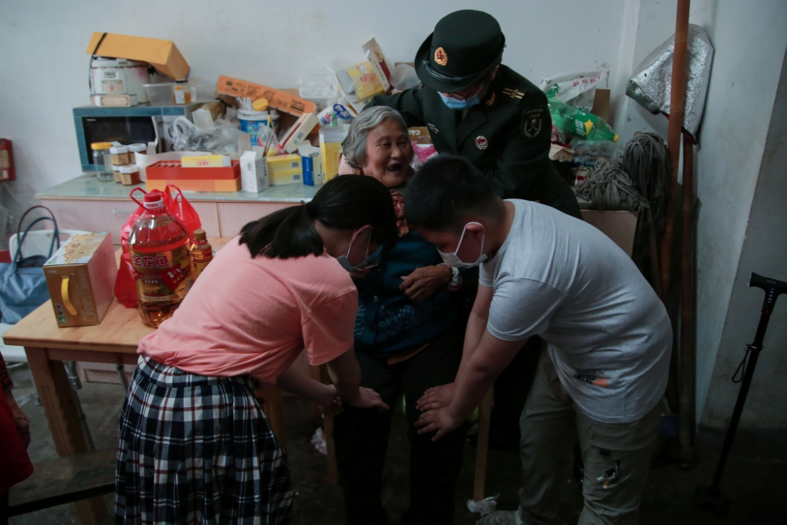

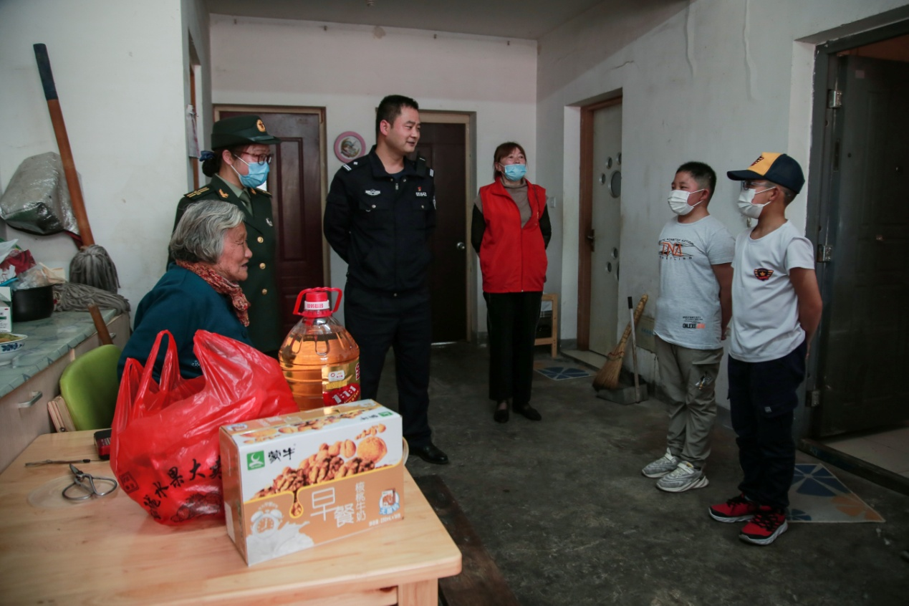

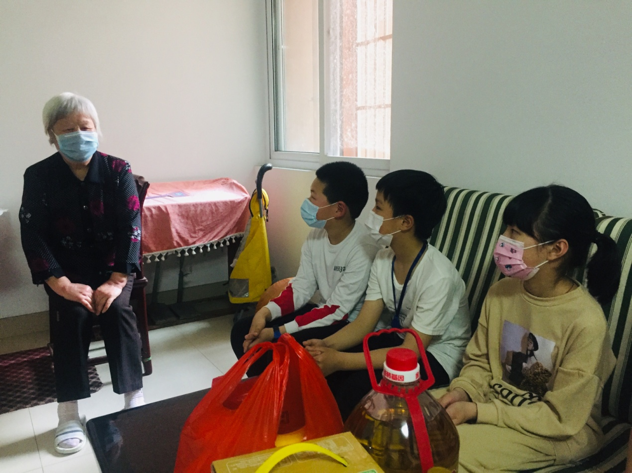

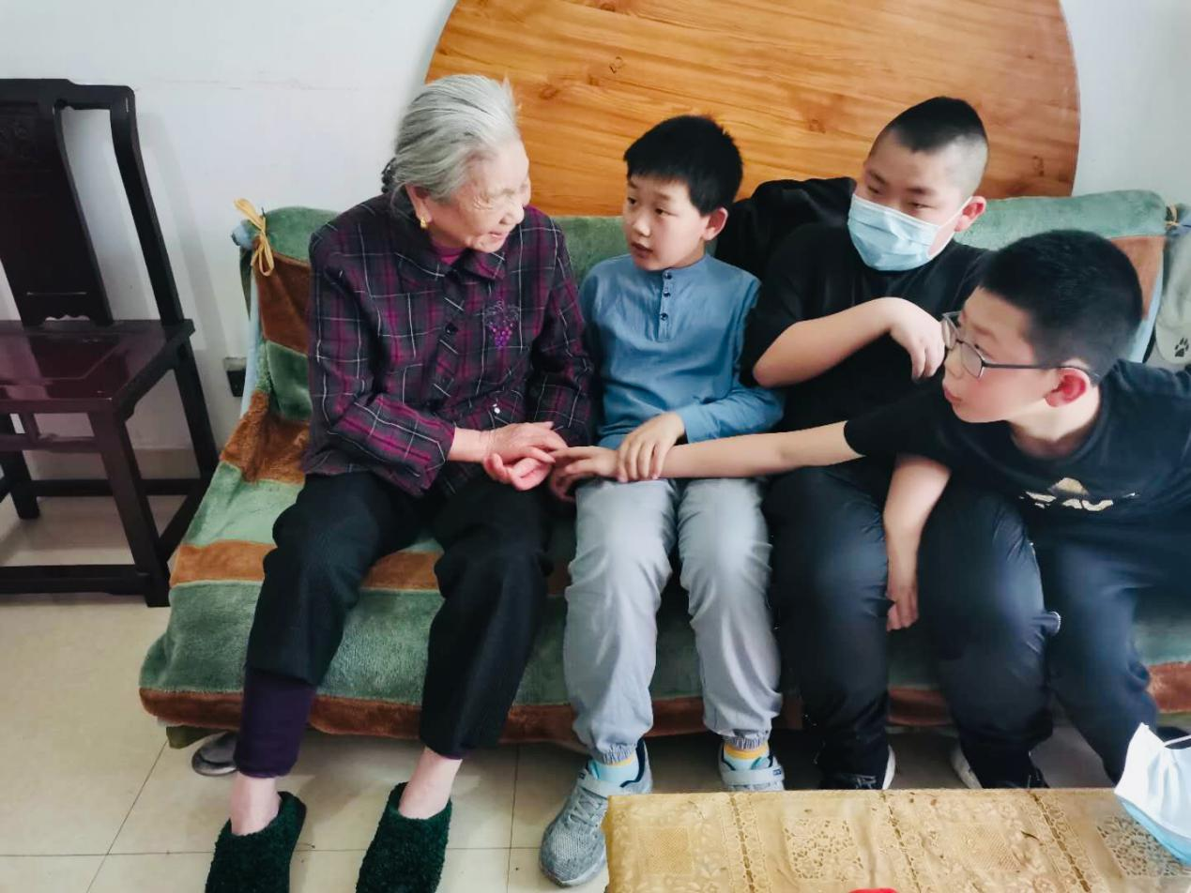

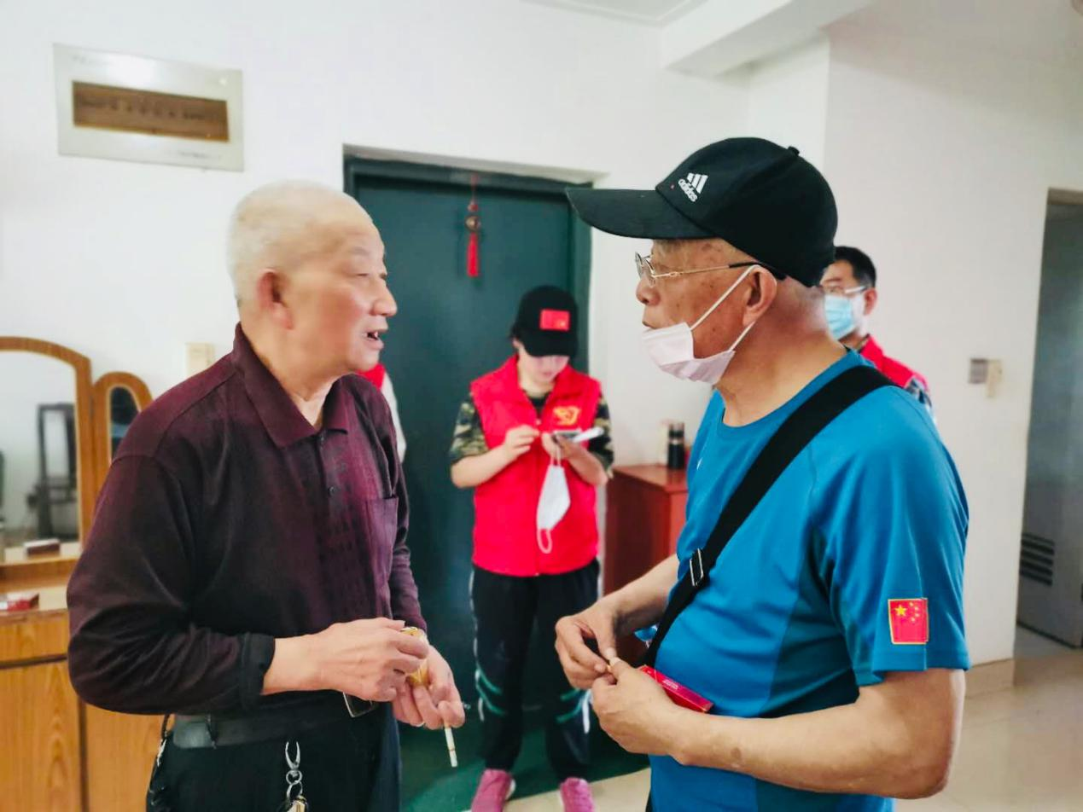

除了以上活动，高远同学和缪忆锋奶奶还想出了为贫困地区捐献衣服的金点子，汪昱煕同学想到了在淘宝网站上购买贫困地区特产的金点子，“五一”期间他们也及时开展了活动。

In addition to the above activities, classmate Gao Yuan and grandmother Miao Yifeng also came up with golden ideas for donating clothes to impoverished areas. Classmate Wang Yuxi thought of buying golden ideas for special products from impoverished areas on the Taobao website.

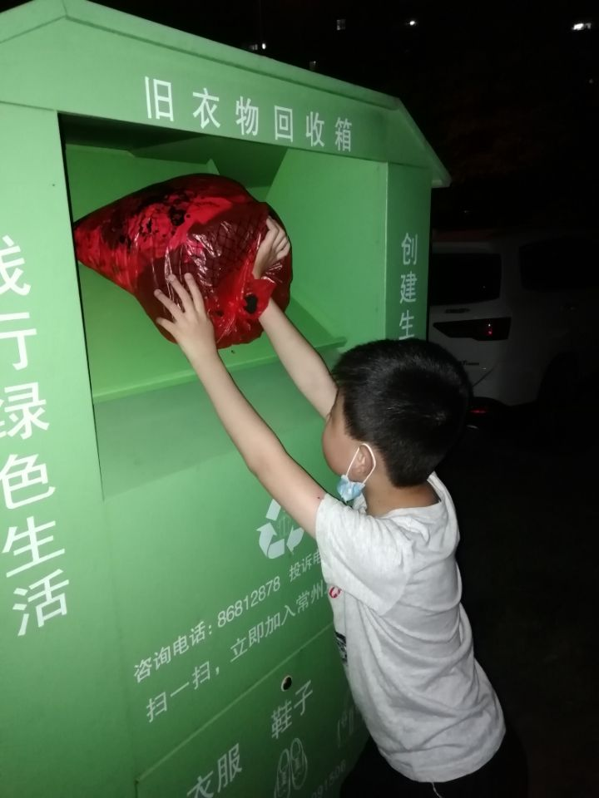

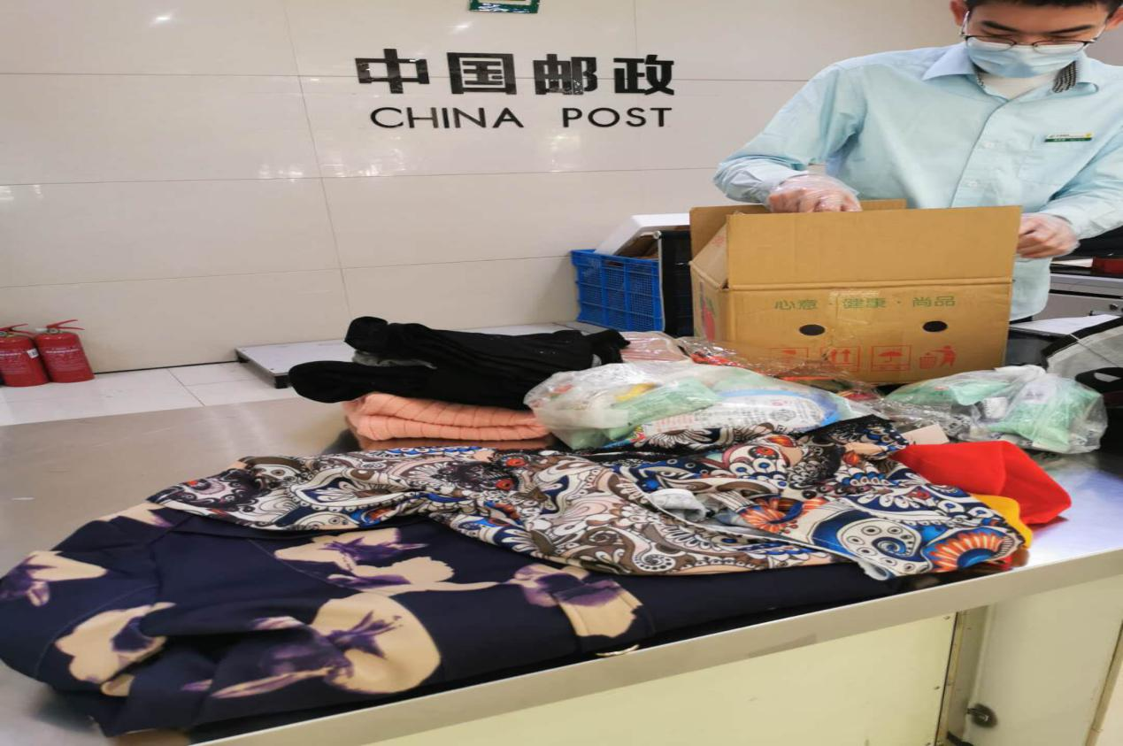

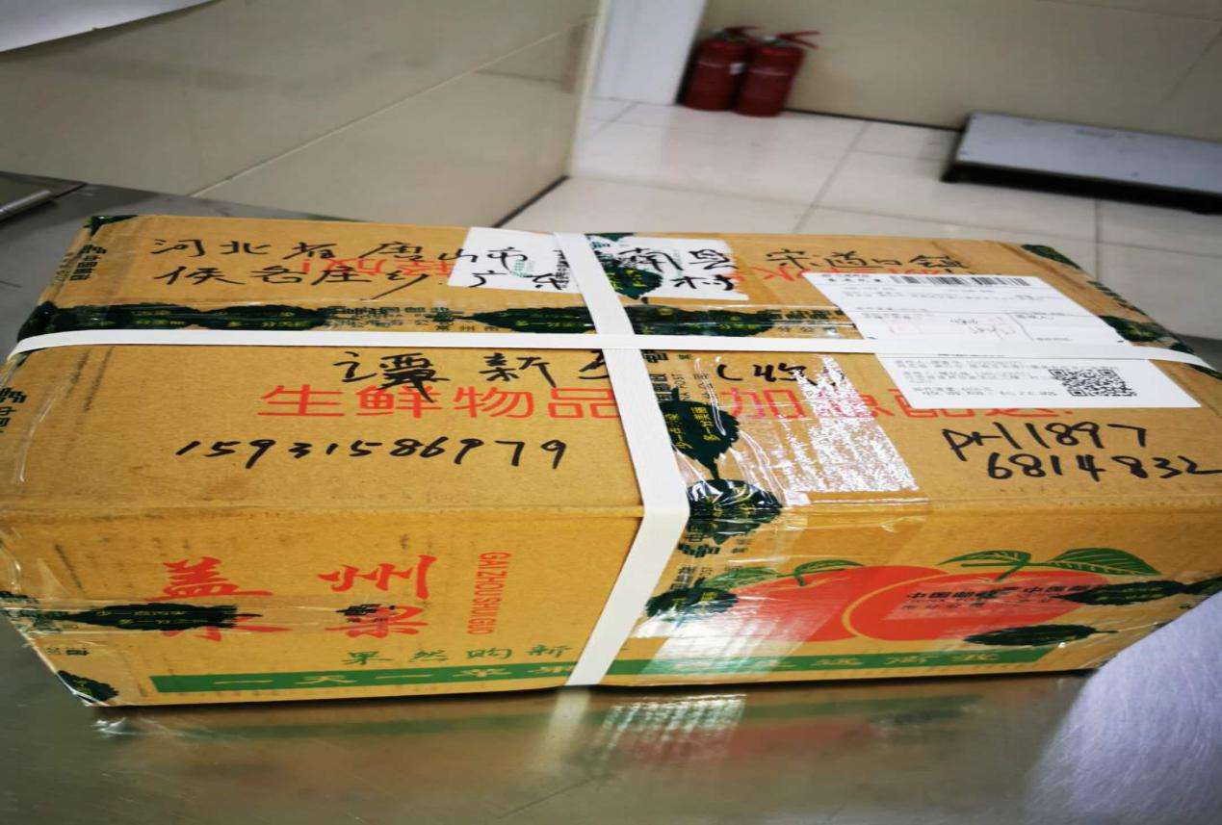

相信有了以上活动的参照和启发，整个五月份后面开展的“扶贫”实践活动会更丰富，更多元！

I believe that with the reference and inspiration of the above activities, the "poverty alleviation" practice activities carried out after May will be more abundant and more diverse!

（撰稿：丁小明 摄影：学生家长）

(Prepare: Ding Xiaoming [photograph](http://www.baidu.com/link?url=Go0UahuvyQk8OMcqgTEyJKtyeu3UbjJE4-XfK3l-Vra4MilGuR3uDKod9GRBSKnUuFM34SdclVfM5i9QMpy_4chQxzNAAitx5EiO7LMdD_ycx-ZIhDFUYN9iwqGoIwjo" \t "https://www.baidu.com/_blank): Parents)