**网络直播细指导，后续学习有保障**

**Webcast Detailed Guide,follow-up learning is guaranteed.**

——“可持续发展•隔代共学互学大学堂”龙小系列报道之二

“为什么学？”“学什么？”“怎么学？”这是困扰家长和祖辈的三大问题。如果不把这三个问题搞明白，“2030年可持续发展”的学习研究活动是开展不起来的。

"Sustainable Development • Intergenerational Learning and Mutual Learning University Hall" Part 2 of Long Xiao Series Report

"Why learn?" "What to learn?" "How to learn?" These are the three major problems that trouble parents and grandparents. If these three issues are not understood, the study and research activities of "sustainable development in 2030" cannot be carried out.

为了解除困扰，保障后续学习活动的有效开展。丁小明副校长在信息组徐妃老师的帮助下，组建了“隔代共学互学”微信群，并在5月3日下午14:30进行了线上直播。参加听课的学生、家长、祖辈共计一百多人。

In order to relieve the troubles and ensure the effective development of follow-up learning activities. With the help of Xu Fei, the information group, Vice President Ding Xiaoming established the WeChat group of "Intergenerational Learning and Mutual Learning", which was broadcast live online at 14:30 pm on May 3. There are more than 100 students, parents and grandparents participated in the lecture.

直播课上，丁校长以“2030，我们在行动！”为主题，紧紧围绕“我们为什么做？”“我们做什么？”“我们怎么做？”这三个问题，跟学生、家长、祖辈进行了深入的交流，并对学习手册中的六张学习单进行了详细的指导。

In the live class, President Ding took the theme of "2030, we are acting!", And made a in-depth exchanges with students and their parents focused on the three questions of "why do we do?" "What do we do?" , and detailed guidance was given to the six study sheets in the study manual.

龙小是一所百年老校，也是一所国际理解学校，深厚的人文底蕴和先进的办学理念交相辉映。我校有着多年国际合作研究的实践经验和理论基础。“幸福作业”就是一项在全世界有影响力的项目研究，世界上多个发达国家的教育专家和教授来我们学校参观和学习过。他们对我校学生良好的沟通交往能力，合作创新能力，理解表达能力，动手实践能力，志愿服务能力都给予了高度的评价，认为我们学校的学生培养目标已经和国际接轨，达到了国际发达国家的水平。

Long Xiao is a century-old school and an international understanding school. Its profound humanistic heritage and advanced school-running philosophy complement each other. Our school has many years of practical experience and theoretical basis for international cooperative research. "Happy homework" is an influential project research in the world. Educational experts and professors from many developed countries in the world have visited and studied in our school. They gave a high evaluation of our students' good communication ability, cooperative innovation ability, understanding expression ability, hands-on practical ability, and volunteer service ability. Therefore, they believe that our school's student training objectives have been in line with international standards and reached the level of international developed countries.

“隔代互学”是我校又一项引起联合国教科文组织重视的研究项目。随着全球老龄化社会的到来，老年人成为了推动或阻碍社会进步的重要组成部分。如何充分利用和挖掘老年人的优秀资源，发挥他们的余热，让他们融入社会，和时代一起进步，是全世界遇到的又一大难题。我们龙小通过一年多的“家庭内的隔代互学”，“ 1+X家庭的隔代互学”及“和河海老年学校的隔代互学”，取得了良好的研究成效。实践证明，老人们有着丰富的社会阅历，他们富有同情心和爱心，他们比孩子的父母有更多的时间、精力和耐心投入到下一代的培养中去。所以，“隔代共学互学”是促进老人和孩子共同进步的一种很好的方式。

"Intergenerational learning" is another research project in our school that has attracted the attention of UNESCO. With the advent of the global aging society, the elderly have become an important part of promoting or hindering social progress. How to make full use of and dig out the elders' excellent resources, make use of their residual heat, let them integrate into the society, and make progress with the times which is another big problem encountered by the whole world. Our School Long Xiao has achieved good research results through more than one year of "intergenerational learning within the family", "intergenerational learning between 1 + X families" and "intergenerational learning with Hehai Senior School". Practice has proved that the old people have a rich social experience, they are compassionate and caring, they have more time, energy and patience than the children's parents to devote to the training of the next generation. Therefore, "intergenerational mutual learning" is a good way to promote the common progress of the elderly and children.

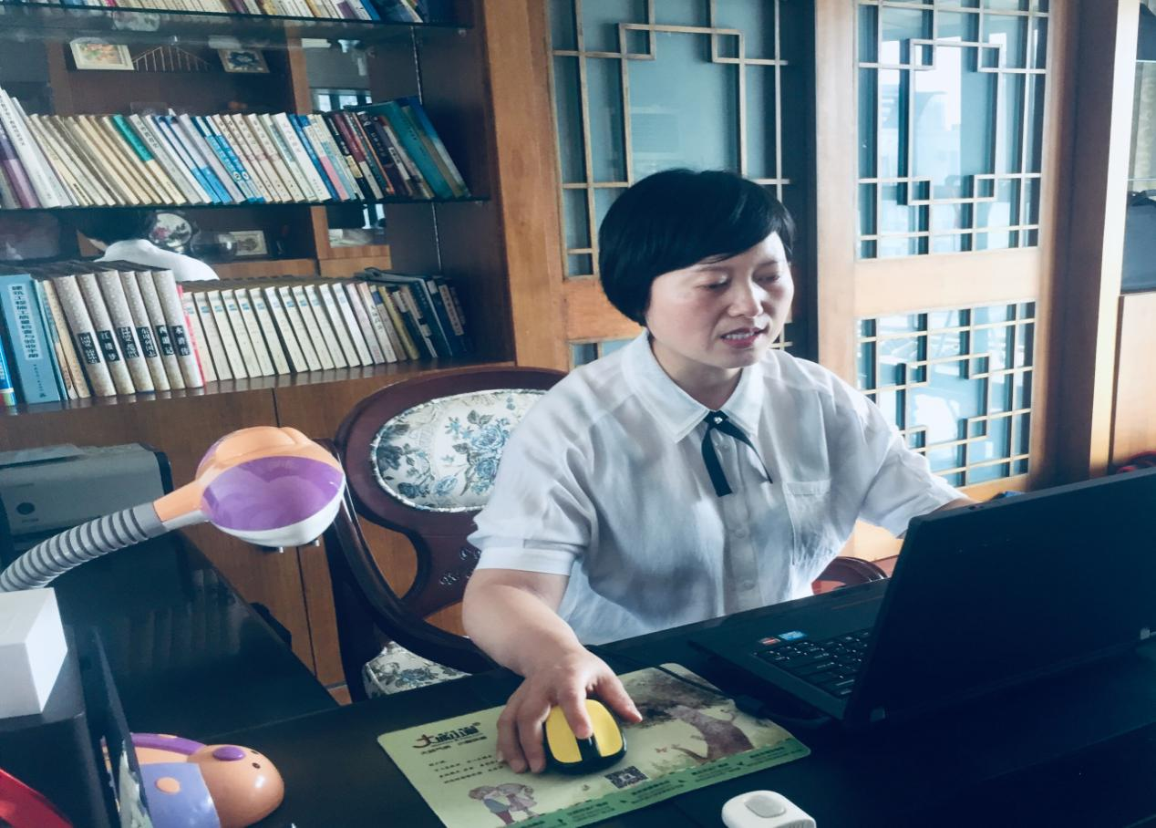

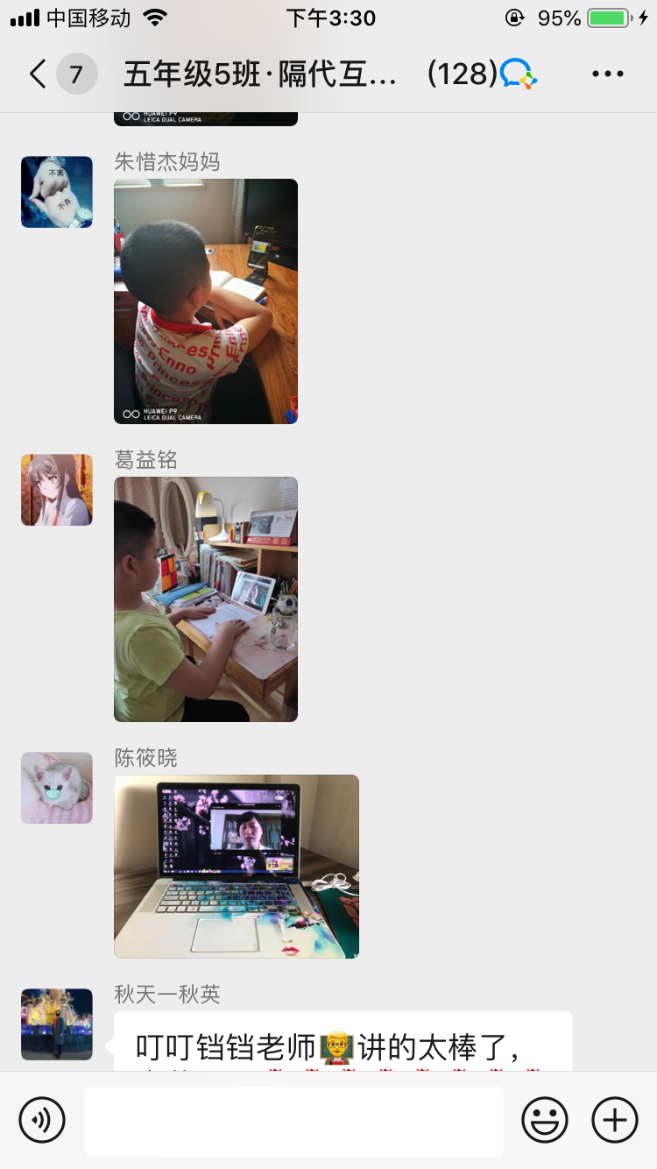

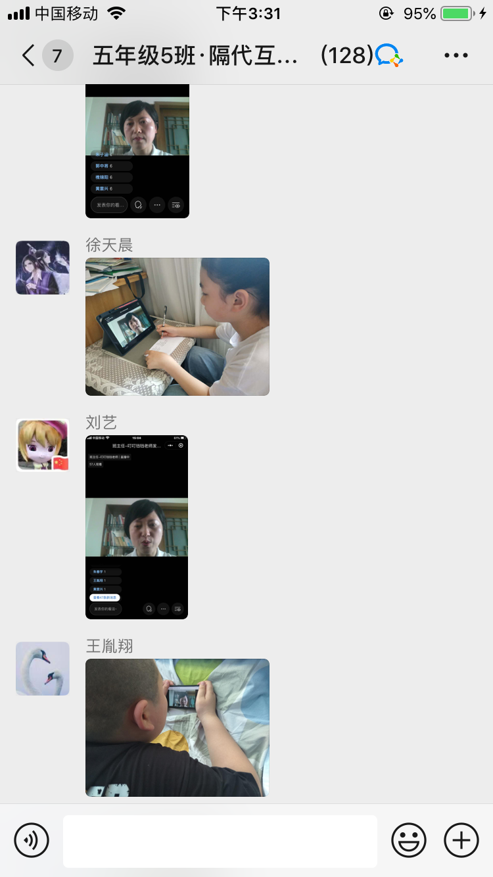

本次直播课结束后，学生、家长、祖辈反响热烈，他们觉得龙小的办学理念先进，对学生未来培养目标有明确的方向，丁校长的指导具体、清晰，有操作性。他们明白了学校为什么要开启此项研究，认同“隔代共学互学”是一种很好的学习方式，他们对后面的学习活动充满了信心和期待。

After the live class, students, parents and grandparents responded enthusiastically. They feel that Long Xiao ’s concept of running a school is advanced, and has a clear direction for the future training goals of students. As well as, President Ding ’s guidance is specific, clear, and practical. They understood why the school started this research and agreed that "intergenerational mutual learning" is a good way of learning. They are full of confidence and expectation for the following learning activities.

当天傍晚，孩子们和老人们就迫不及待地开展了“消除贫困”的后续互学和交流活动。孩子们倾听了老人们小时候贫困的故事，相互交流了对“贫困”的理解；召开了家庭会议，讨论了节约开支的家庭消费项目；商量了作为老人和孩子分别可以为家庭、社区、中国、世界“消除贫困”做些什么。

In the evening of the same day, the children and the old people could not wait to carry out the follow-up mutual learning and exchange activities of "eliminating poverty". The children listened to the old people's stories of poverty when they were children and exchanged their understanding of "poverty". They held a family meeting and discussed household consumption items that saved money. And discuss what can be done for the elderly, the children, and the family, community, China, and the world to "poverty eradication".

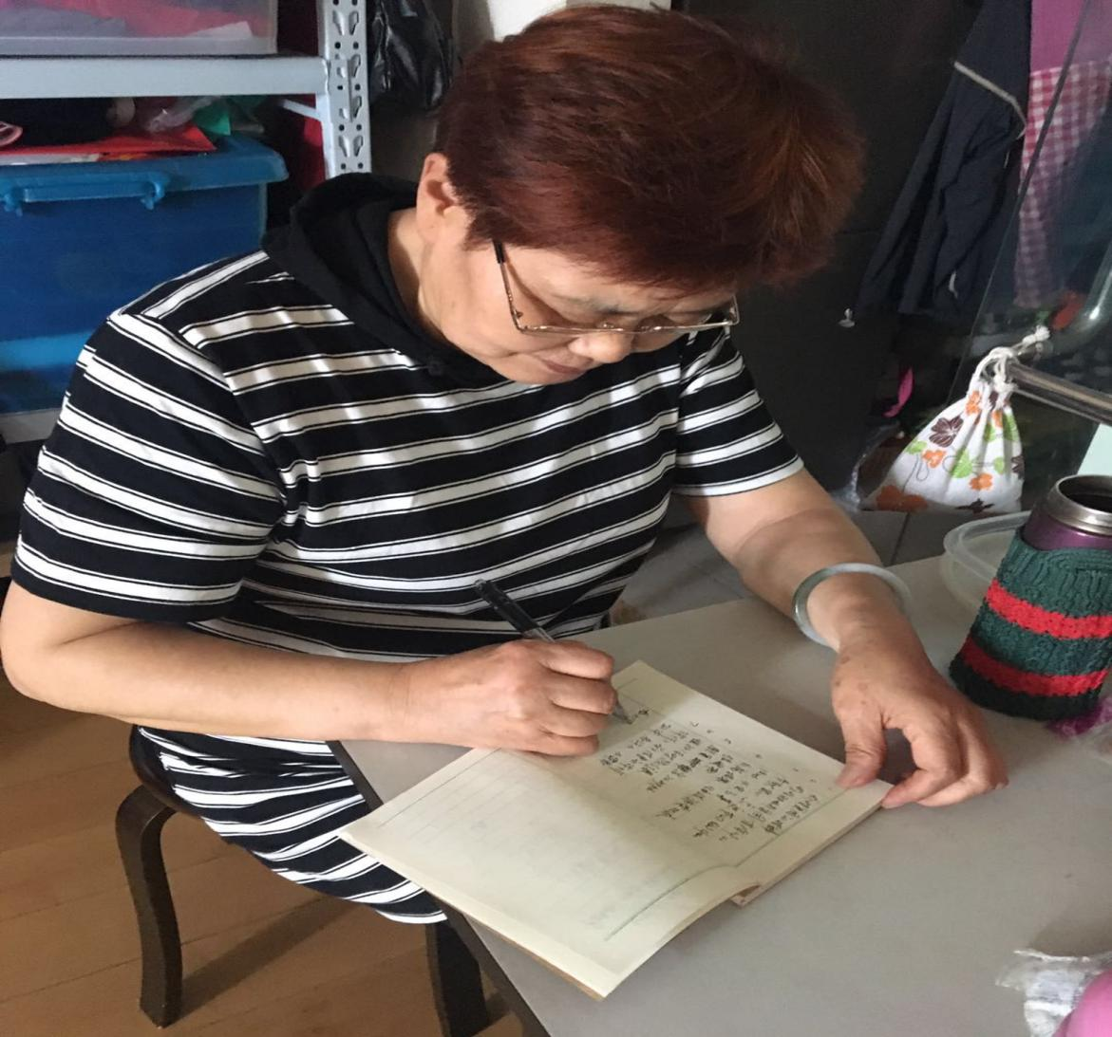

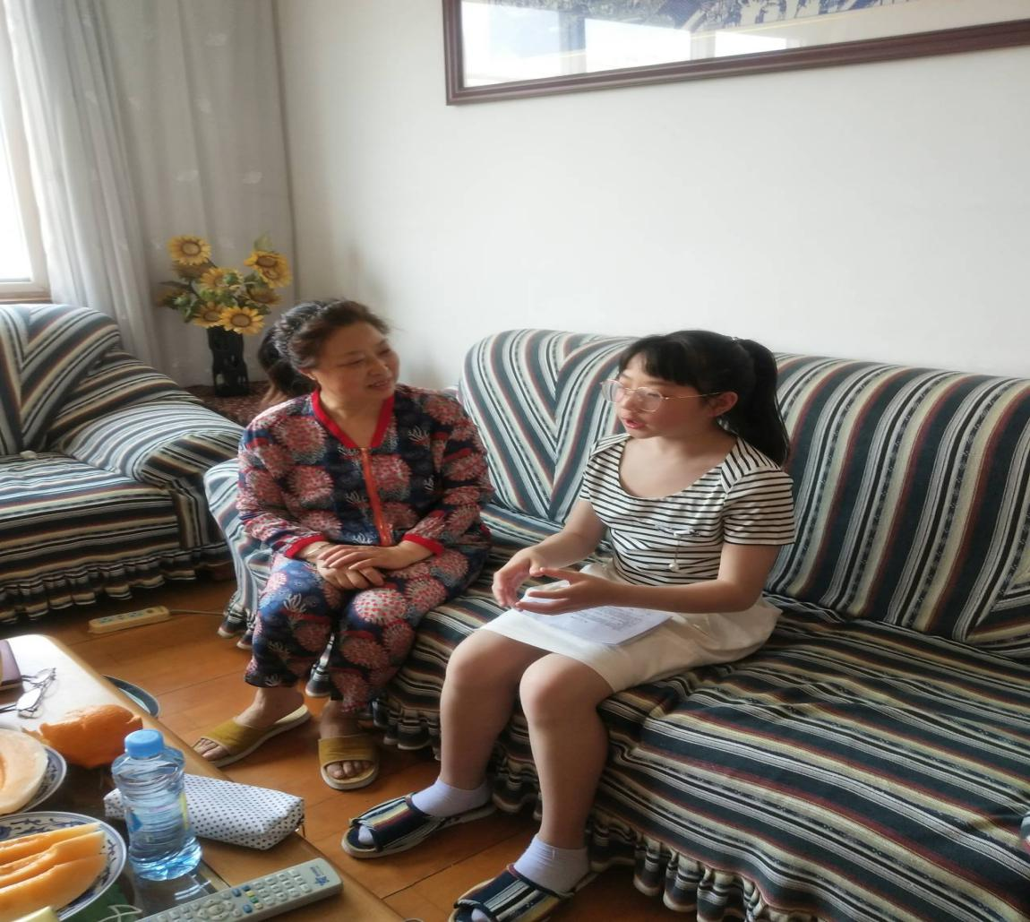

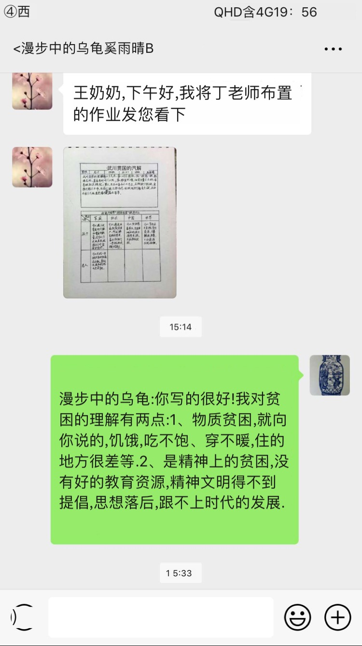

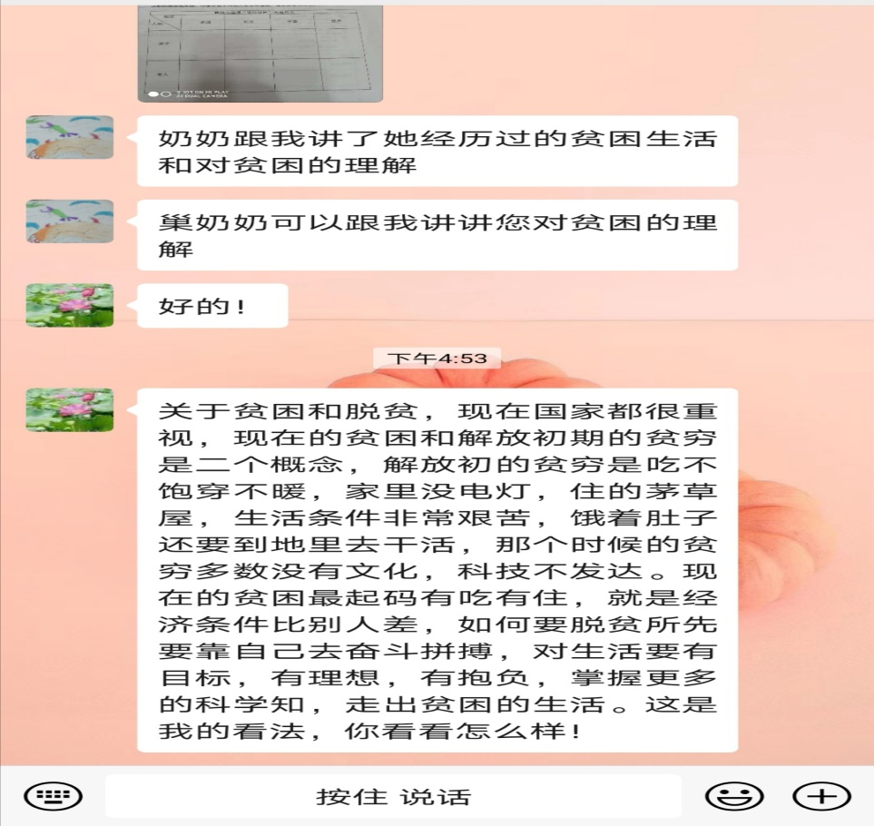

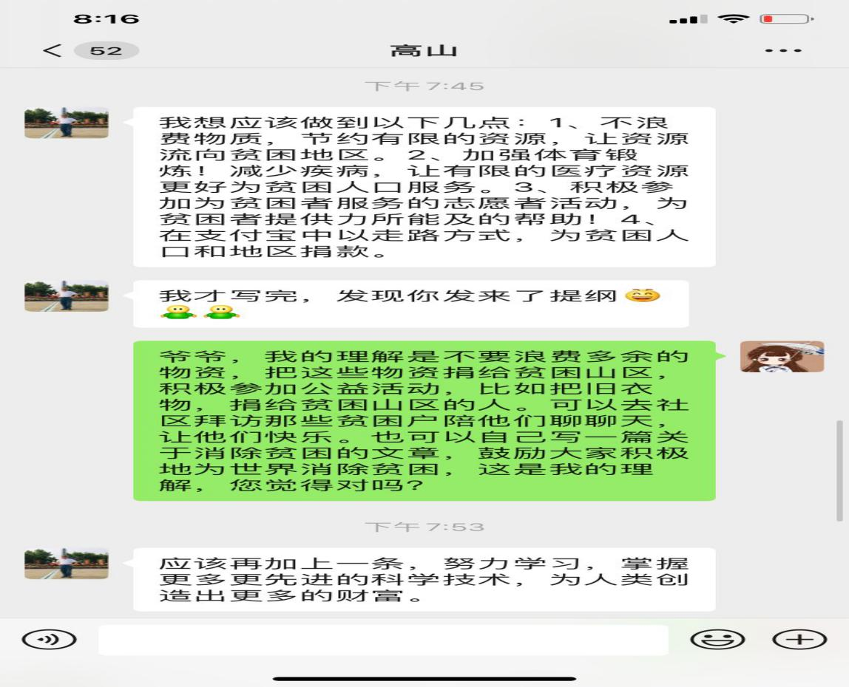

相信随着学习的不断深入，“可持续发展”的理念一定会在孩子、家庭、社会中不断生根、发芽、长叶、开花！

I believe that with the continuous deepening of learning, the concept of "sustainable development" will continue to take root, sprout, grow leaves, and bloom in children, families, and society!

（撰稿：丁小明 摄影：各位家长）

(Prepare: Ding Xiaoming [photograph](http://www.baidu.com/link?url=Go0UahuvyQk8OMcqgTEyJKtyeu3UbjJE4-XfK3l-Vra4MilGuR3uDKod9GRBSKnUuFM34SdclVfM5i9QMpy_4chQxzNAAitx5EiO7LMdD_ycx-ZIhDFUYN9iwqGoIwjo" \t "https://www.baidu.com/_blank): Parents)