**紧抓时代脉搏，开启脱贫共学篇章**

**Grasp the pulse of the times and start a chapter of learning from poverty**

——“可持续发展•隔代共学互学大学堂”系列报道之一

The frist of series of reports on "Sustainable Development • Intergenerational Learning and Mutual Learning"

随着中国社会加快完成由工业文明向生态文明时代的转变，社会、经济、环境与文化领域以及全体公民迎来了“如何可持续发展”的严峻挑战。鉴于此，教育系统理应承担起帮助所有学习者与全体国民“学会可持续发展”的时代责任。

As Chinese society accelerates the transition from industrial civilization to ecological civilization, the social, economic, environmental, and cultural fields and all citizens have ushered in the severe challenge of "how to develop sustainably." In view of this, the education system should assume the responsibility of helping all learners and all citizens to “learn to be sustainable”.

在这样的形势下，如何适应可持续发展需要，以“学会可持续发展” 为导向，校正教育改革、发展与创新的方向，明确新时代人才培养目标、充实新的教育内容、创新教学与学习方式，是新时代教育面临的新挑战，也是教育工作者应思考、践行的新课题。

In such a situation, The question of how to adapt to the needs of sustainable development with "learning sustainable development" as the guide, correct the direction of education reform, development and innovation, clarify the goal of talent training in the new era, enrich new education content and innovative teaching and learning, which will to be a new challenge facing education in the new era, and a new subject that educators should think about and practice.

在上海华东师范大学李家成教授的引领下，我校加入了“2030年可持续发展”的项目研究，并以“隔代共学互学”的方式展开学习活动。

Under the guidance of Professor Li Jiacheng of East China Normal University in Shanghai, our school joined the project research of "Sustainable Development in 2030" and launched learning activities in the form of "intergenerational learning and mutual learning".

“2030年可持续发展目标”一共有17个大主题。本次“五一”长假，我们开展了第一个大主题——“消除贫困”的学习活动。本主题的学习手册由我校丁小明副校长设计，也由我校在全国率先开展本主题的研究活动。

There are 17 major themes in the "2030 Sustainable Development Goals". In this "May Day" holiday, we launched the first major theme-learning activities for "Poverty Eradication". The study manual on this topic was designed by our school's vice president Ding Xiaoming, and our school took the lead in carrying out research activities on this topic nationwide.

2020年，是中国决胜全面小康、决战脱贫攻坚的收官之年，也是实现“两个一百年”奋斗目标的历史交汇之年。中国“扶贫工作”的成功，对联合国减少贫困的千年发展目标作出了巨大的贡献。

2020 is the year of China's final victory for a comprehensive well-off society and a decisive battle against poverty. It is also a year of historical convergence in achieving the goal of "two hundred years". The success of China's "poverty alleviation work" has made tremendous contributions to the UN Millennium Development Goals of poverty reduction.

为了让孩子和老人们了解联合国2030年可持续发展中关于“消除贫困”的指标，中国自2012年以来开展的扶贫工作，了解中国政府的扶贫方法、扶贫策略和扶贫进程，进一步理解扶贫的目的和意义。丁校长推荐了《消除贫困》《2020年中国如何确保脱贫攻坚任务如期全面完成？》《关于苦难和贫穷的名人故事》《茨朗的孩子》等5篇文章和一部纪录片。这些文章对于孩子们来讲，可能有点难懂和枯燥，丁校长就利用时间，带着孩子们一起学习。通过讲解和举例，尤其是观看纪录片，孩子们泪流满面，他们没有想到，在现代这个社会，还有那么贫穷的地方，孩子们过着那么贫穷的生活。对这个主题由一开始的“不理解、不关心、不知道自己能做什么”，慢慢地明白了此项工作的重大意义和责任担当，最后决定要为全世界“消除贫困”作出自己应有的贡献。

In order to let children and the elderly understand the UN poverty reduction indicators for sustainable development in 2030, China has carried out poverty alleviation work since 2012, as well as the Chinese government ’s poverty alleviation methods, poverty alleviation strategies, and poverty alleviation processes. In order to further understand the purpose and significance of poverty alleviation. Principal Ding recommended five articles and a documentary such as "***Eradicating Poverty***", "***How to ensure China's poverty alleviation mission is completed on schedule in 2020***", "***Celebrity Stories about Suffering and Poverty***" and "***Children of Crang***". Because these articles may be a bit difficult and boring for children, Headmaster Ding used the time to take the children to study together. Through explanations and examples, especially watching documentaries, the children burst into tears. They did not expect that in this modern society, there are so poor places where children live such a poor life. From the beginning, "I don't understand, don't care, don't know what I can do" on this topic, and slowly understand the significance and responsibility of this work. Finally, it was decided to make its due contribution to the world's "poverty eradication".

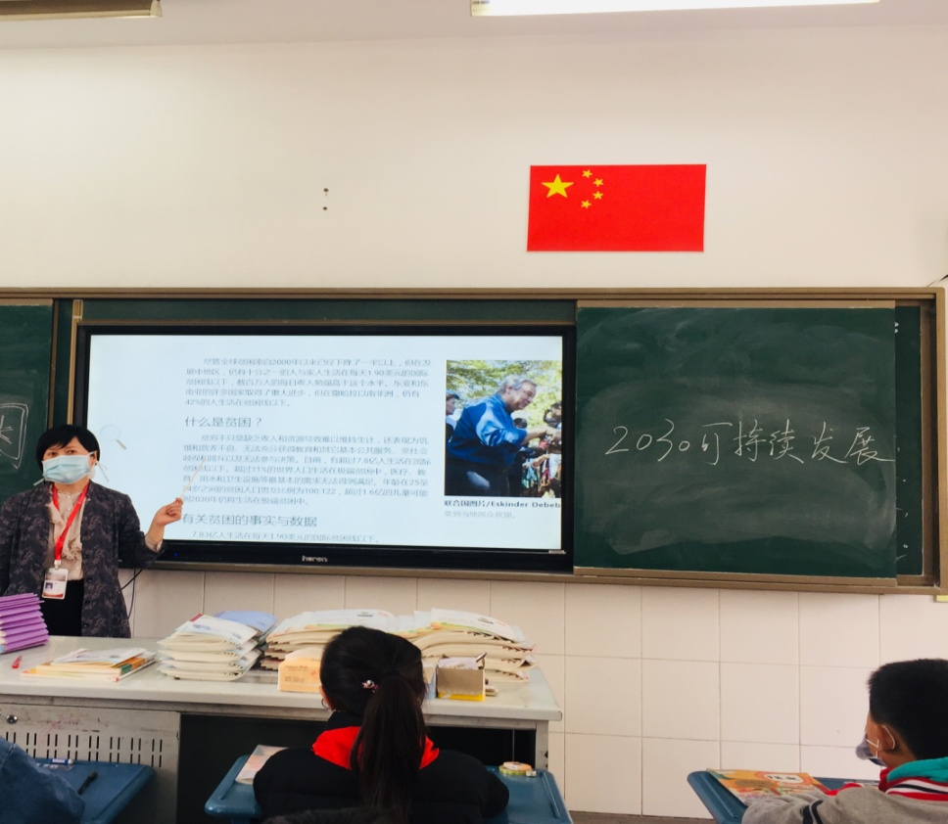

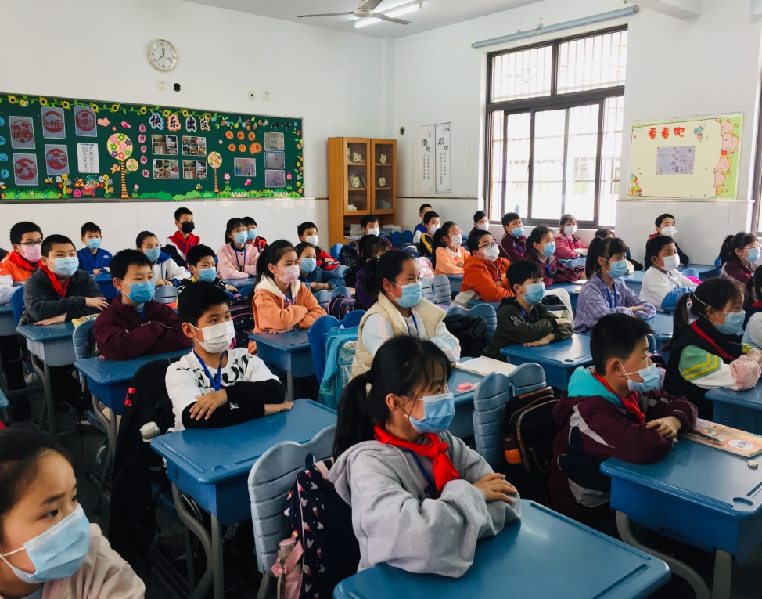

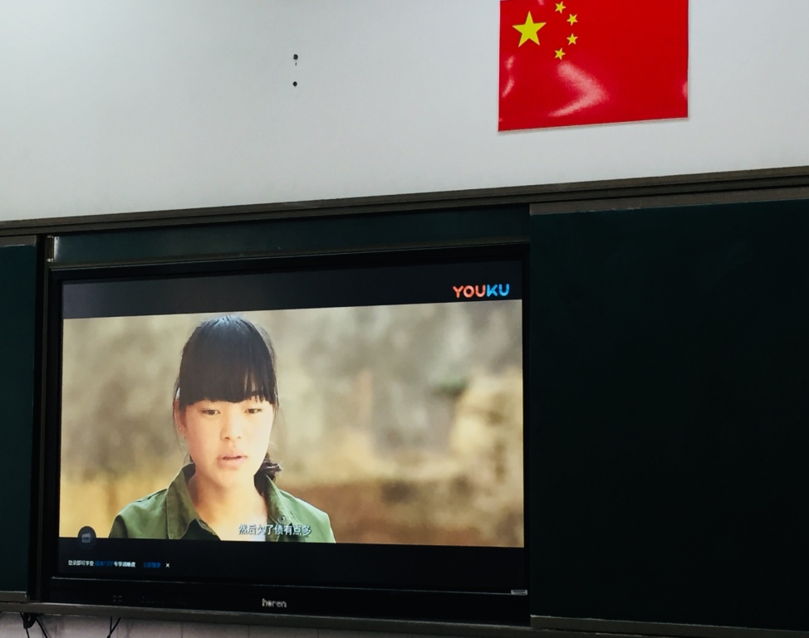

“五一”长假伊始，孩子们就和自己的爷爷奶奶开展了线上或线下的共学活动。有的爷爷奶奶不识字，孩子们就读给他们听。因为班里有12个孩子的祖辈在老家没有智能手机，不会使用智能手机，无法开展共学互学活动。丁校长立即为他们结对了河海老年学校的学员，老人们有了一个新孙子或新孙女非常兴奋，孩子们也欢呼雀跃，有孩子说“真开心，我有两个爷爷啦！”。然后，他们立即互加好友，建立了“家庭共学互学微信群”，然后在群里开启共学互学活动，经过阅读丁校长推荐的文章、纪录片，孩子和爷爷奶奶还阅读了很多相关主题的文章和新闻报道，最后两代人都完成了第一张学习单，表达自己对“贫困”的理解。

At the beginning of the May Day holiday, the children and their grandparents carried out online or offline co-learning activities. Some grandparents are illiterate and the children read to them. Because the grandchildren of the 12 children in the class do not have smartphones in their hometowns, they will not use smartphones, and cannot carry out mutual learning activities. Principal Ding immediately paired the students of Hehai Senior School for them. The old people were very excited to have a new grandson or granddaughter, and the children cheered. Some children said, "I am so happy, I have two grandpas!" Then, they immediately added friends to each other and established a "family mutual learning and mutual learning WeChat group", and then started a mutual learning and mutual learning activity in the group. After reading the articles and documentaries recommended by President Ding, the children and grandparents also read many related topics. Articles and news reports, the last two generations have completed the first study sheet to express their understanding of "poverty".

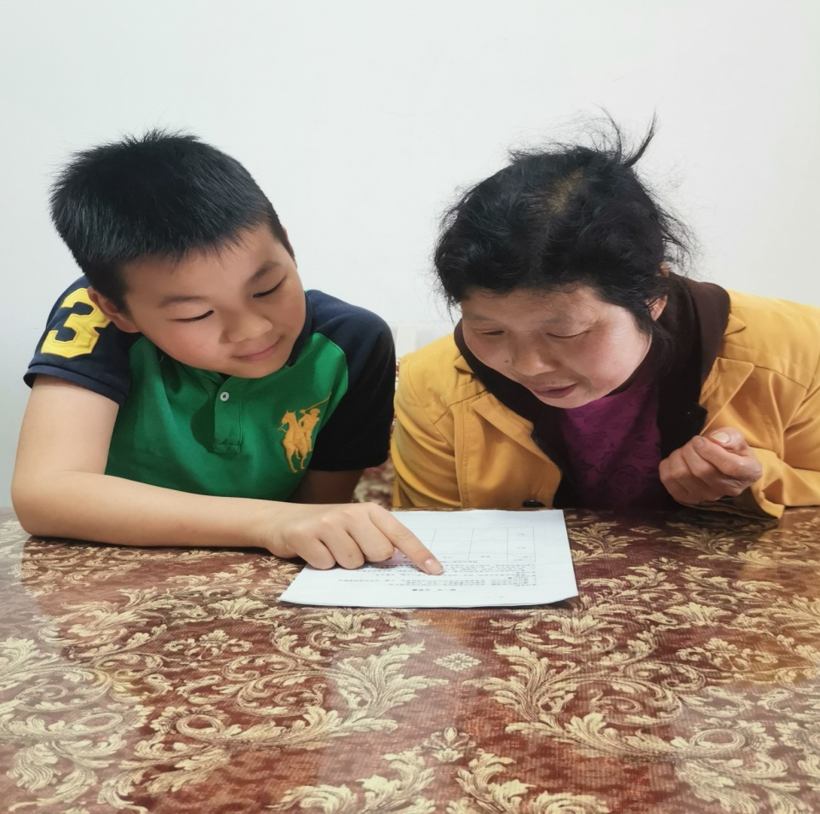

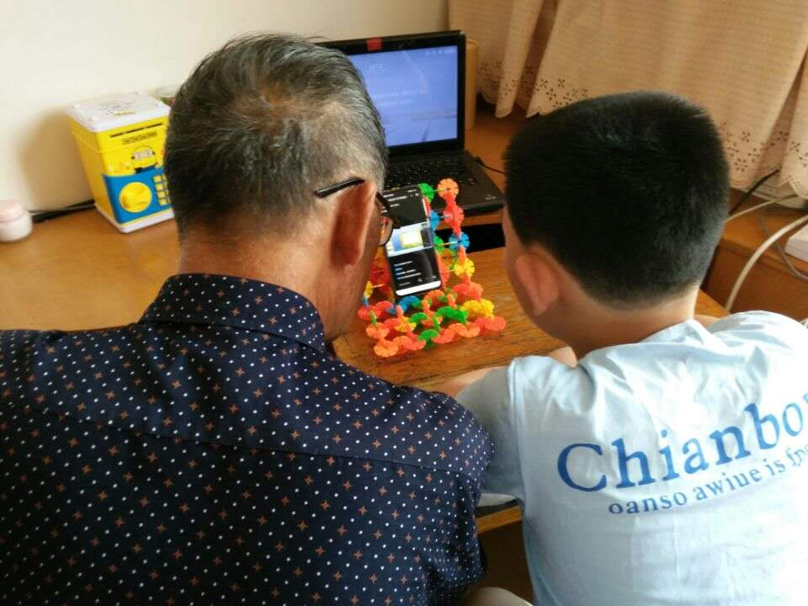

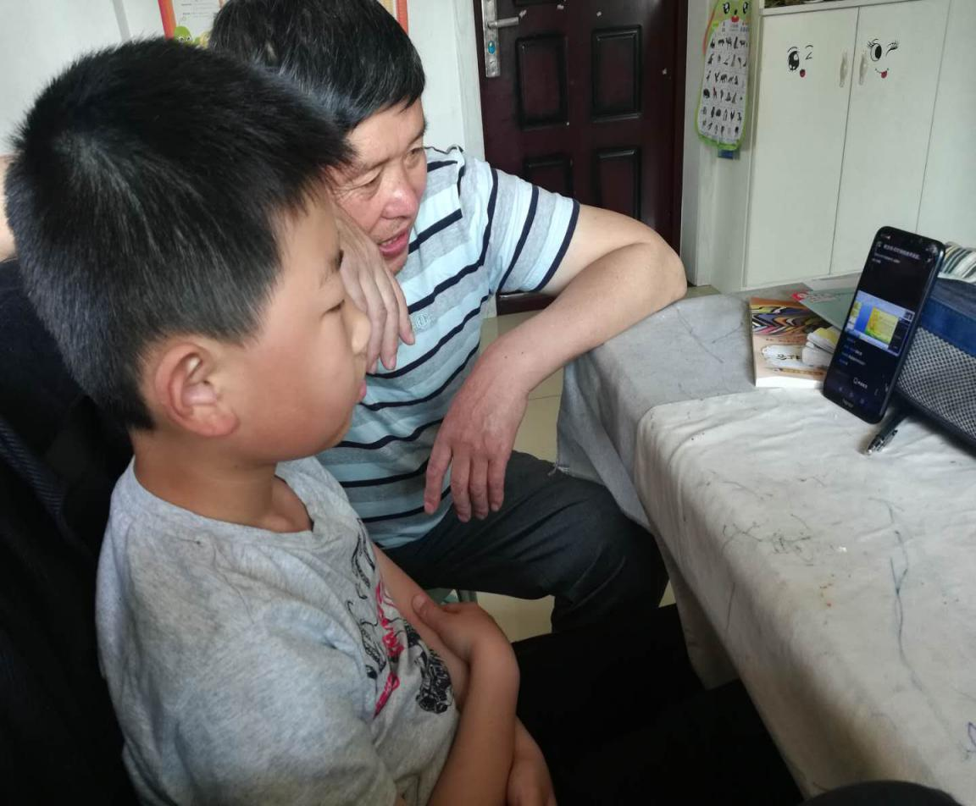

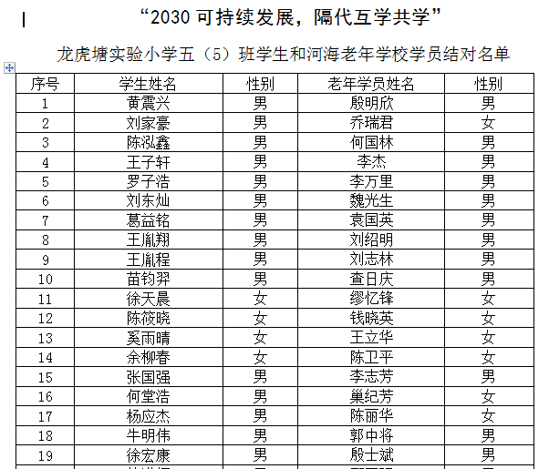

2030年可持续发展，龙小在行动！在2020年我国决战脱贫攻坚收官之年开启此项研究，意义深远。培养担当未来可持续发展大任的新一代地球公民，学校责无旁贷。

2030 sustainable development, Long Xiao is in action! It is of far-reaching significance to start this research in the year 2020 when China decisively fights against poverty. The school is duty-bound to train a new generation of global citizens who will be responsible for future sustainable development.

习总书记在今年“五四青年节”来临之际说，“今天，新时代中国青年处在中华民族发展的最好时期，既面临着难得的建功立业的人生际遇，也面临着‘天将降大任于斯人’的时代使命。”，而这种时代使命感需要从小培养！

General Secretary Xi said on the occasion of the May 4th Youth Day this year, "Today, Chinese youth in the new era are in the best period for the development of the Chinese nation. They are faced with both rare life experiences and career missions that was given from heaven". And this sense of mission of the times needs to be nurtured from an early age!

（撰稿：丁小明 摄影：学生家长）

(Prepare: Ding Xiaoming [photograph](http://www.baidu.com/link?url=Go0UahuvyQk8OMcqgTEyJKtyeu3UbjJE4-XfK3l-Vra4MilGuR3uDKod9GRBSKnUuFM34SdclVfM5i9QMpy_4chQxzNAAitx5EiO7LMdD_ycx-ZIhDFUYN9iwqGoIwjo" \t "https://www.baidu.com/_blank): Parents)