My nice house

This is my house. There are three bedrooms, two bathrooms, a study, a kicthen and a large living room.

In the living room, there is a table.

There are some sofas beside the table. I always sit on the sofa and watch TV.

There are some pictures on the wall.

There is a piano near the window. I play the piano after dinner.

In my bedroom, there ….



同学们，请你们用至少8句话来介绍一下自己的家吧。

_________________________________________________________________

_________________________________________________________________

___________________________________________________________________

My school

This is our school. There are …classrooms in my school.

There are three Music rooms. It’s on the …floor. There is a piano in the music room.

There are two Art rooms. It’s on the … floor. There are many photos on the wall.

There are two Computer rooms. It’s on the … floor. There are …computers in it.

There is a library and a reading room on the first floor. There are a lot of books on the boolacases.

There is a large playground. We can play football on it.

There are some small gardens. There are some flowers and trees in the graden.

There is not …

There are not any …

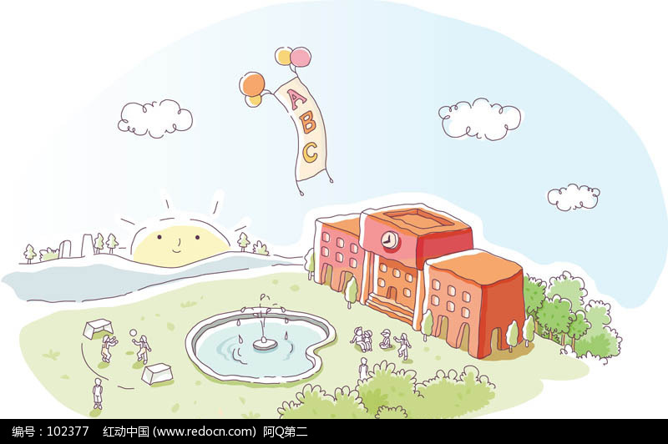

同学们，你们能描述一下自己的学校吗？（至少8句）

___________________________________________________

­­­­­­­­­­­­­­­­­­­­­­­­­­­­­­­___________________________________________________

___________________________________________________

­­­­­­­­­­­­­­­­­­­­­­­­­­­­­­­___________________________________________________

___________________________________________________

**My animal friend**

This is my animal friend. It is powerful but friendly. It has a long nose，big ears and a short tail. We can see it on TV or in the zoo. Although(尽管) they are so heavy, they run fast. Elephants eat leaves and bananas. They like walking slowly and playing in the water. I like elephants. I want to be strong, so I can protect my family.



亲爱的同学们，你肯定也有自己喜欢的动物朋友，请你用7, 8句描述一下吧！

_______________

_______________________________________________________________________________________________________________________________________________________________________________________________________________________________________________________________________________________________________________________________________________________________________

**My hobbies**

Everyone has his own hobby. I have many different hobbies, such as reading, watching films and travelling. I like travelling very much. I often have a travelling in my summer holiday. I want to travel around the world. It is very interesting. I also like watching films. I usually go to the cinema with my family at weekends. Hobbies bring me happiness.

亲爱的同学们，你肯定也有自己的兴趣爱好，请你用7, 8句描述一下吧！

_______________

_______________________________________________________________________________________________________________________________________________________________________________________________________________________________________________________________________________________________________________________________________________________________________

**Unit 5 What do they do**

There are three people in my home. My father is a cook. He can make many nice food. He likes cooking. My mother is a doctor. She helps sick people. And my brother is a teacher. He teaches Maths. I love my family.

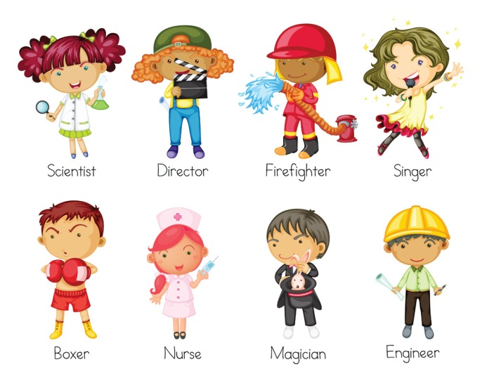

亲爱的同学们，请你用7, 8句话描述一下你家人的职业吧！

_______________

_______________________________________________________________________________________________________________________________________________________________________________________________________________________________________________________________________________________________________________________________________________________________________

**Unit 6 My e-friend**

I have an e-friend. She is Lucy. She is 13 years old. She lives in Australia, but she can speak Chinese. She studies Chinese after school. Lucy likes Art and Music. She can draw and sing well.

亲爱的同学们，你肯定也有一位e-friend吧，请你用7, 8句话描述一下他（她）吧！

_______________

_______________________________________________________________________________________________________________________________________________________________________________________________________________________________________________________________________________________________________________________________________________________________________

A colorful weekend

Hello, I’m Miss Shen. I have a colorful weekend. On Saturday morning I often visit my grandparents with my daughter. We often take a walk in the park. We fly a kite in the park. like playing table tennis with my daughter very much. On Saturday afternoon, We often go to the cinema. We watch a film on Saturday evening, my e-friend lives in the US.I sometimes chat with her on the Internet .On Sunday morning I read newspapers and magazines. On Sunday afternoon，I draw pictures and watch TV with my family.

At weekends, I’m very busy and colorful. How about you?



亲爱的同学们，你肯定也有自己丰富多彩的周末，请你用7, 8句描述一下吧！

_______________

________________________________________________________________________________________________________________________________________________________________________________________________________________________________________________________________________________________________________________________

Unit 8.Christmas

Christmas is on the twenty-fifth of December. On Christmas Day. The children wake up very early, and can’t wait to open the presents in their stockings. Then they wake up their parents calling. “Merry Christmas”. What does Christmas mean? Christmas Day is the birthday of Jesus Christ. When he was born nearly two thousand years ago .May people gave him presents. So today people still do the same thing to each other. Every likes presents, but they think it’s better to give than to receive.



亲爱的同学们，你心中的圣诞节是什么样的，请你用7, 8句描述一下吧！

_______________

________________________________________________________________________________________________________________________________________________________________________________________________________________________________________________________________________________________________________________________