交往互动式教学设计
课题 |  | Unit4 Then and now |  |  |  | 教时 |  | 第一课时
 |  |  |  |  |  | 日期
教学目标：  1.听说读单词then and now ,e-book, mobile phone, newspaper, radio, telephone, e-friend, anywhere,并能运用于语句中。  2.掌握动词过去式的发音及用法，会说…years ago,…could/ could not…Now,…  3、能通过观看视频、阅读文本等方式理解文本内容，形成思维方法；  4.能正确地理解并朗读文本内容，用创新的方式演绎对课文的理解，提高了合作能力和创新能力；  5、能借助文本，尝试创编对话，进一步巩固语言知识，达到交际的目的；  6.通过过去和现在的对比，感受到e时代给生活带来的巨大改变，从而深切感受到社会的进步。 |  |  |  |  |  |  | 重 点  与  难 点 |  | 教学重点：能正确地理解并朗读课文内容，在教师的引导和帮助下尝试复述课文内容.  教学难点：能了解社会的变迁，能正确使用一般过去时和一般现在时谈论过去和现在的事情。
Teaching Procedures
Time | Steps |  |  | Teacher’s activities | Learners’ activities |  |  |  |  | Purpose, Feedbacks &Aims
5  min | Step 1  Warming-up  吸引注意，积累语言 |  |  | Say something about my special friend: mobile phone.  What can we do with the mobile phone?  Say something about the life 20 years ago. | Know something about the teacher life.  Learn the new words. |  |  |  |  | 通过交流信息工具在生活中的运用学习新词，达成目标1
25 | 核心过程 |  | Step2  Pre-task  导出目标，生成结构 | 1.compare the teacher’s then and now.  2.Ask the students to say something about the their then and now. | 1.Know somethings about the teacher’s then and now  2.show the stuents’ then and now  Work in pairs:  Then, I was ...I could...  Now,I am ...  I can .... |  |  |  |  | 对比教师过去和现在的生活，呈现核心词汇和核心句型，学生交流自己六年前后的生活。达成目标2
25 |  |  | Step3  Task 1  回忆相关知识，初步运用结构 | 1.Look and say  Who are they?  What are we going to talk about?  2.Watch and choose  What are the changes about Mike’s family?  Talk about Mike’s family and try to know the change of the time with the help of the text. | 1. Watch the vedio find the change of time:  Six/twenty/thirty years ago.  - Watch the cartoon and choose the changes about Mike’s family, then say in class.  - and know more about the changes about Mike’s family. |  |  |  |  | 通过文本预测和观看视频，理清文本脉络，整体了解过去和现在的生活的变化。达成目标3.
25 |  |  | Step4  Task 2  呈现刺激材料，活用结构 | 1.Listen and say  Then, Mike could____, but he couldn’t______  Now, Mike can_______  2.Read and write  Organize the group work and class work, write on the blackboard.  随机指导 | 1.Look at the pictures and say something about Mike.  Listen to the tape and check.  2..Read and write  Group work:  (1)Finish the form by themselves.  (2)Check the answer in groups, help each other.  (3)Report |  |  |  |  | 通过听录音、细读文本、同桌交流、全班反馈、等方式进一步理解文本内容。 通过朗读进行强化，同时梳理文本结构。达成目标3.
25 |  |  | Step5  Task 3  引发期待行为，强化结构 | 1..Read the story time.  2.Retell the text according to the key phrases .  choose one way to act retell in groups. | 1.read the stroy time.  2.choose one way to show（方式自选） |  |  |  |  | 通过表演体现学生对文本的理解，为学生搭建语言创造的平台。达成目标4.
10  min | Step6  Post–task  提供反馈评价，巩固结构 |  |  | 1.The changes in my family.  (1)T sets a model.  (2)Organize the students to discuss in groups.  2. Watch the vedio: E-time  3. Homework:  (1)read the story time.  (2)Try t ofinish the exercise on page38 | 1.Understand the teacher’s model and practice it in pairs.  Show in class.  - Watch the vedio: E-time  3. homework |  |  |  |  | 以文本为载体，创编对话，进一步掌握语言，达到交际的目的。达成目标5.  通过观看视频，感受E时代给我们生活带来的巨大变化，达成目标6.
板书设计 |  |  |  | 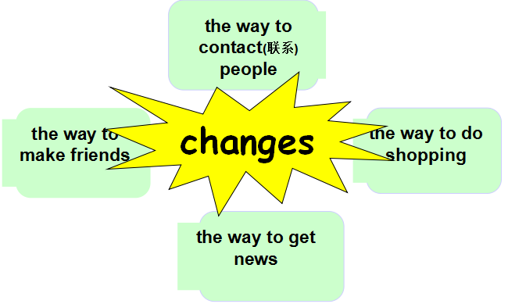  Unit4 Then and now

