**Who is your real-life idol? 学案**

Name： Class：

*Task 1 A Hot Tibetan Man.*

1.Read and match the main idea of each part.

2.Read and fill in the blanks.

|  |  |
| --- | --- |
| A Hot Tibetan Man | |
| Who is Tamdrin? | He is a 20-year-old Tibetan man.  Many people 1.________ a lot of attention to him recently after watching a short video of him on Douyin. |
| About Tamdrin's 2._____ | He has sun-kissed skin, mop of brown hair and his smile makes people  3.__________ |
| What did he do after becoming famous? | Tamdrin got over 2.5 million fans on Douyin, but he 4.______ to become a professional online celebrity(网络名人/网红).  Tamdrin has been hired to promote tourism in his hometown  and he will be paid 3,500 yuan each month as his salary(工资). |
| People's 5._________ | We're glad to see that Tibetans can introduce our own culture, food and places of interest to the world. |

1. Further thinking.

*Task 2 A great doctor and honest scholar.*

1.Read and choose.

( )1.What achievements did Zhong make in the fight against SARS? (细节理解题)

A. He was the first doctor to start treating SARS patients.

B. He treated the most serious patients online.

C.His treatment plan saved lots of people.

D.He stated that SARS was under control.

( )2.What does the underlined word”refute”mean ?(词汇推测题/熟词僻义题)

A.To support others' opinion.

B.To say that a statement was false.

C.To mock or laugh at authorities.

D.To be in the fight against the epidemic(流行病).

( )3.The purpose(目的) of writing the news is to_________. (推理判断题)

A.let more people know who Zhong Nanshan is

B.prove that even old men can make contributions to our country

C.praise Mr. Zhong for his spirit and call on more people to learn from him

D.introduce what Mr. Zhong did to fight against the disease

2.Read and fill in the blanks.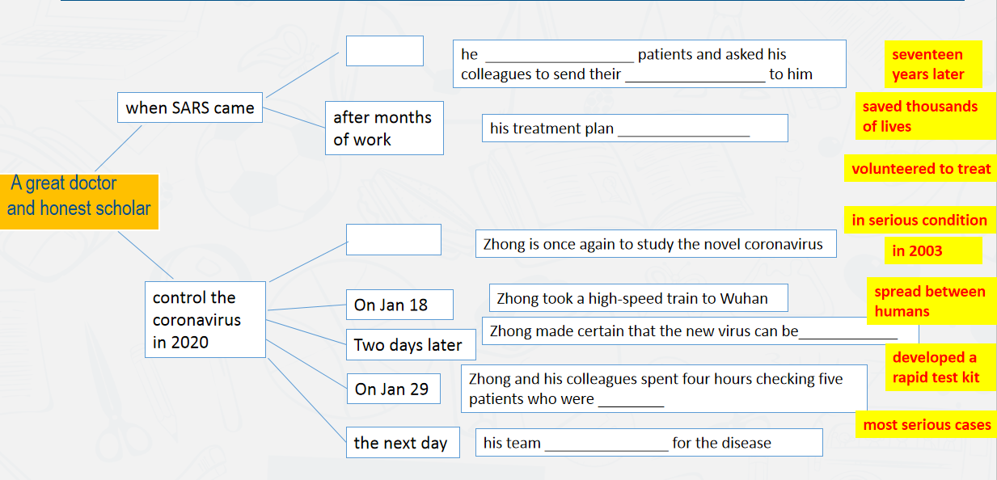

*Task 3 Brainstorming—Making a profile.*

Hello, everyone. I'm... I would like to introduce my idol to you today.

_____________________________________________________________________ _______________________________________________________________________________________________________________________________________________________________________________________________________________

What makes my idol inspiring?__________________________________________

___________________________________________________________________________________________________________________________________________________________________________________________________________________________________________________________________________________

In my opinion,__________ is a real-life idol because _______________________

____________________________________________________________________________________________________________________________________________________________________________________________________________________________________________________________________________________

Thank you!

**My Real-life Idol**